FOREWARD
In our ongoing effort to promote equity and dignity for all, it is crucial that we focus on the principles of empowerment and accessibility for individuals with disabilities, including those with deafblindness and multiple disabilities. This publication represents a critical advancement in our shared mission to ensure that behaviour modification strategies are inclusive and accessible to everyone, regardless of their abilities.
The path to understanding and implementing effective behaviour modification is fraught with challenges, particularly due to the widespread lack of awareness and simplified information from the lay persons perspective. Individuals with disabilities may face challenging behaviour and there is an aimed at promoting positive behavioural modification in the student.
Yet, the core tenets enshrined in the Universal Declaration of Human Rights, along with progressive legislative frameworks like the Rights of Persons with Disabilities Act-2013, make it clear that every individual has the right to access comprehensive behaviour modification strategies, tools, and resources. This publication, "Booklet on Behaviour Modification for Persons with Disabilities," reflects our unwavering commitment to the holistic development of individuals with disabilities, providing a crucial resource that promotes understanding, awareness, and effective training methods.
This manual has been meticulously crafted to address the unique behavioural needs of individuals with deafblindness and multiple disabilities/ disabilities. It offers a robust framework for special educators, parents, caregivers, and professionals working in this field, equipping them with the knowledge and skills necessary to support behaviour modification with confidence, respect, and inclusivity.
To ensure that the contents of this manual are appropriately adapted to meet the unique needs of each learner, it is essential to identify the core themes and areas that professionals in the field deem crucial for achieving the ultimate goal. Given the diverse educational backgrounds of professionals in this area, the manual is designed with flexibility, allowing for adaptations that accommodate varying levels of knowledge and experience.

Acknowledgment
We extend our heartfelt gratitude to the many individuals and organizations whose unwavering support made the creation of the "Booklet on Behaviour Modification for Persons with Disabilities" possible. This effort would not have been successful without the collaborative contributions of a diverse group of dedicated people.
It is our hope that this resource significantly contributes to advancing the understanding and effective implementation of behaviour modification strategies for individuals with disabilities, including those with deafblindness and multiple disabilities, as well as their caregivers and educators.
First and foremost, we express our deepest appreciation to the individuals with deafblindness and multiple disabilities, their parents, family members, and special educators for their willingness to share their experiences and insights. Their unique perspectives have provided a valuable foundation for understanding the challenges and behavioural needs of persons with disabilities.
We would also like to acknowledge the wholehearted support of our partners in 23 states of India, Bangladesh and Nepal whose contributions have enriched the content of this publication.
Special recognition goes to Ms. Mahek Swadia and Mr. Sachin Rizal for their dedicated and constant efforts in developing the content of the training booklet. Their expertise and commitment to the cause have been crucial in structuring the material into coherent and comprehensive chapters. We also recognize the valuable contributions of Ms. Rutu Trivedi and Mr. Vishvendu Shastri.
We also acknowledge the efforts of Mr. Uttam Kumar and Mr. Akhil Paul in enhancing the script and guiding the overall quality and impact of this manual. The bulk of the credit for this publication is due to the tireless efforts of the entire team at Sense International India.
The "Booklet on Behaviour Modification for Persons with Disabilities" stands as a testament to the collective commitment of everyone involved.
Special thanks

Contents
INTRODUCTION 4
Module 1: Understanding Behaviour 5
1.1 What is behaviour 5
1.2 Is this behaviour important to change or consider? 5
1.2.1 Problem behaviour 5
1.2.2 Causes of problem behaviours: Understanding communication as a major challenge 6
1.3 How do we learn positive and negative behaviours? 8
1.3.1 Classical conditioning 8
1.3.2 Operant conditioning 8
1.3.3 Modelling 9
Module 2: Assessing target behaviours 10
2.1 Functional Behaviour Assessment 10
2.1.1 Functional Assessment steps 10
2.2 Problem behaviours into target behaviours as excess and deficit 17
2.2.1 Behavioural Deficit 17
2.2.2 Behavioural Excess 17
2.3 Importance of defining target behaviour and behaviour goal 18
2.3.1. What is a behavioural goal? 18
2.3.2 Defining a behavioural goal in measurable components 18
Module 3: Positive Behaviour Support 21
Individualized Interventions 21
3.1 Prevention of Problem Behaviour: Modifying and changing antecedents 21
3.2 Reducing the problem behaviour 22
3.2.1 Extinction 22
3.2.2 Time out and Response cost 23
3.3 Skill Building: Teaching new behaviours to reduce problem behaviour 23
3.3.1 Choosing new skill behaviours or alternate behaviours 24
3.3.2 Positive and Negative Reinforcements to increase the positive behaviour 24
3.3.3 Shaping and Chaining 26
3.3.4 Prompts 28

INTRODUCTION
Behaviour modification is a crucial component in the learning journey. Persons with disabilities often face unique challenges in communication, which can significantly impact their behaviour, learning process, and interactions with others. As they struggle to express their needs, desires, or frustrations effectively, challenging behaviours can arise. These behaviours may not only hinder their learning process but also affect their social interactions.
Understanding behaviour modification becomes essential for special educators working with learners across various disabilities. Behaviour modification techniques offer a structured approach to addressing these challenges by focusing on replacing specific behaviours with more adaptive ones, thus enhancing the student’s ability to communicate effectively and engage positively with their surroundings.
This booklet is designed to equip special educators with practical tools and strategies for identifying and addressing challenging behaviours in students with disabilities. It provides a comprehensive guide on how to recognize behaviours that interfere with learning and social interactions, and how to analyse their underlying causes. By employing systematic approaches to behaviour assessment and modification, educators can create a more supportive and effective learning environment and
Behaviour modification is not just about managing behaviours but about fostering an environment where individuals with disabilities can thrive. It should empower educators to handle diverse behavioural issues with confidence and skill and can make a meaningful difference in the lives of their students.
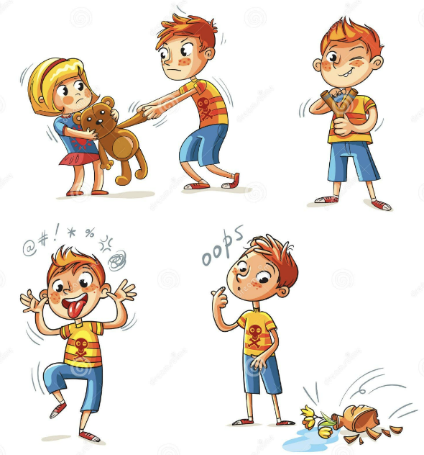

Module 1: Understanding Behaviour

1.1 What is behaviour
Before delving into behaviour modification, it's essential to establish a clear understanding of what constitutes "behaviour." While terms like "action," "performance," "response," and "reaction" are often used interchangeably with "behaviour," (Sarafino, 2011). From a behaviour modification perspective, we understand "behaviour" as any observable and measurable reaction to environmental or internal events. This definition encompasses a broad range of behaviour, from overt actions like walking and talking to subtle responses like physiological shifts and emotional reactions.
When describing any behaviour, it is common to focus on prominent traits or broad, stable characteristics rather than specific instances (Sarafino, 2011). For example, one might describe a child throwing tantrum in a grocery store as energetic, strong-willed, yet impulsive. These broad characteristics provide a convenient and efficient way of communicating a lot of information. Although traits such as being strong-willed are derived from observed behaviour, these traits themselves cannot be considered behaviour (Sarafino, 2011).
To effectively address and change behaviour, it is important to focus on specific actions. Impulsiveness, for example, may only be showing up in certain contexts. A child might share toys with friends and wait for their turn during games but struggle to stay calm when disappointed or when immediate desires are not met, especially in a noisy and crowded place such as a grocery store.
By precisely describing the behaviour to be changed, it is possible to measure and improve them effectively. Instead of labelling a child as impulsive, identifying specific behaviour like the frequency, intensity, and contexts of tantrums can allow for targeted interventions. For example, focusing on teaching specific behaviour like effectively communicating what they want, strategies to manage emotions surrounding unmet needs, or learning ways to regulate in a noisy environment.

1.2 Is this behaviour important to change or consider?

1.2.1 Problem behaviour
Once we understand exactly which behaviours we are targeting, we need to determine if they are actually problem behaviours, why they are occurring, and how they developed. Behaviours are considered "problematic" when they interfere with an individual's ability to interact effectively with their environment and achieve positive outcomes. These problem behaviours can be harmful to oneself or others, inappropriate for the individual's age and expected behaviour, or unacceptable reactions to specific situations and contexts.
Example scenario
In the previous example of a child throwing a tantrum in the grocery store due to unmet demand, the behaviour may be expected if the child is very young and lacks developmentally appropriate self-regulation skills. However, aggressive or self-injurious behaviours during the tantrum, such as hitting, head, banging, throwing or breaking things can be considered problematic.
Other examples may include behaviours such as procrastination, skipping school, and poor instruction following can also interfere with the learning process, impacting daily lives, social interactions, and overall functioning. It is important to consider the frequency, intensity, and duration of such behaviours to further prepare any intervention plan.

1.2.2 Causes of problem behaviours: Understanding communication as a major challenge
Understanding the underlying reasons for problem behaviour is crucial for determining the most appropriate behaviour modification strategies. Children often engage in challenging behaviours to communicate their needs or respond to their environment.
Communication challenges are a major cause of problem behaviours for individuals with disabilities. These challenges significantly contribute to stress and difficulty in initiating, maintaining, and thriving in social settings. When individuals struggle to express their needs and desires effectively, it can lead to misunderstandings, frustration, conflict, and feelings of loneliness within the family unit and in social interactions. Additionally, communication barriers in public and educational environments create significant accessibility challenges. Inadequate communication aids prevent effective interaction with the environment, leading to frustration, disruptive behaviours, and social isolation. These difficulties hinder individuals' ability to navigate their surroundings and place extra stress on families and caregivers.
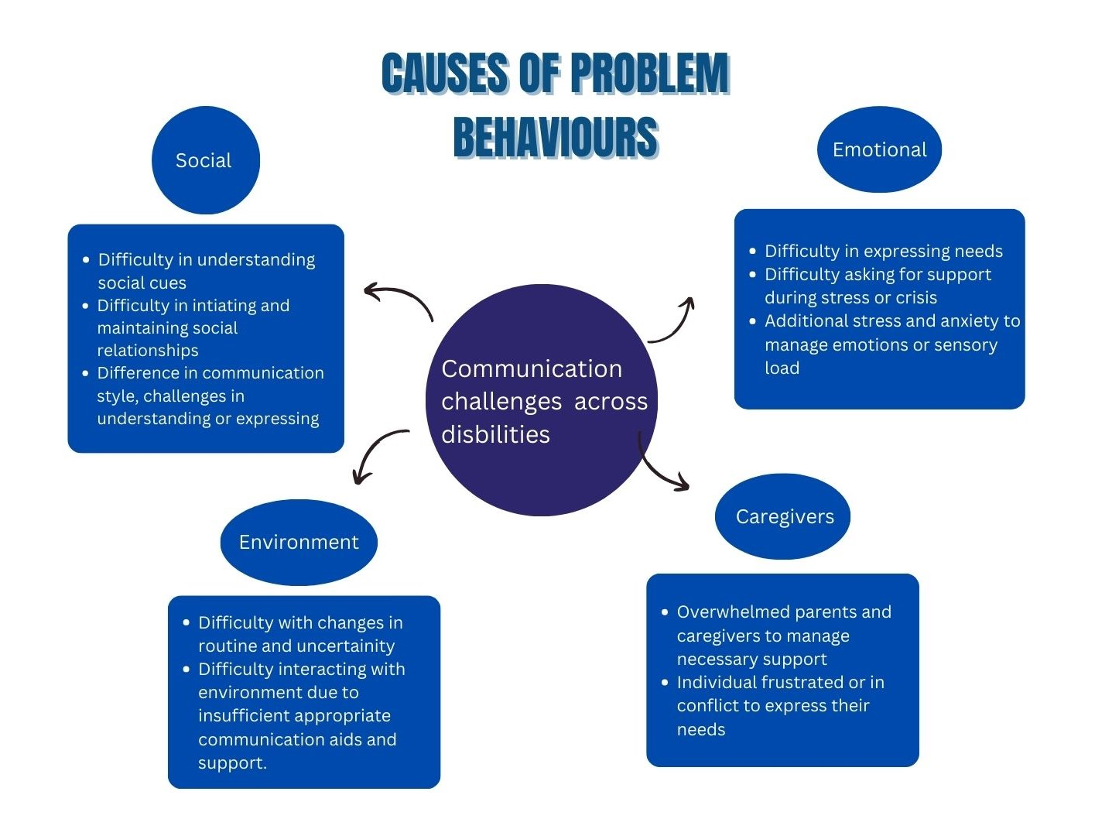
Considering these factors, developing skill behaviours is essential. Skill behaviours, such as effective communication, appropriate social interactions, academic proficiency, self-regulation, and daily living skills, are desirable actions that individuals can learn and develop through practice and reinforcement to interact effectively with their environment and achieve positive outcomes.
Case Scenario:
Background:
A 15-year-old boy with cerebral palsy. He uses a wheelchair and has limited verbal communication skills. His school has some accessibility features, but they are often inadequate.
Challenges
At School: He finds it challenging to navigate the school environment due to the lack of ramps and elevators. Additionally, his communication board is frequently ignored by peers and teachers, making it hard for him to participate in class or express his needs. This results in frequent frustration and disruptive behaviours, such as yelling or refusing to follow instructions.
At Home: His parents struggle to manage his frustration and emotional outbursts, which are often triggered by his experiences at school. They feel guilty for not being able to advocate more effectively for his needs and worry about his future. The family dynamic becomes strained as they try to balance his needs with those of his siblings.
Impact
His daily frustration due to inadequate accessibility and communication support leads to emotional outbursts and social isolation. The stress on his family grows as they try to support him without sufficient resources or understanding from the school.

1.3 How do we learn positive and negative behaviours?
Behaviours can be learned. Just as desirable or skilled behaviours are learned, problem behaviours can also be learned. Understanding how a problem behaviour was learned is crucial for developing an appropriate plan to reduce it.

1.3.1 Classical conditioning
People learn behaviours through classical conditioning, by linking a neutral stimulus with a meaningful one. So problem behaviours for individuals with a disability could have been learned by associating a neutral situation, event, or object with some stressor.
For example, a 16-year-old deafblind person may always get angry at their mother while going to the park. They could be associating the park with constantly requiring their mother's support to navigate the path, and feeling of isolation when other children are not always ready to include them and communicate through signs.

1.3.2 Operant conditioning
Operant conditioning is another way in which problem behaviours can be learned, as the consequences that follow an action can influence behaviour.
- Reinforcements
Consequences that increases or strengthens a behaviour are called Reinforcements.
A behaviour often increases when it is followed by the addition of a pleasant stimulus, called positive reinforcements or the removal of an unpleasant stimulus, called negative reinforcements.
Following the previous example of a young deaf-blind boy, if after he got angry for going to the park, was not taken to the park by his mother, it would be a pleasant stimulus that he wanted. So every time the park is mentioned, thereafter, he might show increased angry behaviour.
- Punishments
Consequences that decreases the likelihood for the behaviour to occur again are called punishments.
A behaviour often reduces when it is followed by adding an unpleasant stimulus, called as positive punishment or removing a pleasant stimulus, negative punishment.
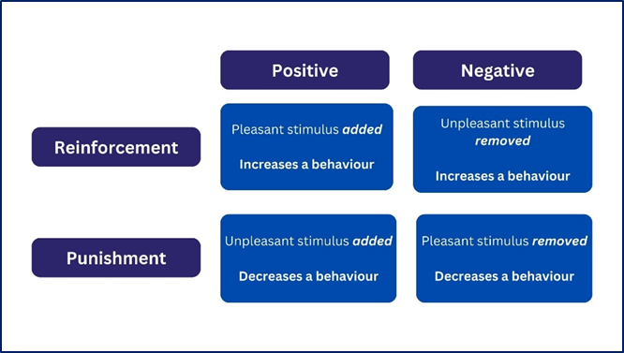

1.3.3 Modelling
Observational learning or modelling is another way in which behaviour is learnt by imitating or watching others.
If the young deaf-blind boy has observed others in his house shouting and fighting when they are in uncomfortable situations, there is a higher likelihood that his problem behaviour would be getting angry when he feels scared to go to the park.

Module 2: Assessing target behaviours

2.1 Functional Behaviour Assessment
Since behaviours are caused by various factors and are also acquired and sustained through the events that follow, it is crucial to understand these influences for behaviour modification.
Functional Behaviour Assessment (FBA) is a systematic approach to understanding and modifying problem behaviours by analysing what occurs before and after them. It identifies triggers and reinforcements through which problem behaviours are learnt and sustained (Sarafino, 2011).
A critical part of designing a program to change behaviour is answering the question, ‘‘What functions does the behaviour serve?’’. Thus, to determine how the person benefits from his or her current pattern of behaviour, it is important to know the situations, such as the places and times, in which the behaviour does or does not occur (Sarafino, 2011).

2.1.1 Functional Assessment steps

Problem behaviour(s) to be assessed
In a functional assessment, first step has two key factors. First, it is crucial to precisely identify and describe the specific behaviour, rather than relying on general characteristics, as explained in previous model. Second, it is important to determine how many problem behaviours to choose to address, therefore assess. When selecting and prioritizing problem behaviours for intervention, the following points should be considered:
- Choose only one or two: Limit the focus to one or two behaviours to avoid overwhelming the assessor and the individual with concern.
- Easy to manage: Choose behaviours that can be addressed relatively quickly, as successful management will maintain motivation for both parties. Overly difficult behaviours should be avoided, as they can lead to frustration and stress for both assessor and individual with concern.
- Injurious or harmful behaviours: Give priority to behaviours that are harmful to the person themselves or others.
- Interference with learning and communication: Address behaviours that significantly disrupt the person’s learning activities. This will facilitate better learning and communication which will further limit new problem behaviours that are used by the person to communicate discomfort.
- Consult with the parents when selecting and prioritizing behaviours for intervention.

Functional Assessment tool
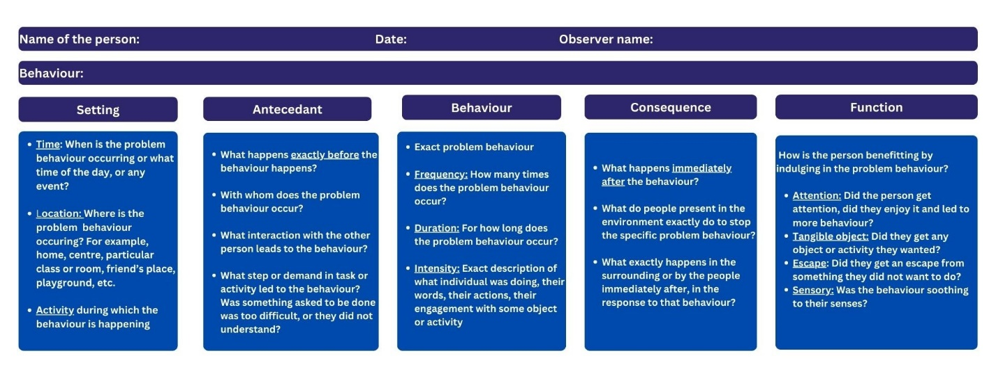

Specify criteria for antecedent and consequent events
Typical conditions, or Antecedent and Consequences that can be planned to help in measuring and comparing problem behaviour include:
- Attention condition: The consequence to the problem behaviour is to not allow them to engage in that situation, for example, "No, don’t do that”. It is to be observed for how long, and to what intensity does the behaviour continues, or not.
- Tangible condition: An object or activity that is liked by the individual is given to them as a consequence following each problem behaviour.
- Demand condition: Setting or Antecedent is a task presented to the individual. After the problem behaviour it is removed for a brief period as a consequence.
- Neutral condition: Neutral condition in which contexts or antecedent involve person engaging with activity or object, the assessor interacts positively with the them and any instances of the problem behaviour are ignored

Generate hypothesis
This step focuses on the outcome and next steps of the assessment. Assessment should help understand the relationship of Antecedent and Consequences with Behaviour. Assessment has to be analysed to find patterns of “When this happens” in Antecedent and Consequence and “then, individual does this” in Behaviour. This analysis helps
a. Determine which antecedents produces the behavioural excess or deficit.
b. To understand how consequences reinforce the behaviour and fulfil functions such as gaining attention, escaping situations, seeking sensory stimulation.

Functions as reinforcement
Behaviour is learned and maintained because of its consequences. When consequences fulfil what behaviour was trying to seek, it is reinforced and person may persist to behave in the same way. So it is important to understand the functions of problem behaviour in terms of reinforcement. The function matrix is a useful tool for identifying the possible causes or the ways that a behaviour was reinforced.
that is, the reason people learn and persist in a behaviour is that it results in reinforcement. if it leads to negative reinforcement, they get out of something they don’t want, such as an unpleasant task. Thus the function of the behaviour is to get something or get out of something, either of which strengthens the behaviour that accomplishes the goal.
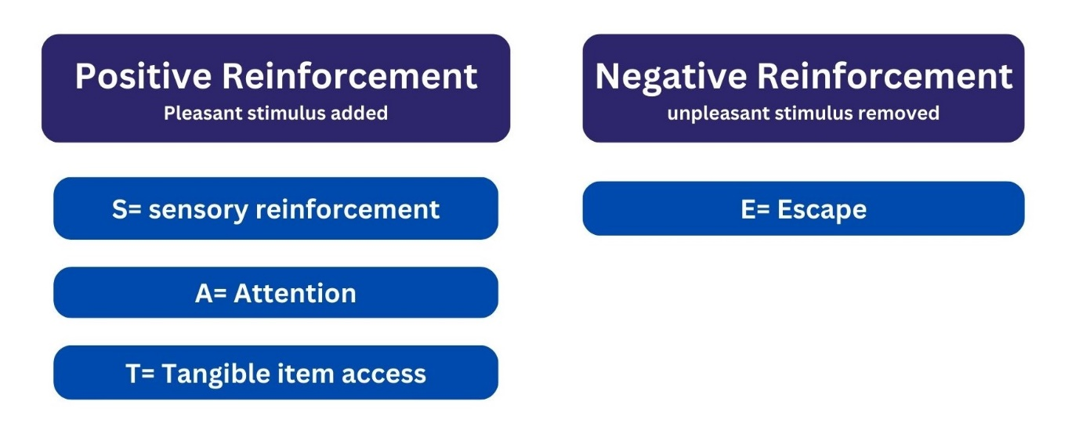
- Positive reinforcement consequences and function
If the behaviour leads to positive reinforcement, the individuals get something they want, be it any object, or experiences immediately after a behaviour, it increases the possibility of behaviour learnt well and to be repeated
- Automatic reinforcement function: Internal satisfaction
Automatic reinforcement, also known as sensory reinforcement. Individuals engage in certain behaviour because the behaviour itself produce sensory stimulation or satisfaction, independent of external consequences or rewards.
Case scenario:
Background: A 12-year-old boy with autism who engages in repetitive rocking behaviour while listening to music
Context | Antecedent | Behaviour | Consequence | Function
Music activity, 10:30 am | Educator switches on the system and music plays | Boy is repeatedly rocking on the beats of music. Does for 4 minutes till the song playes | Music gets over
 | Music gets over | Boy resumes his activity previously doing. He does not look for his educator to start it |  | Sensory/Automatic reinforcement
Note; He repeatedly rocks without seeking attention or tangible items during (Behaviour) or after the music (Consequence). This rocking behaviour serves the function of automatic reinforcement as provides sensory satisfaction and stimulation independent of external consequences.
    - Attention Function: Craving social attention
When behaviour are aimed at gaining attention, interaction, or recognition from others, they are said to be serving function of attention. When any consequence followed by a behaviour involves even negative attention such as “stop that”, it reinforces and strengthens behaviour as person was able to capture the attention of caregivers, peers, family members or anybody in their surroundings. This function often arises from a basic human need for social connection and engagement. For very younger children, it could be as simple as a tantrum as they do not know to communicate for help.
Case scenario:
Background: A 14-year-old girl who apparently disrupts her classroom and seeks attention from her classmates and educator.
Context | Antecedent | Behaviour | Consequence | Function
Vocational training  12:00 pm | Educator asks to put button the model shirts and fold | Girl enjoys talking to learners around her, makes funny faces and tell them jokes | Educator asks her to keep quite
 | Educator asks her to keep quite | Girl stops and focuses for 45 seconds. Then she tries to talk to other educator. |  | Attention
Notes: The behaviour serves the attention-seeking function. She constantly wants to engage with someone around her to gain the attention and validation of her peers and teacher
    - Access to tangible items: Obtaining Desired Objects
When a behaviour is aimed at obtaining a particularly desirable objects, activities, or experiences, it is said to be serving the purpose of trying to access something tangible. Individuals may engage in certain behaviour to gain access to items they find desirable, whether it’s a favourite game, time with their friend, or a preferred activity. When consequence of their problem behaviour leads them to these, the behaviour becomes stronger.
Case scenario:
Background: A 16-year-old girl, tries to explain to her new coach using sign language, that she wants to be in her friend’s team as she will be able to help her and they have played and won together earlier.
Context | Antecedent | Behaviour | Consequence | Function
Sports  11:30 am | Coach is not able to understand girl’s sign language and firmly asks her to take her position | After 2-3 attempts of trying to explain him, girl starts crying | Educator notices and helps interpret her desire to the coach
 | Educator notices and helps interpret her desire to the coach | Girl wins the game and is happy |  | Access to desirable experience
Notes: When environment around the person does not facilitate effective communication, behaviours such as crying or being aggressive may occur. Others may consider that as problem behaviours but it might only be as a result of trying to express what an individual want. If the individual themselves are not equipped with correct ways of interacting and people around them help every time, they cry or are angry, they may take less interest in learning those ways and resort to problem behaviours to access
- Negative reinforcement consequences and functions
If the behaviour leads to negative reinforcement i.e. an event or object that the individual did not like or was uncomfortable with is removed, immediately after a behaviour, it increases the possibility of behaviour learnt well and to be repeated.
- Escape function: Seeking relief from demand
Problem behaviour occurs when person is trying to avoid or escape from an unpleasant, challenging or uncomfortable task, demand, or an activity. It provides them a temporary or immediate relief from that situation. If the consequence of the behaviour is to somehow allow them to be away from that particularly disliked activity, it has served the function of escape. There is more likelihood that person would engage in the same behaviour in same situations to escape.
Case scenario:
Background: A 7-year-old boy often goes to washroom between 12 and 2 pm. Educators are increasingly concerned about his health.
Context | Antecedent | Behaviour | Consequence | Function
Thursday 12:00- 1:00 pm  Maths | Teacher is writing a sum on blackboard. | He is copying. Attempting to solve for 1.5 minutes and then asks to go to washroom | Educator gives permission to go to washroom
Friday  1:00-2:00 pm  Maths | Educator asks the learners to submit their Math homework | Gives his book for submission and asks to go to washroom | Educator gives permission to go to washroom | Escape
Same as above | Educator gives permission to go to washroom | He comes back to his room after 12 minutes | Educator forgets to mention all the sums he has made mistakes in
Notes: His behaviour may seem like a health concern without an assessment of context, time, activity and duration. It is only when one takes detailed assessment, it is understood that washroom rounds serves the escape/avoidance function. He could be finding Math sums difficult or would be afraid of the educator. Educator missing to help him correct his mistakes (consequence), strengthens his tendency to leave classroom when Math tasks become difficult

2.2 Problem behaviours into target behaviours as excess and deficit
After analysing the problem behaviours using the Functional Assessment tool, the intervention may involve goals to replace the problem behaviours by teaching new, appropriate behaviours. It may also involve decreasing the frequency, duration, or intensity of the problem behaviours by modifying the antecedents or consequences that are identified in the assessment as reinforcing the behaviours. The goal, whether it is a new behaviour or a reduction in the problem behaviour, is referred to as the target behaviour.
Determining whether to teach a new behaviour or decrease the problem behaviour as the goal depends on whether the issue involves a lack or an excess of the behaviour. Therefore, it is crucial to understand the concepts of behavioural deficit and behavioural excess (Sarafino, 2011).

2.2.1 Behavioural Deficit
A behavioural deficit is when a desirable behaviour is not performed often, long, well, or strongly enough. Examples include not exercising often, not studying enough, and not speaking loudly enough.
Example scenario:
A child who struggles with social interactions, a behavioural deficit might be not initiating conversations with peers or not engaging in social play often enough. The child may benefit from targeted interventions to teach skill behaviours that encourage more frequent and effective social interactions.

2.2.2 Behavioural Excess
A behavioural excess is an undesirable behaviour that is performed too frequently, strongly, or for too long. Examples include aggressive acts, drinking alcohol too often, and experiencing excessive fear during tests.
Example scenario:
An individual who does not wait for their turn in group activities, is restless, moves around frequently in class or centre, and talks a lot with peers between tasks is exhibiting behavioural excess. To address these behaviours, interventions might focus on goals to improve the person's focus on tasks, self-regulation, and evaluate whether the tasks are too difficult, which can lead to inattention and restlessness.

2.3 Importance of defining target behaviour and behaviour goal

2.3.1. What is a behavioural goal?
A behavioural goal is the level of the target behaviour we hope to achieve in a program. For example, for the target behaviour of jogging daily, the behavioural goal might be to increase jogging to three 1-hour sessions each week.
To change the target behaviour, the goal could include adding certain behaviours if there was a behavioural deficit. Choosing the appropriate behaviour to add involves multiple considerations, such as any skill-based behaviour that could help the individual manage the situation. Skill behaviours could also be prerequisite skills, that are to be taught step by step in order to learn a major skill.
If there was a behavioural excess, the goal could involve removing certain behaviours or adding a replacement behaviour to phase out the undesirable behaviour.

2.3.2 Defining a behavioural goal in measurable components
Very often, expected outcomes and behavioural goals are different. Outcomes are broader or less directly tied to specific behaviours. Behavioural goals include sequences or specific behaviours that enable attainment of the outcome (Sarafino, 2011). For example, parents and teachers who want to improve students’ learning often focus on an outcome goal, usually grades, rather than on the behaviours that help reach those grades.
Defining the behavioural goal in measurable terms is also important because it helps avoid the misconception that a behaviour occurred when it actually didn’t, or missing it when it did.
Example scenario
Considering a scenario related to academic learning for a 16-year-old. Suppose a goal is set for the teenager to "improve in math." This goal is vague and open to interpretation. Does "improve in math" mean understanding algebra better, increasing test scores, completing homework assignments on time, or something else?
If the goal is not defined clearly, one might think progress is being made when the student is spending more time studying, but not necessarily understanding the material better or achieving higher scores. Defining the behaviour goal as "complete and correctly solve at least 90% of the assigned algebra problems on each homework assignment" makes it measurable.
Components to consider when defining a behaviour in measurable terms can be time frame in which the goal behaviour should occur, the duration or frequency of the desired behaviour, the intensity or level of performance expected, and the specific context or situations in which the goal behaviour should manifest.
- Time frame and Duration
Specifying a clear time frame, like daily, weekly, or monthly, helps set a timeline for evaluating if the goal has been reached. Similarly, defining the duration or frequency of the behaviour, such as completing a task within a certain time period or engaging in the behaviour a specific number of times, offers a concrete metric for measuring performance. For example, "the student will complete all algebra homework within 60 minutes, 4 out of 5 times per week".
- Intensity
The intensity component refers to the quality or degree of the goal behaviour, such as achieving a minimum percentage of correct responses or demonstrating a certain level of proficiency. For example, ''the student will correctly solve at least 90% of assigned algebra problems on each homework assignment."
- Context
Finally, specifying the context in which the goal behaviour should occur, such as in the classroom or during independent study, helps plan for appropriate supports and realistic, manageable steps that do not overwhelm the person. For example, ''The student will correctly solve at least 90% of assigned algebra problems on each homework assignment completed during independent study.”
By considering these measurable components, educators and learners can establish clear, achievable, and observable goals that facilitate effective monitoring, identifying specific areas for improvement, and implementing strategies and intervention strategies to support the desired behavioural changes and learning outcomes. Defining measurable behavioural goals in this way helps bridge the gap between desired outcomes and the actual steps required to reach them.
To bring any behavioural change, antecedents and consequences need to be altered. If a target behaviour is defined vaguely, it becomes uncertain when, where, and how to introduce appropriate antecedents and consequences.

Module 3: Positive Behaviour Support
Positive Behaviour Support (PBS) is a proactive approach that aims to reduce challenging behaviours and promote positive alternatives by using a variety of evidence-based strategies. These strategies are designed to create a supportive environment that fosters the individual's overall well-being.
It is informed by the findings of a Functional Behaviour Assessment (FBA) and encompasses a range of strategies such as positive reinforcement, teaching alternative behaviours, and addressing the specific triggers that prompt the challenging behaviours.
Additionally, PBS emphasizes teaching functional communication skills to encourage effective expression of needs and desires.

Individualized Interventions
Individualized interventions are tailored to address the specific needs of the individual based on the Functional Behavioural Assessment. If the behavioural goal involves reducing an excess behaviour, it would include preventing the problem behaviours by understanding their function, the antecedents that trigger them, and the consequences that reinforce them. It could also involve teaching alternative behaviours that serve the same function and reinforcing the new behaviours.
If an individual's Functional Behavioural Assessment reveals a behavioural deficit or lack of an important behaviour, the focus would be on teaching that behaviour and reinforcing to strengthen its learning and real-life applications.
Another key strategy is to teach communication skills as well as other coping or self-management skills that can address the need for the problem behaviour.

3.1 Prevention of Problem Behaviour: Modifying and changing antecedents
Preventing problem behaviour before it occurs is a key component of PBS. One of the primary prevention strategies involves modifying antecedents, as they can trigger challenging behaviours. There are various antecedent factors that may increase the likelihood of behaviour problems, such as specific settings, situations, places, people, times, demands placed on the individual, task difficulty levels, instructional methods, and sudden changes in routine. These factors can lead individuals to engage in problem behaviour to seek attention as a mode of communication or to escape an uncomfortable situation.
By changing the environment, altering the way instructions are given, or adjusting the level of task difficulty, problem behaviours that serve the functions of attention or escape can be addressed.
For example, in the scenario of a 7-year-old boy with behaviour of going to washroom in Math class with function of escape, an FBA might reveal that the behaviour occurs when the tasks are too difficult. In this case, the intervention could involve simplifying the tasks or providing additional support, such as visual aids or step-by-step instructions. By addressing the antecedents, educators can reduce the likelihood of challenging behaviours and create a more supportive learning environment.

3.2 Reducing the problem behaviour
When challenging behaviours occur, strategies for reducing these behaviours are called interventions, but this term does not carry the traditional punitive connotation. These strategies aim to reduce problem behaviours without resorting to punitive measures. Often, intervention involve teaching alternative behaviours or new skills, along with rewards and reinforcements to increase desirable behaviours while decreasing the frequency of problem behaviours through punishment strategies. Some strategies of punishment are as below.

3.2.1 Extinction
Excess in problem behaviours often stems from an attempt to gain attention or access to an object. When the consequence of the behaviour gives them the desired attention or access, the behaviour is reinforced. Extinction, which involves ignoring the behaviour, can reduce its occurrence. This approach does not address the underlying function of the challenging behaviour, as the consequence fails to reinforce it by withholding the desired attention or object. This strategy falls under the negative punishment, as it tries to reduce problem behaviour by removing a desired stimulus
Example scenario
If a child engages in attention-seeking behaviour, such as yelling out in class, the teacher might use extinction by not responding to the behaviour. Instead, the teacher would reinforce positive behaviours, such as raising a hand to speak.

3.2.2 Time out and Response cost
Both time-out and response cost are negative punishments that aim to reduce the occurrence of problem behaviour by removing a reward or preferred activity from the individual following the problem behaviour.
Time-out removes the individual from a rewarding experience or situation. Response cost, on the other hand, involves the child returning a reward they may have earned as a consequence or reinforcement for any desirable behaviour they performed.
Example scenario
An individual is trying to seek attention or escape work by laughing and enjoying time with friends at centre. Time out would involve removing them from this enjoyable experience by asking them to complete the work in a different room. They can also be asked to come at a different time or batch then the other friends.
Similarly, in the same situation, response cost would involve asking them to return a badge or reward they might have earned for doing work quickly, or effectively previously

3.3 Skill Building: Teaching new behaviours to reduce problem behaviour
Problem behaviours are often a result of a skills deficit. When an individual lacks certain skills or appropriate behaviours to engage and interact with their surroundings, they may resort to problem behaviours. Teaching alternate skills and behaviours that are more socially acceptable and effective in meeting their needs helps reducing problem behaviours with different functions.
As explained in Module 1, a very common cause of problem behaviour can be a lack of communication skills. Teaching how to communicate when a task is difficult can help reduce problem behaviours with the function of escape. Similarly, an appropriate way of communicating their wants can help reduce problem behaviours with the function of accessing tangible items.
Additionally, self-regulation or coping skills can help individuals manage the difficulties they face and therefore reduce problem behaviours.

3.3.1 Choosing new skill behaviours or alternate behaviours
Skills or alternative behaviours are selected based on a behavioural goal made after understanding why the individual is engaging in that behaviour, by analyzing functions, antecedents, and consequences through a Functional Behaviour Assessment. The educator can select a skill or alternative behaviour that meets the same need as the function of the challenging behaviour but in a more appropriate and constructive way.
For example, if a student frequently interrupts class to gain the teacher's attention, the educator could teach them to raise their hand and wait to be called on. The goal is to provide the student with a socially acceptable way to receive attention.
In a scenario where a learner acts out every time they have to tie their shoelaces, the goal can be that the learner ties their laces with help at least once a day and asks for help at least three times a week. The alternative behaviour could be teaching them to use a "help" card or verbally request assistance when they feel overwhelmed, and there can be a plan to teach lacing it step by step.

3.3.2 Positive and Negative Reinforcements to increase the positive behaviour

a. What are they and why are they important?
Reinforcers are rewards that motivate individuals to engage in certain behaviours. When these reinforcers are given immediately following the behaviour, it is more likely to increase the behaviour.
Rewards can be objects or experiences a person wants. These are called positive reinforcement when given after the behaviour. Rewards can also be a break from objects or experiences the person does not want. Providing such a reward after a desirable behaviour is increases the likelihood of engaging in that desirable behaviour again. This is called negative reinforcement. For example, if a student who completes their work on time, they might be allowed to skip cleaning up the class activity at the end of the day. This strategy can be effective in promoting positive behaviours while simultaneously reducing negative behaviours.
It is understood from the functions of behaviour in previous modules that even problem behaviours may be learned and repeated when reinforcers are given in consequence. By the same principle, by reinforcing positive behaviours, educators can help individuals build new skills and reduce the likelihood of challenging behaviours.

b. Choosing reinforces
Reinforcers must be identified so that they are meaningful or enjoyable when provided after the desirable behaviour. The reinforcers can be identified through Functional Behaviour Assessment. If the FBA reveals that the primary function of the challenging behaviours is attention, then praise, validation, time with friends, and other social validation can be chosen as reinforcers. If the function is access to tangible items or automatic reinforcement, reinforcers can be the objects that the individual seeks or finds soothing. If the function is escape, the activity the individual dislikes can be used as a reward by providing a break or relief from it in exchange for the desired behaviour (Sarafino, 2011).
Following to take care of when choosing and selecting rewards to increase or reinforce the newly taught behaviour.
- Varied reinforcers
Using different rewards is important because relying on just one reward can make it less effective over time. This happens because the person might get too used to the same reward or simply get tired of it.
For example, if an individual always receives the chance to listen to their favorite song as a reward for completing tasks, they might eventually lose interest in that song, and their motivation to finish tasks could decrease. To prevent this, a variety of rewards could be offered, such as different songs, , or a short video. This keeps the rewards fresh and maintains their motivation.
- Explaining reinforcers: Token economy
A token economy is a positive reinforcement system where tokens are used as a form of currency to reward desired behaviours. Tokens are typically given immediately following the desired behaviour to reinforce the connection between the behaviour and the reward.
Tokens have no inherent value but can be exchanged for valuable items or privileges, known as backup reinforcers. For example, a person might earn 10 tokens for completing tasks which they can later trade for tangible rewards such as free time with friends, extra screen time, or additional holidays.
Over time, the token economy helps to increase motivation and encourages the repetition of positive behaviours. It also allows for a variety of rewards to keep individuals engaged and interested in participating in the system.
It is important to explain and demonstrate the value of tokens to individuals. Otherwise, the unpredictability or ambiguity of when and how one might earn tokens can be frustrating, potentially leading to a loss of motivation for performing desired behaviours.
- Choice of the individual
Choosing from a spectrum of reinforcers after displaying desirable behaviour is crucial, as it allows the reinforcement to be personalized and meaningful to the individual. This increases motivation, making the positive behaviour more likely to be repeated. Having the opportunity to choose a reinforcer may sometimes be more important than the reinforcer itself. The decision-making process and the opportunity to choose can be reinforcing in their own right.

3.3.3 Shaping and Chaining
Shaping and Chaining are techniques used to teach new behaviours and skills.
In shaping, a person is gradually taught a new behaviour by rewarding small steps that lead to it. This involves giving praise or rewards for actions that are close to the desired behaviour. As the person improves, only the actions that are even closer to the final goal are rewarded. By following this process, the person slowly learns the new behaviour step by step.
Example scenario:
Teaching an individual to clean their room by shaping. Initially, they might receive praise and rewards for taking a small step, such as picking up and putting away just books in the cupboard. Once they consistently perform this action, the expectation is gradually increased, with rewards given for putting away other the dishes back in kitchen, then the clothes kept properly in the cupboard, and eventually for tidying the entire room. Through the reinforcement of these small, successive steps, they gradually learn and adopts the complete desired behaviour of cleaning their room.
Chaining, on the other hand, involves breaking down a complex task into smaller, manageable steps that can be taught sequentially. Each step serves as a cue for the next step in the chain, ultimately resulting in the completion of the complex task. Provide immediate and specific feedback for each step to guide the individual towards the desired behaviour.
Chaining helps teaching complex skills or task that an individual might be trying to escape and show challenging behaviours.
- Forward chaining
In forward chaining, the individual learns each step of a task in sequence, starting with the first step. Next step is added only after the previous one is mastered, eventually leading to the completion of the entire task.
- Backward Chaining:
In backward chaining, the individual is taught the final step of a task first, and then each preceding step is introduced one by one. This method ensures that the task ends on a successful, reinforcing note as the individual completes the entire sequence.
For instance, with backward chaining, you might first teach the child to clean and put away the toothbrush, and then gradually add the previous steps until they can complete the entire task independently.
Example scenario
Teaching a child to brush their teeth through chaining. The task is broken down into smaller steps, such as:
Forward chaining steps | Backward chaining steps
- Picking up the toothbrush. | - Cleaning the brush and putting it away
- Applying toothpaste to the brush. | - Rinsing the mouth.
- Turning on the water. | - Brushing the bottom teeth.
- Brushing the top teeth. | - Brushing the top teeth.
- Brushing the bottom teeth. | - Turning on the water.
- Rinsing the mouth. | - Applying toothpaste to the brush.
- Cleaning the brush and putting it away | - Picking up the toothbrush.

3.3.4 Prompts
Prompting plays a crucial role in teaching new behaviours within Positive Behaviour Support (PBS). Prompts are guidance and cues that help individuals perform the desired behaviour. Prompts are used to assist learners in acquiring new skills, ensuring they successfully engage in the target behaviour until they can perform it independently. This systematic use of prompts helps facilitate learning and promotes positive behaviour change.
a. Types of Prompts
i. Verbal Prompts: These involve using spoken instructions or cues to guide the individual toward the desired behaviour, such as saying "Remember to say thank you."
ii. Gestural Prompts: These consist of physical gestures, like pointing or nodding, that signal what action should be taken, providing a visual cue to the learner.
iii. Modelling Prompts: This type involves somebody demonstrating the desired behaviour for the learner to imitate, offering a clear example of what is expected.
- Physical Prompts: These prompts involve physically guiding the learner's movements to help them perform the behaviour, such as gently helping them hold a pencil correctly.

- Visual Prompts: These include the use of pictures, symbols, or written instructions to cue the desired behaviour, offering a non-verbal guide that the learner can follow.
b. Fading of Prompts
As the learner becomes more proficient in the behaviour, prompts are systematically faded by gradually reducing the level of assistance provided at each attempt. This helps the learner to perform the behaviour independently and ensures that they do not become reliant on prompts or external cues to complete the task.
References:
Martin, G., & Pear, J. J. (2019). Behavior modification: What it is and how to do it. Routledge.
Sarafino, E. P. (2011). Applied behavior analysis: Principles and procedures in behavior modification. John Wiley & Son

Thanks

