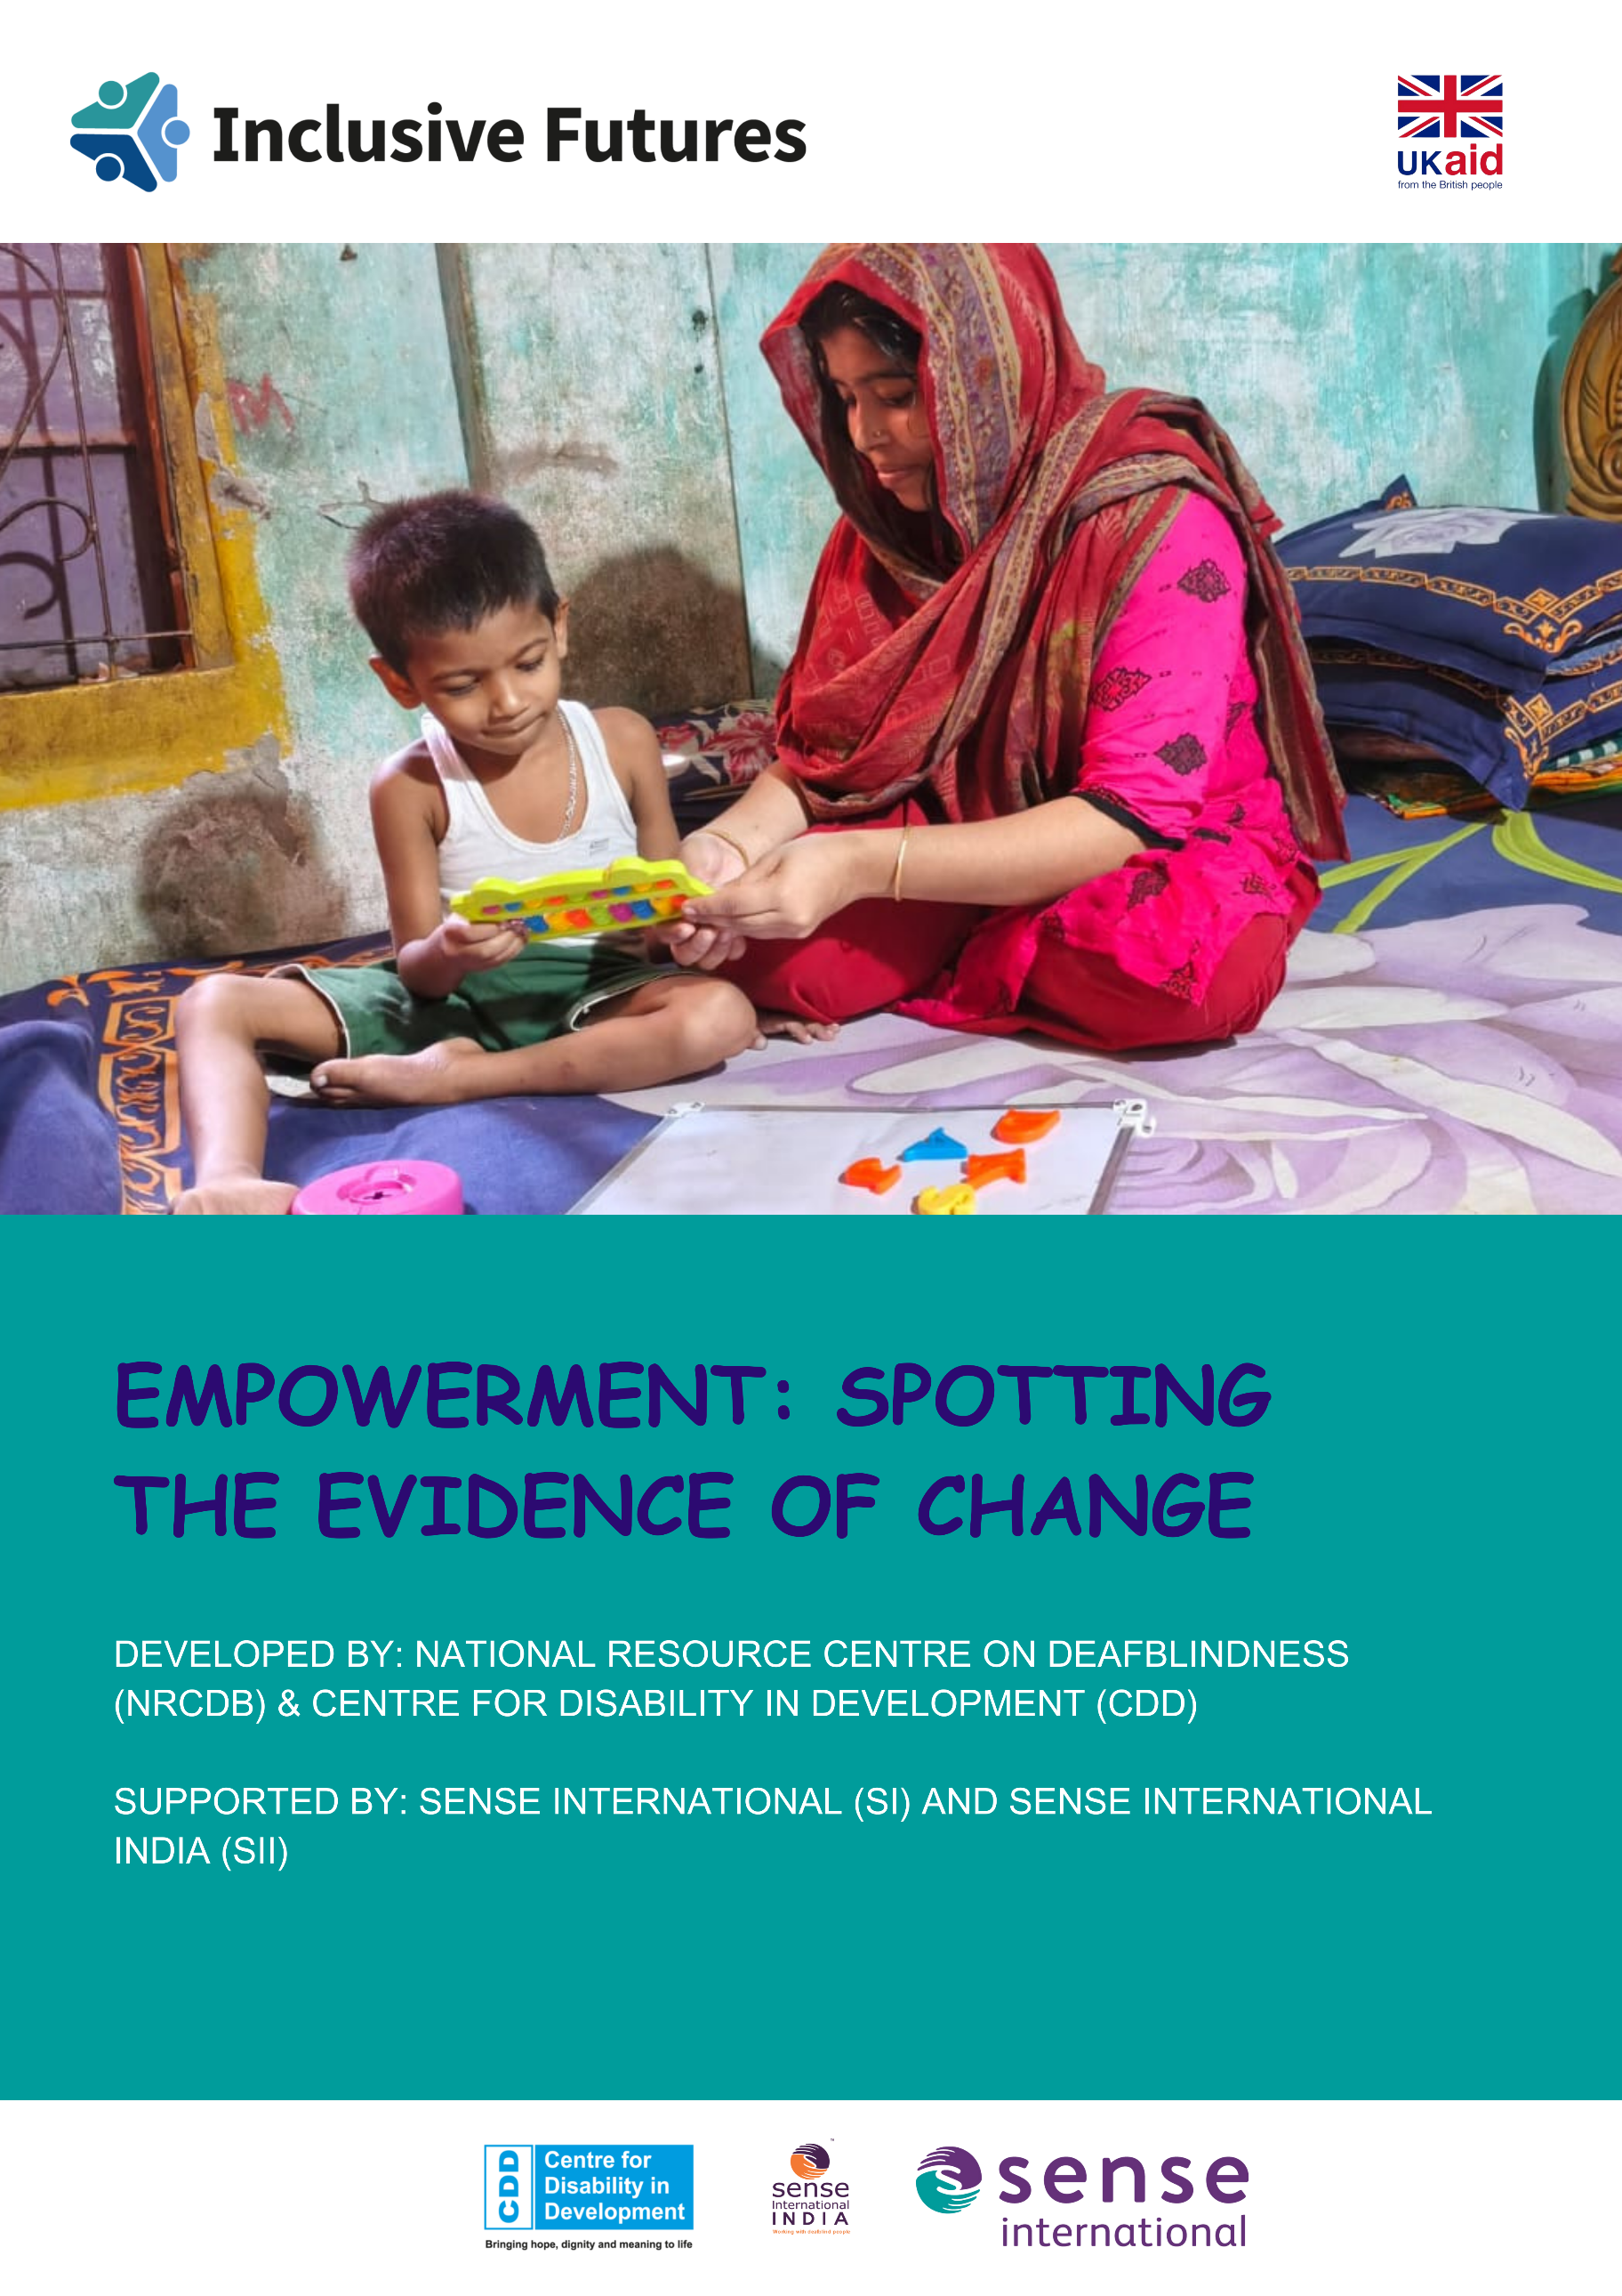

Table of Contents

Executive Overview: A Story of Empowerment and Progress 2
Context, Objectives and Dramatic Knowledge Gains 2
1. Background and Objectives 2
2. Methodology 3
3. Key Findings: Knowledge (K) 3
Attitude and Skill Development 4
4. Key Findings: Attitude (A) 4
5. Key Findings: Skills (S) 5
Safeguarding and Recommendations 5
6. Safeguarding Knowledge and Practice 5
7. Conclusion and Recommendations 6
Key Recommendation Areas: 6

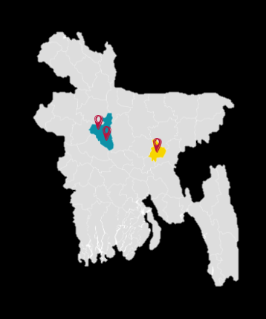
Locations: Sirajganj Sadar, Tarash, Narsingdi Sadar, Bangladesh.

278 participants (parents/caregivers)

Executive Overview: A Story of Empowerment and Progress
The Endline Survey on Knowledge, Attitude, and Skills (KAS) for parents and caregivers has demonstrated significant and positive progress across all three domains. The data confirms a massive, positive shift in how equipped families feel to support their children with deaf-blindness or severe and multiple disabilities, validating the effectiveness of the targeted interventions.
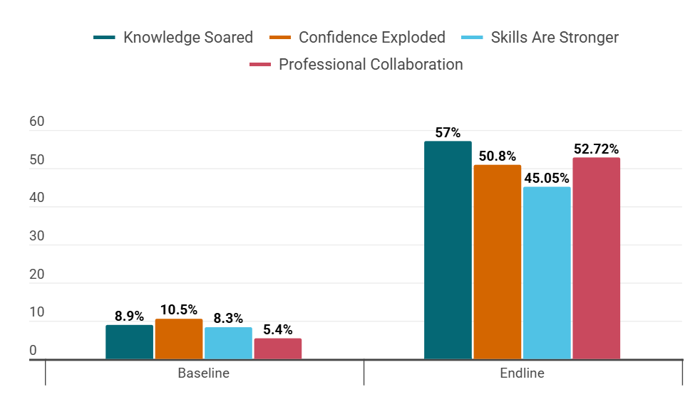

Context, Objectives and Dramatic Knowledge Gains

1. Background and Objectives
Disability affects an estimated 15% of the global population, with Persons with Severe and Multiple Disabilities (SMD) facing particularly pronounced challenges and limited opportunities. The project, "Strengthening systems for the enrolment, retention and support of children with disabilities in primary education," aimed to provide inclusive education to children with Severe and Multiple Disabilities.

Specific Objectives:
- To measure the change in the knowledge level of parents and caregivers between baseline, midline, and endline.
- To understand the attitudes expressed by parents and caregivers.
- To get information about the previous and current skills of parents and caregivers toward a person with disabilities.

2. Methodology
- Study Design: Endline evaluation, building upon baseline and midline data to assess changes in the behavioral state of family members and neighbors toward People with SMD.
- Data Collection: Primary data was collected using a semi-structured Knowledge, Attitudes, and Skills (KAS) questionnaire.
- Analysis: Data was cleaned, sorted, and analyzed using MS Excel, with findings visualized through charts to compare endline with baseline results.

3. Key Findings: Knowledge (K)
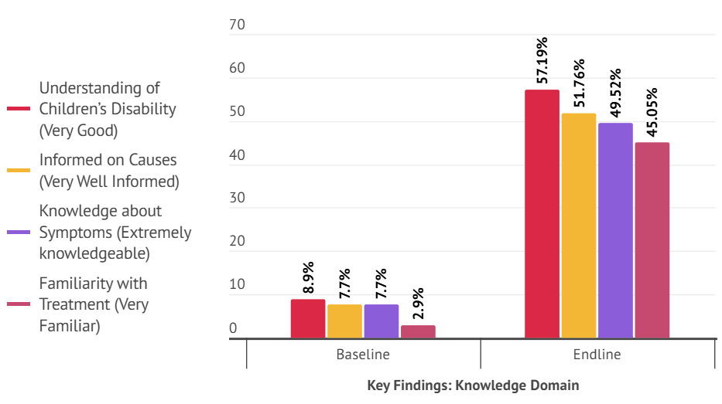
The program was highly successful in improving caregivers' understanding of their child's disability, causes, and symptoms, effectively moving the majority into the "informed" tier.
- Understanding of Children’s Disability: The percentage reporting a "Very good" understanding soared from 8.9% to 57.19%. Lower categories ("Fair," "Poor," "Very poor") saw a dramatic decrease.
- Informed on Causes: The percentage reporting being "Very well informed" surged from 7.7% to 51.76%. The lowest categories ("Not very informed" and "Not at all informed") plummeted from a combined 45.1% to just 0.32%.
- Knowledge about Symptoms: Caregivers rating themselves as "Extremely knowledgeable" increased from 7.7% to 49.52%.
- Familiarity with Treatment: The proportion who were "Very familiar" increased from 2.9% to 45.05%. Total familiarity (Very/Somewhat) reached 77.64%.

Attitude and Skill Development

4. Key Findings: Attitude (A)
Attitude changes reflect increased acceptance, confidence, and openness, essential for creating an inclusive environment for the child.

- Confidence in Support: The proportion of parents feeling "Very confident" in supporting their children rose from 10.5% to 50.8%. The lowest confidence ratings were eliminated.
- Feelings Towards Disability: "Very positive" feelings rose from 3.5% to 42.49%. Overall positive sentiment (Very/Somewhat) reached 77.32%.
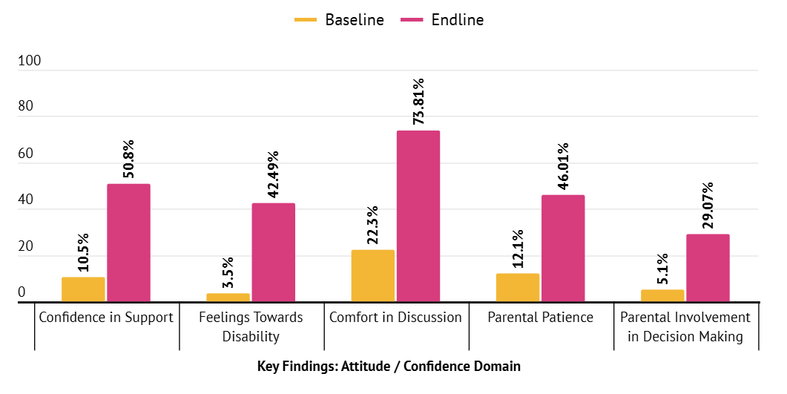
- Comfort in Discussion: The combined comfort in discussing the child’s disability ("Very comfortable" and "Somewhat comfortable") increased from 22.3% to 73.81%.
- Parental Patience: The response "Very patient and understanding" increased from 12.1% to 46.01%. The "Very impatient and frustrated" response saw a dramatic drop.
- Parental Involvement in Decision Making: The number of parents who were "Very Involved" rose by 23.97 percentage points, from 5.1% to 29.07%.

5. Key Findings: Skills (S)
Caregivers reported substantial improvements in their perceived skill levels, indicating that the training component of the intervention was highly effective.

- Support for Activities of Daily Living (ADL): The percentage who feels "Very skilled" in providing ADL support jumped from 8.3% to 45.05%. Combined skilled responses (Very/Somewhat) moved from 44.7% to 81.47%.
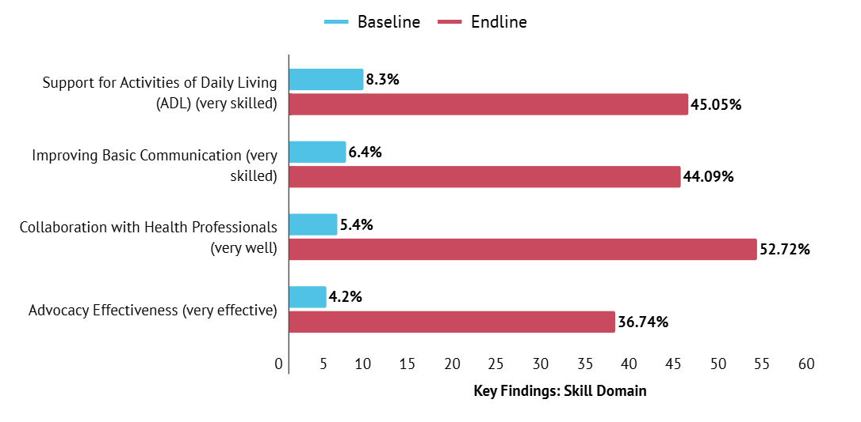
- Improving Basic Communication: The number of parents who felt "Very skilled" in this area rose sharply from 6.4% to 44.09%.

- Collaboration with Health Professionals: The proportion of respondents reporting "Very well" collaboration increased from 5.4% to 52.72%.
- Advocacy Effectiveness: Advocacy rated as "Very effective" increased from 4.2% to 36.74.

Safeguarding and Recommendations

6. Safeguarding Knowledge and Practice
An area of focused intervention, safeguarding knowledge, showed some of the most dramatic and positive changes, ensuring a safer environment for children with SMD.

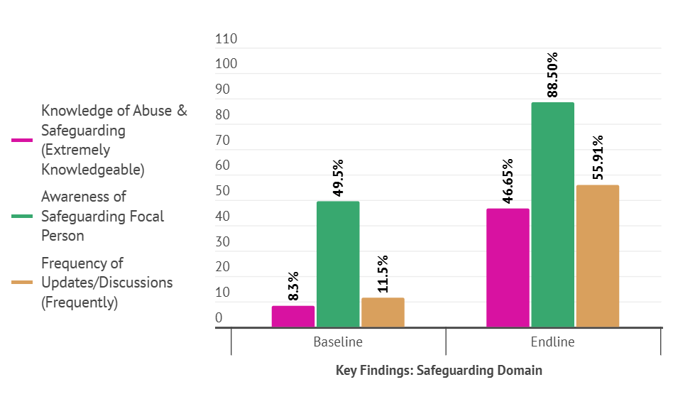
- Knowledge of Abuse & Safeguarding: Respondents rating themselves as "Extremely knowledgeable" soared from 8.3% to 46.65%.
- Awareness of Safeguarding Focal Person: The percentage of respondents who knew the name and number of the focal person increased from 49.5% to 88.50%.
- Frequency of Updates/ Discussions: Respondents receiving updates "Frequently" rose dramatically from 11.5% to 55.91%. Crucially, the "Never" response was eliminated, dropping from 49% to 0%

7. Conclusion and Recommendations
The Endline survey findings indicate promising improvements across all measured domains. Parents have demonstrated significant gains in their self-reported skills and knowledge, particularly concerning their child’s protection needs, recognizing and reporting abuse, and connecting with key contacts.

Key Recommendation Areas:
- Sustain and Expand Community-Based Programs
Continue and expand awareness-raising initiatives, including regular discussion sessions, workshops, and community-based programs. This is essential for reinforcing knowledge, improving attitudes, and sustaining good practices.


The home-based education facilitator regularly visited our home and provided consistent support services. By observing his work, we also learned how to carry out these activities ourselves. As a result of receiving this support, my younger son is gradually returning to a more independent and near-normal daily life & both of my children are now attending school regularly.

I have received various caregiver trainings and also had the opportunity to participate in a caregivers’ meeting in Dhaka. At present, I personally support my child not only with his education but also by carrying out all necessary therapy-related activities at home.
- (Shabana, Caregiver of Habibur)

- Focus on Legislation Implementation
While knowledge has increased, gaps remain in caregivers' knowledge of disability-related legislation58. The final recommendation is to emphasize the need for more effective implementation of disability regulations and policies protecting the rights of persons with disabilities.

- Ensure Caregiver Continuity of Support
Develop a formal program for graduation and aftercare, offering a reduced-frequency schedule of support (e.g., check-in calls) for successful caregivers to proactively monitor progress and prevent isolation once the intensive project phase ends.

Developed By: National Resource Centre on Deafblindness (NRCDB), Centre for Disability in Development (CDD). A-18/6, Genda, Savar, Dhaka-1340; Phone: +8801713021695; E-mail: info@cdd.org.bd. Overall Supervised by: Md. Sazzd Kabir; Prepared by: Israt Jahan Rupa, Alif Shish Islam, Mos. Sonali Akter Moue; Proof & Designed by: Jannatul Fardausi.

