Learning and Achievement
Publisher
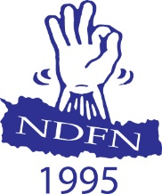

National Federation of the deaf Nepal (NDFN)
(National Resource Center for the deafblind)
Lazimpat, Kathmandu
Book : Learning Achievement
Learnings of the Promoting Inclusive Education for Children and Young People in Nepal Project
Publisher : National Resource Center for the deafblind
National Federation of the Deaf Nepal (NDFN)
Lazimpat, Kathmandu
Phone no. : 01-4435514
E-mail : admin@deafnepal.org.np
Website : www.deafnepal.org.np
Copyright : In publisher
Version : First, July, 2023
Copies :
Collaborations : Nelumbo Foundation,
Sense International,
Sense International India

Printed by : ......................

Author and editor team :
Shankar Singh Chaisir
Suman Adhikari
Sanu Khimbaja
Durga Dutt Joshi
Advisor:
KP Adhikari
Ramesh Pokharel
Pushpa Raj Rimal
Lhakpa Nuru Sherpa

Remarks from The National Federation of the Deaf Nepal
The National Federation of Deaf Nepal, in partnership with Sense International and Nelumbo Foundation, executed the project titled "Promotion of Inclusive Education for Children and Youth with Deafblindness" from April2020 to March 2023. The project aimed to provide access to quality education for children with deafblindness. Additionally, it focused on empowering youth who acquired deafblindness later in life, equipping them with essential skills for self-advocacy and independence. The project also successfully established a network for parents of children with deafblindness, offering them information and guidance to effectively care for and support their children. This network has helped raise awareness about the rights of these children and enabled parents to advocate for those rights. To achieve these successes, the National Federation of Deaf Nepal (NDFN) collaborated with the Society of Deafblind Parents (SDBP), the Deafblind Association Nepal (DAN), and the Nepal Association of the Blind (NAB). The National Resource Center on Deafblindness is delighted to present the remarkable achievements of the project and share them with our esteemed stakeholders.
People with disability are a marginalized community, however society is now increasingly focused on enabling meaningful participation of individuals with disabilities in overall development processes. The understanding of disability has evolved from a medical and welfare concept to encompass social and human rights dimensions, establishing it as a matter of human rights. However, despite this progress, addressing the specific needs and providing support for underrepresented groups within the disability community, such as people with deafblindness, still poses significant challenges. Individuals with deafblindness face obstacles in obtaining identity cards that truly represent their identity and lack developed alternative communication methods, like tactile communication, resulting in limited access to early identification and services. This deprivation hampers their ability to access proper education, communication, mobility, and personal development.
Deafblindness is a unique condition where individuals experience both hearing and vision disabilities, necessitating distinct approaches and support in communication, mobility, and learning methods. It is encouraging that the government of Nepal has recognized deafblindness as a distinct category of disability and included it in the disability-related questionnaire for the 2021 census. However, accurately identifying the number of people with deafblindness remains challenging due to the shortage of skilled personnel capable of identifying deafblindness. To address the critical gap in education for children with con genital deafblindness, the Center for Education and Human Resource Development, in collaboration with local bodies, is making progress in establishing resource classes. However, there is an urgent need for competent teachers in these resource classes, who can accurately identify individuals with deafblindness and provide essential support in communication, mobility, and education for those in need.
This "Learning and Achievement" booklet has been published in collaboration with Sense International and Nelumbo Foundation NDFN would like to express its heartfelt gratitude to the dedicated employees of the National Resource Center for Deafblindness under the Federation for their valuable support in the production of this book. Furthermore, sincere appreciation goes to all the employees of partner organizations who contributed to the lay out, design, and editing of this booklet.
Finally, we wholeheartedly urge you to share this learning and achievement booklet, which encompasses all the accomplishments related to the issue of deafblindness in Nepal, with all relevant stakeholders. The NDFN family always appreciates and welcomes your valuable suggestions and support for the holistic development of individuals with deafblindness.
K.P. Adhikari
Chairman

Table of contents

Remarks from The National Federation of the Deaf Nepal 4
The history and journey of deafblindness 6
"A School for this child?" 9
My second life 11
I Found my identity 14
Transformed lifestyle through therapy. 16
Does "Tuku also attend school? What does "Tuku" study? 18
We are empowered. 21
Individuals of extraordinary achievement. 23
MOBILITY PRACTICE: AN EFFECTIVE TOOL FOR RAISING AWARENESS 27
“Striving for the better quality of Life" 29
School Principle Voice: 29
School resource teachers Voice: 30
It feels like a family now... 34
Embracing Life's Challenges 36
Individuals with deafblindness on an adventurous trek 39
What the reader can learn from this book 47

The history and journey of deafblindness
Although the history of addressing deafblindness in Nepal is recent, formal, and informal efforts began around the year 2000. The Danish Association of Parents of People with Deafblindness, in collaboration with DPOD Denmark, initiated their work by establishing a day care service at Naxal Deaf School, focusing on the education of children with deafblindness in the country. This project ran from 2000 to 2005 and played a vital role in the establishment of the Society of the Deafblind Parents. Subsequently, Ankur Foundation managed classes at Ankur School, providing services for several years and contributing to human resource development by studying deafblindness in neighboring countries like India. The Nepal Association of the Blind also facilitated human resource development in India to address this issue.
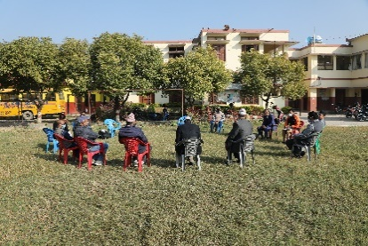
In 2011, the National Federation of the Deaf (NDFN) collaborated with a person with deafblindness from Canada who volunteered in Nepal. This collaboration highlighted the need to develop alternative communication methods, such as tactile communication, as many individuals within the deaf community also experienced vision-related issues leading to deafblindness. Since then, NDFN has actively addressed the issues of deafblindness in Nepal, collaborating with the Society of Deafblind Parents and the Nepal Association of the Blind to collect data on individuals receiving services. In partnership with the Danish Deafblind Association (FDDB); NDFN ran a project on Data collection with project entitled ‘Building the Base’ from 2015 to 2017. The project address deafblindness in the country and led to the strengthening of the Deafblind Association Nepal (DAN) established in 2012. This association has consistently worked with organizations to develop alternative communication methods, including tactile communication and haptic signals, in Nepal.
In 2017, the National Federation of the Deaf, in partnership with Sense International, made significant progress in the campaign for deafblindness in Nepal by establishing the National Resource Centre for Deafblindness. A pilot project was initiated in four districts, involving the Nepal Association of the Blind, the Society of the Deafblindness Parents, and the Deafblind Association Nepal. Following the pilot project, the three-year ‘Healthy Life Project’ for the deafblind, in collaboration with Jersey Overseas Aid, was conducted until mid-2023. Similarly, in 2020, after the successful implementation of the project 'Promotion of Inclusive Education for children and Youth with deafblindness in collaboration with Sense International and supported by the Nelumbo Foundation, the campaign to support the education of children with deafblindness reached new heights in the education sector. This project has significantly contributed to policy-level improvements and effectively supported the implementation of existing policies. Prior to this initiative, children with congenital deafblindness faced exclusion from school enrolment due to challenges posed by their condition.
Through our work resource classes for children with deafblindness were successfully established in three community schools, marking the start of formal education of children with deafblindness in community schools across Nepal. Efforts were also made to ensure these children received scholarships and benefits like children with other types of disabilities. Advocacy efforts led to children with deafblindness being granted residential program scholarships for those children with deafblindness holding the red colour disability ID cards (indicating category ‘A ‘severe disability) whilst they attended daytime only resource classes, to support with their costs of attending.
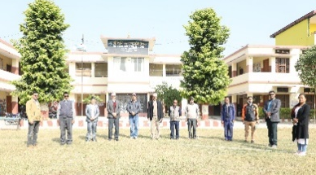
The project also provided facilities and training for teachers, caregivers, and parents involved in the resource centers. Notable progress has been made in orientation sessions and capacity development training for various stakeholders, including local representatives, office employees, health workers, and teachers. Parent organizations have been established in two districts to effectively advocate for the rights of individuals with deafblindness.
Additionally, the latest project facilitated the establishment of a network of youths with deafblindness, fostering collaboration and knowledge exchange between youths with deafblindness from Nepal and India. Discussions on development, technology, and education have also progressed through visits by Nepalese government officials and representatives to learn from what is happening in India.
To enhance access to information for individuals with deafblindness, resource materials have been created and discussions held on effective management within the Global Hub to make information more accessible to the deafblind community. These remarkable achievements have been made possible through the contributions of various stakeholders. The goal of this book is to ensure that children and youths with deafblindness, parents, and caregivers from across Nepal and other regions can access similar services and benefit from the exemplary work presented here.

"A School for this child?"
‘Before this project began, we were completely unaware of our child's (Prashant) disability and the available services. Seeing other children his age attending school, we felt a deep longing for our son to have the same opportunities. However, we faced challenges as our son was both visually and hearing impaired. We sought help from various hospitals and even turned to Dhami Jhankris based on our religious beliefs.

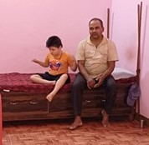

Initially, the doctor informed us that our son had a vision impairment, but as he grew older, we became concerned about his hearing as well. It was a great shock to learn that he could not hear. We felt immense mental stress and questioned why such a calamity had befallen us, shedding tears of anguish. Nevertheless, we had to continue with life's rhythm, accepting whatever path it took us on. During this challenging time, we lacked support and understanding of how to manage the situation and teach our son. As he grew older, he faced challenges in communication and daily activities, and we found it difficult to leave him alone, even briefly. He could not communicate when he needed to go to the toilet, and eating solid food was also a challenge. At a certain point, home based educators visited our home and engaged us in discussions about disability. They suggested that we get our son's disability checked and obtain a disability identification card. Following their advice, we went for the assessment, and our son's disability was officially recognized. With their support, we obtained his identity card, and the project's team members started providing home-based services, teaching essential daily life skills for about a year.
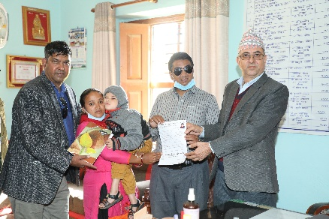
Surprisingly, they suggested enrolling our son in school, which initially made us hesitant. We questioned whether such a child could attend school. However, the project team members reassured us that children like our son could learn and be taught daily life activities through different methods. Their encouragement filled us with joy, and we began to dream of our son attending school. Gradually, we learned that there were other parents facing similar challenges, and the project team members gathered us together to educate us about our children's identity, needs, effective teaching methods, their rights, and the services provided by the state.
Through numerous training sessions, we gained valuable knowledge about children with deafblindness. When the first phase of the corona epidemic passed, we were overjoyed to finally enroll our son in the resource class at Shanti Namuna School in Rupandehi. Initially, he struggled to interact with people outside the family, but he quickly adapted to the school environment. The school's therapy sessions have led to remarkable progress in his mobility and communication skills. He now enjoys going to school and has experienced significant positive changes since joining. The government's social security allowance and the scholarship he receives at school have eased our financial burden. Our lives, once filled with darkness and uncertainty, are now filled with excitement and hope. We are now eager to share our experience with others, encouraging them not to keep children like our son at home but to send them to school, provide therapy, and advocate with the government for their rights. We express our heartfelt gratitude to all the dedicated individuals who worked tirelessly on this project and to all those who supported and assisted us on this journey’.
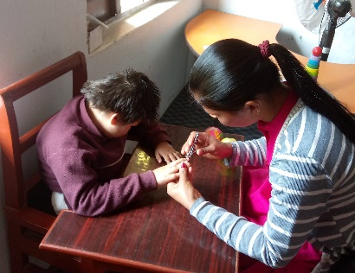
Prepared based on conversations with Prashant's parents.

My second life
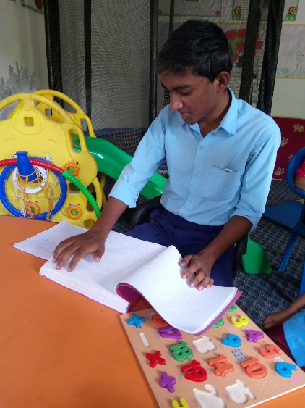
Deepak's journey from enduring mental stress to finding profound happiness has been truly remarkable. At a young age, he was studying in a school for deaf children in Bhairahawa when an unexpected problem with his eyes arose, causing distress to himself and his family. Despite trying various treatments and visiting numerous places for about four years, his eyesight could not be cured, and due to the costs of the medication they lost their property in the process.
Deepak became disheartened and withdrawn, contemplating drastic actions, but thankfully, his parents prevented him from taking such steps. During this challenging period, Deepak was identified by an educator working under the Nelumbo Foundation project. Upon connecting with the project, Deepak received mobility training, enabling him to move comfortably at home and outside. He later joined the resource class established through the project at around the age of 15. Due to a prolonged absence from using sign language, Deepak had forgotten some signs and appeared aggressive when interacting.

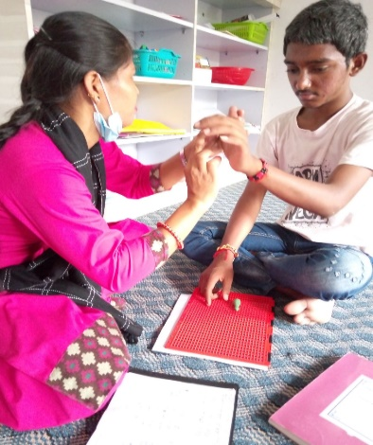
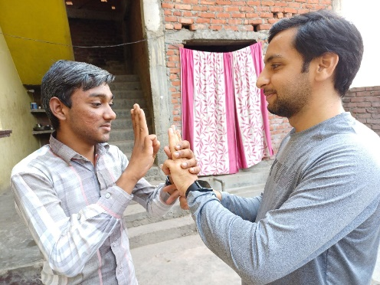
However, in the resource class, he regained proficiency in sign language, actively participated in programs for youth with deafblindness, and learned to communicate through tactile sign language.
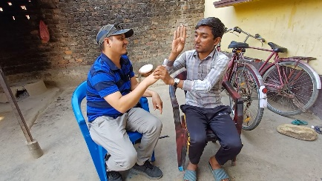
His early exposure to sign language facilitated this process, and the resource class teacher's knowledge of sign language made communication at school accessible for him. Deepak's passion for reading is exceptional, and he has even learned Braille during his time in the resource classes. Now, he reads Braille books with ease and aspires to rejoin regular classes with the support of a sign language teacher or assistant. Deepak actively listens, thinks critically, responds thoughtfully, and is always eager to understand new vocabulary. He enjoys traveling, follows a vegetarian diet, and independently manages daily tasks while devoting much of his time to reading and writing. Embracing technology, he now uses a Braille device and a laptop provided by the school and local government, respectively.
Despite the resource class being quite a distance from his home, Deepak diligently attends school 3 to 4 days a week, using the school bus for transportation. His parents take him to the bus station, and during the journey, he initiates new friendships with those he meets, including people without disabilities.
His school friends assist him in reaching the classroom, enhancing his socialization skills. Deepak's next goal is to attend regular classes in grades 7 or 8 and participate in examinations. Deepak is a promising young man, eager to learn whenever an opportunity arises. He participated in the youth camp to the Himalayas and completed the 3-day walk with enthusiasm, always positioning himself at the front. He approaches each subject and opportunity with eagerness to learn and possesses an incredible memory, recalling people and places even after a long time. The positive transformation of Deepak has not only lifted the spirits of his parents but has also sparked a belief in his remarkable potential, akin to following the path of Helen Keller. For his regular studies, having the support of a dedicated teacher or sign language interpreter is crucial. With this support in place, Deepak will be empowered to attend classes regularly, just like his peers. As the Nepal government embraces the concept of inclusive education the need for friendly and accommodating classrooms with inclusive teaching and learning practices becomes evident.
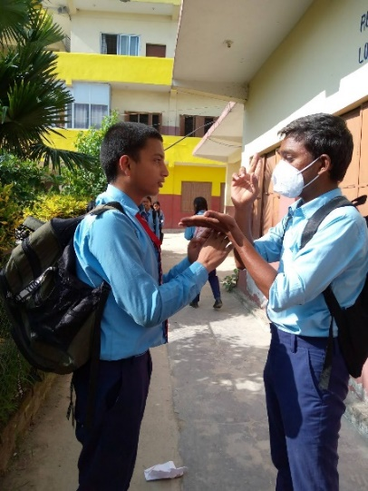
Prepared based on conversations with Deepak and Deepak's parents

I Found my identity
“I [Kalpana] am uncertain when I lost my hearing. Gradually, I became aware of its diminishing state, along with a weakening of field of vision. Presently, I can only hear sounds above 75 decibels and have limited vision straight ahead. Despite these challenges, I success fully completed my graduation, despite facing difficulties with reading and hearing. At that time, I had no familiarity with sign language or Braille.
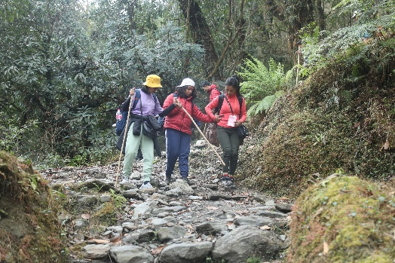

Upon finishing my studies alongside hearing friends, I entered the job market. However, I encountered numerous challenges due to my hearing impairment. Many places hesitated to hire me, citing concerns about communication difficulties, and I even experienced discrimination during salary negotiations, where my abilities were overshadowed by my disability. At that point, I lacked awareness of disability rights. One day, my friends took me to an institution for the hard of hearing, where I gained some insights into disability. Encouraged by them, I had the opportunity to participate in a district-level workshop for youth with deaf blindness. There, I met many friends facing similar challenges, primarily communicating through sign language. Though I did not understand sign language initially, I attentively observed the movements of their lips while they spoke. The program brought me immense joy and fulfilment, and we ended up talking all night long. Following that experience, the Nelumbo Foundation project offered us numerous opportunities to participate in various training courses. We formed a youth group, meeting weekly to support one another and learn sign language together. Engaging in self-advocacy training, we learned about different types of disabilities and the rights that should be upheld for people with disabilities. Initially, my parents were hesitant to allow me to go out alone due to my deafblindness, as my mother was concerned about my safety. However, as I attended more programs and involved my mother in parent training, I gained the freedom to move around independently. I participated in the regional youth trek, where I met friends with deafblindness from India, learning a great deal from them.
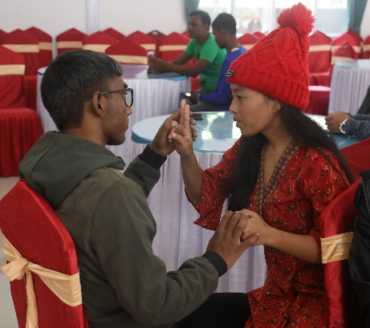

The opportunity to join this 3-day trek for the first time, exposed me to various cultures and the Himalayan landscape, providing valuable lessons about mobility in different environments. In the resource class, we learn sign language together every week, and now I can confidently communicate using it. Additionally, I have learned Braille and can communicate through tactile sign language as well. Over the past two years, this project has been a tremendous source of learning for me. I am also keen on expanding my knowledge about computers and aspire to serve in this field with my acquired skills”.
This article was prepared based on interactions with Kalpana.

Transformed lifestyle through therapy.
Manisha thoroughly enjoys attending school and finds it more fulfilling than staying at home. Since the inception of the deafblind resource class at Adarsh School in Biratnagar, she has been regularly attending the resource class. Despite facing some transportation challenges, her parents ensure she can attend school. Manisha was identified by Koshi Association of the Deaf under a project that preceded the Nelumbo Foundation project and started receiving services. Following a medical examination, it was confirmed that she had deafblindness, and her disability identity card citing ‘deafblindness’ was issued. As a result, Manisha became eligible for a social security allowance. During the initial phase, the project established a daycare center that offered therapy services twice a week, including therapy sessions for Manisha.

Through these interventions, her muscle strength significantly improved, enabling her to sit and stand up with greater ease. Manisha has a keen interest in acquiring new knowledge and skills. The daycare center, kept a variety of learning materials, and Manisha expressed a strong liking for these resources. Over the past two years, remarkable transformations have taken place in Manisha's life. Previously, her family had lost hope for Manisha, but through the project she experienced a profound change.
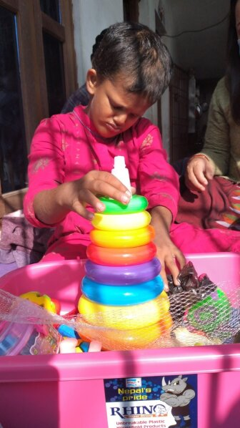
Manisha can now independently stand up and walk, she can attend to her toileting needs, feed herself, and communicate her requirements effectively. Manisha's father kept saying he felt as if her disabilities were a result of some past wrongdoing or misfortune. They had not met any other children who cannot see and hear at the same time. However, as Manisha started learning, her family witnessed other children facing similar challenges, and they came to realize that this was just a disability like others. They became more determined to support Manisha's education and learning.
After the resource class was initiated, Manisha developed a habit of attending school regularly. The teacher noticed she now express es a keen interest in acquiring new knowledge. As a testament to her dedication, Manisha has even embarked on learning Braille. This remarkable progress in her learning journey became achievable due to the consistent application of therapy and engaging learning exercises. The positive transformation in Manisha has brought immense joy not only to the teachers but also to her parents. Recognizing that children like Manisha face challenges in commuting to school daily, Adarsh School, with the support of Biratnagar Metropolitan Municipality, has prepared to introduce disability-friendly buses. The school administration has announced that starting from the academic session 2022/23, the disability-friendly buses will be in operation.

Based on the author's conversations with Manisha's parents.

Does "Tuku also attend school? What does "Tuku" study?
‘As parents, we were initially unsure about the nature of our children's disabilities, and we held onto the hope that they might recover after hospital visits.
However, when our child began receiving services from the project, it opened new opportunities for us to participate in various training sessions. In the beginning, gathering parents for these trainings was challenging, and there were misconceptions about what children with such severe disabilities could achieve. However, the training enlightened us about the disability, and we came to know that our children are deafblind. We then worked towards obtaining proper identity cards for them. At first, it was really challenging to obtain appropriate identity cards for our children. Many of them were labelled as mentally challenged or having multiple disabilities.
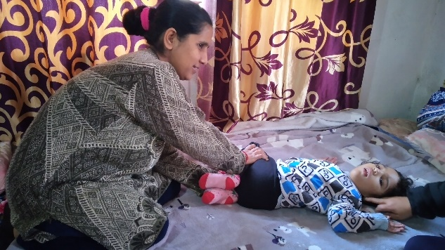

We had to engage in lengthy discussions with officials at the disability identity card distribution center to rectify this issue. After providing orientation training to the representatives and employees of provincial ministries, municipalities, and rural municipalities through the project, the process of issuing identity cards became easier. Subsequently, we were able to modify the existing identity cards to accurately reflect the disabilities of deafblindness. In the beginning, as parents, we used to work independently. However, as the project progressed, all the parents came together and collaborated on the initiative. We were provided with various training. As a result, we eventually formed a cohesive group and began working collectively. Presently, an official organization for parents has been established. This has led to the development of our skills and capabilities. Together with the project staff, we embarked on advocacy campaigns. There is now a better understanding of deafblindness in almost all municipalities of the Morang district. Some municipalities have even started allocating budgets for programs related to these kinds of disabilities. The most significant achievement of this project is that it has encouraged even our children to attend school. This has resulted in a positive shift in the perception of our community and neighborhoods.
Previously, it was widely known that our children used to remain in bed all day, and nobody could have imagined that they would ever go to school. “Now, I accompany my daughter to school in the morning, which has sparked curiosity and amazement among people in the neighborhood. They often inquire with surprise, "Tuku also goes to school? What does Tuku study?" Our mentality used to be confined to the belief that education only revolved around children learning the alphabet (A, B, C). However, the notion that learning daily life activities is also a form of education is not well understood by everyone. Our children are also asked similar questions.
Previously, we also never even considered the possibility that our children would go to school. But today, through the initiative of the project, we have achieved something that we never thought was possible. Our children also express a strong desire to attend school like other children and continue learning new things. However, they face certain challenges. The school is far away from home, which makes it difficult for some parents to bring their children to school regularly. There are many such children who attend school only two times a week. In our school, we have one teacher and one assistant to support the children. Most of the children require an individual teacher or assistant. Therapy services are crucial for many children, and they receive therapy to aid their development. Children also engage in various activities related to daily life, such as eating, dressing, using the toilet, sitting, standing, and walking during school hours. When we initiated the resource classes, those who used to stay in bed all day are now able to sit up.
Children who previously struggled to chew food are now eating independently. Some children are even attempting to write using their feet. Some are learning sign language and Braille. Some can use the toilet independently or express themselves when they need to use the toilet. Observing these changes in the children, it becomes evident that if our children had the opportunity to attend school from the age of 3 or 4, they would have learned so much by now.
After gaining information about deafblindness, there has been a growing interest in exploring job opportunities in different countries through social networks. We have observed that in developed countries, young people with deafblindness have successfully achieved employment, with the state providing special arrangements to support them. However, we lack such facilities in our country. Nonetheless, this realization has inspired us to believe that nothing is impossible if we strive for it from our place. In Nepal, the government has taken positive steps by providing monthly social security allowances and scholarships in schools, which has significantly aided parents; still, it is not sufficient.
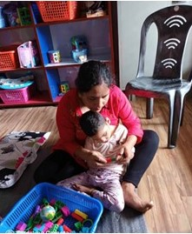
Based on a group discussion by the author with the parents of the Morang district.

We are empowered.
‘Until two years ago, none of us knew each other, and there was little awareness about disability. We were aware of our hearing impairment, and our vision was slowly being limited, but we did not pay much attention. Occasionally, we received some treatment for our condition. However, around the beginning of 2021, our lives took a significant turn when we met the team from the project focusing on Deafblindness. They provided us with an opportunity to participate in a training session, and from that day onward, our lives changed for the better. We connected with many friends who shared similar experiences, and we found our identity. We got the opportunity to learn about deafblindness. As young people with our own desires, wishes, and dreams, being deafblind presents us with unique challenges. We cannot hear or see, and this creates a significant barrier between us, our families, and society.
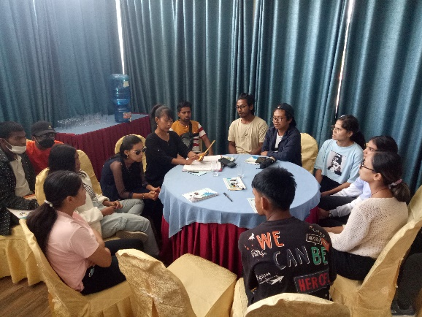
Our family and society often struggle to understand us, and we also find it challenging to understand them. This communication barrier exacerbates the problems we face, making it feel like we are drowning in a sea of challenges day by day. As beneficiaries of this project, we have been given numerous opportunities to learn.

We have gained a deeper understanding of our identity, rights, and the discrimination we face due to our deafblindness. We recognize that our understanding alone is not sufficient. It is essential to explain our obstacles, rights, and potential to our families and society, so we are engaged in self-advocacy. Proactively, we have reached out to various local governments, urging them to remove obstacles and create a conducive environment for us.
We have the skills, knowledge, and capabilities to excel, but we are still often defined solely by our obstacles. We express our heartfelt gratitude to the project and all its contributors for empowering us. With the advancement of technology, we have not only gained information about our rights, but we are also able to advocate for our rights. The thought has developed that we should advocate and strive to address the challenges faced by youth with deafblindness like us. Initially, we had no knowledge of sign language, but with the help of our friends, we have now become proficient in communicating through sign language. Additionally, we have learned to read and write in Braille. Looking ahead, our aspiration is to seek employment opportunities and progress towards economic development’.
Based on the results of a study conducted with deafblind youth.

Individuals of extraordinary achievement.
Kamal is a child who faces challenges of cerebral palsy and hearing and visual loss. His father and mother are deaf, and they come from a modest background. His father works as a laborer, while his mother takes care of the household. Kamal's cerebral palsy was present from birth, and later, it was confirmed that he also had deafblindness. Before becoming a part of the project, Kamal used to stay at home. His parents said that they lacked sufficient information about his condition, and communication barriers hindered their ability to seek help. However, with the implementation of the project in the Rupandehi district, health workers and women health volunteers received orientation on deafblindness.
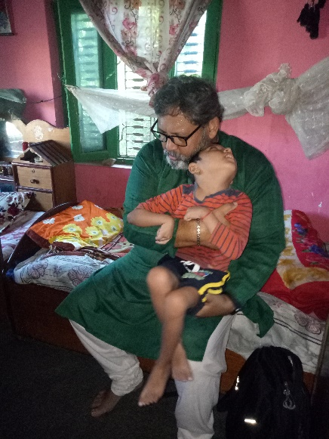
As a result of their initiative, Kamal was included in the project and started receiving support. Kamal used to sleep all day. However, after the establishment of the resource class at Shanti Namuna School in Rupandehi district, Kamal was enrolled in the class. Despite the distance from home to school posing challenges, the project staff conducted home visits and encouraged Kamal's parents to send Kamal to school regularly. In mid-2022, representatives from Sense India and Sense International, partner organizations of the project, visited Kamal's home to monitor his progress. At that time, Kamal couldn't even sit still, and the monitoring team provided Kamal's parents with additional suggestions for care and therapy. Following this, Kamal's parents began bringing him to school regularly, where he received consistent therapy services. After about 6 to 7 months of regular therapy, Kamal has made significant progress and can now sit independently. The resource teacher played a vital role in this success, as she personally provided Kamal with therapy, exercises, and continuous learning activities.
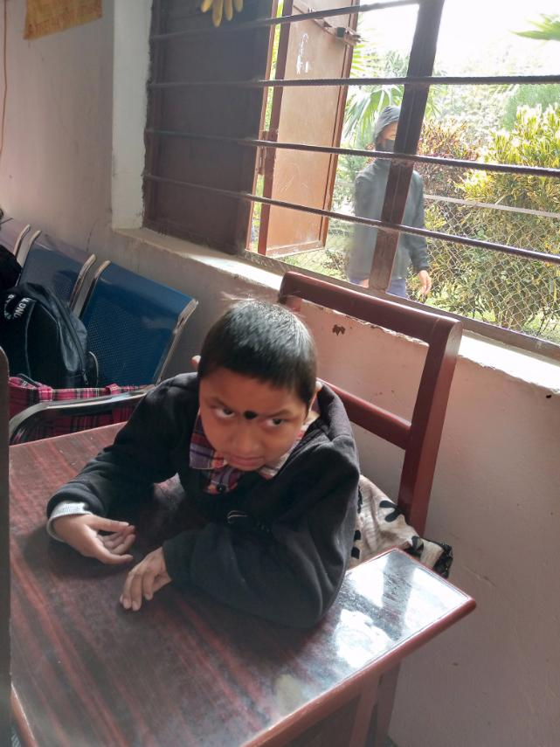
Now, Kamal can sit still independently for more than 30 minutes and is able to stand with assistance. Kamal has also started making efforts to chew food. These remarkable improvements have brought joy and satisfaction to Kamal's parents. The positive transformation in Kamal's abilities demonstrates the significant impact of the investment made by the project. Abhishek Despite having reached to teenage; Abhishek still appears childlike. However, he feels so happy to attend school. At the time of enrolling in the resource class, there was uncertainty about whether he would show improvement, considering his age. Nevertheless, after approximately two years in the resource class, remarkable changes have been observed in him.
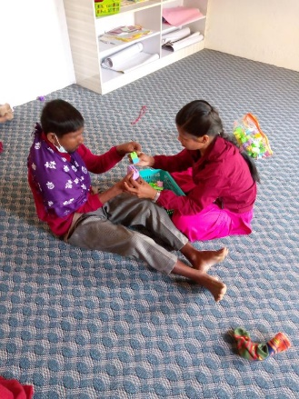
Abhishek's parents attended parent training for the first time, where they shared about Abhishek's daily activities. Abhishek used to spend his entire day locked up at home, most likely bored, without the understanding of appropriate behavior and how to communicate his basic needs, which was a significant problem for his parents. However, since joining the resource class, he spends his days engaging in therapy, play, and learning activities with various materials. The first of his left hand used to remain closed, making it difficult for him to hold anything. His left hand was extremely stiff, making it challenging for him to make a fist, and he also struggled to lift his left leg. To address these issues, he received therapy in the resource class, which included exercises using learning materials to develop his fine motor skills like adding blocks, removing them, and arranging ring pyramids to improve the muscles in his hand's fingers.
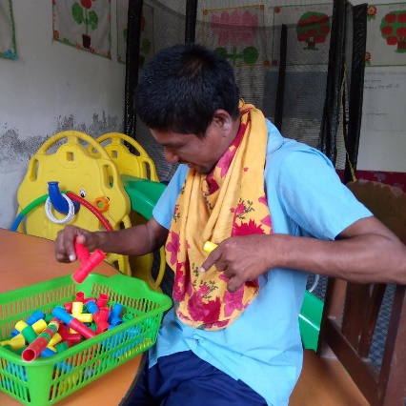

Abhishek has been one of the most regular attendees at school for the past two years. Whenever asked to go to school, he quickly finishes his meals, wears his school uniform, and becomes extremely delighted. He displays obedience in class and has a deep affection for those who are younger than him. He can now stand on his own, wear sandals. There have been improvements in his left hand and legs. He can now lift objects with his left hand and move his left leg more easily when walking. In the past, he had difficulty expressing his basic needs like hunger, thirst, or the need to use the restroom.
However, since attending school, he has learned to communicate these needs effectively to his class teacher using indications. This positive change in Abhishek has brought immense joy to his parents and teachers. Fursang: We met Fursang for the first time when she joined the school after the resource class was established. At that time, Fursang had a habit of poking her eyes with her fingers, throwing food and new toys, and seemed hesitant to interact with anyone other than her parents.
To support her development, we created an Individualized Education Plan (IEP), similar to the other children in the resource class, and designed various activities to encourage Fursang's active participation. Through consistent engagement in regular activities such as exploring new objects, refraining from touching her eyes, and receiving hand muscle therapy, we have witnessed remarkable progress in Fursang.
Presently, she displays the ability to feed herself, drink from a bottle on her own, and communicate when she needs to use the restroom. Previously, Fursang did not make any sounds. Now, her speech development has improved significantly. She vocalizes words, asks for specific foods by name, and even attempts to mimic words spoken by others. Following regular therapy and consistent practice, Fursang has shown significant improvement in refraining from putting her fingers in her eyes.
However, due to the distance between her house and the school, Fursang faces challenges attending class on a daily basis. Nonetheless, her class teacher firmly believes that with proper transportation arrangements, Fursang can make significant progress in the learning process.
Prepared based on discussions with parents and first-hand observations.

MOBILITY PRACTICE: AN EFFECTIVE TOOL FOR RAISING AWARENESS
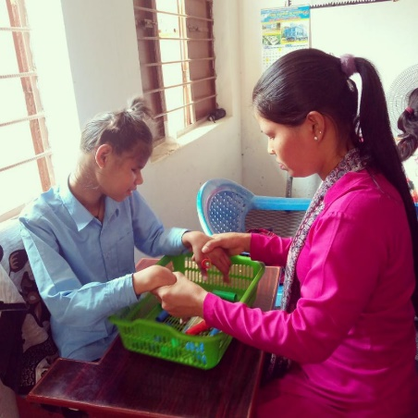
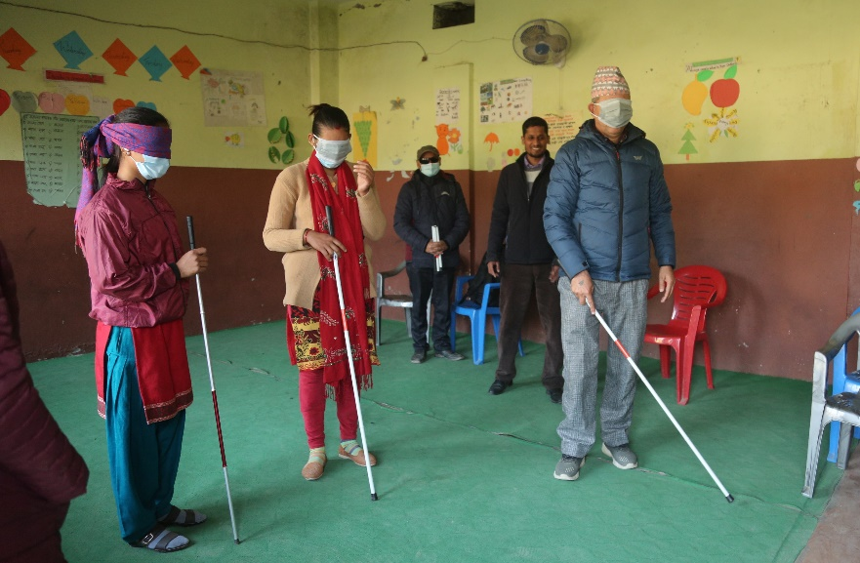
To effectively raise awareness about deafblindness, mobility exercises have been implemented as a key educational tool in this project.

The aim is to foster a better understanding of deafblindness among various stakeholders, including government employees, public representatives, parents, and community members in different districts.
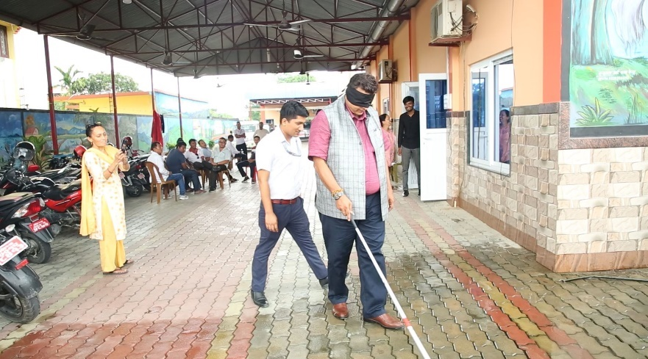
By engaging participants in exercises such as walking with closed eyes and ears, self-feeding, and identifying objects, they gain firsthand experience of the obstacles and challenges faced by individuals with deafblindness. This approach has proven to be highly effective in advocating for their needs. Despite repeated attempts to bring attention to the issue during meetings with government employees and people's representatives, there was little response. However, after experiencing mobility exercises, these officials could empathize with the challenges of deafblindness, leading them to address the matter more seriously in their programs and policies. Similarly, this method was applied in teacher training, emphasizing the significance of understanding deafblindness.
As a result, participating teachers reported that they were better equipped to create teaching materials, adopt effective teaching strategies, and establish an inclusive learning environment for students with deafblindness. The main impact of such orientation programs has been the success in influencing decisions made by local and federal governments concerning deafblindness.
Mobility and self-orientation are essential skills for individuals with deafblindness. Without assistance, those with complete deafblindness face significant challenges in mobility and recognizing their surroundings. Mastering these skills empowers individuals to become self-reliant and independent.
Based on direct participation and observation in various activities.

“Striving for the better quality of Life"

School Principle Voice:
"We have been educating more than 7,000 children at our school, and it fills us with immense pride to see them leave our institution equipped with knowledge and skills. However, when children with deafblindness joined us, we realized that our work was not complete. Anyone can teach someone who can hear, see, speak, and move. They even have the ability to learn on their own.

Our responsibility is just to manage a suitable environment for their learning. It is our duty to provide education and support to communities in society who have difficulties in performing their daily living activities. The children coming to school don't have the opportunity to learn beforehand, so we are striving to improve their learning conditions through continuous efforts. This cannot be achieved with a single effort. Achieving this goal requires ongoing dedication and the collaboration of all stakeholders involved."

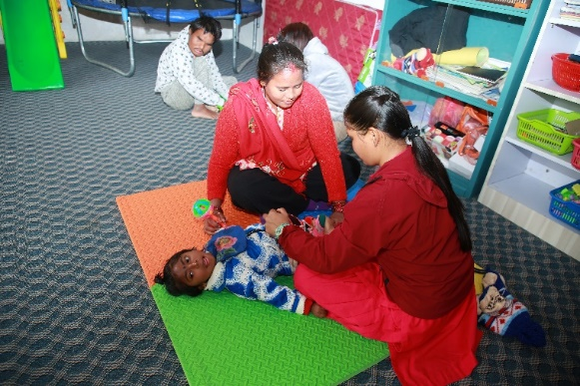
Kul Prasad Lamichhane, Principal - Shanti Model Secondary School Rupandehi.

School resource teachers Voice:
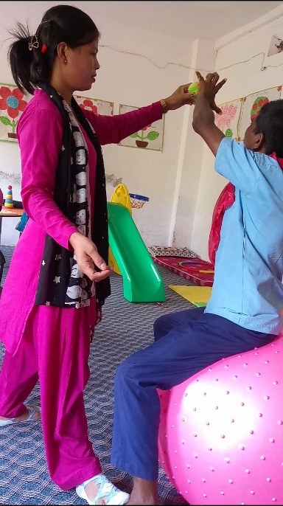
‘I have been working with children with deafblindness for approximately 2 years. Prior to joining the resource class, I had no prior knowledge about disabilities. The school was looking for staff, and I decided to apply, drawing from my previous experience working with small children experience working with small children.
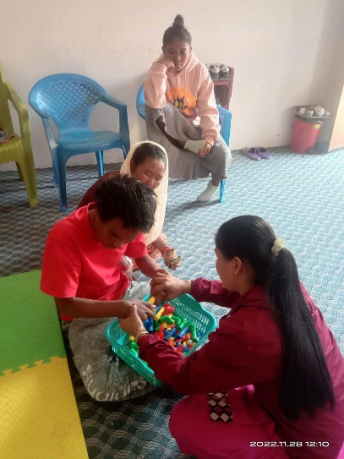
Though I had some familiarity with children, I ventured into this field without much knowledge about disabilities. After being selected, I attended the orientation program for the first time. It was a strange and eye-opening experience for me. There was no prior information about disability and its specific types, so the orientation provided a valuable opportunity to learn many things about deafblind ness. Gradually, children with deafblindness were enrolled in the resource classes.
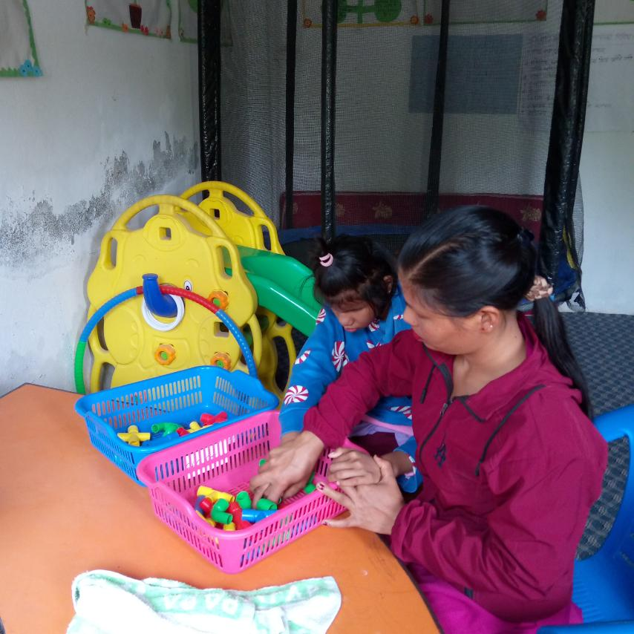
I felt very anxious when I met children with deafblindness for the very first time. They could not hear or see, and I was uncertain about how to teach them. I was new to them, and they were new to me. It took considerable time to develop a connection with them. The children were attending school for the first time. Additionally, as they were not accustomed to socializing outside of their homes, it was a gradual process for them to feel comfortable with me as well.
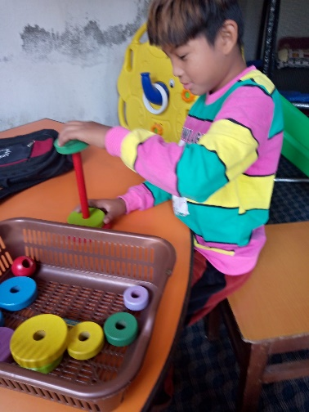
I utilized the skills acquired during training and my own experience to teach the children. Initially, upon their arrival, most of them tended to lie down in one place. The project offered therapy services twice a week, and I assisted the therapist during these sessions, engaging the children with toys and exercises to keep them occupied and involved.

Sometimes, I find myself questioning my ability to teach children, especially when it takes months to teach them even a single task, and they seem to forget what they have learned when they are not at school regularly. The project's mentors often reassure me that children with deafblindness require more time to learn, and I should not feel overwhelmed. Looking back at the past two years, I can see the progress the children have made. Those who used to lie down the whole day can now walk while holding hands and can sit still on their own.

Children who struggled to hold objects with their hands can now confidently grasp toys, water bottles, and other items. Some have even started walking on their own. Some have gained the ability to feed themselves independently. I also had an opportunity to learn Nepali Sign Language online.
This has significantly improved my communication with children who can read sign language, making it easier for me to teach them various signs. Additionally, I have taken the initiative to learn Braille. Participating in various training sessions and educational tours has motivated me to work with children.

Important lessons I learned:
- Definition and types of disability
- Rights of persons with disabilities
- Introduction, definition, and types of deafblindness
- Individual Educational Plan (IEP) creation and updating.
- Creating and using teaching-learning materials
- Ways of communicating with children with deafblindness
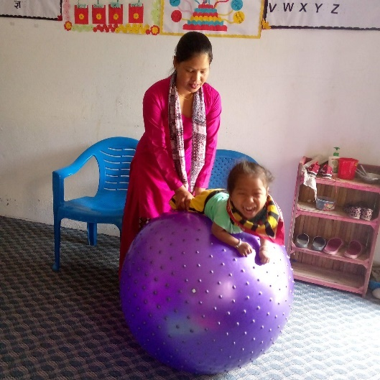
- Expanding relationships with children with disabilities
Some advice for the betterment of the Resource class to the school and local authority:
- Addition of skilled human resource as per the number of children
- Provision of regular therapy
- Restroom attached to the classroom.
- Kitchen Room
- Playground
- Therapy and sensory room
- Further orientation to parents
- Arrangement of transportation
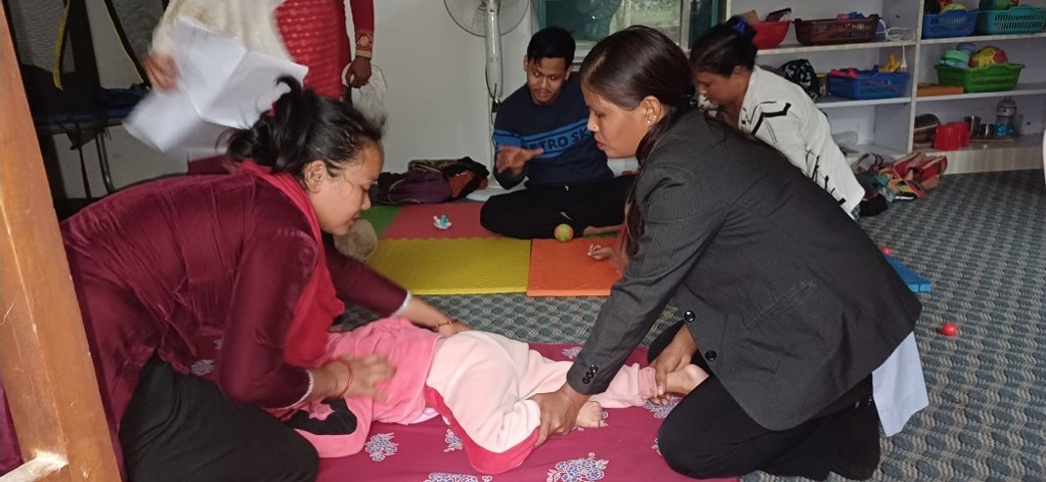
Based on observations made in resource classes, conversations with principals, resource teachers, and their own experiences.

It feels like a family now...
‘I have been working with Sense International for nearly four years, and time has flown by quickly. When I first joined, deafblindness was an entirely new subject for me. The initial training in Kathmandu was my first opportunity to meet children with deafblindness, and it left me feeling perplexed. I questioned how to effectively teach children who could neither hear nor see, and at times, I doubted if I had made the right decision in taking up this job. During the 3-day training, I gained valuable insights into various types of disabilities, including deafblindness.
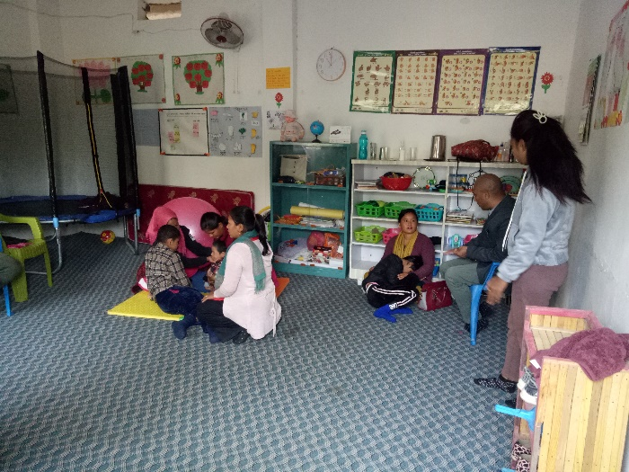
As I progressed and learned more about working with children with deafblindness, the job gradually became less challenging. At the beginning, there was no available data on the number of children with deafblindness in the district. To address this, we relied on data from the municipality and conducted house-to-house visits to identify children with multiple disabilities, including deafblindness.

Some parents were cooperative and provided helpful information, while others were hostile and skeptical of our intentions. Despite facing challenges, we remained committed to building meaningful connections with the parents. We engaged with them about their joys and sorrows, working together to support them in their daily tasks.
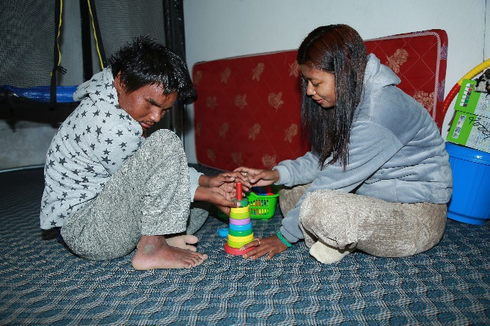

Through continuous meetings and conversations, we gradually gained their trust, and they began sharing their struggles and stories with us. Many parents were unaware of services and support available for individuals with disabilities, including the benefits of accessing disability ID cards. We provided training to the parents, enlightening them about the state-provided services for their children. We accompanied them to their municipality to create or amend their children's disability ID cards, making them eligible for social security allowances. By the fourth year, we have successfully welcomed 42 children and youth with disabilities from Rupandehi district and neighboring areas.
Thanks to the project's support, a resource class for deafblind has been established at Shanti Model Secondary School in the district. Currently, 12 children are benefiting from therapy services and learning essential life skills in the classroom, while the remaining children and youth receive training and education for daily life skills at home. Remarkable progress has been observed in the children's development compared to before. Previously inactive children are now more engaged and present.
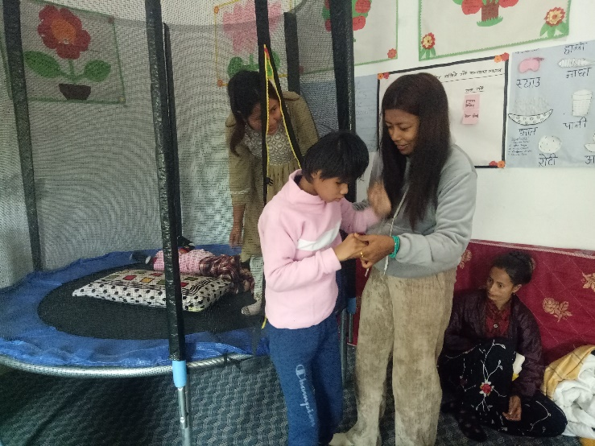
Some children who were hesitant to touch certain things are now actively playing with toys and materials. The children who used to display biting, crying, or aggressive behavior toward strangers are now attending school. Furthermore, children who were non-verbal started to express themselves using a few words.
Those who stay at home have become more helpful to their families in various tasks, and witnessing their growth and contribution is a source of immense happiness. Parents have been able to organize regular meetings to discuss their children's progress and plan for the future’.
Based on the author's conversation with Educator Laxmi.

Embracing Life's Challenges
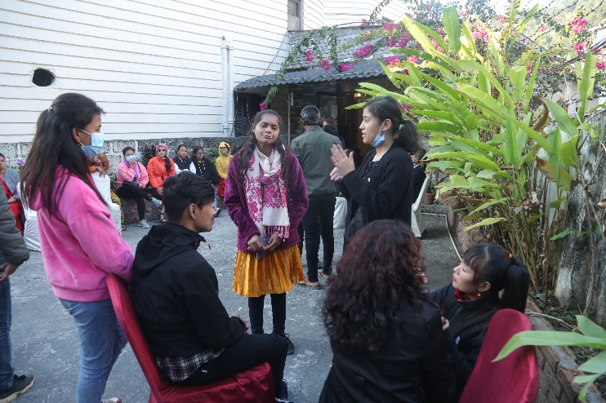
“I am Sarita, a youth with deafblindness, representing the Lumbini region. I was born and raised in an ordinary family of farmers, and we have five members in our household, including my parents. Both my sister and I are deafblind. I was born with some vision, being able to perceive light, dark, and different colours. However, since I turned 17, my hearing ability has gradually decreased, and it has now reached a critical point where it is declining further. Despite facing challenges, I managed to complete my education up to the secondary level at Shanti Namuna School. Currently, I am pursuing my studies at the graduate level in Kathmandu. My life experiences have taught me the true meaning of happiness, sorrow, and struggle.
Our family's financial constraints prevented me from receiving proper and timely treatment for my eyes and ears, which led to the loss of my sight and hearing. Had I solely viewed life in terms of the physical organs of my body, I might not have reached a point where I can express myself like this today. The unwavering in spiration from my family, relatives, and elders has granted me the opportunity to understand life fully. Life flowed smoothly until my eyesight started to weaken, but when my hearing diminished, I encountered numerous challenges. The most significant hurdle was communication. A study indicated that 95% of life's information is absorbed through the eyes and ears. With these two senses impaired, I have to navigate with only 5% of the information. Indeed, obtaining even 5 percent of the information was not an easy task. Coping with this limited knowledge requires learning various alternative methods, such as relying on touch, smell, and taste to gather essential information. Obstacles seem to be everywhere and overcoming them is an ongoing struggle I face.
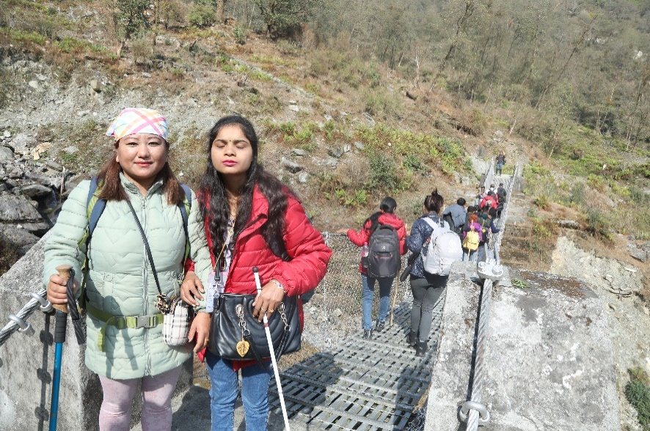
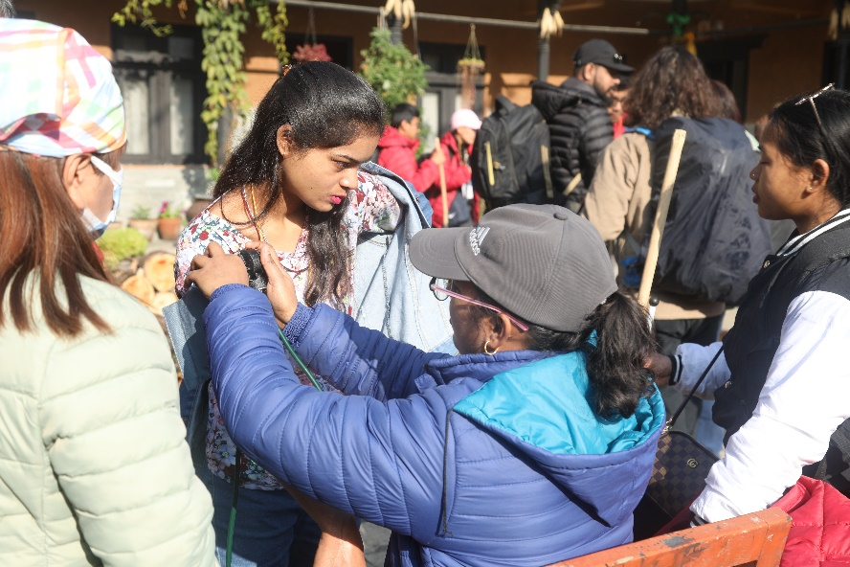
If these barriers can be eliminated, the true essence and significance of life will become evident. The Deafblind Education Project has been a constant companion in my challenging life. Being a part of the activities organized by the National Federation of the Deaf, I have gained valuable insights into life. One of the major obstacles I used to face was mobility. Leaving the house was a struggle, and it caused me considerable hardship.

However, this project taught me essential mobility skills that have significantly improved my life. I consider myself incredibly fortunate to have had the opportunity to participate in two youth camps and trekking expeditions. As someone born and raised in the Terai region, I never imagined trekking up to the Himalayas. Geographical difficulties, combined with my deafblindness and economic circumstances, made it seem like an unattained able dream. However, thanks to the project's initiative, I got to experience the mountains, learn about different cultures, and navigate challenging terrains.
Along the way, I made many friends and gained a deeper understanding of the struggles people face in remote circumstances. Initially, I could not comprehend why people endured so much pain to climb Mount Everest, but I also got an opportunity to feel happiness after being at such heights. My body was in pain, and my feet struggled to walk, but as I approached the mountain and felt the cold air, all my sorrows and troubles seemed to fade away.
With the assistance of a helper and a white cane, I learned so many new things. It taught me that one can thrive even in the face of pain. I gained a profound understanding of daily life in the mountains, learning to navigate and detect obstacles along the way, and adjusting my walk accordingly.
Throughout the journey, I experienced the beauty of hills, waterfalls, rivers, and suspension bridges. Though I may not have such an opportunity again in my life, each moment became unforgettable”.
Based on the author's conversations with Sarita

Individuals with deafblindness on an adventurous trek
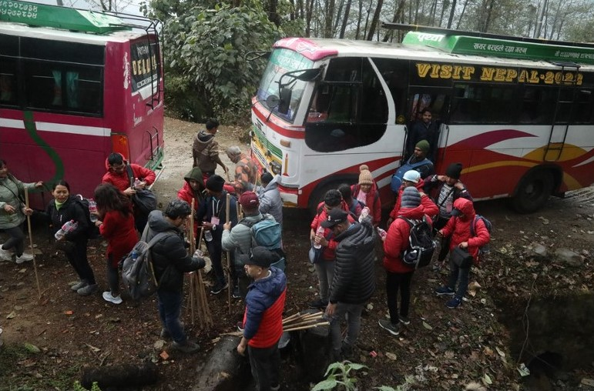
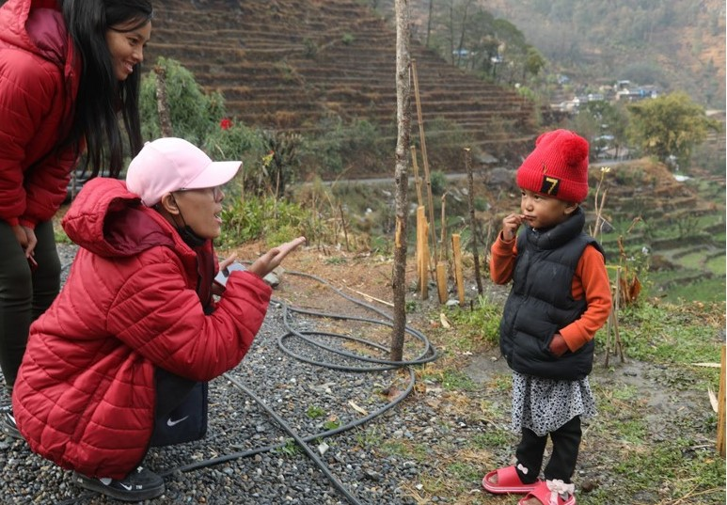
Firstly, everyone should know that Deafblindness is also a part of disability and has difficulty levels ranging from normal to profound. It can be present from birth or occur after birth. In this trek, individuals with deafblindness, ranging from normal to profound, participated.
By providing communication support and increasing accessibility, people with deafblindness can actively participate in any activities. This trek serves as an example; the Annapurna trek is renowned worldwide as a challenging route. With the collaboration of the National Federation of Deaf Nepal and Sense International UK, this event was organized. A total of 55 people participated in this trek, with 29 of them having deafblindness.
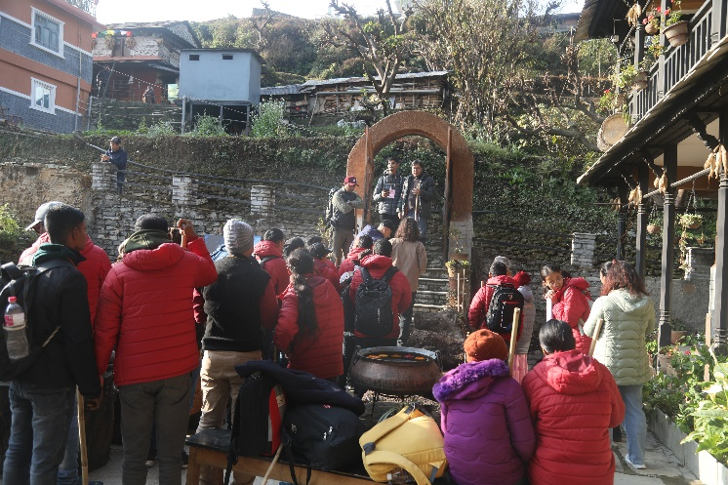
Participants were selected through an online form survey and underwent two months of preparation for the trek. Some Nepalese and Indian participants were involved, starting at 250 meters above sea level and reaching up to 2300 meters. This trek may be the first in the world undertaken by people with deafblindness.

Despite the challenging trekking route, expert technicians and support personnel managed it effectively, completing it within the provided timeframe. The trek started from Pokhara, and on the first day, the journey began by bus, reaching Ghandruk village in about 3 hours. Participants enjoyed the culture of Ghandruk and the natural beauty. In the evening, the local indigenous mothers' group performed a cultural dance, marking the completion of day 1. On the second day, the journey covered approximately 10 km from Ghandruk to Chhomrong, a village near the Annapurna Base Camp.
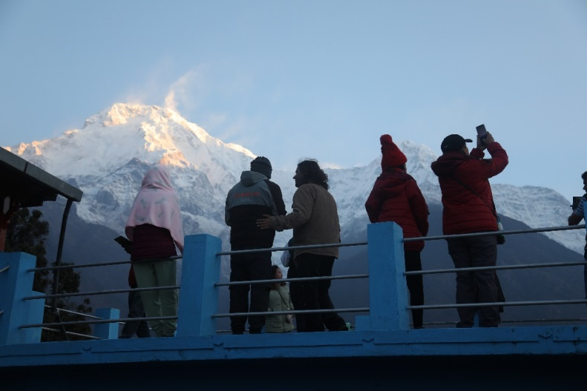
The trek featured ups and downs, with a rough pathway along the route. Every individual was supported by assistants and sign language interpreters who described the beauty and structure of the trekking route. After a 4-hour trek, the team reached Khorlabesi for a midday meal.
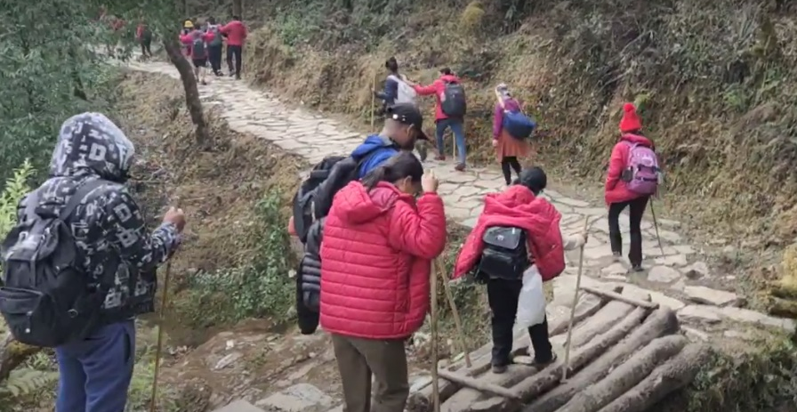
It was the first time that adults with deafblindness participated in such a challenging geographic structure. Despite feeling a degree of tiredness, supporters and interpreters minimized tiredness by engaging them in discussions about the beauty of nature and the surroundings. The presence of Rhododendron and other varieties of flowers, small waterfalls, streams, suspension bridges, and the breathtaking view of white mountains infused energy into the forward trek.
The trek concluded at around 7 pm, starting at 8 am in the morning. In the evening, all the participants gathered for dinner, where they shared their learnings from the entire day. Despite physical exhaustion, the participants expressed a sense of diversity and happiness, marking this experience as a unique and fulfilling one. They woke up early at 5 o'clock to behold the stunning panorama of the Annapurna Himalaya range.

The Annapurna range was clearly visible, situated very close to Chhomorong village. Support personnel and interpreters provided a vivid description of the beauty surrounding the Annapurna and Chhomorong village. The proximity to the mountains was evident as the cold wind confirmed the assistant's earlier descriptions.
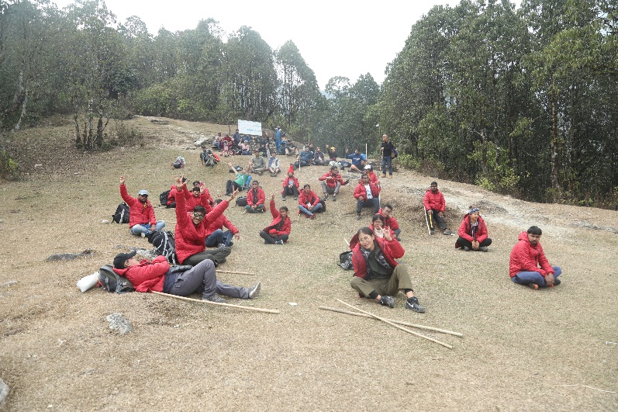
People with deafblindness, unable to see with their eyes, but they imaginatively depicted the shape, color, and overall beauty of the mountains. After exploring the culture of Chhomorang village and admiring the picturesque snow-capped range in the morning, the journey proceeded to Landruk following breakfast. The weather on the second day, unlike the first evening's rain, was clear and beautiful, with a tempting blue sky, lush green mountains, and striking white peaks. The descent from Chhomorong to Jhinu Danda presented a challenging downhill road, making everyone feel a bit uncomfortable.
Despite the difficulty, the trek became more manageable as they approached Jhinu Danda through a well-maintained state road. Crossing the Modi River on the way, the journey continued towards Landruk. Given the absence of hotels along the route, reaching Landruk for lunch became essential, emphasizing the challenging nature of trekking. Trekkers must be prepared to manage light and packed food themselves in such situations. After enjoying the food, they carried, the group arrived in Landruk village around 4 o'clock in the afternoon, coinciding with the onset of rain.
The rain added excitement to the journey and intensified the cold weather. After lunch until about 5 o'clock, everyone settled in Tolkha, a village slightly above Landruk. On the fourth day, the journey took us through the picturesque tourist village of Dhampus to Pokhara following breakfast. Following a roughly 4-hour uphill trek in the morning, we reached the renowned tourist destination, Potna, via Deurali. Recognizing that 10 individuals faced difficulty walking uphill from Tolkha, arrangements were made to transport them directly to Pokhara in a jeep.
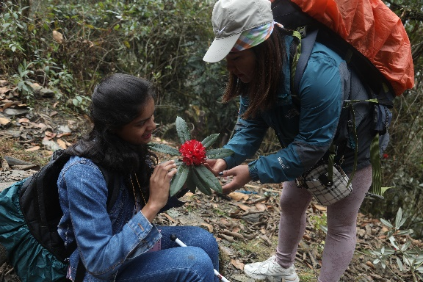
After a satisfying lunch in Potna, we took a one-hour rest and then walked to Dhampus. As Dhampus is easily accessible by buses, the trek concluded with a one-and-a-half-hour bus journey from Dhampus to Pokhara. On the morning of the fifth day, a comprehensive review of the trek took place with the active participation of everyone.
The group collectively reflected on the challenges encountered, lessons learned, and offered suggestions for future endeavors. Participants shared their individual experiences and insights gained throughout the trek. Sarita, a person who is completely blind and has limited hearing, shared her experience, expressing enjoyment of the first day.
Having been born and raised in the Tarai, she experienced high mountain geography for the first time. Touching the national flower, Rhododendron, and observing the natural river and waterfalls up close were new and exciting experiences. Despite the geographical complexity posing challenges, the support of colleagues provided energy.
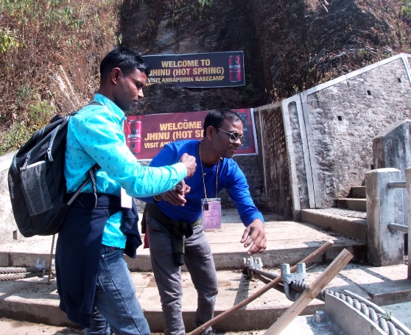
At times, she doubted her ability, but viewing trekking as a complicated journey with inherent challenges, she completed the journey successfully, building self-confidence. Reflecting on the possibility of missing out on the trek and geographical diversity, she expressed happiness, confidently stating that she trekked up to 2300 meters on the Annapurna trail.
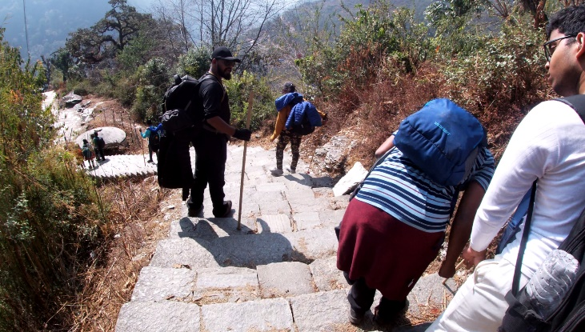
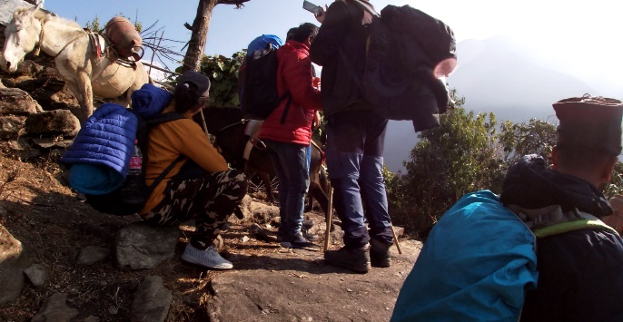
Gobinda, a participant from India, shared his story of being born and raised at a low altitude, around 250 meters above sea level, and facing limitations due to deafblindness. Joining a group of deafblind youth in India marked the beginning of his outreach. Despite communication difficulties, his brother provided support. Visiting Nepal for the first time and experiencing mountainous terrain ignited a desire to go even higher, touching the snow. He expressed eagerness for future opportunities to explore the mountains. Deepak, a total deafblind youth from Nepal, reflected on his realization during the trek as he observed porters carrying loads on their backs. He admitted not knowing how tough life is for them in the mountains. Despite residing in a lowland area with easy access to buses, he acknowledged the challenges of mountain life.

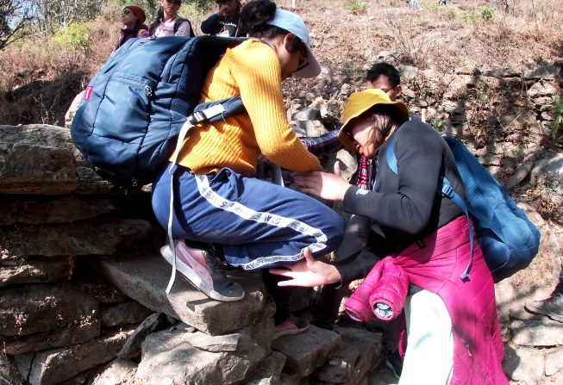
Excited by the weather and cold air, he felt alive in the mountains, aligning with his Hindu faith and worship of Lord Shiva, who resides in the mountains. Shrutilata, sharing her experience as someone with deafblindness involved in coordination and participation in her first trek, expressed immense learning. Despite facing numerous challenges, she conveyed happiness at reaching the destination and proving themselves to the world. Acknowledging the importance of proper support and guidance, she highlighted the need for thorough preparation before undertaking bigger challenges. She expressed confidence that everyone would be well-prepared for the next adventure.

Omita described her experience, emphasizing that it was her first-ever trek, and the encounter proved to be truly enriching. The journey provided them with an opportunity to engage with and learn from different individuals, gaining insight into their abilities. The trek presented unique challenges, particularly in terms of mobility and orientation amidst the ups and downs, small and narrow, rough, and slippery terrains.
Additionally, Omita had the responsibility to interpret and share information about the environment. Despite these difficulties, the group successfully completed the journey, navigating the terrain just like any other able person, without taking shortcuts. The experience was memorable and inspiring, witnessing the determination exhibited by the youth with deafblindness and their support persons.
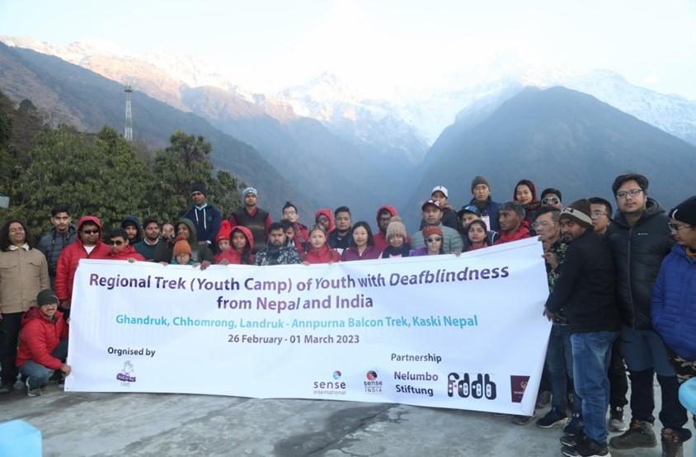
Omita expressed that this adventure allowed them to develop a deeper appreciation for the potential and strength of individuals with deafblindness. She conveyed gratitude for the opportunity to be a part of this transformative experience.
This trek has introduced a new dimension to sports for individuals with deafblindness, proving to the world that, given the opportunity and access, they can be equal to others in all areas. The success of this trek emphasizes that people with deafblindness require the right guidance, opportunities, and proper support to showcase their capabilities.
Entertainment is a right that people with deafblindness should also enjoy, and the policies of Nepal affirm this. The participation of individuals with disabilities in various adventure sports should be acknowledged and encouraged. Inclusive trek routes can contribute to the development of tourism while safeguarding the entertainment rights of people with disabilities.
Creating an inclusive environment ensures that individuals with deafblindness can fully participate and be protected in their pursuit of adventure and entertainment.
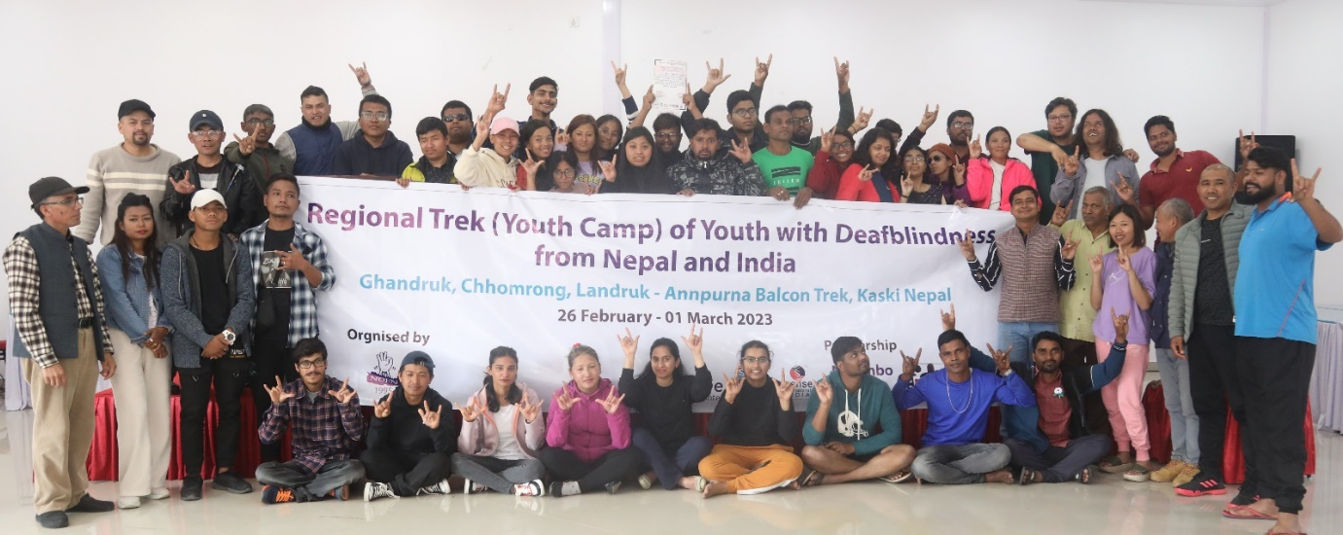
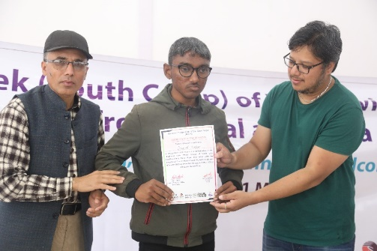
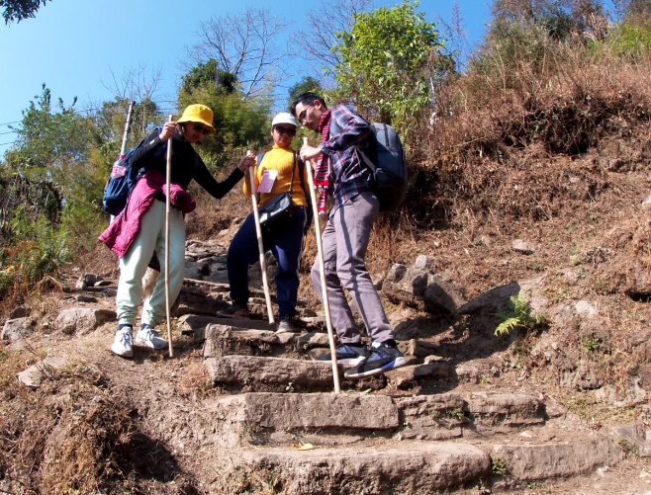

What the reader can learn from this book
In this book, readers will gain comprehensive insights into deafblindness, from its emergence in Nepal to the challenges faced by children and young people with deafblindness and those that support them. The book celebrates the commendable efforts in providing education for children with deafblindness and highlights key policy achievements in the field of deafblind education. Through inspiring success stories, this book aims to motivate and support children with deafblindness across the country, empowering them to access education and acquire essential life skills. Parents and stakeholders will find encouragement in the diligent efforts and advocacy showcased here, serving as a source of empowerment for others facing similar situations. Join us on this enlightening journey as we discover the transformative power of education, compassion, and resilience in shaping the lives of people with deafblindness and fostering an inclusive society.
The end

