
Home based education: a pathway to inclusion

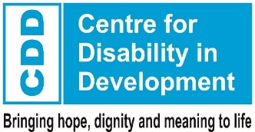
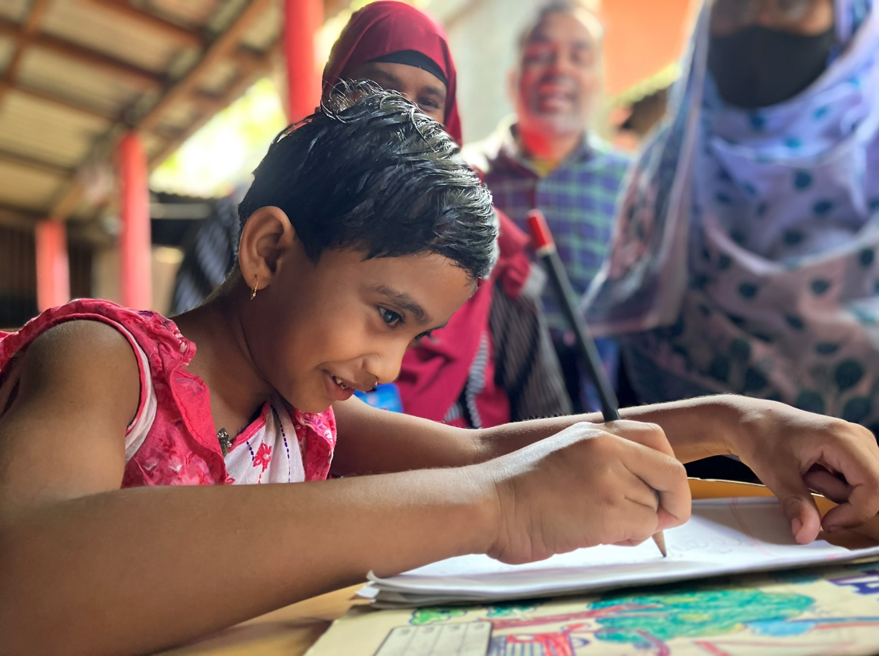
Supported by:

Context
Bangladesh is home to 56.9 million children¹, of whom 1.7% have a disability, and 3.6% have functional difficulty in at least one of the domains of seeing, hearing, walking, fine motor skills, communication, learning, playing or controlling their behaviour².
Only 5% of girls with disabilities, and 9% of boys with disabilities, take part in pre-school education, compared with 72% of their non-disabled counterparts³. 97% of all children in Bangladesh are enrolled in primary education⁴, but this is only true for 40% of boys and girls with disabilities.
Many families, teachers and policy makers believe that children with severe or multiple disabilities will never be able to attend mainstream school. But since 2022, Sense International and the Centre for Disability in Development have supported 160 children with complex disabilities in Narsingdi (78 children) and Sirajganj (82 children), with the Home-Based Education (HBE) model. Of these children, 95 – nearly 60% - have started formal education.

Barriers to education for children with disabilities
The HBE approach addresses key physical and social barriers to full access to education:

Physical
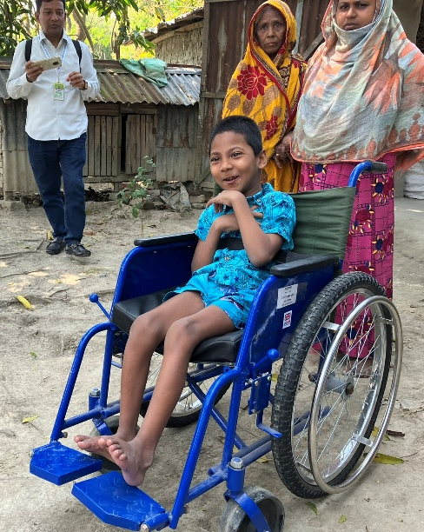
Assistive devices, technology and therapy: Without early screening and support, children do not receive the assistive devices and therapy that could enable them to fully participate in education. These are available in Bangladesh, but the healthcare system is complicated, and parents and carers find it difficult to understand and navigate the system, as well as arranging transport for appointments.
School infrastructure and teaching: As well as physically inaccessible buildings (including toilets and washing facilities), many schools lack materials that are adapted for children with disabilities. Even if schools are accessible, teachers are often inadequately trained, motivated or supported to teach children with disabilities effectively. Strategies for including children with disabilities in mainstream classrooms are not emphasised in the teacher training curriculum, and teachers, headteachers and education authorities are likely to hold the same prejudices about children with disabilities as other people in their communities.
A young boy learns to use his specialised wheelchair

Social
Discrimination: Children with disabilities consistently face stigma and discrimination, and they and their families are marginalised by their communities.
Families with children with disabilities typically have a lower household income, partly because at least one adult has to be in the home to care for the child. The stigma they face means that they cannot lean on neighbours for support, and this has a significant negative impact on the whole family’s mental and emotional wellbeing.

The Home-Based Education approach
Home-Based Education addresses these barriers by taking a holistic approach. Support is highly targeted and individualised, encompassing the child and their parents / carers.
The aim of HBE is not to replace formal education, but to prepare and support children with severe and multiple disabilities to participate in mainstream schools.
An overview of the HBE approach follows, with key recommendations for fully embedding the programme in the current operating locations, and to scale it up.

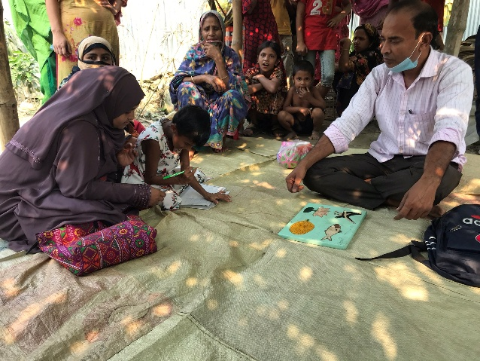
1. Identify and recruit children with severe and multiple disabilities: Sense International and CDD carry out surveys in communities, and solicit referrals from healthcare or child protection agencies, to find children and families who need support.
Home-Based Education Facilitators (HBEFs)
Once the family begins the Home-Based Education programme, they are allocated an HBEF from their own community, who will stay with them throughout the process. HBEFs are local people with experience in healthcare, early years development, education, disability inclusion or a combination of these, and receive intensive training to implement the HBE approach. Each HBEF can support up to 15 children at a time.
A child practises writing with her mother and HBEF
There are significant benefits to HBEFs working in their own communities. They have a deep understanding of the prevailing social norms, including prejudices and misconceptions around disability, meaning that they are able to tackle them effectively.
Local HBEFs are also known and trusted by schools and healthcare providers. This means that their voices are heard when they advocate for children with severe or multiple disabilities, and they have a network they can call on for various kinds of support.
Recommendation: The HBE programme has reached children whose disabilities are so severe or complex that they are not reached by other disability inclusion programmes. HBEFs must tailor their support to each child’s specific needs, and it is unreasonable to any professional to have deep expertise in such a wide range of severe disabilities.
A centralised, formal training programme for HBEFs is needed, to equip them with the skills required to address the needs of children with severe and multiple disabilities. Training should cover inclusive education approaches, use of assistive technologies, communication strategies (eg alternative and augmentative communication systems), and the creation and implementation of individual education plans.
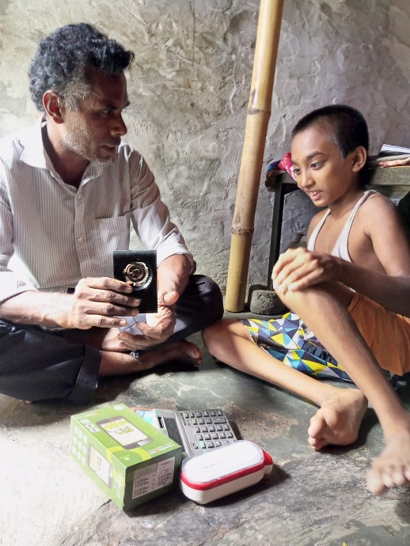
2. Conduct a Functional Assessment and create an Individual Support Plan: The HBEF carries out a thorough evaluation of the child's current abilities within their home environment. They then create a plan to address the child’s developmental, educational, and personal care needs.
3. Provide home-based support: The HBEF visits the child in their home at least weekly, to implement their individual plan. Parents / carers learn basic therapeutic and educational techniques, so that they can support the child between visits.
Caring for a child with severe or multiple disabilities can be stressful and frustrating, but the involvement of a child’s primary carers in the HBE process is critical. HBEFs have to educate families on their child’s rights and potential, convince them to commit to the process, teach them to provide specialist care to their child and support them through engagement with healthcare and education agencies. The emotional strain on families should not be underestimated, and HBEFs spend time managing this while still focusing on the child’s development plan: 69% of families supported in Sirajganj and Narsingdi received counselling from their HBEF.
A child practises using sensory learning materials with his HBEF
Recommendation: Support for parents / carers should be a core component of all programmes working with children with disabilities. Training for HBEFs, medical professionals and teachers should include how to involve parents / carers in supporting the child’s development. Furthermore, the mental and emotional wellbeing of carers should be monitored as part of all professional support to each child.
4. Coordinate additional support: The HBEF provides speech therapy, physiotherapy and other support to a certain level, but arranges external provision when they cannot meet the child’s needs. For instance, if the initial functional assessment indicates issues with hearing, the HBEF will refer the child for further testing, accompany them and their caregiver to all appointments and coordinate treatment, therapy and / or provision of assistive devices.
91% of families in the HBE programme needed their HBEF’s support to access medical facilities. This includes help with securing referrals, booking appointments and travelling to clinics, as well as having someone present to ask questions and advocate for the child, as parents / carers may lack the understanding or confidence to do this at first.
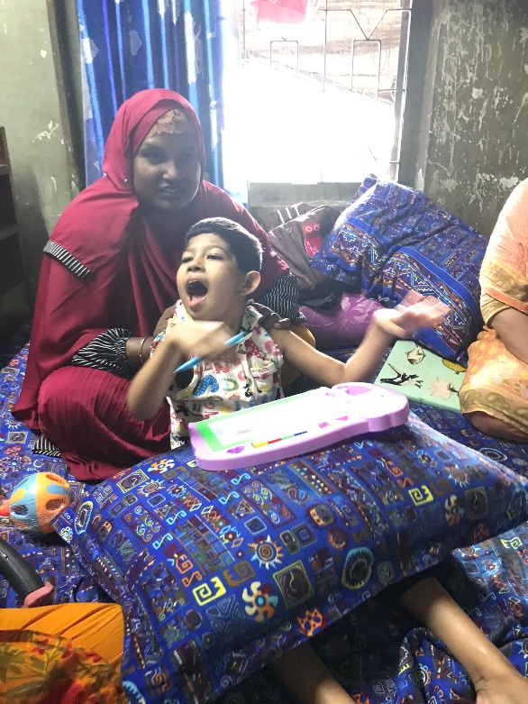
The fact that over 40% of children in this programme received assistive devices while they were being supported indicates the significant lack of engagement with specialist medical professionals in our target communities: without the HBEFs’ intervention, it is likely that these children would still not have the assistive devices they need, and to which they are entitled.
Recommendation: A multisectoral task force should be established, led by the Ministry of Education, to address the complex needs of children with severe and multiple disabilities, ensuring a holistic approach to education, healthcare, and social support. This would include the development of robust monitoring frameworks and reporting structures.
Coordination between the various medical professionals supporting children with disabilities and their families should be improved, with comprehensive, digitised case files. There is also an urgent need for better understanding of multiple and complex disabilities amongst all medical professionals, to expedite referrals, improve communication with families / carers, and ensure access to assistive devices and therapeutic services.
A young child plays with sensory toys alongside her mother
5. Transform community attitudes: Alongside this home-based support, the HBEF works in the community of each child with severe disabilities and their families. They raise awareness of the realities of disability, dispelling myths and tackling prejudices.
Recommendation: Community-driven awareness campaigns should be launched to address societal stigma, improve public attitudes toward children with severe and multiple disabilities, and encourage greater acceptance and participation in HBE programs. Partnering with local authorities and civil society organisations reduces the burden on HBEFs, and extends the reach of the programme: awareness-raising campaigns involving radio and TV stations, religious leaders, schools and other groups have been notably successful in improving acceptance and integration of children with disabilities and their families.
6: Facilitate transition to mainstream education: The HBEF also holds relationships with mainstream primary schools in the local area, and assesses their capacity to welcome and teach children with severe and multiple disabilities. The HBEF identifies and analyses potential access barriers, and works with the school leadership team to address these, but do not have the resources or authority to make significant changes.
Policies are in place to ensure inclusion in mainstream schools, but these are not always implemented at local level. Budget allocation for inclusion should be consistent and compulsory, and compliance should form part of the school inspection programme.
Recommendation: Children with severe or multiple disabilities require sustained support, and their families need long-term accompaniment, if they are to progress to mainstream education. This means that consistent funding is required, to avoid breaks in provision and to ensure that all children with disabilities are reached. Funding is needed for HBEF training, supervision and salaries, procurement of assistive devices, therapeutic and educational materials, and direct financial support to families for transport and health-related expenses.

Impact
The Home-Based Education model has been proven to be effective, impactful, cost-efficient and flexible enough to adapt to a wide variety of contexts. Of the children participating in the HBE programme:
- 73% show an improvement in physical skills, particularly with daily self-care tasks
- 86% have an improved ability to interact and communicate with others
- 88% are better able to take part in social situations
- 81% have improved behaviour and emotional wellbeing
- 72% are better able to understand and retain educational concepts
- 74% have improved academic skills, including basic literacy and numeracy
This includes all children supported, not just those who are now participating in mainstream education. Parents and carers report that HBE support has been transformative for their own mental health, and for the wellbeing of the family as a whole.
Sense International and the Centre for Disability in Development are now in a position to build on the success and learning from the first iteration of HBE, and to expand the approach more broadly. As HBE relies on highly individualised support, it could readily be adapted to other countries and contexts.

“We could never imagine that Jihan would be able to write…he could not even hold pencils with his own hands. After enrolling in HBE, Jihan now writes with his own hand.” – Mother of Jihan, a child participating in HBE

