
Home based education: a pathway to inclusion
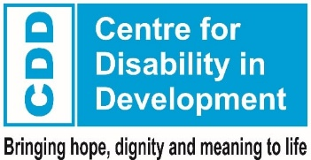

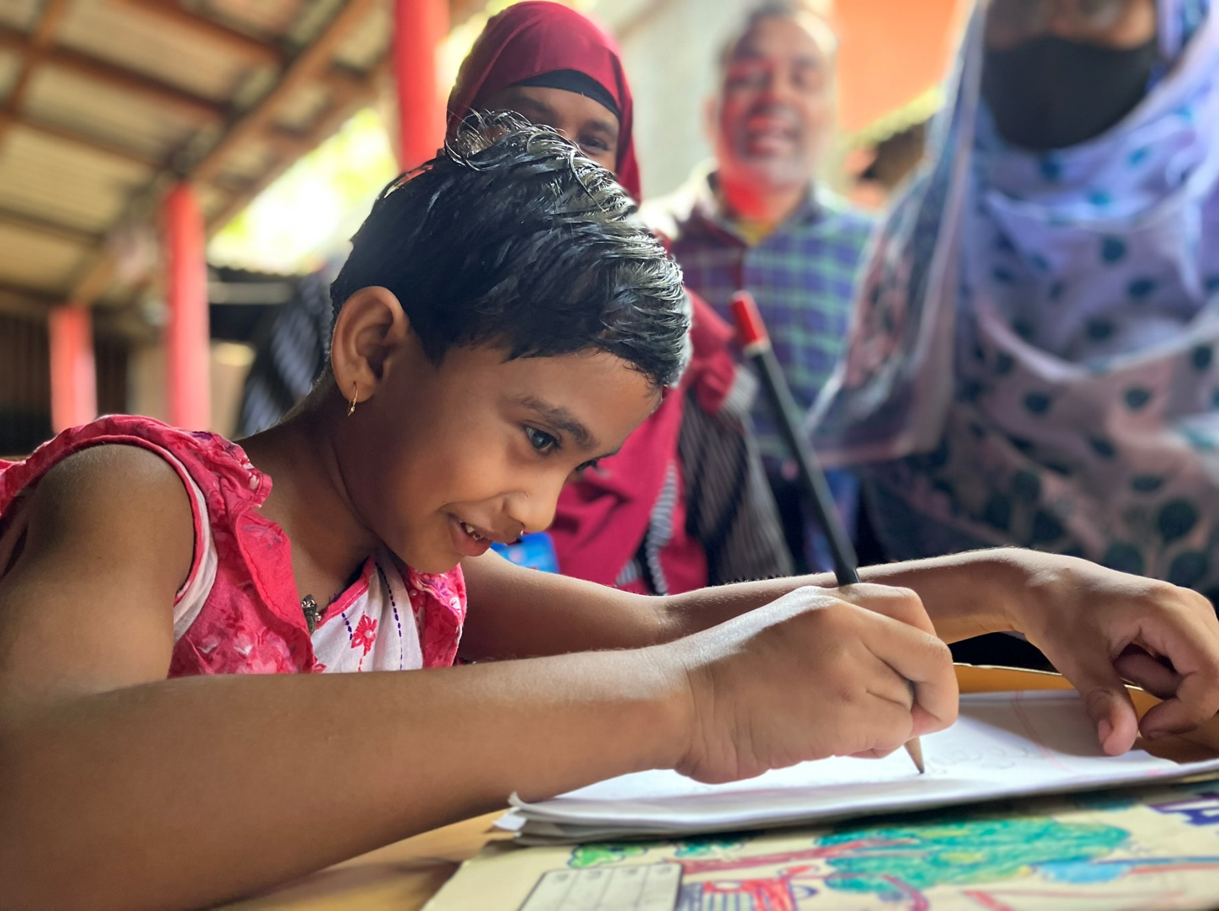
Supported by:

Contents
Context 1
Barriers to education for children with disabilities 2
The Home-Based Education approach 3
The impact of the Home-Based Education approach 7
Challenges and keys to success 11
Summary of impact 14

Context
Many families, teachers and policy makers believe that children with severe or multiple disabilities will never be able to attend mainstream school. But since 2022, Sense International and the Centre for Disability in Development have supported 160 children with complex disabilities in Narsingdi (78 children) and Sirajganj (82 children), with the Home-Based Education model. Of these children, 95 – nearly 60% - have started formal education.
Bangladesh is home to 56.9 million children¹, of whom 1.7% have a disability, and 3.6% have functional difficulty in at least one of the domains of seeing, hearing, walking, fine motor skills, communication, learning, playing or controlling their behaviour².
The Government of Bangladesh ratified the Convention on the Rights of Persons with Disabilities³ in 2006, and legislation is in place that – in theory – guarantees the right of every child to quality early years, primary and secondary education.
However, in practice, boys and girls with disabilities are missing out on early years and primary education. Only 5% of girls with disabilities, and 9% of boys with disabilities, take part in pre-school education, compared with 72% of their non-disabled counterparts⁴. 97% of all children in Bangladesh are enrolled in primary education⁵, but this is only true for 40% of boys and girls with disabilities. Although there has been progress towards inclusion of children with disabilities who require minimal support, children with severe and / or multiple disabilities are still left behind.

Primary education as a critical building block
Ensuring that all girls and boys complete primary and secondary education is a target of the of the 2030 Agenda for Sustainable Development. Education is a vital prerequisite for combating poverty, protecting children from hazardous and exploitative labour, and improving overall life chances, especially for girls.

The importance of school readiness
Nearly all schools in Bangladesh now offer a year of free pre-primary education, which includes the foundations of literacy and numeracy, as well as enabling children to develop their motor, cognitive, language, socio-emotional and regulatory skills and capacities⁶. Children who receive at least one year of pre-primary education are more likely to develop the critical skills they need to succeed in school, and less likely to repeat grades or drop out of school⁷.

Barriers to education for children with disabilities
In recent years, progress has been made towards inclusion for children with disabilities, but there is still much to be done if all children – particularly boys and girls with severe and multiple disabilities – are to achieve their right to quality pre-school and primary education.
The Home-Based Education model addresses key physical and social barriers to education:

Physical
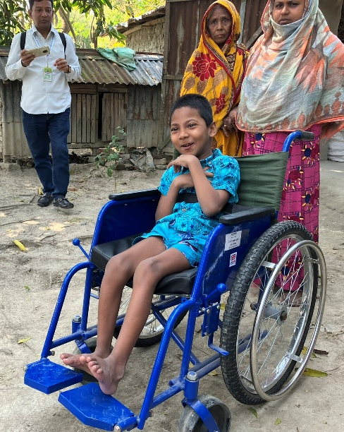
Transport: Children with severe and multiple disabilities are often unable to travel to schools. Particularly in rural or remote areas, terrain can be difficult to navigate on foot, and school or public transport is scarce, unreliable and sometimes inaccessible.
Assistive devices, technology and therapy: Without early screening and support, children do not receive the assistive devices and therapy that could enable them to fully participate in education. This includes crutches, wheelchairs, glasses, hearing aids and so on, as well as physiotherapy, occupational therapy and speech therapy.
All of these are freely available, but the healthcare system is complicated. For parents or carers with limited resources, and with low levels of education themselves, understanding and navigating the system, travelling for various appointments and negotiating with providers can be incredibly challenging.
A young boy learns to use his specialised wheelchair
School infrastructure: As well as physically inaccessible buildings (including toilets and washing facilities), many schools lack materials that are adapted for children with disabilities. Books in Braille or large print, equipment that supports development of cognitive and fine motor skills – all of these are needed to support children with severe and multiple disabilities, but are not consistently available in mainstream schools.
Teaching: Even if schools are accessible, teachers are often inadequately trained, motivated or supported to teach children with disabilities effectively. Very few can communicate in sign language, or read or teach Braille. Strategies for including children with disabilities in mainstream classrooms are not emphasised in the teacher training curriculum, and teachers, headteachers and education authorities are likely to hold the same prejudices and misconceptions about children with disabilities as other people in their communities.

Social
Discrimination: Children with disabilities consistently face stigma and discrimination, and they and their families are marginalised by their communities. Some communities see disability as a punishment or a curse, and as a result, children and their families are abused and ostracised. Simple things like playing with the neighbours’ children, or sharing a meal, are out of the question for families whose children have disabilities.
This isolation makes it even more difficult for children with severe disabilities to develop physical or social skills, or to build the emotional resilience needed to succeed in education. Very few children with disabilities are sent to school, as they are thought to be incapable of learning, and in general are seen as a burden on their families, rather than a positive asset to their communities.
Parents / carers: Without support, no parent or carer is equipped to support a child with severe or multiple disabilities. Parents tell us that they are focused on ensuring that their child is comfortable and healthy, and – surrounded as they are by continual discrimination against people with disabilities – have extremely low expectations of them.
Even if parents / carers understand developmental milestones, they do not know how to help their children to progress towards them, or see the link with education. As noted above, the state support system is complicated and not user-friendly, and very few parents have the knowledge or resources to navigate it successfully.
Families with children with disabilities typically have a lower household income, partly because at least one adult has to be in the home to care for the child. The stigma they face means that they cannot lean on neighbours for support, and unsurprisingly, this has a significant negative impact on the whole family’s mental and emotional wellbeing.

The Home-Based Education approach
Home-Based Education addresses these barriers to education by taking a holistic approach: support encompasses the child and their parents / carers, and is highly targeted and individualised.

The overarching aim of HBE is to prepare and support children with severe and multiple disabilities to enrol, participate and thrive in mainstream education. It is not intended to replace formal education, but to give children and their families, every possible tool to join mainstream schools.

Step 1: Identify and recruit children with severe and multiple disabilities
Sense International and the Centre for Disability in Development carry out surveys in communities, and solicit referrals from healthcare or child protection agencies, to find children and families who need support. Home-Based Education Facilitators (HBEFs) then go and meet with these families, to explain the HBE model. Some families are enthusiastic straight away, while others are more hesitant, still believing that there is no way their child could ever participate in education.
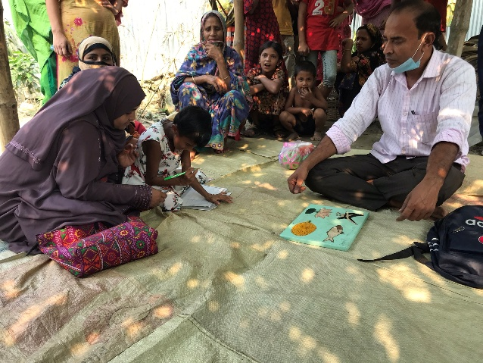
Home-Based Education Facilitators (HBEFs)
A child practises writing with her mother and HBEF
Once the family begins the Home-Based Education programme, they are allocated an HBEF from their own community, who will stay with them throughout the process. HBEFs are local people with experience in healthcare, early years development, education, disability inclusion or a combination of these, and receive intensive training and supervision to implement the HBE approach. Each HBEF can support up to 15 children at a time.
There are significant benefits to HBEFs working in their own communities. They have a deep understanding of the prevailing social norms, including prejudices and misconceptions around disability, meaning that they are able to tackle them effectively.
Local HBEFs are also known and trusted by schools and healthcare providers. This means that their voices are heard when they advocate for children with severe or multiple disabilities, and they have a network they can call on for various kinds of support.

Step 2: Conduct a Functional Assessment
The HBEF carries out a thorough evaluation of the child's current abilities, limitations, interests and developmental needs within their home environment. This sets a baseline to measure future progress, and the basis for an individual plan for targeted interventions. The capacity of other household members is taken into account, and an Ecological Assessment Checklist is used to assess the child’s home environment and its potential use for learning and development.

Step 3: Create an Individual Support Plan
With the results of the functional assessment, the HBEF designs a personalised plan to address the child’s specific developmental, educational, and personal care needs. The plan is created with the child’s parents / carers. This is a crucial step, given their central role in implementing the plan, which encompasses aspects such as mobility, communication, activities of daily living, basic literacy and numeracy.

Step 4: Provide home-based support
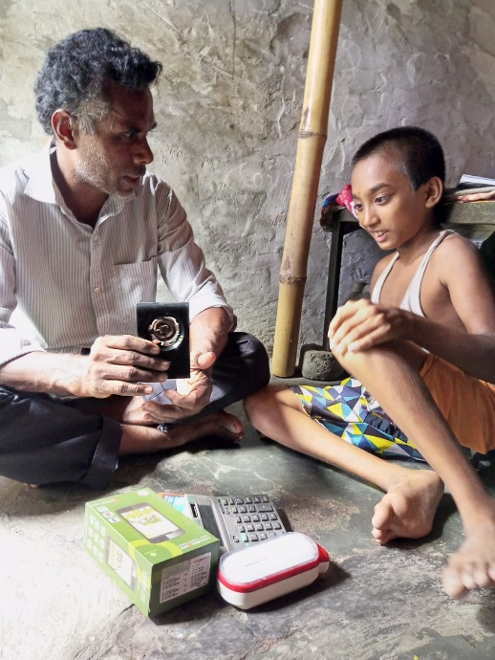
The HBEF visits the child in their home at least weekly, to implement their individual plan. Knowing the child’s interests enables the HBEF to design activities that will be stimulating and engaging, while the child makes progress towards developmental milestones. The HBEF involves the parents / carers in activities, encouraging repetition with the child on their own. This means that the child receives support every day, not just when the HBEF visits.
A child practises using sensory learning materials with his HBEF
As well as supporting the child in their journey towards school readiness, these visits are crucial for the caregivers. Having been isolated, stigmatised and judged for years, it can be difficult to accept help, and to gain confidence in their ability to support their child. As noted above, parental involvement in children’s education and development is critical, so a key part of the HBEF’s role is to equip, empower and motivate them to persevere.
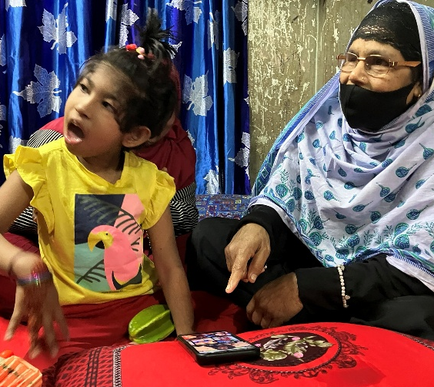
Jakir’s Story
Jakir is a nine-year-old boy in Tarash, Sirajganj, who has severe physical and intellectual disabilities. He was identified by a local Home-Based Education Facilitator, and joined the HBE programme. The HBEF has been visiting his home twice a week for eighteen months, and sometimes brings other professionals to give additional support, like speech and occupational therapists.
Jakir’s main caregiver is his mother, and she has worked hard to learn techniques to stimulate his sensory, cognitive, and motor development. She provides therapy and basic learning activities between the HBEF’s visits, so that he has some kind of intensive support every day.
Having support in the family home is absolutely crucial for Jakir and his family, as there is no way his mother could take him to therapeutic appointments twice a week. Although Jakir still needs help with nearly every daily task, his family has noticed small but meaningful improvements, and this progress keeps them motivated.

Step 5: Building social capital
Alongside this home-based support, the HBEF works in the community of each child with severe/multiple disabilities and their families. They raise awareness of the realities of disability, dispelling myths and tackling prejudices. Where possible, the HBEF introduces carers to other families with children with disabilities in the local area, and helps them to build relationships with neighbours. Reducing isolation in this way can be transformative for the wellbeing of the parents / carers, with significant positive effects for their children.

Step 6: Coordinate additional support
The HBEF provides speech therapy, physiotherapy and other support to a certain level, but arranges external provision when they cannot meet the child’s needs. For instance, if the initial functional assessment indicates issues with hearing, the HBEF will refer the child for further testing, accompany them and their caregiver to all appointments and advocate for priority treatment, therapy and / or provision of assistive devices.
This reduces the burden on caregivers to navigate complicated support systems, but having the HBEF with them when they attend appointments builds their capacity to obtain support for their child in future.
HBEFs also support the family to access benefits and entitlements, including student scholarships. In some cases, HBEFs have helped families to obtain basic identity documents such as birth certificates, which are required for school enrolment.
Over 36 months, families supported by HBEFs in Narsingdi and Sirajganj received the following:
Services | % of families receiving
Individual Education Plan | 100%
Disability-friendly learning materials | 57%
Support to access medical facilities | 91%
​​​​​Assistive devices | 41%
Counselling | 69%
Support with income generating activities | 3%
Cash assistance | 16%

Step 7: Facilitate transition to mainstream education
Throughout the process, the HBEF is monitoring the progress of the child and their family, tracking progress towards developmental milestones, adjusting the plan and bringing in additional support as necessary. The HBEF also holds relationships with mainstream primary schools in the local area, and assesses their capacity to welcome and teach children with severe and multiple disabilities. The HBEF identifies and analyses potential barriers to school inclusion, and meets with the school leadership team to discuss these. The HBEF will suggest actionable solutions, and connect schools with organisations that can provide additional support or funding if needed.
For instance, if the HBEF is supporting a child with a hearing impairment, and the local school has no teachers who are able to communicate in sign language, they will aim to facilitate training before the child comes to enrol.
The HBEF also accompanies the child and their carers to visit the school, supporting the carers to ask questions, meet teachers and if possible, connect with other parents. This transition period can be challenging for everyone involved, so the HBEF remains connected with the family and school to ensure that everything is in place, and the child can settle in well.
If a child is not ready to enrol in mainstream school after three years, HBE support continues, with ongoing referral to other agencies as needed.

The impact of the Home-Based Education approach

Increase in enrolments
The stated aim of the Home-Based Education programme is to prepare and support children with severe and multiple disabilities to enrol, participate and thrive in mainstream education. The results of HBE were studied in two districts in Bangladesh. In Narsingdi, 78 children are receiving support, of whom 47 (60%) have now enrolled in mainstream school. In Sirajganj, 48 of the 82 (59%) children supported are now attending formal school. This means that overall, 59.3% of children participating in HBE have moved into mainstream education.

Improved functional skills and psychosocial wellbeing
The Early Child Development Index was created to inform public policy regarding the developmental status of children in Bangladesh, and defines milestones that children are expected to achieve by ages 3 and 4. These milestones cover four domains, and children participating in HBE are assessed on specific criteria within each one:
Physical: If the child can pick up a small object with two fingers, like a stick or a rock from the ground, and if the caregiver reports that the child is hardly ever too unwell to play, the child is considered to be ‘on track’ developmentally.
73% of participating children showed an improvement in this domain, particularly in being able to do daily self-care tasks. This suggests that these children are prepared to attend school sessions without needing constant personal care, for example, with toileting. The improvement in psychosocial and life skills is underlined by reports from parents and carers that children are able to care for themselves in ways they had previously thought impossible, including feeding, dressing and washing themselves with little or no assistance – tasks that had been carried out entirely by carers before HBE.
Social-emotional: This considers how the child interacts with other children, whether they can communicate, play with others without kicking, biting or hitting, and whether they can play without becoming distracted too easily.
86% of participating children had improved ability to interact and communicate with others, and 88% were better able to take part in social situations. 81% had improved behaviour and emotional wellbeing. This indicates that children are already spending more time with their peers in the community, and their improved ability to communicate and play together is a positive predictor of successful integration in mainstream school.
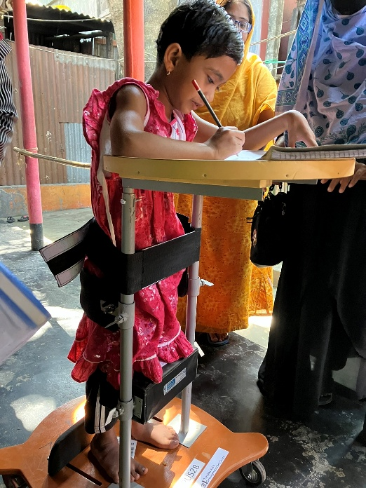
Learning: This considers the extent to which a child can follow simple directions on how to do a simple, age-appropriate task correctly, and how far they can do the task independently.
A young girl writes using her assisted mobility device
Literacy-numeracy: This includes the child’s ability to identify letters of the alphabet and numbers, and to recognise simple words.
72% of participating children are better able to understand and retain educational concepts, and 74% had improved academic skills. Being able to recognise and name letters, numbers, shapes and colours, to understand a story and follow simple instructions demonstrates a level of progress that astonished many parents and carers. Some of the children with severe or multiple disabilities who participated in HBE are now at the same development level as other children in pre-school – in other words, they are starting with much less of a disadvantage.

“We could never imagine that Jihan would be able to write…he could not even hold pencils with his own hands. After enrolling in HBE, Jihan now writes with his own hand.” – Parent of a child receiving HBE support

Long-term benefits for children, families and communities
Children participating in HBE, their families and communities, report benefits beyond quantitative improvements in the child’s development.
In the short-term, when children with disabilities acquire self-care skills, the strain on their caregivers is reduced. Parents and carers report that their mental and physical health has improved, and that they spend less time worrying about their child’s future. When they are worried, they report that they have more people to turn to for support, and know how to ask for professional help when needed.
With children receiving care and education through HBE, parents and caregivers report that they can dedicate more time to work or income-generating activities, and this increases further when the child begins to attend school. This improves household financial stability and reduces dependency on social safety nets.
When people understand that children with disabilities and their families can make positive contributions, rather than being regarded as a drain or a burden, communities become more diverse and cohesive. This in turn leads to improved resilience, and the creation of long-term social capital.
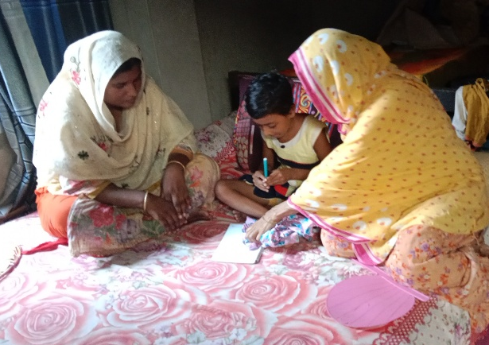
Sadia’s parents sought medical help, but they were told that treatment would be lengthy and expensive, and they knew that they would not be able to afford it. They had no choice but to accept that Sadia would always be dependent on them for everything. They foresaw a life for her where she rarely left the home, and had no friends, as the children in the community refused to play with her, and often made fun of her. They certainly didn’t imagine that Sadia would ever go to school. They were an isolated, lonely family.
The turning point came in 2022, when the family was approached by a Home-Based Education Facilitator in Sirajganj. After conducting a functional assessment, the HBEF developed an Individualised Education Plan in consultation with Sadia's parents, and everyone agreed on the way forward.
From then on, the HBEF came to Sadia’s home for two to three hours, twice a week. She worked with Saida on daily living skills, basic communication and preschool skills development. She also showed Saida’s parents how to support her with basic physiotherapy and speech therapy exercises.
Nothing changed overnight, but gradually, Sadia started to improve. Sadia’s family were amazed by her progress, and redoubled their efforts to provide her with special care. She became able to sit, stand and walk with minimal assistance. She learned to feed herself, brush her teeth, use the toilet and dress herself with a little help, and drooled much less.
In January 2023, Sadia enrolled in her local mainstream primary school. Accompanied by her mother, Sadia attends school regularly, and both her teachers and fellow students have accepted her. The neighbouring children also invite Sadia to play with them – they no longer laugh at her or tease her.
Sadia's parents are immensely grateful for everything the HBEF has done for their daughter, and the support they continue to receive as she adapts to her new life. Her family now dream of Sadia continuing with her education, and becoming a respected member of the community.

Sadia’s story
Sadia is seven years old, and lives with her mother and father in Sirajganj. Her father works as a night guard, and her mother looks after Sadia full-time, so the family often struggle financially. Sadia was born with severe physical disabilities: she couldn’t stand or sit without support, and was unable to clean, dress or feed herself. Her fine motor skills were so weak that she could not pick up or hold objects, and she was unable to stop herself from constantly drooling.

Challenges and keys to success
The role of Home-Based Education Facilitator is not straightforward. HBEFs have to navigate a complex landscape of cognitive, physical, and emotional hurdles for each child, taking into account unique household situations. Key challenges, success factors and recommendations for scale-up include:
Complexity of needs: the HBE programme has reached children whose disabilities are so severe or complex that they are not reached by other disability inclusion programmes. As they are embedded in local communities, HBEFs have unique access to families who lack the resources or information to advocate for support for their child, and can recruit them to the programme.
Children with severe and / or multiple disabilities may present with deafblindness, intellectual disabilities and physical impairments. HBEFs must tailor their support to each child’s specific needs, and it is unreasonable to expect any professional, experienced and trained though they are, to have deep expertise in such a wide range of severe disabilities. This means that expert supervision and support has to be available to HBEFs at all times, through initial screening and planning, to implementation of the individual plan, and to ongoing assessment and monitoring.
Recommendation: A centralised, formal training programme for HBEFs is needed, to equip them with the skills required to address the needs of children with severe and multiple disabilities. Training should cover inclusive education approaches, use of assistive technologies, communication strategies (eg alternative and augmentative communication systems), and the creation and implementation of individual education plans.
Lack of coordination: 91% of families in the HBE programme needed their HBEF’s support to access medical facilities. This includes help with securing referrals, booking appointments and travelling to clinics, as well as having someone present to ask questions and advocate for the child, as parents / carers may lack the understanding or confidence to do this at first. The fact that over 40% of children in this programme received assistive devices while they were being supported indicates the significant lack of engagement with specialist medical professionals in our target communities: without the HBEFs’ intervention, it is likely that these children would still not have the assistive devices they need, and to which they are entitled.
Recommendation: A multisectoral task force should be established, led by the Ministry of Education, to address the complex needs of children with severe and multiple disabilities, ensuring a holistic approach to education, healthcare, and social support. This would include the development of robust monitoring frameworks and reporting structures.
Coordination between the various medical professionals supporting children with disabilities and their families should be improved, with comprehensive, digitised case files. There is also an urgent need for better understanding of multiple and complex disabilities amongst all medical professionals, to expedite referrals, improve communication with families / carers, and ensure access to assistive devices and therapeutic services.
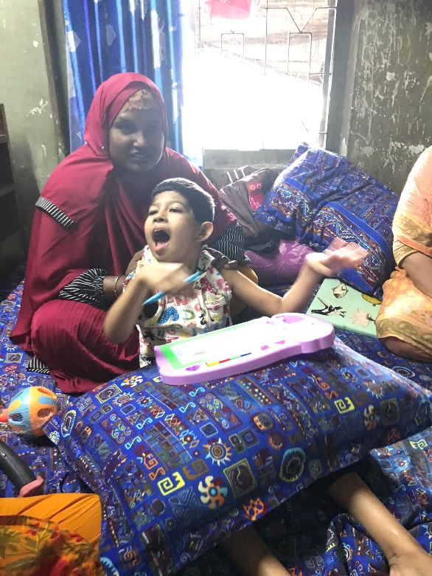
Involvement of parents and carers: Caring for a child with severe or multiple disabilities can be stressful and frustrating, but the involvement of a child’s primary carers in the HBE process is critical. HBEFs have to educate families on their child’s rights and potential, convince them to commit to the process, teach them to provide specialist care to their child and support them through engagement with healthcare and education agencies. The emotional strain on families should not be underestimated, and HBEFs spend time managing this while still focusing on the child’s development plan: 69% of families supported in Sirajganj and Narsingdi received counselling from their HBEF.
Recommendation: Support for parents / carers should be a core component of all programmes working with children with disabilities. Training for HBEFs, medical professionals and teachers should include how to involve parents / carers in supporting the child’s development. Furthermore, the mental and emotional wellbeing of carers should be monitored as part of all professional support to each child.
A young child plays with sensory toys alongside her mother
Community support: HBEFs are local and familiar with the communities they serve, but they often face challenges in building community support for the education of children with severe and multiple disabilities. Harmful local attitudes can affect the overall effectiveness of the programme, particularly in terms of integrated the child in mainstream school. HBEFs therefore have to tackle negative stereotypes at all levels.
Recommendation: Community-driven awareness campaigns should be launched to address societal stigma, improve public attitudes toward children with severe and multiple disabilities, and encourage greater acceptance and participation in HBE programs. Partnering with local authorities and civil society organisations reduces the burden on HBEFs, and extends the reach of the programme: awareness-raising campaigns involving radio and TV stations, religious leaders, schools and other groups have been notably successful in improving acceptance and integration of children with disabilities and their families.
Mainstream education readiness: even when children with severe or multiple disabilities are ready for mainstream school, their local school may not be fully ready to accommodate them. HBEFs work with schools to improve accessibility, but do not have the resources or authority to make significant changes. Advocacy by disability organisations, parent-teacher groups and others, directed at the Ministry of Education, can be effective in ensuring that resources are allocated in accordance with the inclusive education policy.
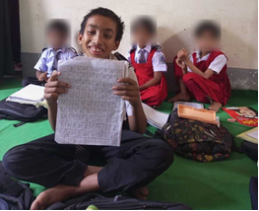
Recommendation: Children with severe or multiple disabilities require sustained support, and their families need long-term accompaniment, if they are to progress to mainstream education. This means that consistent funding is required, to avoid breaks in provision and to ensure that all children with disabilities are reached. Funding is needed for HBEF training, supervision and salaries, procurement of assistive devices, therapeutic and educational materials, and direct financial support to families for transport and health-related expenses.
The HBEF explained how the Home-Based Education programme could help Ramzan, but his grandparents were skeptical – all their lives, they had heard that children with disabilities were unable to learn or to socialize with their peers. Although they loved Ramzan, they did not believe he had any kind of future outside the home.
Despite the grandparents’ reluctance, the HBEF persisted. “She came so many times, explaining how Ramzan could benefit,” his grandfather said. Eventually, they were persuaded to participate in the HBE programme.
The HBEF carried out a full assessment of Ramzan’s functional abilities, and made an Individual Education Plan that would build on the strengths she identified, preparing him to take part in an inclusive education setting.
Once he began receiving physiotherapy, Ramzan made quick progress. His grandmother was astonished that he could soon move and control his legs and hands, which had been impossible before.
At the same time, Ramzan was moving forwards with his cognitive abilities, learning to identify and name colours and shapes, and to count. All of this happened within six months of him joining the HBE programme.
Ramzan has now enrolled in his local primary school, which he attends regularly with his grandmother’s support. The school buildings still need work to make them accessible, so Ramzan relies on his teachers and classmates help him to get around.
This is not the end of Ramzan’s story, and he will continue to need physical and psychosocial support for years to come, if he is to thrive in school and beyond. As his grandmother says, "We just want these supports to keep going so Ramzan can have a bright future.”

Ramzan’s Story
Ramzan is a 12-year-old boy with multiple disabilities. His parents couldn’t cope with his disabilities, and left him to be cared for by his grandparents. When the Home-Based Education Facilitator first met him, Ramzan has spent his life confined to a single room. His grandparents were too poor to take him for medical assessment or treatment, and just tried to keep him comfortable.

Summary of impact
The Home-Based Education model has been proven to be effective, impactful, cost-efficient and flexible enough to adapt to a wide variety of contexts. Of the children participating in the HBE programme:
- 59% have progressed to mainstream education
- 73% show an improvement in physical skills, particularly with daily self-care tasks
- 86% have an improved ability to interact and communicate with others
- 88% are better able to take part in social situations
- 81% have improved behaviour and emotional wellbeing
- 72% are better able to understand and retain educational concepts
- 74% have improved academic skills, including basic literacy and numeracy
This includes all children supported, not just those who are now participating in mainstream education. Parents and carers report that HBE support has been transformative for their own mental health, and for the wellbeing of the family as a whole.
Sense International and the Centre for Disability in Development are now in a position to build on the success and learning from the first iteration of HBE, and to expand the approach more broadly. As HBE relies on highly individualised support, it could readily be adapted to other countries and contexts.

This is not the end of Ramzan’s story, and he will continue to need physical and psychosocial

