Copyright @2024

ISBN: 978-81-951593-9-0

Title: Training Manual on Sexual and Reproductive Health and Rights for Adults with Deafblindness and Multiple Disabilities

Author: Sense International India

First published in India in 2024
This book is published, produced, and distributed by Sense International India.

Sense International India
2nd Floor, Admin Block
Andhjan Mandal Campus
Vastrapur, Ahmedabad 380 015
Tele: +91 79 26301282
Website: www.senseintindia.org
Email: info@senseintindia.org

All Rights Reserved
No part of this book may be reproduced or used in any form or by any means (graphics, electronic, mechanical, photocopying, recording, taping, web distribution, information storage and retrieval systems or otherwise) without prior written permission of the publisher.

Printed in India

  - FOREWORD
In pursuit of equality and dignity for all, it is imperative that we extend the principles of accessibility and empowerment to persons with disabilities including Persons with Deafblindness (PwDb) and Multiple Disabilities. Within this context, the publication in your hand represents a significant step forward in our collective endeavour to ensure that adults with deafblindness and multiple disabilities can understand the need of sexual and reproductive health and rights (SRHR).
The journey towards inclusive SRHR practices for adults with deafblindness and multiple disabilities has been marked by numerous challenges, chief among them being the pervasive stigma and lack of awareness. Too often, adults with deafblindness and multiple disabilities are overlooked or marginalized when it comes to discussions and initiatives surrounding sexuality and reproductive health.
Yet, the fundamental principles enshrined in the Universal Declaration of Human Rights, as well as more recent legislative frameworks such as the Rights of Persons with Disabilities Act-2016, assert definitively that every individual, irrespective of disability, possesses the right to access comprehensive sexual and reproductive health information, services, and education without discrimination.
The "Training Manual on Sexual and Reproductive Health and Rights” serves as a testament to our commitment to holistic empowerment of adults with deafblindness and multiple disabilities. The manual is tailored for adults with deafblindness and multiple disabilities. It presents a vital resource for promoting awareness, training methods, knowledge, and understanding of SRHR issues and the unique needs of adults with deafblindness and multiple disabilities with regards to sexuality.
Through this training manual, we have strived to break down barriers and foster a culture of inclusivity and empowerment by equipping special educators, parents and caregivers with the necessary information and tools to navigate sensitive SRHR topics and to develop the skills to educate every adult with deafblindness and multiple disabilities with confidence and respect.
As we embark on this journey towards inclusive SRHR practices, let us remain resolute in our commitment to challenging societal norms, promoting awareness, and advocating for the rights of PwDb and multiple disabilities and disability as a whole. Together, let us strive to create a world where everyone, regardless of disability, can exercise their sexual and reproductive health and rights with dignity and autonomy.
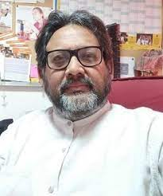
In order to ensure that the contents of the module are adapted to the learner’s unique needs, we must identify core areas/themes considered by the professionals as crucial for achieving the final goal. Since the professionals working in this field are very heterogeneous in terms of their educational background, the module is developed in a flexible way, allowing adaptations to accommodate different levels of knowledge.
Akhil Paul,
Founder and Executive Director,
Sense International India
  - Acknowledgment for the “Training Manual on Sexual and Reproductive Health and Rights for Adults with Deafblindness and Multiple Disabilities”.

We extend our heartfelt gratitude to the numerous individuals and organizations whose unwavering support made the creation of the Training Manuals on Sexual and Reproductive Health and Rights (SRHR) possible. This endeavour would not have been successful without the collaborative efforts and contributions of a diverse group of people.
It is our hope that these resources contribute significantly to advancing the understanding and promotion of sexual and reproductive health and rights in adults with deafblindness and multiple disabilities, their caregivers and special educators.

First and foremost, we express our deepest appreciation to PwDb and multiple disabilities, their parents, family members, and special educators for the willingness to share their experiences and insights. Their unique perspectives have provided a valuable foundation for understanding the challenges and SRHR needs of PwDb and multiple disabilities.
We would like to acknowledge the wholehearted support of our partners in 24 states of India, which has enriched the content of this publication.
Special recognition goes to Mr. Sachin Rizal and Ms. Vruddhi Patel for their dedicated and constant efforts in developing the content of this training module. Their expertise and commitment to the cause have been crucial in structuring the material into coherent and comprehensive chapters.
We acknowledge the efforts of Mr. Uttam Kumar and Mr. Akhil Paul in enhancement of the script and their guidance for elevating overall quality and impact. The bulk of credit for this publication is due to the ungrudging efforts put in by the entire team of Sense International India.

The Training Manual on Sexual and Reproductive Health and Rights for Adults with Deafblindness, and Multiple Disabilities stands as a testament to the collective commitment of everyone involved.
We acknowledge the valuable contributions of Ms. Mercy Chingnunmuang, Mr. Rashmikant Mishra, Mr. Srinivasan Prasannan, Ms. Bhavika Shah and Ms. Shrutilata Singh. Special recognition goes to Mr. Shivkumar Sharma for his outstanding work in designing this training manual.
Finally, we extend our sincere thanks to Ms. Vina Lakhumalani and Ms. Viveka Chattopadhyay for their exceptional contributions to this SRHR Training Manual.

TABLE OF CONTENTS

GUIDELINES FOR FACILITATING THE TRAINING ON SRHR 6
Notes for the Facilitator 7
Role of the Facilitator 9
A. INTRODUCTIONS 10
Icebreaker Exercise: The Better Half 10
About the Program 11
Pre-Test
13
B. FOUNDATIONS OF RESPECT: VALUES, CONSENT, AND HEALTHY
RELATIONSHIPS 15
Introductory Game-I am Special & Unique 15
My Flag 16
Understanding Respect: Respecting Self & Others 17
Personal Values 20
Influences on my Values 22
Value Voting 23
Values affect Behaviour 25
Consent in relationships 26
Global Values & Human Rights 28
Responsibility 32
Building Healthy Relationships 34
C. MY LIFELONG JOURNEY 38
Body Changes 38
Understanding our Bodies: In Adolescence and Puberty 40
Sexual Reproductive System 44
  - Male Reproductive System 45
  - Female Reproductive System 49
  - Menstruation 54
  - Conception & Pregnancy 57
  - Family Planning- Contraceptives 60

D. GENDER ROLES & EQUALITY 61
If I were, I would 61
Experiencing a Power Imbalance 62
Sex & Gender 64
Sexuality 68

E. RESOURCES 75
Annexure 1: WORKSHEET: Outer/External Male Reproductive Organs 75
MALE BODY OUTLINE
Annexure 2: External/Outer Parts of Female Sexual & Reproductive System 75
Annexure 3: Woman Body Mapping 76
Annexure 4: Man Body Mapping 77
Annexure 5: Internal Reproductive System Women 78
Annexure 6: Gender bread Person for activity 79
Comprehensive Evaluation Tool- For Adults with Deafblindness
and Multiple disabilities 80

References/work-cited/Bibliography: 85

GUIDELINES FOR FACILITATING THE TRAINING ON SRHR

Sexual and Reproductive Health and Rights Training Manual for Adults with Deafblindness and Multiple Disabilities
People with disabilities may struggle with sexual and reproductive health not because of their disability, but due to a lack of attention, legal protection, and support. Many face difficulties in getting basic information about their sexual health, leaving them unaware of their bodies and rights.
This training guide aims to equip trainers with the tools and skills needed to conduct effective workshops on Sexual and Reproductive Health and Rights (SRHR). However, it is important to note that this manual serves as a flexible guide. Each training session should be adaptable to meet the unique needs of participants, considering various factors that may impact learning.
Key Components of Training:
- Rationale of the Training: At the beginning of each session, clearly state the purpose of the training. This ensures that both trainers and participants understand the goals and processes involved. It also establishes the scope and limitations of the training, making it clear that it may not cover everything but has specific goals.
- Trainer Skill Set:
  - Self-awareness: Trainers should be aware of their biases that might influence the training. While having personal perspectives is fine, if biases could impact certain topics, it is advisable to assign another trainer for those sections.
  - Knowledge of Topics: Trainers should possess basic knowledge of the curriculum topics to answer questions effectively.
  - Communication and Facilitation Skills: Effective training requires strong communication skills. Trainers should be adept at managing discussions, rephrasing statements for clarity, and summarizing discussions.
  - Group Work Skills: Since the curriculum involves group activities, trainers should have basic skills in group management, role plays, and other techniques to facilitate effective group learning.
  - Information about Peer Education Resources: Trainers should be familiar with additional resources that complement their understanding of Sexual and Reproductive Health and Rights (SRHR) issues. This includes knowledge of other training modules and resources, allowing them to adapt the curriculum based on the evolving needs of trainees.
Remember, this guide is a starting point. Adaptability and a clear understanding of the participants' needs are crucial for a successful SRHR training session, especially when working with specific target audiences like the adults with deafblindness and multiple disabilities.

Notes for the Facilitator

USING THE MANUAL
Here are a few guidelines to help facilitators use the manual effectively.
In general:
- It is important to follow the order of the activities without skipping any, as each activity leads to the next.
- Work with a group size of approximately 15-20 adults aged 18 years or above.
- Seating in a circular/oval arrangement (on chairs or floor, whatever is convenient)- so that the facilitator can see everyone in this seating style and this is the most effective way of conducting the training. This will encourage participation from all the participants and make the facilitator and participant relationship more equal.
- Ensure that interpreters have sufficient time to interpret.
- Sometimes it may be necessary to extend the time limit of a session to conclude a crucial discussion properly.
Before the sessions start:
- Ensure that you have undergone training on the issue and how to use the manual.
- Before initiating this workshop, please read this manual from start to end in order to understand the flow and content of the workshop.
- Conduct a baseline survey (Pre-Test) with participants to gauge existing knowledge and attitudes.
- Each participant has their own mode of communication and level of understanding (each young person is unique due to his or her disability, language, understanding and intellectual level) as well as the interpreter/educator/parent who accompanies the young learners with deafblindness, and multiple disabilities. They will almost need individual attention along with his/her interpreter or teacher so that the trainers can be sure that the learning needs of each learner are addressed.

During each session:
- Start the session by setting ground rules so that the group can work together comfortably. Ground rules may include giving everyone a chance to participate, respecting each other's opinions, maintaining confidentiality, and so on. Please ensure as much as possible that the ground rules come from the participants themselves.
- Ensure interpreters actively engage participants.
- Remind the participants that no question or thought that they would like to share is bad, funny, or wrong.
- Conduct a quick verbal recap at the beginning of each day to remind participants of the session held on the previous day.
- Number of days the trainers can spare. Trainers then can decide what are key sections that they can cover in that duration.
- Use as much practical exercises for the training. Remember the young person’s vision, hearing and mental levels are varied. When groups are formed, there should be a mix of males and females, as both need to understand their own bodies and those of the other sex.
- Be prepared for unexpected questions from the young learners and their parents. As the training is on sex and sexuality, trainers must be prepared for very personal questions which may cause some consternation.
- The trainers have to overcome their own shyness to be able to help the participants. This is probably the first time that the participants may have been an opportunity to learn about their own physical and sexual development, especially about the other sex. So be prepared for embarrassment and reluctance to speak, take time to draw them out by the trainer being open, using biological terms and making them comfortable.
- The training manual has many pictures of parts of the body, but given that the participants might have low/no vision or hearing, use alternate materials/tools that can be handmade by you or what you can find in the market.
- Dolls might not be the most suitable material, as they are made from plastic or other materials which are very different from the texture of the human body.
- Kneaded flour is one option which can provide some kind of alternative solution.
- Materials such as bras, underwear, sanitary towels, and condoms will be required for the demonstration.
- Homework to participants should be avoided, as it is always better to do the work during the session in a participatory approach and practical way.

After each session:
- Conclude by asking the group about the learning points for the session.
- After completing the entire training, conduct an end-line survey to measure the shift in participants' knowledge and attitudes.
- Revisit areas/topics that need further clarification.
Role of the Facilitator
- Be a “friend” rather than a teacher: This will enable young people to be more open and share their doubts and concerns frankly.
- Provide accurate information and options to participants. This will enable them to make informed choices, help them be responsible, and stay safe in their personal lives.
- Avoid imposing personal values on the group. This will enable participants to share their own views and values more freely.
- Be credible: Often, the facilitator becomes a role model for young people. The facilitator’s credibility depends on whether his or her actions outside the sessions echo the messages given during the sessions.
- Maintain confidentiality: If participants share personal information, the facilitator should be careful not to break the young person’s trust.
- Refer: If a young person shares a problem that is beyond the capacity of the facilitator, he/she should refer the young person to more credible professional help, for example, a medical doctor or counsellor.
- Do not worry: The facilitator need not worry if he or she does not have the answer to all the queries. If necessary, the facilitator can do some research from a reliable source and address the queries in the next session.
- Keep it simple: It is also important for the facilitator to present the information simply and avoid using technical terms and unnecessary details. Information overload may confuse participants and result in them forgetting even the basics.
- Make it fun: Enjoy the sessions and make them interesting and memorable for the participants.
- Adopt a sex-positive approach to the workshop. A sex-positive approach accepts that sex and sexuality are part of life, and that open expression of sexuality, free from taboo, shame, and judgment, is important to an individual's wellbeing.
- Establish a safe space and encourage open and honest dialogue. No question is a silly one!
- Support individuals who may need to take some time out or talk privately.

INTRODUCTIONS

Icebreaker Exercises: The Better Half
Session 1: Activity 1  Icebreaker Exercises  The Better Half | Objective  - Introductions  - Getting to know one another  - Become familiar with each other  - Setting ground rules | Issues/Information  - Self-awareness  - Interpersonal communication  - Respect for each other
Time: 45-50 mins | Material required: None

Activity 1: Introductions
- Welcome and greet the participants and introduce yourself to them.
- Divide the participants into pairs by counting - 1, 2, 3, 4, Set.
- Allow 5 minutes for discussions in pairs. Encourage participants to ask questions about their partners' friends and families, preferences in food, best memories, and current activities.
- After the discussions, ask each pair to introduce their partners to the rest of the group, mentioning what their partner hopes to gain by participating in the training.
After Icebreaker sessions:
Facilitator says: We are all here together, with lots of positive energy between us. Let us make the most of this opportunity. To work effectively together, let us set some ground rules that we can all agree to.
GROUND RULES: To set the ground rules, encourage participants to list a few and best is if they come up with these pointers.

Everyone can brainstorm. Some examples of ground rules can be:
- Let us respect each other’s views and opinions.
- Let us be punctual.
- Switch off the cell phones.
- Confidentiality – everything that happens in the group is kept private. Information can be shared outside the group, but not stories or names.
- Ask to slow if session going fast, leaving no time to interpret.
- Interpreters to interpret in exact same language, not bringing bias or judgement.
- Interpret questions/queries as asked without editing information.

About the Program
Session 1: Activity 2  About the Program | Objective  - Background information.  - Purpose of the training.  - Expectation of participants. | Issues/Information  - Objective of the training  - Content of the training  - Understanding expectations.
Time: 40 mins | Material required: Flip charts & markers

Facilitator’s Tip: Your introduction can start with these pointers:
STAY INFORMED
  - There is a lot to understand when it comes to sex and sexuality.
  - This includes getting to know our own bodies, reflecting on our sexual orientation, determining our emotional and physical readiness, learning about self-protection, being informed about contraceptives, understanding the concept of consent, and recognizing our rights and responsibilities towards others.
  - It is essential to make decisions about our sexual behaviours based on our own feelings. Everyone may need different amounts of time to decide what they want, when, with whom, or if they want a sexual relationship at all.
  - Our choices, as well as the choices made by others regarding their sexual lives, should be respected without judgment.

REFLECT

As we journey through life, it is crucial to recognize our rights and responsibilities. When sharing this journey with someone, it is beneficial to determine where, when, and how far we want to go. Asking ourselves questions like, 'Am I emotionally and physically ready for this? Do I know myself and my partner well enough? Do I have enough information about sex?' is important? Even if it feels a bit awkward, talking to our parents, guardians, or other trusted adults about sex and relationships can provide valuable advice and support.

ACT
Accurate information is the key to making informed choices. Therefore, we always need to seek trustworthy information when learning about sex. For example, we need to be careful when navigating the internet or talking to other people, as they offer a wide range of information. We must ensure that we find information that is right for us! Additionally, learning life skills also helps us in making decisions.
*Remember while explaining the purpose of this training, it is important to:
  - Provide participants with accurate information about sexuality and reproductive health.
  - Help them to learn new skills for making good decisions and protecting their health.
FACILITATOR:
- Ask the group to brainstorm a list of what they hope to gain or learn from the sexuality education sessions. Give examples if the group is having difficulties – e.g., “to learn about my body” etc.
- Share the day-wise plan with the participants.
- Ask each participant to give at least 1-2 expectations.
- Write the expectations on the flip chart and speak them up in front of the groups.
- Give a brief overview of the workshop/training and the goals for this program.
- Share the day-wise plan with the participants.
Or
ASK THREE EXPECTATIONS, PARTICIPANTS HAVE FROM THIS TRAINING
1.
2.
3.

THREE CONCERNS YOU HAVE ABOUT THIS TRAINING
1.
2.
3.

SESSION 1 Activity 3: PRE-TEST*
PRE-POST TEST*: Adolescent Reproductive and Sexual Health Training Program
Participant Information:
Name:
Age:
Gender:

- If a boy kisses a girl, she can become pregnant? Yes/No
- Changes during adolescence happen to all girls and boys at the same time? Yes/No
- Girls and boys have equal rights? Yes/No
- Puberty is a stage of:
a) Emotional, physical and hormonal changes
b) No growth
c) Personal growth

- Being attracted to the opposite sex is a normal part of growing up! Yes/No
- Which of the following are parts of the male reproductive system?
a) Ovaries
b) Breast
c) Uterus
d) Penis

- What is the main function of the female reproductive system?
a) Producing sperm
b) Menstruation
c) Producing eggs
d) Passing urine

- In relationships, how can one show respect for oneself and others?
- Ignoring personal boundaries
- Open communication
- Controlling behaviour
- Avoiding discussions on sensitive topics

- What are personal values?
  - Universal and unchanging
  - Shaped by individual beliefs and experiences
  - Only relevant in professional settings
  - Imposed by society

- What does consent mean in a relationship?
a) Mutual agreement
b) One-sided decision
c) Ignoring the other person's feelings
d) Using force or pressure to make someone do something against their will.

- Taking responsibility in relationships involves acknowledging one's actions and working towards solutions! Yes/No
- Family planning involves the use of contraceptives? Yes/No
- "Sex" typically refers to the biological differences between males and females! True/False
- A baby is conceived when the egg and sperm meet in a woman’s body? True/False
- Having a vasectomy (male operation) or using any form of contraception reduces manliness? True/False
Answer Key:
1. No. 2. No. 3. Yes. 4. a. 5. Yes. 6. d.
7. c. 8. b 9. b. 10. a 11. Yes. 12. Yes.
13. True. 14. True. 15. False.

FOUNDATIONS OF RESPECT: VALUES, CONSENT, AND HEALTHY RELATIONSHIPS Top of Form RNEY

Introductory Game- I am Special & Unique
In Session 2, a variety of activities are presented. Please select the ones that best suit the participants. If time permits, feel free to engage in multiple activities, as they are all related and prepare participants for the following days.
Session 2: Activity 1  Introductory Game-  I am Special & Unique | Objective  - To identify what is needed for a person to feel confident.  - Commit to doing one thing to strengthen their self-confidence.  Issues/Information  - This basic life skill will prepare participants for 3 days training and encourage them to speak openly.
Time: 30 mins | Material required: Small objects (e.g., stones/nuts) for each person.

*Discussion and Demonstration (5 minutes)
- Provide each participant with a unique tactile object, ensuring diversity in textures and shapes. Objects could include soft toys, textured fabric squares, rubber shapes, or any other safe and distinct tactile items.
- Ask participants to explore their tactile object, identifying the unique characteristics that make it special. Encourage them to use their sense of touch to understand the object's shape, texture, and any distinctive features.
- Instead of gathering all the objects in a pile, consider placing them on a large, flat surface (like a table) to allow for easier exploration.
- Facilitate a guided activity where participants, one by one, come forward to locate and identify their own object from the table based on its unique characteristics. Provide support from facilitators or volunteers if needed.
- After participants have found their object, ask a few of them to comment on what was special about their object.

Facilitator’s Note:
  - Participants may think it is impossible to distinguish between the object they originally found and all of the other objects. Encourage them to continue their search.
  - Participants may also look at the objects already selected by other participants to make sure their original object has not been misidentified by another person.

FACILITATOR’S DEBRIEF or Summarization: Just as each object is unique, each person is also unique and possesses unique talents and strengths. Recognizing their own talents and strengths can build their self-confidence.

Individual Activity My Flag
Session 2: Activity 2  Individual Activity  My Flag | Objective  - To identify ways to build the confidence of self and others.  Issues/Information  - Self-awareness & confidence.
Time: 30 mins | Material required: Visual means for recording ideas (chart paper or board, markers/chalk)

- Participants can receive support from interpreters and volunteers. In cases where participants may not fully grasp the activity, facilitators can offer brief prompts to the interpreters for assistance.
- Facilitator's Note: It could be beneficial for you to draft a sample personal self-confidence flag as an illustration, using your assessment of your own self-confidence.
Top of Form

- Ask participants to create their personal self-confidence flag. Have them divide a piece of paper into three columns or use three sheets of paper and tape them together.
*Interpreters can draw for Db participants
  - In one column, have participants write or draw the skills (leadership, teamwork, creativity), knowledge (computers, current affairs), and talents (artistic abilities, cooking, writing) they recognize in themselves.
  - In the second column, have them list the people (siblings, family, grandparents, mentors, teachers) who appreciate their strengths.
  - In the third column, have them write or draw strengths (considerate, kind) people appreciate about them.
- Have participants read/sign to share their flags with one another (sharing can be done by facilitator, interpreter, or the Db adult).
The facilitator should emphasize and explain that participants are required to:
- Listen to others' flags.
- If they appreciate something about a person, share their appreciation. (This will only happen if participants actively listen when others are presenting their flags)
- When others express appreciation for them, include their name and note the skill, knowledge, or talent mentioned in their own flag.
*OPTIONAL & ADDITIONAL- HOMEWORK: Personal Application for Participants- The personal application for participants could be done as a homework assignment.
- Encourage participants to act on their ideas for building their personal self-confidence by doing the following:
  - Notice the skills and talents they have. Add these skills and talents to their flag over the next few weeks.
  - Notice when others say they appreciate something about them. Add these comments to their flag as they hear them.
  - Develop a new skill. Add these skills to their flag over the next few weeks.
FACILITATOR OF THE ACTIVITY: The outcome of the self-confidence flag activity is an individualized representation of participants' strengths, knowledge, and talents. It fosters self-awareness, encourages reflection, and promotes a positive, supportive environment. The shared flags contribute to building a collective understanding of diverse strengths within the group, enhancing overall confidence and mutual appreciation.
Linking Sentence to next activity: Teaching respect for oneself and others is essential for fostering positive relationships, conflict resolution, and emotional well-being. In the above activity, we learned to appreciate ourselves and others. Now, let us explore the meaning of respect and understand its significance in any relationship.

Understanding Respect: Respecting Self & Other
Session 2: Activity 3  Understanding Respect: Respecting Self & Others | Objective  - To identify ways to show respect for self and others.  - Understand how respecting one another and expressing appreciation to others contributes to positive relationships.  Issues/Information  - Difference between what respect is and is not.
Time: 60 mins | Material required: Chart paper or board, markers/chalk, paper, pencils/pens for participants.

INSTRUCTIONS:
- Begin by asking participants to describe "RESPECT." Accept three or four ideas and record them on chart paper or the white/chalkboard.
- Post two signs, Agree and Disagree. Participants can use thumbs up or thumbs down to indicate agreement or disagreement.
- Explain that you will describe situations involving a person or group acting in a way that may or may not show respect. Participants are to decide if they agree or disagree that the situation demonstrates respect.
- Describe the first situation. Allow participants a moment to think about their response, then ask them to signal agreement (thumbs up) or disagreement (thumbs down). Finally, ask a few participants to explain their reasons for agreeing or disagreeing.
SITUATIONS
- Your teacher asked you to help her with some work. You are already late for your next class, and you tell him/her you cannot.
- Your classmate is struggling with bags of groceries. This same classmate has been critical (talking bad) about how you and your friends dress and talk. You do not offer to help the classmate.
- Your parents tell you to watch your younger sister while they go out for buying fruits/vegetables. You had planned on going to meet with a friend. You decide to take your sister, even though she does not want to be there and is bored.

- After the activity, the facilitator to explain the participants why the above situations will fall under respect or disrespect.

- Situation A - Inability to assist due to time constraints. This is not disrespect.
- Situation B - This could be interpreted as a lack of immediate assistance but does not necessarily mean disrespect. Consider the classmate's critical behaviour and how it may influence the decision not to offer help. Individual boundaries and feelings are important in evaluating the level of respect or disrespect.
- Situation C - Prioritizing parents' requests over initial plans shows respect for parental authority. However, it may involve disregarding the sister's needs and choices, which can be seen as disrespectful.

- Conclude, by thanking participants for sharing their opinions on respect and express the intention to continue exploring this critical topic by considering ways to show respect for oneself and others.

- Provide definitions of 'respect for others' and 'self-respect' similar to the following:
- Respect for others is to feel or show honour or regard for the worth of someone.
- Self-respect is when a person believes in their personal worth and is willing to stand up for themselves.
- Acknowledge the frequent dilemma of showing respect for both oneself and others simultaneously, as evident in the discussed situations.

Information to Share: Facilitator Input (5 minutes): Definition of RESPECT
- Refer to the definitions of respect that they suggested at the beginning of the session. Invite participants to clarify their ideas by listing what respect “is” and “is not.” Create a split sheet chart like the one given below.

RESPECT IS | RESPECT IS NOT
- Automatically given in some situations and needs to be earned in others  - Valuing oneself and others  - Showing honour for the worth of others  - Believing in one’s personal worth  - Standing up for one’s self | - Blind obedience  - Tied to whether or not you like someone  - Being selfish  - Mistreating others  - Blind respect for elders  - Automatically earned with age or authority

Encourage participants to add more points to each column based on their understanding and experiences. This reflection will help deepen their comprehension of the nuanced aspects of respect.
Facilitator’s Note: Participants should understand the distinction between obedience and respect. Emphasize, that blind obedience may negatively impact respect for oneself. Obedience involves choosing to follow instructions or behave in accordance with a law, rule, or order. "Blind obedience" is when someone follows a higher order without critical thinking or making a clear choice.
Facilitator Input and Demonstration (10 minutes)
- There are numerous ways to demonstrate respect for oneself and others. One effective method is through the use of statements of appreciation. Let me give you an example:

- Imagine a scenario where a friend notices that you've been feeling overwhelmed with work. This friend takes the time to help you organize your tasks, offers valuable advice, and provides emotional support. In this situation, you can express your respect and gratitude through a statement of appreciation. You might say:
“'When you took the time to help me organize my work, provided valuable advice, and offered emotional support, I appreciated it because it made a significant difference in managing my workload and reducing my stress. Thank you for your support.”
- This example demonstrates how a statement of appreciation acknowledges the specific actions of the friend and articulates why those actions were meaningful and appreciated.
- Explain the two parts:
    - Describe what the person did.
    - Tell why you appreciated what the person did.

- Demonstrating Self-Appreciation for Self-Respect: Demonstrate the process of making a statement of appreciation to yourself as a way to show self-respect. Note that this form of self-appreciation is done privately, either in your mind or in a personal journal. When crafting a statement of appreciation to yourself, describe what you did and explain why it contributed to the development of your self-respect.
OPTIONAL & ADDITIONAL- HOMEWORK
- Encourage participants to begin a journal or diary of self-appreciation, they can record this too on their phones.
- One message to themselves each day. The message should be something they did well or something they appreciate about themselves

Personal Values
Session 2: Activity 4  Personal Values | Objective  - To become aware of values and priorities.  - Articulate and explain personal values.  - Examine the relationship between values and behaviour.  Issues/Information  - Empowered to assert their boundaries.
Time: 60 mins | - Material required: Chart papers & pens (documenting purpose)

INSTRUCTIONS:
- Brainstorming Personal Values: Ask participants to brainstorm a list of different things that hold importance in their lives. If they have difficulty starting, provide an example, such as 'education.' List all suggestions on the flipchart paper. (Answers may include things like education, health, family, friends, work, religion, respect, love, honesty, kindness, hard work, and talent.) The list should be comprehensive.
- Introduction to Values: Explain that the upcoming activity centres around values. Clarify that the term 'values' has a couple of meanings.
- Understanding Values: Elaborate on the two meanings of values: one pertaining to the actual monetary worth of an object and another involving a more personal measure of worth. In this context, personal values refer to how important certain things, beliefs, principles, or ideas are to someone.
- Interactive Activity: Write 'My personal values are...' on flipchart paper. Record their correct responses on the flip chart paper as follows:
- Definition of Personal Values: Complete the sentence: "My personal values are the things that are important to me in life."
By providing a clear structure and expanding explanations, participants will likely have a more guided and enriching experience during the activity.
Facilitator’s Note:
Values are:
- What I perceive as right and wrong.
- What I find desirable or undesirable.
- What I consider worthwhile or not.
- What I deem acceptable or unacceptable.

Explanation: Values include our judgments and assessments about what is right or wrong, desirable, or undesirable, worthwhile, or not, and acceptable or unacceptable. These are the guiding principles that shape the way we choose to live and work. They serve as the foundation for our decision-making, influencing our actions, interactions, and the choices we make in our personal and professional lives.
In essence, values are the core beliefs that reflect our understanding of morality, desirability, worth, and acceptability. They provide a framework for navigating the complexities of life, influencing our behaviour and shaping our perspectives. Understanding our values is crucial as it allows us to align our actions with our core principles, fostering a sense of authenticity and purpose in both our personal and professional endeavours.

- Guided Reflection: Ask participants to provide one or two examples of their personal values. If they encounter difficulty, offer another example, such as 'I believe that it is wrong to lie.'

- Sharing Session: After approximately five to ten minutes, redirect their attention to the front. Go around the room and request each participant to share the number one item on their list. Encourage all participants to attentively listen to each other.

- Discussion Points: ASK

  - What values did many participants mention?
  - Did boys & girls participants mention similar or different values? If differences arise, inquire: Why do you think there are variations?
  - As we grow up, various people and institutions influence our values. Ask: Who or what has influenced your values? (Answers may include parents and family, religion, media, friends, teachers, traditional and religious leaders, education, reading.)
  - How do values affect behaviour? (Values guide your behaviour and assist you in making decisions.)

- To give further clarity, provide examples of values such as:
  - Be honest with yourself and others.
  - Treat everyone with respect.
  - Girls have the same rights as boys and should be treated equally.
  - Education and skills are important to get a job.

- Ask the participants what they learned in this session and add any of the following points if not mentioned:
  - Your personal values are things that are important to you in the way you live and work.
  - Our values are influenced by the people around us and by ideas we get from things like religion, the media, and books.
  - Values influence our behaviour and the choices we make.
Linking Sentence to next activity: As we discussed, families, religion, school, reading, the media and culture can influence our personal values. We will now look at some of those influences on our values.

Influences on my Values
Session 2: Activity 5  Influences on my Values | Objective  - To identify the values, they were taught by their family, culture, religion and friends.  - To explain how they decided what their personal values were on those topics.  Issues/Information  - Explore the influence of family, culture, religion and friends on their values.
Time: 40 mins | - Material required: Flipcharts/white board and markers,

- Introduction:
Tell the participants that in this activity, they are going to discuss the values they learned from their families, culture, religion, and friends about sex and the distinctions between males and females.

- Guided Reflection:
Ask participants to think about what they learned from their family, culture, religion, and friends about the following topics. Write down what they were taught, and make a note if they did not learn anything about the topic from the source. Remember that sometimes we learn from people’s behaviour, not just their words.
- What did you learn about the difference between men and women from your:
  - Family
  - Culture
  - Religion
  - Friends
- What did you learn about males and females from your:
  - Family
  - Culture
  - Religion
  - Friends

- Discussion of Responses:
Go through their responses with them by asking one person to share what they learned from their family about the differences between men and women and males and females. Then ask who learned something different. Make notes on two or three different values that different participants learned.
- Ask further questions listed below.
- What were the topics that your family, culture, religion, or friends did not teach you? If so, which ones?
- Does family, culture, religion, or friends have the most influence on your values? Why?
- Do you share all of your family’s values? Why or why not?
- Who decides what your personal values are? (Only you do.)
- Summarization:
Ask participants to summarize what they learned from the activity. Add any of the following points that are not mentioned.
- Each one of us is influenced by the values of our family, culture, religion, and friends.
- Sometimes we learn different values from different sources.
- We need to decide for ourselves what our personal values are.
Linking Sentence for facilitator for next activity: “When it comes to values related to sexuality, communication is often indirect, as parents may feel shy or uncertain about discussing such topics with their children. Understanding our family’s values is crucial because they significantly impact our own values. However, it's important to note that we may not always adopt or share all of our family’s values. Now, let's delve deeper into our individual values."

Value Voting
Session 2: Activity 6  Value Voting | Objective  - State their position on the topics discussed.  - Logically explain the reason for their position.  Issues/Information  - To recognize what values are important to us.
Time: 40 mins | - Material required: FLASH CARDS- AGREE, DISAGREE & UNSURE
Preparation before activity by facilitator
- Prepare three signs marked Agree, Disagree and Unsure.
- Read through the values statements and participants decide which FLASHCARDS they want to use.
Facilitator’s resource:
Value statements
- Men need education more than women.
- Men are bread earners for their families.
- Having a job, you love is more important than making a lot of money.
- Raising a child is solely women’s responsibility.
- A wife should not refuse to have sex with her husband for any reason.
- A man who cries is like a woman.
- It is okay for men to have more than one sexual relationship at a time.
- Girls should stay at home so men cannot rape them.
- A family with many children is better than a family with fewer children.
- Men should always have the last word when it comes to making family decisions.
- Getting contraception is the girl’s responsibility because she is the one who gets pregnant.
- Having a son is better than having a daughter.
- We have a right to decide over our health and body.
- Introduction:
When a person is clear about their own values, they can easily talk about them in front of others. To know what your own values are, you need to figure out what you truly believe, regardless of what your family or others around you believe. And you need to be willing to say what you really think and not what we think that is what others want to hear. We should not be afraid to stand up for our own values.

- Explanation of Activity: Explain to participants that in this activity, they will express their feelings about statements that show particular values. Show participants the three signs labelled Agree, Disagree and Unsure.

- Give the following instructions for this activity:
- Facilitator will read out loud different statements.
- After the statement is read, you will decide if you agree, disagree, or are unsure about it. For example: If you agree with the statement, pick up Agree sign (sign can be thumps up), if you disagree, pick up Disagree sign (sign can be thumps down) and if you unsure, pick up Unsure sign (raise both hands).
- There are no right or wrong answers, only opinions based on your values. Each person is entitled to his/her own opinions.
- For each response, facilitator to ask a few of participants to explain why they decided on that. If they change their mind about their position, they are free to choose another sign.
Note to facilitator: Having participants share the reasons for their positions is the most important part of this activity.
- Ask the following questions to generate a discussion:
  - How easy was it to decide your position?
  - Did you follow the crowd on any of the statements or give an answer that all agreed to? If yes, why?
  - Does peer pressure or family ever influence your values and decisions in other situations? Why do you think this happens?
SUMMARIZE:
- We need to think carefully about what your own values are – they may not be the same as our family’s or other people’s values.
- It is important to know your own values and be confident enough to share them with others. This helps others understand and respect your opinions and decisions.

Linking Sentence to next activity: Your values should guide your behaviour, so they play an important role in the choices that you make. Being clear about what your values are will help you to know what to do in different situations. Sometimes we act in ways that are not consistent with our values – this can be due to peer pressure or because we have adopted others’ values that are not truly our own. Let’s look at how our values affect our behaviour.

Values affect Behaviour
Session 2: Activity 7  Values affect Behaviour | Objective  - To understand the relationship between values and behaviour.  - Logically explain the reason for their position.  Issues/Information  - To recognize how values guide behaviour.
Time: 60 mins | - Material required: Print of story for interpreters

  - INSTRUCTIONS: Inform participants that in this activity, they are going to discuss the relationship between values and behaviour.
  - Ask them:
  - If someone says that family is one of the most important things in life, how will they act? What things will they do? (Possible replies- Take care of their family members, spend time with them, help when there are problems.)
  - If a person values their health, what will they do? (Possible replies - Have a healthy diet, not drinking, not smoking, exercise.)
STORY-TELLING MERI’S STORY:
Meri is 19 years old and comes from a family with strong family values. She was raised with the belief that one should wait until marriage to engage in sexual activity. Additionally, Meri values the importance of using protection during sex to avoid unplanned pregnancies and sexually transmitted diseases. About a month ago, Meri met Peter, and they quickly developed a strong connection. They began spending a lot of time together, growing closer each day. Meri finds herself falling in love with him. However, the situation took an unexpected turn last night when Peter, while alone with her, started touching her without consent. He expressed his love for her and a desire to engage in sexual activity. Caught off guard by Peter's actions, Meri was unsure of how to respond. She contemplated her feelings for him and worried about the potential impact of rejecting his advances on their budding relationship. Influenced by her friends' experiences, some of whom engage in sexual activity with their boyfriends, Meri eventually agreed to have sex with Peter, under the condition that he use a condom.
DISCUSSION/THOUGHT PROVOKING QUESTIONS:
- What are Meri’s values about sex and protection?
- Which value did Meri follow?
- Which value did she not follow?
- Why did she ignore that value?
- If she had followed both of her own values, what should she have done?
- Did Peter do the right thing by touching Meri without her permission?
- What should Peter have done first?

  - Generate a discussion about why Meri did not act according to all of her values. *Probing question: What was she thinking about when she had to decide what to do?
  - Then ask:
  - How do you feel when you do something that is against your values?
  - Probing question: How do you think Meri felt later?

  - Why do people sometimes behave in ways that are not in line with their values?
(Possible answers: encouragement or pressure from friends or peers; fear of losing friends; fear of losing a relationship; wanting to make someone else happy; feel unsure about own values or choices – feel conflicted; feel insecure; curiosity – wanting to ‘try’ something or try someone else’s values.)

  - What helps people to behave in ways that are in line with their values? (Possible answers: It feels good; having strong clear beliefs; wanting to please parents and other adults.)

SUMMARIZE:
- Our values should guide our behaviour, but people often behave differently from what they say or think they value.
- When we act in ways that are not in line with our values, we may feel conflicted or guilty.
- If you are acting in ways that are not in line with your values, you need to think about what your personal values really are.
FACILITATOR: At this point, taking the cue from Meri’s story, highlight the importance of *CONSENT IN RELATIONSHIPS.
CONSENT IN RELATIONSHIPS:

Consent is a fundamental aspect of everyday life. It is part of every relationship we have. It is crucial to recognize that individuals, including yourself, have the right to say 'no' to activities they are not comfortable with. Equally important is the understanding that they, and you, have the agency to say 'yes' to actions aligned with their desires.
Consent will help have healthy relationships. Everyone needs to learn about consent.
EXPLANATION BY FACILITATOR:
  - You may have different types of relationships with different people in your life.
  - It is up to you to decide whom you want to have a close relationship with.
  - You can only have someone as your boyfriend or girlfriend if you and the other person both want this.
  - You can talk to someone you trust if you want to meet more people so you can have more relationships.
  - It is OK for you to end a relationship if you want to.
  - You might feel sad when a relationship ends but you may have another one at some later time.
  - There are different types of touch you can have with another person. This will depend on the type of relationship you have with the other person.
  - Always ask someone if it is OK before you touch or hug them and wait for them to say ‘Yes’.
Linking Sentence to next activity: So far, we’ve talked about our personal values and some of the things that influence them, like our family values. There are also international/global values that are expressed as human rights. The last activity of this unit is about our human rights, related to sexuality, gender, and health.

International values refer to principles, beliefs, or ideals that are considered important and shared on a worldwide scale. These values are often more important and surpass cultural, geographical, or political boundaries.
Some examples of international values include:
- Human Rights: The fundamental rights and freedoms that every person is entitled to, such as the right to life, liberty, and security of person.
- Equality: The belief in equal rights and opportunities for all individuals, regardless of factors like gender, race, religion, or socioeconomic status.
- Peace: The promotion of harmony and the resolution of conflicts through non-violent means on a global scale.
- Environmental Sustainability: A commitment to preserving the planet's natural resources and maintaining ecological balance for the well-being of current and future generations.
- Justice: The fair and equitable treatment of all individuals within legal and social systems.
- Freedom: The idea that individuals should have the freedom of expression, thought, conscience, and religion.

Global Values & Human Rights
Session 2: Activity 8  Global Values & Human Rights | Objective  - To understand our human rights related to health, sexuality and gender.  - To understand rights come with responsibilities.  Issues/Information  - Familiarize participants with their basic human rights related to health, sexuality and gender.
Time: 90 mins | - Material required: Flipcharts, pens etc.

Preparation before activity by facilitator:
- Write each of the most important nine rights on BOARD or Chart paper.
    - The right to be treated equally and with dignity.
    - The right not to be discriminated against for any reason.
    - The right to feel safe.
    - The right to control our bodies
    - The right to privacy in our personal life.
    - The right to marry, when we are legally old enough, and have a family.
    - The right to ask for, receive and share information.
    - The right to have a healthy life.
    - The right to education.

- Write the definition of “Right” on a chart paper or flipchart.
A right is something that all people are entitled to, or have the freedom to do, just because they are human beings.
Ask them for a couple of examples of some human rights.

  - INSTRUCTIONS: Tell participants that this activity is about human rights.

  - Ask: Can someone tell me what a right is?
- Facilitator to write down the inputs from the participants on the flipchart/whiteboard. Acknowledge each response with – ok, yes, good, and use their responses to come up with a definition similar to the following and display the following definition of Right that you have already written on chart paper/flipchart.
A right is something that all people are entitled to, or have the freedom to do, just because they are human beings.

Ask them for a couple of examples of some human rights.

  - Tell participants that our human rights have been agreed upon internationally in treaties developed by the United Nations. One example is the UNCRPD: (Convention on the Rights of Persons with Disabilities) that lists all the rights of PWD. There is another one (the Convention on the Elimination of All Forms of Discrimination Against Women) just on women’s rights.

  - Explain that these treaties include the rights that all people have related to gender, sexuality and health.

  - Now explain that they are going to work in small groups. Each group will pick one right that is related to health, sexuality, and gender. They will discuss the following questions in their groups:
    - What does the right mean to you and other young people you know? In other words: How should one be treated? What should not happen to someone?

  - Divide participants into nine groups. Make slips of nine rights mentioned on the board. Have each group pick one of the rights out of the bag. Give them 20 minutes to discuss in their groups and develop their presentation.

  - After 20 minutes, call their attention back to the front of the room. Call the group with the first right and ask them to present.

  - After each presentation, ask the other participants if they have any questions for the group. If there is anything in the presentation that is not clear or that is inaccurate, ask the group questions to clarify or make corrections. Help the group to answer questions from others or to clarify as needed. Use the ‘Facilitator Answer Key’ below to guide you.

FACILITATOR’S ANSWER KEY

- The right to be treated equally and with dignity.
- All (young) people should be treated the same way. No one should be treated differently. It doesn’t matter who or what they are.
- We all have exactly the same rights.
- We should be treated with respect. We should be treated as a person with value and worth. We should not be disrespected or treated as a worthless person.

- The right not to be discriminated against for any reason.
  - No one should treat any of us differently from any others for any reason – it doesn’t matter what our race, ethnic group, colour, sex, language, religion, political or other opinions, family background, social or economic status, birth or nationality, or any other characteristic or status.
  - All of us should be treated fairly and like all others.
  - There is no justification or reason for discrimination (different or unfair treatment).

- The right to feel safe.
  - We should feel safe and not in danger.
  - Our lives should be free from violence and fear. Violence includes sexual violence, intimate partner violence and other forms of gender-based violence.
  - We should not be hurt, harmed or humiliated (shamed).

- The right to control our bodies.
  - Our bodies belong to each of us.
  - We are the ones who make decisions about what happens to our bodies – for example, if we have sex, get pregnant, have an HIV test, take medicine, drink alcohol, have an operation, get circumcised, get a tattoo, get piercings, or any other change to our bodies.
  - We can decide for ourselves whether to have sex or not.
  - We should choose our partners and spouses.
  - We should not be abused or injured or have our bodies violated in any way. We should not be forced to have sex.
  - No one can alter our bodies without our agreement.
  - We cannot be forced to sell our bodies for money.

- The right to privacy in our personal life.
  - No one has the right to harm or attack our reputation (good name).
  - No one can invade our privacy or interfere with or bother our family without a good reason.
  - Our privacy should be respected when we go for health care. Confidential information given to health care workers should not be shared with others without our permission (unless in an emergency or absolutely necessary, and then only with a parent or guardian if we are minors).
  - We are the only ones who can tell others about our private affairs.

- The right to marry, when we are legally old enough, and have a family.
  - When we reach the legal age of marriage, we can marry the person of our choice.
  - No one can force us to marry someone.
  - No one can force us to marry when we are underage.
  - No one can choose our partners for us.
  - We can decide to have children if we want to.
  - We can decide not to have children if we do not want to.
  - We can decide when to have our children.

Note to facilitator: In marriage, both partners have the same rights.

- The right to ask for, receive and share information.
  - We can ask for any information that we need.
  - If we ask for information, we should get that information for ourselves
  - We should get information about our health and sexuality.

- The right to have a healthy life.
  - We should enjoy the healthiest life possible, including in our sexual and reproductive health.
  - We can go to get sexual and reproductive health services, including family planning services, and testing, treatment, care and support for STIs and HIV.
  - No one can refuse to give us health care we need.

  - No one should accuse us or treat us badly if we go to health services.

- The right to education.
  - We should be educated, including about health and sexuality.
  - We should all have the chance to go to school or to get more training and education.
  - We should have the opportunity to develop all of our talents and our mental and physical abilities.
  - We should not be forced to get married.

OUR RIGHTS COME WITH RESPONSIBILITIES.
- We have the responsibility to learn about our human rights and the laws and policies of our country.
- Only we can stand up for our rights and ensure that they are respected.
- We have the responsibility to respect and protect the rights and freedoms of others, as they should protect and respect ours.
9. Then ask the participants the following questions:
      - Which rights are the most important to you?
      - What does having the responsibility to respect the rights of others mean?
      - Why is there a special human rights convention just for PWD’s? (Answer: need to be protected.)
      - What about the one just for women? (Answer: Because women have traditionally been discriminated against and treated unequally.)
      - According to human rights, is there anyone with more rights than others?

- Emphasise that everyone has the same rights. No person, group, or government anywhere in the world can take these rights away from you.
- In this session, you learned about your human rights and your related responsibilities. Does this mean you have the right to disobey or disrespect your parents?
(Answer: No. Your parents are responsible for your safety and well-being. While you are living under their roof, you need to consider their guidance unless your human rights are truly being violated.)

11. SUMMARIZE: The main things that they learned from this activity.
- We all have the same rights, freedoms and responsibilities just because we are human beings.
- Women and men of all ages have the right to experience their sexuality in a safe, healthy, responsible, and respectful way.
- We have a responsibility to respect and protect the rights of others.
- No one can take away our human rights.
CONCLUDING NOTES: As you grow and have more experiences, your values may develop and change. To become yourself, you need to continue to identify your own personal values – those things that are important to you, that you think are right and wrong for yourself. And you need to live by your values. Knowing what our human rights are can give us a sense of our dignity and worth as human beings. For everyone to enjoy their rights, we must all respect the rights of others.
OPTIONAL ACTIVITY: *In case participants are having difficulty in understanding responsibility, below activity 9 can be incorporated for further understanding or else can be skipped.
Teaching responsibility with rights is necessary to create a more balanced and sustainable society where individuals are not only aware of their entitlements but also actively contribute to the well-being of the community. This balanced approach fosters a sense of shared responsibility and ensures that the exercise of rights does not come at the expense of others. It is more important that youth with Db understand their responsibilities along with their rights.
OPTIONAL SESSION:\

Responsibility
Session 2: Activity 9  Responsibility | Objective  - To identify the benefits of responsible behaviour and the consequences of irresponsibility.  - To understand ways to demonstrate responsible behaviour in a variety of situations.  Issues/Information  - Responsible behaviour is the foundation of any good relationship.
Time: 40 mins | Material required: Visual means to record idea (these are for the organization).

Activity and Discussion (15 minutes)
- Direct participants to form three small groups by having them count off with each participant saying one of the numbers, “1, 2 & 3”. Have the “1” form one group, “2” form the second and “3” be the third group.
- Assign group roles within each small group.
    - The person who travelled the longest distance to get to the training will be the leader. The leader will keep the group working on the task.
    - The person who travelled the shortest distance to get to the training will be the spokesperson for the small group and will share the small group ideas with the large group.

- Assign each small group one of the following categories of people.
    - Friends
    - People in the workplace, such as other workers and supervisors.
    - Family members (substitute teachers or mentors if more appropriate).
    - What behaviours might we see or hear from a responsible person from your assigned category?

- Explain that each group will have 15 minutes to think about the category of people assigned and to discuss the following two questions.
    - What behaviours might we see or hear from a responsible person from your assigned category?
    - How will responsible behaviour help in maintaining good relationships with friends, at work, or with family members?

- Each spokesperson can present their group’s view.

- SUMMARIZE: Participant’s ideas into three main ways to demonstrate responsibility:
  - Do your best.
For example: Participate in discussions (interact), finish what you start, and do not give up.
  - Help others.
For example: Include others in discussions, be willing to do your share or more, and show respect to others by respecting their views.
  - Accept the consequences of your actions.
For example: Admit when you are wrong, do not blame others when things go wrong, and repair any damage that you do.

- Ask participants:
    - Who do you know that demonstrates the three qualities of a responsible person? The people could be friends, family members, other peers or adults, or a famous person.
    - Why do you think people choose to be irresponsible?
Personal Application: Discussion (5 minutes)
- Have participants think about one thing they can do to be more responsible.
- Have them share their ideas with a partner.
- Call on several participants or ask for volunteers to share their ideas with the large group.

Building Healthy Relationships
Session 2: Activity 10  Building Healthy Relationships | Objective  - To help take away at least three things which build relationships and explain why they are important.  - To identify at least three things which can harm relationships.  Issues/Information  - To identify positive and negative factors that influence relationships and to discuss how to build positive relationships.
Time: 40 mins | Material required: A4 sheets/chart paper: visual means to record ideas.

Preparation by facilitator:
- Draw a ship like the one below on a piece of flipchart paper. Leave space below the ship as you will need to write in the water.
- Also take five sheets/chart papers of paper and write the following at the top of one piece of paper each:
  - Peers,
  - Work colleagues,
  - Romantic or sexual partners,
  - Family and
  - Community.

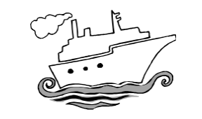
- Start with an open discussion on:
  - Why do people get into relationships or why do people have relationships?
  - What are the different types of relationships that young people find themselves in?

- List their responses on flipchart paper.

- Put up the picture of the ship that you prepared. Explain that just as there are certain things that keep a ship afloat and moving (calm seas, fuel, a solid body), there are certain things that keep relationships afloat.

- Ask for an example of something that is necessary for a strong or healthy relationship (for example, respect) and write it on the body of the ship.

- Then point out that there are certain things that can damage or ruin a relationship, just as stormy seas or a bad storm can sink a ship. Ask for an example (like dishonesty) and write it in the water beneath the ship.

- Divide the participants into five groups and give each group one of the flipchart papers you prepared with the headings: Peers, Work colleagues, Romantic or Sexual partners, Family and Community.

- Tell participants that they have 15-20 minutes to do the following:

  - Identify at least 5 things that help make their particular type of relationship strong.
  - Identify at least 5 things that could damage or destroy the relationship.

- When all the groups are finished, ask one of the participants from each group to present what they have written. Once all the groups have presented, ask them to compare: what similarities do they see? What differences are there?

- Ask them the following questions to generate a discussion:
  - What do you notice about the positive things listed for the different types of relationships? (Answer: Most relationships have similar positive things listed, such as communication, love, kindness, honesty and respect.)
  - What do you notice about the negative things?
(Answer: Again, there are many similar things such as lying, saying hurtful things, and failing to do what one has promised.)
  - Which qualities do you think are the most important in a relationship? Why? How can you show [that quality] in a relationship?
  - Which qualities do you think are the most difficult to find in a relationship? Why? If no one mentions equality, then use the facilitator’s information (below)

SUMMARIZE
- Respect and communication are important for building good relationships.
- We need to be honest with each other. We need to tell each other when things are going right and when we are unhappy about something.
- Sharing power in relationships is necessary. If one person has power over the other, the relationship is actually based on a lack of respect for the person with less power.
- No two people are the same. Being different doesn’t make one person right and the other wrong. We need to understand our differences and compromise for relationships to be successful.

Everyone deserves good relationships. The best relationships result when both people work hard at communicating, understanding each other, and showing respect. We need to keep working at those relationships that are important to us.
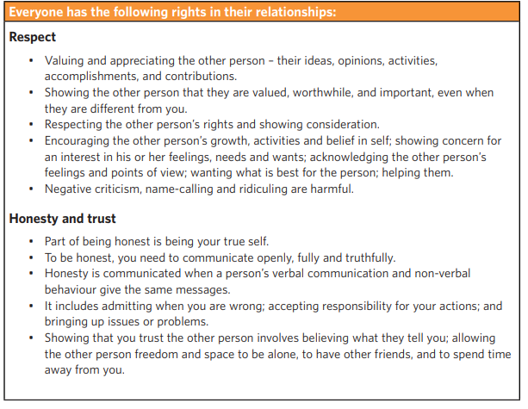
Facilitator’s Information

Communication

Humans communicate both through using words and through their actions, gestures, facial expressions and other body language.

Listening carefully to what the other person says without judging and accepting their feelings, even when we don't agree with them, is an important part of communicating respect and empathy.

In healthy relationships, there is a balance between talking and listening.

Empathy and understanding

Having empathy means trying to understand the other person's position and feelings - trying to put yourself in their shoes, see the situations from their point of view, and understand why they feel the way that they do.

This shows a deeper understanding, particularly if communicated back to the other person using different words.

Understanding someone does not mean that you agree with them.

Sharing power

Sharing power means that you have 'power with' the other person rather than 'power over' them.

When you share power, you make decisions together; seek solutions to problems that both people agree with; are willing to compromise; have a balance of giving and receiving and try to share responsibilities and work equally.

Common values and attitudes

In successful relationships, the two people often have many shared or similar values. If your values about most things differ, you may often be in conflict.

Pressuring the other person to change their values may harm a relationship. If virginity before marriage is valued, for example, then pressure to become sexually active may damage the relationship.

C. MY LIFELONG JOURNEY
Body Changes
Session 3: Activity 1  Body Changes | Objective  - Understand physical, and emotional changes during adolescence in boys and girls. | Issues/Information  - Physical, and emotional changes during growing up why changes during adolescence happen, Exploring Feelings.
Time: 60 mins | Material required: A doll or a flipchart with a girl (character) drawn, Body Growth & Change poster for girls & boys | Power point, Discussion

1. Facilitator, to begin the session by posing this question:
- Does your body undergo changes, or does it remain the same as it was at birth?
- Record responses from participants.
2. Inform using participants’ responses-
- Sexual development is a lifelong process for everyone, as our bodies change constantly. Our bodies go through lots of changes that happen slowly over time.
- We might have some signs of puberty at an early age, while other changes show up years later.
- We can get pimples, not only on our faces but on our bodies too.
- The hair we have on our arms and legs may get thicker and darker, and we are likely to grow hair in new places: young men and women grow hair in their armpits and pubic areas, while young men also grow hair on their faces and chests.
- Stretch marks are common too, as a sign of our adult bodies taking shape.
- Physical changes, from body odours to growth spurts, are just part of our puberty story.

These visible changes are often our first sign of what is happening because we can see them, such as the changes to our external genitals during puberty. However, there are also invisible changes, with puberty also changing our internal reproductive organs.
- Our bodies are unique, so puberty is different for each one of us as we all go through puberty at our own pace.
- No matter how we feel about these changes in our body, we should remember that puberty is a normal part of growing up.
- It’s really useful to understand what is happening in our body when these changes affect us for the first time so that we can feel confident that these are just a normal part of our lives.
- As our bodies change, so do our desires and emotions – and that is part of the process, too.
- We may have all kinds of new feelings, like crushes and being sexually turned on.
- Some of us might worry about the size and shape of our breasts, penis, vulva, testicles, nipples, lips and so on.

LET US BEGIN BY UNDERSTANDING REPRODUCTIVE HEALTH
ACTIVITY 1:
Divide participants into three groups and provide each group with a different question from the list below:
- What do they understand by health?
- What do they understand by Mental Health?
- What do they understand by Reproductive health?
After the responses are received, explain and include the following:
HEALTH- Health has many definitions, but the simplest to understand is:
- Overall well-being of the body and mind.
- Absence of illness.
- Includes factors like feeling good physically, mentally, and emotionally.
- Being healthy means having enough energy to do daily activities.
- Having a positive outlook on life.
- Being able to cope with stress.
- It involves maintaining a balance in various aspects of life, including nutrition, physical activity, mental and emotional well-being, and social connections.
- Good health allows individuals to lead a satisfying and productive life.
MENTAL HEALTH- Mental health means how we feel and think. It's about managing stress, having good relationships, making wise choices, and handling life's challenges.
- Emotional Well-being.
- Stress Management.
- Positive Relationships.
- Self-Esteem: Feeling good about ourselves is important.
- Life's Enjoyment: It's not just about avoiding problems but also about enjoying life.
- Self-Care.
- Seeking Support: It's okay to ask for help when needed.

REPRODUCTIVE and SEXUAL HEALTH
- Reproductive and sexual health, in simple terms, involves taking care of everything related to our bodies, relationships, and choices regarding having children and engaging in sexual activities.

- It includes being informed about our bodies' changes, making decisions about family planning, and protecting ourselves and our partners from infections.

- Reproductive and sexual health is about feeling comfortable, informed, and respected in our relationships while making choices that are right for us.

- Broadly, Reproductive and sexual health includes education and awareness on-

  - Body Awareness: Understanding the changes in our bodies, especially during puberty.
  - Family Planning: Making choices about when and if to have children.
  - Protection and Safety: Taking measures to prevent unintended pregnancies and sexually transmitted infections (STIs).
  - Informed Decision-Making: Being knowledgeable about reproductive choices and sexual activities.
  - Respectful Relationships: Navigating relationships with respect for oneself and others.
  - Communication: Open and honest discussions about reproductive and sexual health with partners or trusted individuals.
  - Consent: Understanding and practicing mutual agreement and respect in intimate relationships.
  - Healthcare Access: Seeking medical advice or services for reproductive and sexual health concerns.
  - Empowerment: Feeling confident and informed to make decisions aligned with personal values and well-being.Top of Form

Understanding our Bodies: In Adolescence and Puberty
Session 3: Activity 2  Understanding our Bodies:  In Adolescence and Puberty | Objective  - To teach about private body parts to help participants understand the concept of privacy.  - To understand changes in male and female body during puberty.  Issues/Information  - Participants become more aware of their bodies.  - Participants understand the difference between girls and boys.
Time: 90 mins | Material required: Male & female body parts model, Outline of women & girls’ body for reference, Outline of men and boys’ body for reference.

ADOLESCENCE & PUBERTY

ACTIVITY 1: BODY MAPPING
To introduce participants in a very non-threatening way to the anatomy of the body and to encourage participants to feel comfortable talking about matters concerning their bodies, particularly the reproductive organs.

FACILITATOR’S DIRECTION:
- Let the participants sit in their respective groups formed earlier.
- Explain that we are going to share what we know about how our bodies function. Divide the larger group into two groups.
- Ask each group to draw an outline of a body on the flip chart of someone like them. The easiest way to do this is for a group member to lie down and for someone to draw around their body.
- Once the body outline has been drawn, ask the groups to add in the body parts that are
- visible
- covered by clothes.

- Ask groups to start with the outline of their own sex and to identify body parts they particularly like, then those which they dislike, or which make them feel embarrassed or uncomfortable and to say why.

FACILITATOR’S QUESTION:
- Ask participants the differences between girls and boys.
- Then ask using visual/tactile resources like anatomically correct dolls, picture books or printed images of a girl’s and boy’s body.
- Name each private part of the body.
For example, that is a penis. Boys have a penis.
- Help participants distinguish between private and public body parts.

Private Body Parts:
- An easy way to tell which body parts are private is that they are covered by underwear. It is important to know about private body parts to understand our bodies, take care of the body and naming body parts correctly.
- Private body parts need to be covered, especially when in public. (more than one person makes it public)

ACTIVITY: Begin by naming male & female private body parts. Give the worksheet to each participant and ask them to map the private body parts.
*You can use visual resources like the anatomically correct dolls to help teach private parts
*Anatomical human body model
*Model of female reproductive system

PRIVATE PARTS OF THE BODY
PRIVATE PARTS OF FEMALES | PRIVATE PARTS OF MALES
- Breasts  - Vulva- outside private body part  - Vagina- is on the inside of the body  - Bottoms (buttocks) | - Penis  - Testicles  - Bottom

Breasts: Women’s chest is called breasts and it can be in different shapes and sizes. Sometimes one breast is bigger than the other. On each breast is a nipple. This is a darker colour to the rest of the breast.

Pubic hair: Hair grows on different parts of the body in Puberty. Hair that grows around the vulva and testicles is called pubic hair. Hair grows under arms, on her legs and sometimes around women’s nipples and hair grows on men’s chest.

It is not OK for anyone else to touch private body parts without her permission.

ACTIVITY 3: Childhood to Puberty- Changes in our body
- Ask participants what changes they have seen in their body since they were 8-10 years old to now?
- Inform the participants that now we are going to talk about the changes that happen in our body during puberty.
- Divide the participants into two groups-name one group as ‘girls’ & other as ‘boys.’ Give each group a chart paper or a sheet out of the flip chart to note down their thoughts and discussions.
- Ask each group to write down the things that might be different for girls if they are in the girls' group and for boys if they're in the boys' group. This includes changes on the inside (like feelings and thoughts) and outside (like how they might act or what they enjoy). For instance, ask them to think about changes in choices, preferences, friendships, and anything else, not just the physical changes.

Facilitator Say: Our bodies go through a lot of changes during puberty. Some changes happen slowly, while others happen quickly. Everyone is different, so it is not easy to know exactly when puberty will start or which changes will come first. For girls, puberty might begin between 8 and 13 years old. For boys, it might start between 10 and 15 years.
PHYSICAL CHANGES
Changes for everybody:
- growth spurts in height and weight.
- increase in strength.
- increase in sweating and body odour.
- increase in oily skin and development of pimples.
- growth of pubic hair and underarm hair and thickening of the hair on the legs.

Changes for girls:
- hips grow wider.
- breast buds develop and eventually grow into breasts.
- discharge starts to come out of the vagina.
- periods, or menstruation, starts.

Changes for boys:
- shoulders and chest become broader.
- hair grows on the face and chest.
- voice breaks and becomes deeper.
- penis and testicles grow bigger.
- erections become more frequent and sometimes happen for no reason.
- wet dreams may start.
- some breast tissue may develop and feel tender. This usually goes away later in puberty.

EMOTIONAL CHANGES:

- Moods change quickly.
- Try to know self.
- Develop own Values.
- Start feeling sexual attraction.
- Feel embarrassed easily.
- Feel closer to friends than family.

SEXUAL REPRODUCTIVE SYSTEM

Male Sexual and Reproductive System
Session 3: Activity 3  Male Sexual and Reproductive System | Objective  - To discuss and understand the parts of the male sexual and reproductive systems and their functions. | Issues/Information  - Name the main internal and external parts of the male sexual and reproductive systems and it’s functions.
Time: 90 mins | Material required:  Poster: Sexual and Reproductive System, Models, etc.  *Take a printout of poster & worksheet: external organs given for activity. | Posters, activities & Discussion
Approach the topic with sensitivity, recognizing that participants may have diverse cultural, religious, or personal backgrounds that influence their perspectives.
ADAPTATION FOR Db:
- Use tactile models and diagrams that students can feel to understand the structure of male reproductive organs.
- Engage students in hands-on activities to explore the physical layout of reproductive organs using tactile materials.
- Incorporate movement and touch to help them understand the location and function of different parts.

Introduction by the facilitator
- Introduce this activity by reminding the group that in the last session they looked at the different changes adolescents go through during puberty. At puberty, adolescents also experience many sexual changes. These include the growth and development of the reproductive organs, and an increase in sexual feelings and desire.
- Reproductive organs start maturing during puberty. Girls begin to ovulate and menstruate and boys begin to reproduce sperm and ejaculate. We will explain it further in the sessions.
- Human beings are biologically capable of having children after reaching puberty. So, it is important to understand how the male and female reproductive organs work.

1: Male Reproductive System
Key Information:
Male Reproductive Organs: The reproductive organs (or ‘genitals’) are the parts of your body that are involved in sex and the process of reproduction.
- Reproductive organs consist of external and internal parts.
External Genitals Penis: The male sex organ through which urine and semen pass.
- When a man is sexually aroused, his penis becomes stiff (erection) and ejaculation of semen may occur.
- The tip is full of nerve endings and is therefore very sensitive.
- The penis increases in size after puberty.
- Penises are of different shapes, sizes and colours. The size of the penis has nothing to do with sexual pleasure.

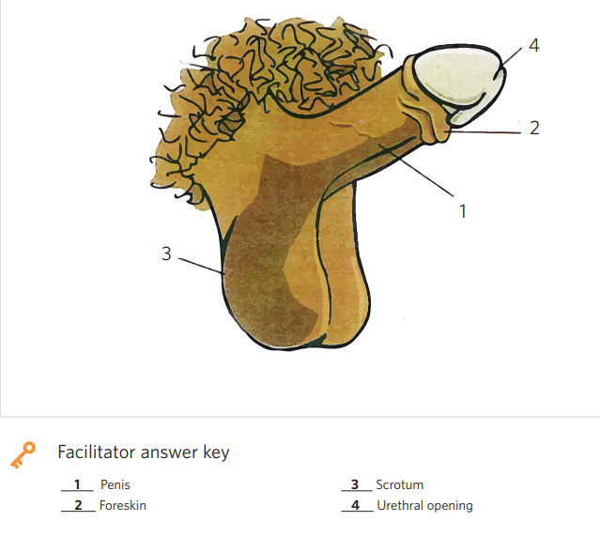
Scrotum: There is a bag of skin that hangs down behind the penis. This bag of skin is called the scrotum. Inside the scrotum are the testes. Some people call them balls because they feel like two balls inside the skin. Some people also call them testicles.

Testicles: The two male reproductive glands are located in the scrotum. They produce sperm and the male sex hormone testosterone. This hormone causes the changes of puberty. The testes are very delicate.
Anus and buttocks: Behind a man’s testes is his anus and buttocks. The anus is where faeces come out when they go to the toilet. Faeces is the correct word for ‘shit.’

Pubic hair: Hair grows on different parts of a man’s body. Hair that grows around his penis and anus and on his testes is called pubic hair. Male may also grow hair on their face, under their arms, and sometimes on their chest and back.

2. Private Body Parts and Private Parts
- Ask participants to name male private parts.
- The facilitator can present a list of visible body parts, including private areas, and encourage participants to identify which are private and which are visible body parts.

SUMMARIZE FOR PARTICIPANTS: A man’s penis, testes, anus, and buttocks are all his private body parts. Men and boys should keep their private body parts covered unless they are in a private place. It is OK for boys and men to look at their private body parts and to touch them as long as they do this in a private place. It is not OK for anyone else to touch a man’s private body parts without his permission.

ERECTIONS
Facilitator to inform participants that we are learning and discussing here is all natural and there should be no shame or embarrassment while talking about it and we all should see these discussions as life processes.
- An erection is when the penis gets hard and stands up.
- Boys can have erections from birth, but it happens more during puberty.
- An erection occurs when the penis fills with blood and becomes hard and straight because a boy or man is sexually excited.
- Erections can happen when boys fantasize and think about sexual things, or sometimes for no reason at all.
- Males do not have any control over when this will happen. It is very common for boys to wake up with an erection in the morning.
- Having erections is not a sign that a boy needs to have sex.
FACILITATOR TO HIGHLIGHT: WAYS TO BEHAVE IN PUBLIC
Sometimes erections can happen when you are in public. They might feel embarrassed and want the erection to go away.

It is crucial and necessary to educate participants on how to handle situations where they experience an erection in a public setting. This involves providing guidance on appropriate actions, emphasizing discretion, and promoting self-awareness. Giving practical tips helps them feel more confident in these situations and teaches them to respond appropriately without feeling embarrassed.

- Divert your mind: You can quickly think about some food or your task at hand
- Tie a jacket around your waist
- Place a backpack or book on your lap
- Go to the washroom
Erections are private: It is important to know that erections are private. Sometimes it can feel good to touch an erect penis. Touching a penis is a private behaviour. It should only happen in a private place- within closed doors e.g. your own room, bathroom etc.
Facilitator to inform that we have discussed private and public parts. Now let’s understand what are public and private places.
A quick and simple rule to learn where private body parts should be covered is:
“Private behaviours involve private body parts and can only be done in a private place.”
A person’s own bedroom and the bathroom at home are private places.

3. Public & private places:
- Facilitator to ask participants what they understand by public place and private place.
- Accept responses from participants and elaborate its meaning using facilitator’s notes.
FACILITATOR’S NOTES:
Private places:
- A person’s own bedroom, bathroom, or toilet is a private place.
- Other people must ask your permission before entering your private place. You can choose to say yes or no.
- Private body parts can be uncovered and private behaviours can happen in a private place. The door and blinds or curtains must be closed.

Public places:
- Any place where other people can be around is a public place. These places are shared with other people.
- Anybody can use a public place, even if they need to buy a ticket or have an invitation to be there.
- Private body parts must be covered in public places.
- Private behaviour must not happen in public places.

Public and private places can look different depending on whether they are:
- In the home
- In the community

In the home, the private places are:
- Your bedroom
- The bathroom/toilet

Public places in the home are the:
- Living room
- Kitchen
- Backyard
- Other people’s bedrooms
- Any other place in the home

These places are public because anybody can be there and you cannot control who comes and goes from the place. In the home, this might be siblings, parents and other visitors.

GROUP WORK FOR THIS SESSION:
- Divide the group into smaller groups of three or four. Give each group a copy of the worksheet of the external Male Reproductive System. Attached as Annexure 1 in resources at the end of the manual.
- Ask the groups to label the different parts of the reproductive system by matching the names on the worksheet to the corresponding body parts.
**Note: Instead of breaking into small groups, you can use the flipchart to conduct this activity with the whole group.
- 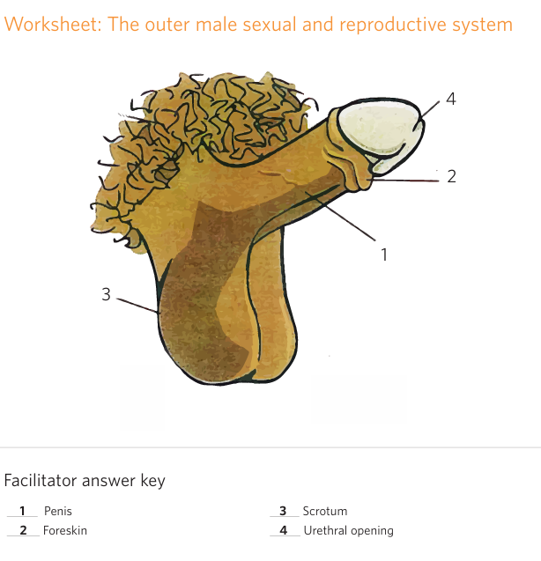 After they have finished labelling the parts, use the flipchart to correctly identify the male reproductive organs. Ask the groups what other names they know for the different sexual parts (for example, for penis, testicles, etc.).

The Female Sexual and Reproductive System
Session 3: Activity 4  The Female Sexual and Reproductive System | Objective  - To discuss and understand the parts of the female sexual and reproductive systems and it’s functions. | Issues/Information  - Name the main internal and external parts of the female sexual and reproductive systems and it’s functions.
Time: 90 mins | Material required:  Poster: Female Sexual and Reproductive System, External & Internal  *Take a printout of poster & worksheet: external & internal organs given for activity. | Posters, activities & Discussion

FACILITATOR ASSESSMENT: * Please assess participants' existing knowledge and determine whether they require basic information on external organs such as the vulva, vagina, urethra, and anus, with specific attention to the three openings.
Assessment questions:
- Name the part of a girl’s body from where the urine comes out- vagina or urethra.
- Can you name any part of the private area on a girl?
- Where does a baby come out when a woman gives birth?
- What's the name of the place where a girl's period comes from?

In case the majority of participants are clueless about the external organs of the female reproductive system, then the facilitator must begin by defining them.
- Facilitator to explain the EXTERNAL FEMALE SEXUAL & REPRODUCTIVE SYSTEM- Give information
A woman’s vulva
The vulva is the part between the tops of a woman’s legs. The vulva is made up of two large and two small lips of skin.
  - These lips are called the labia. The labia cover two holes, or openings, called the vagina and the urethra.
  - Vagina: When a woman has her period, the blood comes out of her vagina opening each month for a few days. We will talk about Periods or Mensuration. A woman can have intercourse with her vagina. If a woman is having a baby, the baby will usually come out of her vagina when it is being born.
  - Urethra: Sometimes people think the vagina is where urine comes out of a woman’s body when she goes to the toilet, but the urine comes out of a different hole called the urethra. The urethra is the small hole above the opening to the vagina.
  - Clitoris is the small organ, shaped like a flower bud, at the top of the inner lips, above the urethral opening.
  - Anus and buttocks: Behind a woman’s vulva is her anus and buttocks. The anus is where faeces come out when she goes to the toilet. Faeces is the correct word for ‘poo’.
  - Mons pubis is the pad of skin and fat over the pubic bone. It protects the internal sexual and reproductive organs. It becomes covered with pubic hair in puberty.

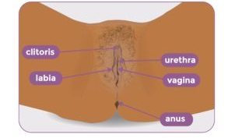

GROUP WORK

- Divide participants into groups of four or five.
- Take a printout of the given picture- attached as Annexure 2-worksheet on external organs of women.
- In their groups, they should discuss the words listed on the worksheet and label the parts on the picture.
- Put up the poster of the external female sexual and reproductive systems (showing the external parts).
- Go through the answers by pointing to each body part and asking the following two questions for each one.
  - What is this part called?
  - What is its purpose?

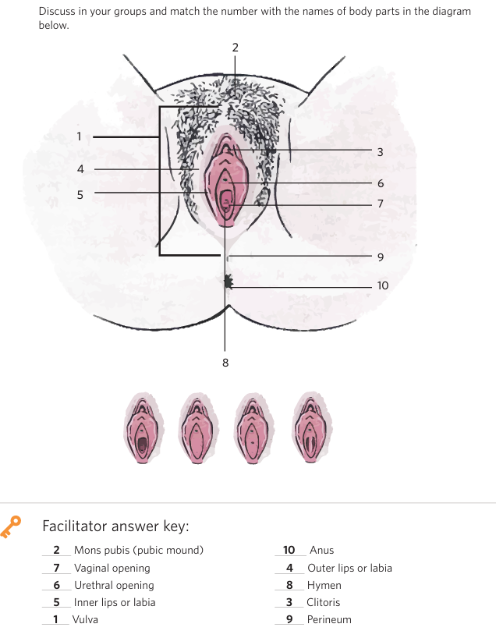

INTERNAL FEMALE SEXUAL & REPRODUCTIVE SYSTEM

Facilitator’s opening remarks:
We should talk about and understand how our private parts work to stay healthy and be safe from things that might hurt us. These parts are like any other body parts, and it's okay to discuss them without feeling shy. We can use whatever names make us comfortable, as long as we all know what we're talking about. Learning the English words for these parts helps us communicate with doctors if we ever need to. Now, let's explore the inside of our bodies.

- The woman’s sexual and reproductive organs are located inside and outside her body.
- The uterus is where a fertilized egg grows into a baby.
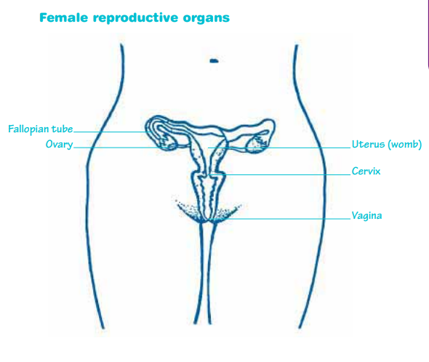
Name and what it is | What it does
Vagina:  A tube inside the body that has a very small opening into the uterus and opens between the legs. | - Penis goes inside the vagina during sex and puts sperm into the vagina.  - Babies come out through it at birth.  - Menstrual blood leaves the body through it.  - The vagina is separate from the anus, the hole through which faeces come and the Urethra from where urine comes out.
Uterus or womb Bag at the top end of the vagina. | - Every month the womb prepares itself for a baby by making a thick lining. If there is no baby, the womb throws away the lining when the girl has her period.  - The baby grows in the womb during pregnancy.
Fallopian tubes:  Two tubes connecting the ovaries to the womb. | - One egg travels along the tube from the ovary to the womb each month.
Ovaries:  Two sacks on each side of the womb. | - Store about 300,000 eggs and take it in turns to send one each month to the womb.
OVA: Eggs Tiny cells inside the woman’s ovaries. | - After sex, an egg joins with sperm at fertilization to make a baby.
Cervix:  An organ that surrounds the opening from the vagina to the uterus. | - Cervix allows the passage of blood (menstrual flow) from uterus to the vagina.  - During childbirth it dilates to allow the baby to pass through.  - Cervix produces mucus that serves as a barrier to prevent infections from entering the uterus.

GROUP WORK

- Divide participants into groups of four or five.
- Take a printout of the given picture- internal female system is also attached as Annexure 5 in the resources.
- In their groups, they should discuss the words listed on the worksheet and label the parts on the picture.
- Go through the answers by pointing to each body part and asking the following two questions for each one.
  - What is this part called?
  - What is its purpose?
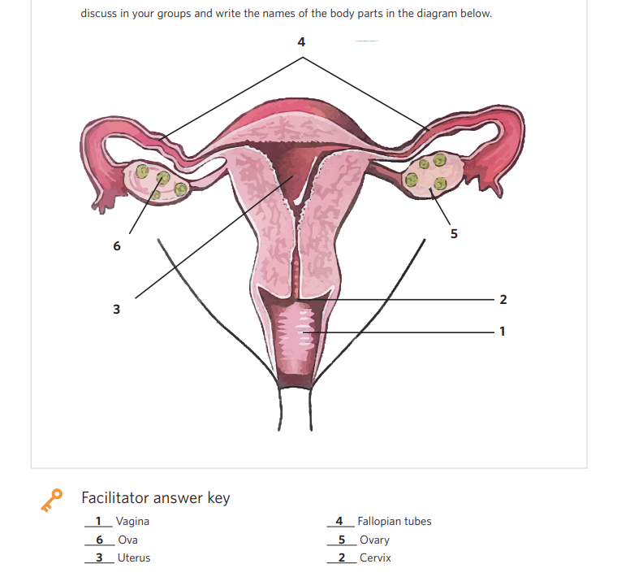
- Ask participants to summarize what they learned during the activity. Add any of the following points that are not mentioned.
- The woman’s sexual and reproductive organs are located inside and outside her body.
- The uterus is where a fertilized egg grows into a baby.
- The clitoris is the only organ in both men and women whose only function is sexual pleasure.

Linking sentence to the next activity: To understand how this reproductive system works to have babies, it is important that we understand menstruation and the menstrual cycle can also help us to avoid unintended pregnancies and to get pregnant when we want to.
MENSTRUATION
Session 3: Activity 5  Menstruation | Objective  - To increase participants’ knowledge about how pregnancy occurs. | Issues/Information  - Name the main internal and external parts of the female sexual and reproductive systems and their functions.
Time: 60 minutes | Materials required- flipchart and markers

- Write the word ‘menstruation’ on flipchart paper. Ask participants: What is menstruation?
(Answer: The breaking down of the lining of the uterus.)
- Tell participants that it is important to know the truth about menstruation and that we will now look at some facts.
- Menarche: The onset of puberty, when the girl has her first period, is known as Menarche. Menarche may take place between 9-16 years of age. During this period, most girls observe bleeding for the first time from the vagina. This bleeding becomes a periodic occurrence in a girl’s life with the cycle of bleeding observed in a gap of 28-40 days.

- Introduce the topic by saying: “If you were to put a baby on a concrete floor, would you just leave it on the naked floor or put a cushion or mattress there before putting the baby on it?
Yes! You would definitely put it on something soft. Similarly, inside the body, when a baby is made, the female body also ensures that there are enough cushions to keep the baby in comfort, that there is warmth and that the baby gets good food.

- How do you think the body provides that cushion?
It makes its own by using blood and some of the body tissues. Let us see how the body does this.

- Girls have thousands of eggs in their ovaries when they are born.
- Every month, or about once in 21-40 days, one of the eggs leaves one of the ovaries, and travels through a fallopian tube. When the egg leaves the ovary, this is called ovulation.
- As the egg travels in the fallopian tube, a spongy lining gets formed within the uterus. This lining is mostly made of tiny blood vessels.
- In case an egg and sperm meet to form an embryo, or a baby, that begins to grow in the uterus and the lining will provide the nutrition.
- If the egg is not joined by a sperm, the lining of the uterus begins to break. The blood that is released from the broken lining, flows out of the vagina. This bleeding is the menstrual period. This whole cycle is called menstruation.

Facilitator to highlight
- When a girl reaches puberty, the body and mind begin to prepare for the formation and storage of a baby. That is the sole purpose of the reproductive system.
- There are many myths and cultural beliefs about menstruation.
- It is important for both boys and girls to know about menstruation because the menstrual cycle is a normal part of reproductive development.
SUMMARIZE: Menstruation, or periods, marks the beginning of puberty in girls. Menstruation is when the lining of the uterus breaks down and flows out of the vagina in the form of blood. When a girl begins to menstruate, it means that she is capable of getting pregnant and having a baby. Young girls’ periods may be irregular at first, but eventually, they will occur once a month. During menstruation, a girl may have pain in the tummy. This is called period pain.

- Once a month, an egg is released from one of the ovaries and travels towards the girl’s uterus. This is called ovulation.
- At this time, the uterus gets ready by making a soft lining, or cushion, for a baby to grow — by using blood and some of the body tissues.
- If the egg does not meet with a boy’s sperm cell, the uterus sheds this lining.
- The girl’s body has to get rid of the product from the lining. This comes out of the girl’s body through the vagina as a dribble of blood that lasts a few days (3 – 7 days).

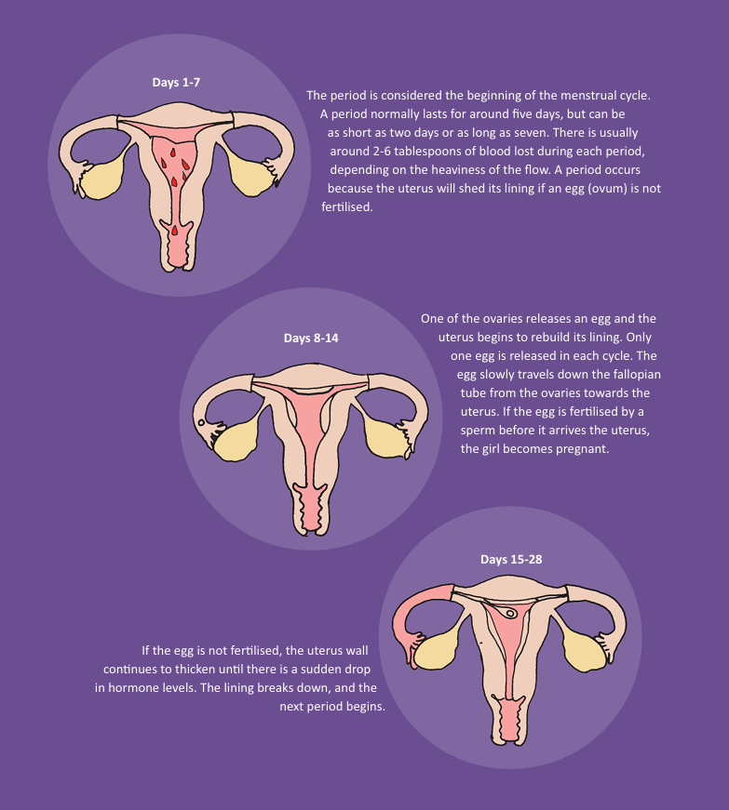
MASTURBATION: Engaging in personal sexual activity. Talking about masturbation can be embarrassing, but it is a natural process and it’s important to talk about it.

- Facilitator can begin by saying that boys or girls start touching and playing with their private body parts when they are very young. They might touch their private body parts because it feels nice.
  - As children grow older, they might start touching their private body parts for sexual reasons. This is called masturbation.
  - Masturbation is a normal part of growing up, just like growing pubic hair or getting acne.
  - Masturbation is a safe activity with practically no risks associated with it. There is no risk of sexually transmitted infections (STIs) or unplanned pregnancy from masturbating on your own.
  - Masturbation can help a person to know what feels good for them and to become familiar with their private body parts.
Masturbation is a normal part of growing up.
It can help a person to:
  - know their body
  - know what feels good for them
  - be comfortable with their body

If your child is familiar with how their private body parts look and feel, it can help them to notice if there are any changes that they might need to talk to a doctor about.
Learning to control and understand one's sexual desires and impulses: Talking about masturbation is also private, as it involves talking about private body parts and private behaviours. It is important to have conversations about masturbation in a place that is private and where the conversation cannot be overheard by people. It is important to understand and regulate one's own sexual desires and impulses related to masturbation. This might involve developing a healthy approach, recognizing personal boundaries, and ensuring that the activity is in line with one's values and well-being. It should not hamper one’s day-to-day activity. Touching private parts of the body, is private and should be done in a private space. Masturbation should be carried out in personal spaces like own bedroom (alone, not in front of siblings, or parents, or a friend) or in the bathroom.

Conception & Pregnancy
Session 3: Activity 6  Conception & Pregnancy | Objective  - To increase participants’ knowledge about how pregnancy occurs. | Issues/Information  - Understand the conception process.
Time: 60 mins | Material required: flipcharts and markers | Posters, activities & Discussion

Introduction:
- Introduce the session by reminding the participants about the information covered in the previous sessions on the sexual changes during puberty and the menstrual cycle.
- Remind them that after reaching puberty, boys and girls become physically capable of having children.
- Ask participants what they understand by Pregnancy?
- Record their responses.
- Ask participants what comes to their mind when you say conception? Record their responses.
- Ask the group what they know or have heard about how babies are born.
- Write their answers on the board. There may be many myths and misinformation about pregnancy. Highlight misconceptions to be discussed.
- Explain that it is important for them to know how conception takes place, so they can prevent unwanted pregnancy and make informed choices about their sexual behaviour.
Pregnancy is the period between conception, when the baby is made, and birth. Conception is when a male sperm and female egg meet in the fallopian tube and the sperm fertilizes the egg. This happens after sexual intercourse.
- Use Key Information to explain the process of how conception occurs.
- Ask participants if they know about fertilization? They could know basic use in Agriculture.
In agriculture, fertilization refers to the process of providing plants with essential nutrients to promote their growth and development. Taking a cue from here, explain the meaning of fertilization.
In both cases, fertilization involves the coming together of elements for growth. In human reproduction, it is the fusion of genetic material from both parents to form a new life. In agriculture, it is the addition of nutrients to the soil to support the growth and development of plants.

Key Information:
Explain Fertilization: During sexual intercourse, the male’s penis is inserted into the woman’s vagina.
- When a male and a female have intercourse, as many as 400 million sperm are ejaculated from the penis into the vagina.
- The ejaculated sperm swim up through the vagina, into the uterus and through the fallopian tube seeking an egg.
- If a mature egg is present, fertilization of the egg by a sperm can take place. Fertilization occurs when a sperm penetrates an egg. Although millions of sperm may be present, only one sperm can fertilize the egg.
- The fertilized egg moves through the fallopian tube and implants itself in the uterus, where the foetus will grow. If the egg is not fertilized, menstruation will occur.
Facilitator to build on the concept of conception:
- Conception occurs when the fertilized egg implants itself in the lining of the uterus.
- Once the egg implants in the uterus, it develops into an embryo.
- When this occurs, a woman is said to be pregnant.
How pregnancy happens:
- Once every menstrual cycle, one ovary releases an egg (ovulation).
- If the woman has unprotected sex at this time or in the five days immediately before it, she may become pregnant.
- Once the mature egg leaves the ovary, it begins to travel down the fallopian tube towards the uterus. It only lives up to 24 hours.
- After the man ejaculates semen into the woman’s vagina, the sperm contained in the semen begin to swim towards the egg. They swim up through the cervix, into the uterus and then into the fallopian tubes. The fastest sperm can reach the egg within 30 minutes of ejaculation.
- If the sperm find the egg, one of them may enter it. This joining of sperm and egg is called fertilization.
- The fertilized egg then begins dividing its cells as it travels down the fallopian tube to the uterus. When it reaches the uterus, it attaches itself to the lining. This is called implantation.
- Once implantation has happened, the woman is pregnant.
- If the couple has unprotected sex, but the man does not ejaculate, some sperm may still enter the vagina in the pre-ejaculate.
- The pre-ejaculate or pre-cum is the small amount of fluid that comes out of the penis before ejaculation.

Summarize the entire process:
- An egg is released by the OVARY, about the middle of the menstrual cycle.
- The egg gets drawn into the fallopian tube.
- Many sperm travel (swim) to the top of the uterus and into the fallopian tubes.
- Only one lucky sperm joins with the egg. This is known as FERTILIZATION.
- The sperm will penetrate the egg head first until it is inside the egg.
- The two, which are now one, start dividing to form a ZYGOTE.
- While the fertilized egg is subdividing, it moves slowly down to the uterus.
- Six or seven days after fertilization, the zygote reaches the uterus and implants itself in the uterine wall.
- This zygote further divides to form an EMBRYO.
Linking Sentence for the facilitator: When we desire to have a baby or start a family, it's crucial to have an open discussion with our partner. Planning for pregnancy should only occur when both partners feel prepared to take on the responsibilities. Now, let's explore different methods of family planning.

Family Planning- Contraceptives
Session 3: Activity 7  Family Planning- Contraceptives | Objective  - To increase participants’ knowledge about how pregnancy can be avoided and safe sexual behaviours. | Issues/Information  - Understand types of contraceptives.
Time: 60 mins | Materials required- contraceptives | Posters, activities & Discussion

Preparation before the session- facilitator to collect available contraceptives- male condoms, contraceptive pills, Copper-T, etc., what is available.
Family Planning Methods
  - Ask the participants what they understand by family planning.
  - Family planning means working out a plan, preferably with your partner, on how you want to deal with your sexual life. This covers things as varied as when and why to get pregnant, the number of children that are wanted, how to deal with fertility issues, how to avoid getting pregnant, whether to consider an abortion or adoption if an unwanted pregnancy occurs, etc.
  - Facilitator to explain the following types of Contraceptive Measures to the participants
    - Male Condom - A condom is a latex sheath, which is rolled onto the erect penis before sexual intercourse. It averts pregnancy by preventing semen that contains sperm from entering into the vagina. The condom not only prevents pregnancy but also protects the sexual partners from sexually transmitted infections/HIV and thus has a dual advantage.
    - Combined Oral Contraceptive Pills for Women - It prevents ovulation, hence a woman who takes oral pills regularly does not conceive. Proper follow-up and periodical check-ups are necessary for women using oral contraceptives.
    - Intra-Uterine Contraceptive Device (IUCD/IUD/Copper-T) - It is a small flexible object (made of plastic and copper) about one and a half inches in length. It is inserted into the woman’s uterus by a doctor or a trained health worker. It prevents pregnancy by preventing the implantation of the fertilized ovum.
Permanent Methods
- Female Sterilisation (Tubectomy) – The fallopian tubes are cut and the ends are tied. In the case of laparoscopic sterilisation, the tubes are blocked with the help of rings. This prevents the sperm from meeting the egg.
- Male Sterilisation (Vasectomy) - The Vas Deferens is cut and tied or blocked so that sperm cannot be released into the semen.
- Emergency Contraceptive: In case of unprotected sex, emergency contraceptives can prevent pregnancy. Emergency Contraceptive Pills (ECPs) are to be taken within 72 hours of unprotected sex. However, use of ECPs should be avoided as a Contraceptive Method on a regular basis.

Facilitator can close this unit here if needed, can demonstrate how to wear a condom on banana or model of penis. HIV/STIs can be mentioned: having multiple partners can be highlighted as a major cause of STIs.

D. GENDER ROLES & EQUALITY
In this session, we will focus on what gender is and to distinguish between sex and gender. The session also challenges the participants to examine how gender roles limit both girls and boys, to consider what they want to see changed about gender, and see how gender stereotypes affect personal development and relationships. We will also understand personal values about gender roles and equality.

If I were, I would
Session 4: Activity 1  If I were, I would | Objective  - To understand what they like about being a member of their own sex.  - Explain what they would do if they were the opposite sex and why.  Issues/Information  - To start discussions about gender by finding out about the opposite sex and about gender roles using a fun activity.
Time: 30 mins | Material required: None

- Have the participants sit in a circle. Tell them that you are going to read them a sentence that they will complete, one at a time, going around the circle.
- Ask for a volunteer to start. Then read the first sentence stem: ‘My favourite thing about being a woman is…’ or ‘My favourite thing about being a man is…’ Have each person answer.
- Then read the second sentence stem: ‘If I were a woman (or man) for one day, I would…’ Have each person answer.
- Then ask the group as a whole:
  - What did you notice about the young women’s answers to the first question?
  - What about the young men’s answers?
  - What did you notice about the young men’s answers to the second question?
  - What about the young women’s answers?
  - What did you learn about gender roles from this exercise?

- Facilitator to pose the final question: What did the group learn about gender roles from this exercise? Encourage participants to reflect on any stereotypes or expectations that surfaced and how individual perspectives may challenge or reinforce them.

FACILITATOR’S DEBRIEF- This activity helps you understand your own perspectives on gender and the experiences associated with being a woman or a man. This also reinforces gender stereotypes as you reflect on your imaginative experiences if you were the opposite gender for a day.

Experiencing a Power Imbalance
Session 4: Activity 2  Experiencing a Power Imbalance | Objective  - To recognize the need for equality among people, society and in relationships.  Issues/Information  - To demonstrate the effects of one group having ‘power over’ another on achieving a goal; and to experience the effects of ‘power with’ or working together equally to achieve a goal.
Time: 60 mins | Material required: Two chart papers, volunteers.

Preparation before activity by facilitator:
Write the following statement on a flipchart: ‘In our community, everybody is equal; no one has the right to use their power over another person.’ Set it aside and turn it upside down so that no one can read it.
- Facilitator will explain that in this next activity, participants will experience a power imbalance.
- Ask for five female volunteers and five male volunteers. (participants or interpreters)
- Tell the rest of the participants that they are members of the community.
- Put the three groups (1. Female, 2. Males and 3. Community) into their positions:
  - Ask the male volunteers to line up their chairs in the middle of the room and take a seat.
  - Ask the female volunteers to stand in front of a volunteer male participant, so that there are two lines facing each other and ten female-male pairs.
  - Ask the male participants to stand on their chairs facing their partners or they can stand at a higher place than females or females can be made to sit on the floor.
  - Ask the female participants to put their hands behind their backs. Explain that they must stay in this position.
  - Ask the community members to surround the pairs in a circle (big circle around all the volunteers) Then put a piece of paper and a pen or pencil in between each female/male pair, on the floor in front of the chairs.
*Adapt for Db/MD participants: put a toy that they can pick up or a glass or money.

- Ask Participants
  - Who are on the chairs, how do you feel standing on the chair? Male participants
  - Participants in front of the chairs, how do you feel standing before the person on the chair? Female participants.

- Facilitator to explain the activity:
    - For this activity, the participants standing on the chairs have more power than the participants standing/sitting in front of them on the floor.
    - For pairs to become equal, they have to draw a perfect circle in the middle on the paper between them. However, the partners must do this together with both partners holding the pen— not just one of them.
*Adapt to participants’ abilities- they can also put a bindi in the centre of the circle.
    - Participants on the chairs must remain standing and cannot squat or bend over. Participants on the floor have to keep their hands behind their backs.
    - Community members watch the activity inside the circle. Remain silent until you show them the flipchart with the statement on it. At that point, you will read the statement aloud to the pairs in the middle.
    - Ask if there are any questions and answer them. Then tell them to begin.

- After 1-2 minutes, ask the participants: Is this working? Are there any perfect circles? (There will be no perfect circles.)
- Tell the participants to switch roles – the females should stand on the chairs and the males on the floor with their hands behind their backs. Then tell them to try to do the same exercise. After another 1-2 minutes, ask the participants: Are there any perfect circles now? (There will still be no perfect circles.)

- Ask the pairs to switch again. When the males are back on the chairs, explain: The males have power over the females, but the community members think this is not right. Ask the community members to read the statement. Hold the flipchart with the statement high in the air so that everyone can see it: ‘In our community, everybody is equal; no one has the right to use their power over another person.’

- After the statement has been read, tell them that the community’s silence has been broken. Tell the females standing on the floor that their hands are free now. Tell them to try to do the same exercise again. Make sure no one cheats by squatting on their chair or bending over.

- After another 1-2 minutes, say: Things have improved, but there are still no perfect circles. Males, please balance your power with the females by getting down from the chair. Ask: Can there be perfect circles now?

- Allow participants to figure out how to draw the circle and then have them show their efforts to community members who can clap for them. Ask participants to return to their seats.

- Discuss the activity by asking the following questions:
  - How did the activity make you feel?
      - When you were on the chairs?
      - Those of you who were on the floor with your hands behind your backs?
      - Those of you who were community members?
  - How did you feel when you were able to switch places and have power over the other person?
  - Did it help you accomplish your goal?
  - Do men and boys worry that sharing power means they will lose their power? Does this happen? If both people have power, does it mean one person has less?

Explain that balancing power does not mean losing power because power does not come in limited supply. It is not a quantity; it is a feeling.
  - How did it feel to be equal?
  - How can we become more equal in our families and communities?
SUMMARIZE:
- When some people use their power over others, the two groups cannot work together well to reach their goals.
- The power imbalance between males and females is not healthy. It creates tension, struggle and resentment.
- Balancing power does not mean losing power because power does not come in limited supply. It is not a quantity; it is a feeling.
- Only when we speak out and reject the power imbalance between the sexes will the consequences of this imbalance on women and girls end.
- Men’s power over women, and our silence about it, allows the discrimination against women and girls to continue.

Linking sentence to next activity: If we want to achieve a healthy and just society and have healthy and just relationships, we need to change the power imbalance between the sexes, personally and in our community. In the next activities, we will learn more about gender, gender stereotypes and how they affect all of us.

Sex & Gender
Session 4: Activity 3  Sex & Gender | Objective  - To understand the difference between sex and gender.  Issues/Information  - Understanding Gender.
Time: 45 mins | Material required: Flipcharts, pen.

- Tell the participants that this session is about the difference between sex and gender.
- Ask the participants to form pairs with their neighbours and to discuss what they know about sex and gender.
- After 2 or 3 minutes, call their attention back to the front of the room. Ask them to share what they have discussed. Use their ideas to come up with a definition of ‘sex’ and of ‘gender’ similar to the following and write them on flipchart paper:

  - Sex is about the biology of being male or female. It is based on the biological differences between men and women.

  - Gender is what it means to be male or female in a specific society. It includes how we expect women and men to behave and what we think are masculine and feminine characteristics, abilities, responsibilities and opportunities.
Note that as long as you don’t use a sexual organ to do something, it is gender.
- Ask participants:
  - What biological differences between men and women do you know?
Answer: Men and women have:
        - different reproductive organs to have babies (for example, men have a penis, women have a vulva & vagina);
        - different chromosomes (women have XX chromosomes and men have XY chromosomes);
        - different dominant hormones (women have more oestrogen and progesterone, men have more testosterone).

  - What are gender roles?
Answer: Gender roles are the different roles (jobs, responsibilities, behaviours) that men and women are expected to do in a specific culture based on their sex.

- Explain that:
    - Sex is the same across the world in all cultures.
    - At birth, your sex is assigned to you based on your genitals.
    - Gender is cultural. What is expected of your gender varies by culture and changes over time.
    - Gender roles are learned as you grow up.

- To assess the participants’ understanding, tell participants that you will read some sentences and they should decide if it reflects sex or gender. If they think, the sentence is about gender, they should raise their hands. Ask those who raised their hands to explain why they think the sentence is about gender. Ask those who did not raise their hands to explain why they think the sentence is about sex. Use their responses to give them the correct answer-
    - Girls are gentle; boys are rough. (Gender)
    - Women give birth to children; men don’t. (Sex)
    - Women do most of the housework. (Gender)
    - Boys’ voices change a lot during puberty. (Sex)
    - Women should not make decisions independently. (Gender)
    - Men can only feed babies using bottles. (Sex)
    - It is important to have male children. (Gender)

- Ask participants:
    - What is another statement linked to sex?
    - What is another statement that shows gender?
    - Have gender roles changed over the last 20 years in your community? How?

- Tell participants that there are only three important differences between men and women. Ask them if they know what they are.
    - Only men can make women pregnant.
    - Only women can get pregnant and give birth to babies.
    - Only women can breastfeed.

SUMMARIZE:
- Sex is the biological state of being male or female. A person’s chromosomes, anatomy and hormones determine their sex. It is the same everywhere in the world and usually does not change.
- Gender is what it means to be male or female in a specific society, including how we expect women and men to behave and what we think are masculine and feminine characteristics, abilities, responsibilities, and opportunities. It is culturally determined; it varies across the world and changes over time.
- The only things that men cannot do are to give birth to a child and to breastfeed a child.
- A woman can do anything she decides to do, except make another woman pregnant.

Linking sentence: Knowing that gender is something that is created by society, that it varies from culture to culture and that it changes over time, we can realize that it is something that we can also work to change.

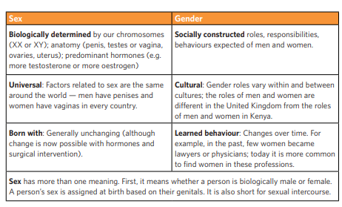

Sexuality- Diversity & Identify
Session 4: Activity 3  Sexuality- Diversity & Identify | Objective  - To understand SOGIESC concepts.  - To recognize different types of sexual identity.  Issues/Information  - Types of sexual orientation.
Time: 60 mins | Material required: Printouts- Genderbread and Metacards

By the end of this session, the participants should know of SOGIESC concepts – including LGBTQIA – and should be able to discuss about the same.

- Begin by talking about Sexuality, ask participants what they understand by it? Record responses.
- If participants are not actively answering, then ask true or false: for answer -true participants will give a thump up & for false it will be a thump down.
    - All people are sexual beings. (true)
    - Our sexuality does not include: our gender — male or female. (false)
    - Sexuality is a natural and healthy part of life. (true)
    - Sexual feelings, fantasies and desires are unnatural. (false)
    - Our sexuality is affected by the norms and values of the society and culture in which we live. (true)
    - Each individual has the right to express their sexuality in a positive, non-abusive way, and to make their own decisions about their sexuality. (true)
    - Sexuality is affected by being male or female and the messages we receive about our gender. (true)
- Explain and elaborate
- Sexuality is a multifaceted aspect of human identity that encompasses a person's feelings, behaviours, and attitudes related to their sexual experiences, desires, and relationships.
- It involves the way individuals express their sexuality, including their emotional, romantic, and sexual attractions, as well as their engagement in intimate relationships.
- Sexuality is a complex and personal aspect of human existence that can encompass a wide spectrum of orientations, expressions, and experiences.
- It involves both the biological aspects of sex and the broader social, cultural, and personal dimensions that shape an individual's sexual identity.

- Point out that sexuality refers not only to our sexual feelings. It is part of our personality and affects our relationships with other people.
- It is important to understand our sexuality, so that we can make good decisions about sexual behaviour and take care of our sexual and reproductive health.
- Sexuality also includes our sexual identity. This means the way we express our sexual feelings as men and women.
- Young people are often unsure about their sexual identity. They may have sexual feelings for someone of the opposite sex, for someone of the same sex, or sometimes for both sexes.
- Sexuality can be expressed in many different ways. (homosexual, heterosexual, Bi-sexual)
- Ask participants if they have heard about sexual orientation? Sexual orientation is about the sex that a person is romantically and physically attracted to– it can be the opposite sex (heterosexual), the same sex (homosexual) or both sexes (bisexual).

Activity: More Than Friends (30 minutes)
Facilitator says- Today we will talk about kinds of relationships. We will talk about relationships with partners, boyfriends, and girlfriends.
- Ask participants to prepare a list of what makes them attracted to someone. It can be about how he or she looks, how someone makes you feel, and what kind of personality they have. Write all their answers on paper.
Possible answers: funny, kind, sexy, look “hot’ in jeans, sweet, considerate, I just want to kiss them, can’t stop thinking about them.
- Facilitator shares that many of the things we want in a partner are the same as what we want in a friend. Now participants to use a different colour marker to circle the things/qualities- ones that are for boyfriends and girlfriends.
- After participants have finished writing. Discuss which one of these answers could happen in a friendship? Which ones are just for partners?

- These are the extra feelings we feel for this person. Sometimes people say that a sexual romantic relationship is a friendship plus more, these extra feelings. These extra feelings are physical or sexual attraction – like having feelings of attraction in our bodies when you look at someone. For some people, the extra feelings may not be about wanting to touch another person in a sexual way.
- What else might these feelings mean?
Possible answers: special connection, wanting to be with just that person, special names, or things you do together (this allows inclusion of relationships that are deep and loving and committed – but not necessarily sexual).
- For some, the extra feelings are sexual feelings. This is the type of relationship is the intimate relationship. Again, it always has to be consensual.

- Introduce the term "SOGIESC" stands for Sexual Orientation, Gender Identity, Gender Expression, and Sex Characteristics. It is an inclusive term that encompasses a range of aspects related to an individual's sexuality, gender, and physical characteristics.
- Sexual Orientation:
Explanation: Who we are attracted to romantically, emotionally, or sexually.
Example: Just like some people like boys, some people like girls, and some people like both. It's about who makes your heart feel happy.
- Gender Identity:
Explanation: How we feel inside about whether we are a boy, a girl, or something else.
Example: Imagine you have an inner feeling of being a boy or a girl, and sometimes it might not match what others see on the outside.
- Gender Expression:
Explanation: How we show our gender to others through our appearance, behaviour, and clothing.
Example: It's like the clothes you choose to wear, the way you do your hair, or the things you like, showing whether you feel more like a boy, a girl, or somewhere in between.
- Sex Characteristics:
Explanation: The physical features that make our bodies male, female, or intersex.
Example: Boys and girls might have different body parts, like how boys have Adam's apples, and girls may grow breasts. But sometimes, bodies can be a bit different, and that's okay too.

- Gender: The socially constructed roles, identities, attitudes, personality traits and behaviours that societies expect of males and females. It is a dynamic concept that changes over time and can be very different in different places and communities across the world. Gender is not the same as sex, which refers to biological differences.
- Gender identity: The way a person self-identifies as male, female, both or neither. It is different from a person’s biological sex.
- Sex: The biological characteristics that define humans as female or male.
- Sexual identity: How people identify themselves in terms of various aspects of their sexuality, including their sexual attractions, desires and expressions. Sexual identity is often closely linked to sexual orientation, but also includes how social and cultural factors influence the way a person chooses to self-identify.
- Sexual orientation: A person’s main preferences and sexual attraction towards other people, based on their sex or gender. This can include being straight, gay, lesbian or bisexual.
- Sexuality: How people experience and express themselves as sexual beings. It includes sexual behaviour, gender identities, gender roles, sexual orientation, eroticism, pleasure, intimacy and reproduction. However, these elements are not always experienced or expressed. Many biological, social, cultural, economic, environmental and contextual factors contribute to people’s sexual behaviours, relationships, feelings, identities, desires, and attitudes. Therefore, each person experiences and expresses his or her sexuality in a unique way.

- Explain this concept with genderbread person.

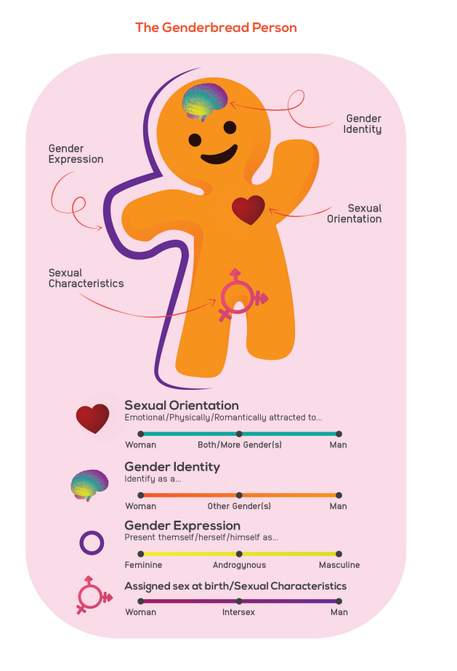

- Facilitator to ask participants if all terms are clear and can summarize following with the participants.

KEY LESSONS/MESSAGES

- A baby is not born a man or a woman.
When a baby is born, it is the doctor or the midwife who says: “It’s a boy!” or “It’s a girl!”. This is often based on what he/she sees (the external genitalia).
- Sex is different from gender.
Sex is what’s between your legs. Gender is what’s between your ears. (in brain/mind)
- Sex is based on characteristics that are biologically defined. (for example, the penis or the vagina). Meanwhile, gender is based on socially constructed features.
- Not all people identify with the sex they have at birth. This means that they have a different way of perceiving themselves. Because of this, they may also express or behave in ways that are not aligned with the sex assigned at birth.
- Gender expression is how a person expresses him or herself. It has nothing to do with sexual orientation or gender identity. For example, many societies assume that a woman should wear a skirt. But there are cultures where men also wear skirts. No culture is superior; so these differences in expression should be respected.
- Behaviour is different from identity. Just because a man wears a skirt, does not mean he is gay or transgender. Only a person can say what his or her gender identity is.
- Gender identity is how a person sees himself or herself. It is very personal. Respect self-identity. Also, respect the pronouns that go with the person’s identity - for example, if a person who was assigned male at birth now self-identifies as a woman (transgender woman), use the pronouns for women (she, her).

ACTIVITY: PIN THE GENDERBREAD PERSON

This activity will help participants identify the familiarity of the participants with SOGIESC concepts- GAY, LESBIAN, PENIS, VAGINA, FEMININE, MASCULINE, BI-SEXUAL, TRANSGENDER, INTERSEX, MALE & FEMALE.

  - Bisexual: An individual who is sexually and romantically attracted to both men and women. A bisexual person may feel equally attracted to both men and women or may feel more attraction to one sex, and this may change over time. Being bisexual does not mean that a person desires more than one sexual partner at a time.

  - Gay: A person who is romantically, physically or sexually attracted to people of their same gender. The term may also refer to people who identify as being a member of a gay community. Sometimes, the term is only used to refer to gay men, but other times it can be used to refer to both gay men and women.

  - Homosexual: A formal or clinical term that refers to someone who has sex with person(s) of the same sex. The term most often refers specifically to homosexual men, but sometimes it can also refer to lesbians or bisexual individuals.

  - Lesbian: A woman who is romantically, physically or sexually attracted only to other women, and self-identifies as being lesbian.

  - Transgender: A gender identity of someone who self-identifies as being a gender that is different from the gender assigned to him or her by society. The term also refers to people who appear or behave in a way that does not conform to dominant cultural norms.

  - Intersex: Intersex people are born with sex characteristics (including genitals, sex glands and chromosome patterns) that do not fit typical binary notions of male or female bodies. Intersex is an umbrella term used to describe a wide range of natural bodily variations. Being intersex relates to biological sex characteristics, and is distinct from a person's sexual orientation or gender identity. An intersex person may be straight, gay, lesbian, bisexual or asexual, and may identify as female, male, both or neither.

METACARDS
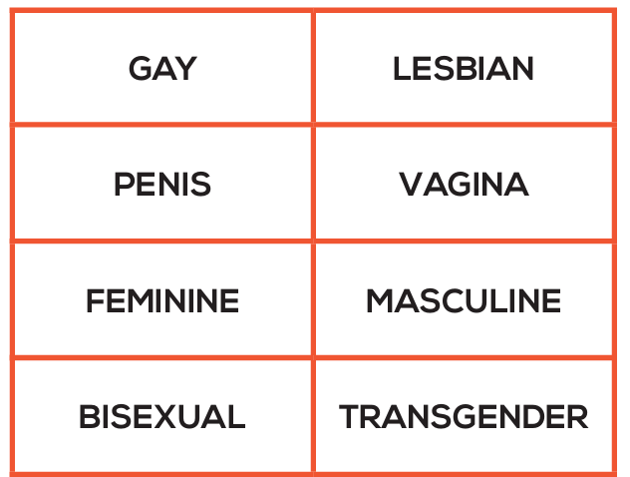



- Facilitator may cut these separately or write them on a flipchart.
- Participants can be divided in groups of four (1,2,3,4 or sitting proximity).
- Give printout of genderbread person given in Annexure 6 to the groups.
- Ask the participants to place where in the genderbread person they think the concepts (written on metacards- gay, lesbian, penis, etc.) should go?
- After the metacards have been placed on the genderbread person, ask the participants if they agree with their placement and give reasons.

Concluding remarks by the facilitator
During adolescence, teenagers may experience feelings of attraction to members of the same sex, and some may have intimate physical or sexual contact with friends of the same sex. This does not always mean that the person is gay. It may just be a phase of exploration and experimentation. Young people who are gay are often made to suffer a great deal by society. Their rights are frequently violated. We should seek to understand those who are different from us, to show tolerance, and to respect their human rights.

Facilitator can address any queries or questions and end the session with post-assessment test.

E. RESOURCES

Annexure 1: WORKSHEET: Outer/External Male Reproductive Organs
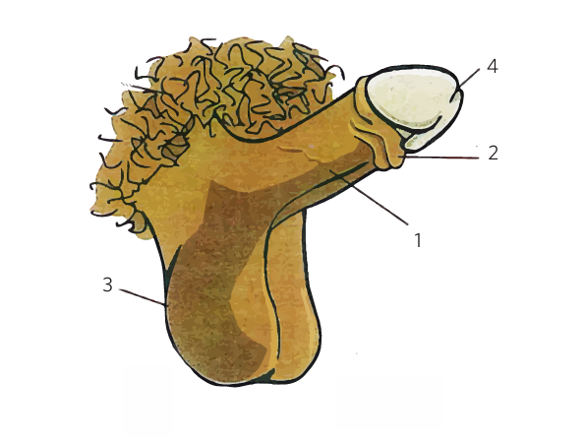

Annexure 2: External/Outer Parts of Female Sexual & Reproductive System
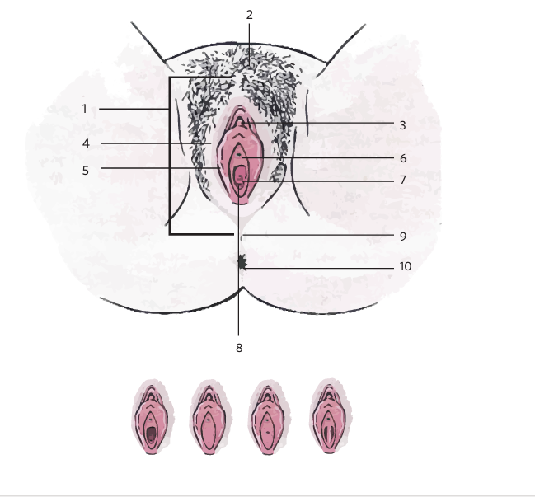

Annexure 3: Woman Body Mapping
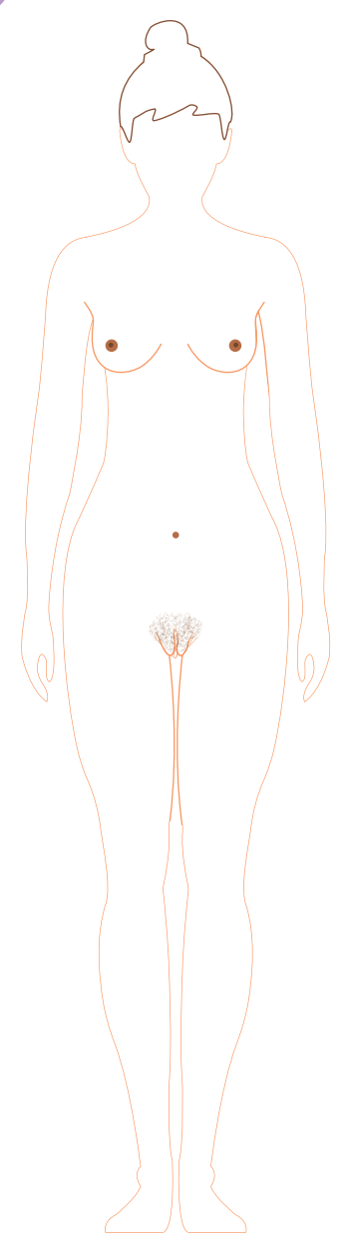

Annexure 4: Man Body Mapping
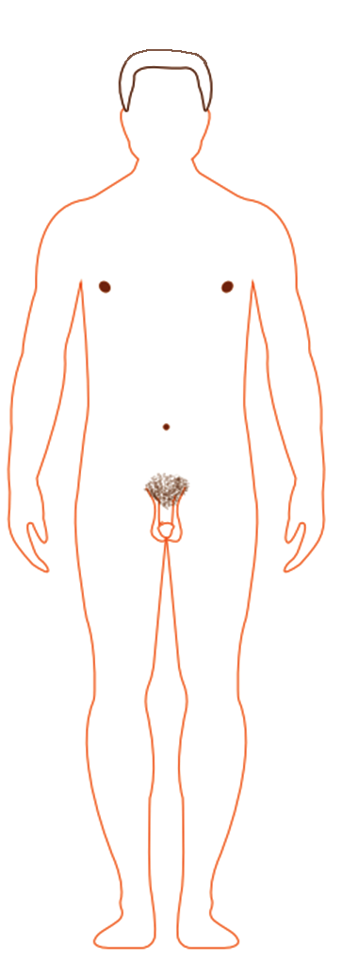

Annexure 5: Internal Reproductive System Women
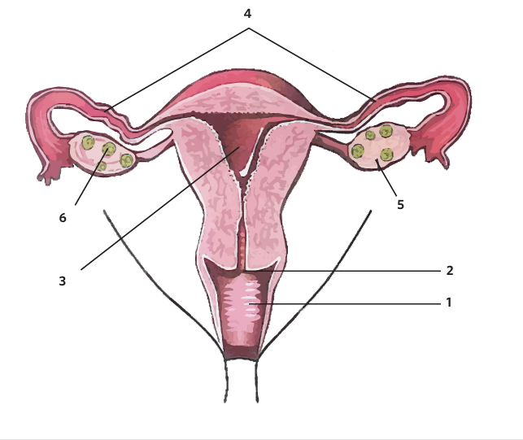

Annexure 6: Genderbread Person for activity

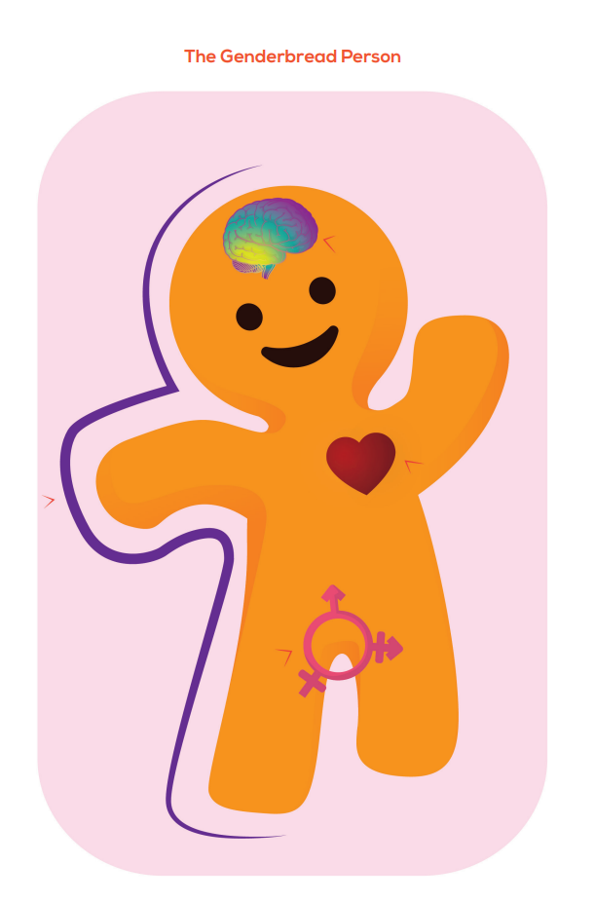

Comprehensive Evaluation Tool- For Adults with Deafblindness, and Multiple Disabilities

This assessment tool has been developed as per the Kirkpatrick assessment model and comprehensively evaluates learners' proficiency in applying, understanding, and recalling information covered during the training. This type of evaluation tool indicates a balanced approach to assessing participants' understanding and retention of the training content.
- Recall: This aspect of the model assesses the learners' ability to remember and recall specific information from the training. It assesses their memory retention and how well they can recall facts and details. In this questionnaire, 31% of the questions are based on the ‘recall’ aspect of the model.
- Understand: This aspect focuses on assessing learners' comprehension and understanding of the material and goes beyond mere memorization. This aspect also tests the comprehension level of the underlying principles and concepts covered in the training. It goes beyond rote memorization and assesses the depth of their knowledge. In this questionnaire, 31% of the questions are based on the ‘understand’ aspect of the model.
- Apply: The "Apply" aspect of the model evaluates learners' ability to apply their knowledge and skills to real-world situations and assesses their capability to use what they have learned. This aspect talks about the ability of the participants to transfer their learning to relevant situations in their everyday lives. In this questionnaire, 38% of the questions are based on the ‘apply’ aspect of the model.

Overall Implications of this evaluation tool:
Participants need not only to remember facts but also to understand the underlying concepts, and main ideas and use the knowledge gained effectively.
The evaluation tool is designed to measure a holistic understanding of the training material, with a focus on the practical application of skills acquired during the program.
Success (a score of 80% and above, especially in the "Understand & Apply" part) in this evaluation will suggest that the participants not only grasped the information but can also apply it in various contexts, showcasing a comprehensive understanding of the training content.
Note:
- When giving this tool to participants, please provide the content without including the titles and additional details mentioned before each question.
- You're welcome to decrease the number of questions in the format. If you choose to reduce the questions, it is recommended to do so from the recall section.

Q1- Respect– Recall
What is ‘Respect’ according to you?
- Blind obedience
- Blind respect for elders
- Standing up for one’s self and believing in one’s worth
- Automatically earned with age or authority
- All of the above

Q2- Personal Values & Gender– Understand
Considering what you've learned from your family, culture, religion, and friends about gender differences, which statement best reflects your understanding?
- Your take on gender roles is solely determined by your family values.
- Cultural influences have no impact on shaping your beliefs about gender.
- Religion is the primary source of understanding gender differences.
- Values about gender are often picked up by observing behaviour from various sources.
- Friends have the least influence on shaping our perceptions and understanding of gender roles.

Q3- Building Healthy Relationships– Understand
Anil is new to the college and has been paired with you to help get familiar with the campus. As you'll be graduating soon, you're eager to support Anil in making friends and positive connections. What actions can you take to help Anil build healthy relationships?
- Help him find people with common or shared values.
- Ask him to develop an art of listening or his listening power without judging the other person.
- Help him develop teamwork so that he can contribute effectively while working as a team.
- All of the above
- None of the above

Q4- Changes in the Body – Understand
In a class, there are students around 11-14 years old. Some look more grown-up, and others still look like children. Sunita is one of the students who seems to be growing more slowly than her friends.
Think about the story. What statement is false?

- Everyone grows up at the same speed during adolescence.
- Sunita might grow differently from her friends.
- People can grow at different rates.
- Everyone goes through similar changes during adolescence.
- None of the above.

Q5- Masturbation – Recall
Which of the following sentences is true about masturbation?
- Masturbation can cause unplanned pregnancy.
- In masturbation, there is a risk of getting sexually transmitted infections (STIs)
- Masturbation is a normal process and involves touching or stimulating your private body parts for sexual pleasure.
- Masturbation is bad for health.
- None of the above.

Q6- Masturbation – Apply
You overhear a conversation where someone is spreading myths and misinformation about masturbation, claiming it leads to serious health issues. How would you handle this situation?
- Join the conversation and support the misinformation to fit in.
- Correct the misinformation and focus on telling about its normalcy to those people.
- Ignore the conversation and avoid getting involved.
- Make jokes about the topic to lighten the mood.
- Share more exaggerated myths to contribute to the confusion.

Q7- Mensuration – Recall
Mensuration is a process …. (complete the sentence)
- Wherein the dirty blood leaves the body.
- Which lasts you your whole life.
- Which repeats itself roughly once a month.
- In which the body absorbs extra nutrients.
- None of the above.

Q8- Mensuration – Understand
What is the primary function of the periods/mensuration?
- To regulate body temperature
- To maintain kidney health
- To support reproductive health
- To control sleep patterns
- To enhance memory

Q9- Conception & Pregnancy – Recall
How does a girl get pregnant?
- When a boy touches or kisses a girl.
- When a boy and a girl use the same toilet.
- When a girl and a boy have unprotected sexual intercourse.
- When a boy and girl are in love.
- When a boy looks at a girl with lust when she is on her period.

Q10- Conception & Pregnancy – Apply
Your friend is considering engaging in sexual activity for the first time and is curious about contraception methods to prevent unintended pregnancies. They ask for your advice. What would be the most appropriate response to give your friend?
- Encourage your friend to avoid contraception as it might have side effects.
- Suggest they rely solely on luck to avoid pregnancy.
- Provide information on the use of condoms and contraceptive pills.
- Ask them to figure out by watching Bollywood movies.
- Ask them not to engage in sexual activity.

Q11- Pregnancy – Apply
During a gathering with your friends, one person says that only women are involved in the process of pregnancy, and men have no role in it. How would you respond?
- Politely nod in agreement to avoid conflict within the group.
- Tell them about how the pregnancy process is a shared responsibility of both men and women.
- Stay silent and let others handle the situation.
- Change the topic to steer away from the discussion on pregnancy.
- None of the above.

Q12- Family Planning- Contraceptives– Apply
Seema & Rohit married last month and decided to wait for at least 1-2 years before planning a baby. However, during their last sexual intercourse, they forgot to use a condom. What should the couple do now?
- Seema and Rohit should wait and see if Seema gets pregnant.
- Seema should immediately consider an abortion.
- Rohit should get a vasectomy.
- Seema should immediately start eating papaya and shift to a fruit diet.
- Seema and Rohit should consider using emergency contraceptive pills within 72 hours.

Q13- Gender– Recall
What does the term "gender" refer to?
- Biological differences between men and women.
- Socially constructed roles and responsibilities assigned to women and men.
- Inherited physical traits from our parents.
- Genetic factors influencing our physical features & behaviour.
- Economic disparities between men & women.
- Top of Form

- Bottom of Form

Q14- Gender– Understand
Which of the following sentences is true?
- Gender and gender biases limit both girls & boys.
- Gender and sex are the same thing.
- Gender roles impact only girls and women.
- Gender differences are necessary for a harmonious society.
- Gender stereotypes do not influence individuals and their behaviour.

Q15- Sexuality– Apply
Your parents are telling you jokes about your new neighbours, mocking their sexual orientation during dinner. What is the most appropriate action to take in this scenario?
- Join in on the jokes to align with your parents' opinions.
- Ignore the conversation and pretend you didn't hear it.
- Confront your parents and explain why mocking someone's sexual orientation is inappropriate.
- Share the jokes with your friends later and laugh over it.
- You cannot do anything in this situation as parents are always right.

Q16- Sexuality– Apply (extra question)
Your close friend confides in you about their struggle with understanding their sexual identity. They express fear of judgment from others. What would be the best way to support your friend?
- Disregard their concerns and advise them to keep it to themselves.
- Share their secret with others to get different opinions.
- Offer a listening ear, reassure them, and encourage them to seek support if needed.
- Mock their concerns to lighten the mood.
- Convince them to conform to societal norms to avoid judgment.

Answer Key:
1. c. 2. d. 3. d. 4. a. 5. c. 6. b.
7. c. 8. c. 9. c. 10. c. 11. b. 12. e.
13. b. 14. a. 15. c. 16. c.

References/work-cited/ Bibliography:
- National Council of Educational Research and Training (NCERT). (2005). Adolescence Education Programme Training Manual. Publisher: NCERT.
- UNESCO Health and Education Resource Centre. (2007). Our Future: Sexuality and Life Skills Education for Young People. International HIV/AIDS Alliance. https://healtheducationresources.unesco.org/library/documents/our-future-sexuality-and-life-skills-education-young-people-grades-6-7
- UNFPA. (2003). Adolescent Reproductive Health Training Manual. Copyright Secretariat of the Pacific Community.
- UNICEF. (2017). Adolescent Girls Toolkit 2017 https://www.unicef.org/media/73606/file/Adolescent-Girls-Toolkit-2017.pdf.pdf
- HSE Sexual Health and Crisis Pregnancy Programme. (2020). Busy Bodies- A booklet about puberty and adolescence for you and your parents (additional edits 2023).https://www.sexualwellbeing.ie/for-parents/busy-bodies-english-language.pdf
- Centre for Development and Population Activities. (2000). GENDER, REPRODUCTIVE HEALTH, AND ADVOCACY: A Trainer’s Manual.
- ICRW, 2014, Parivartan Activity Guide for Group Education Sessions, New Delhi: ICRW- https://assets.publishing.service.gov.uk/media/57a089c0ed915d622c0003a5/Parivartan-for-Girls-Facilitator-Guide.pdf
- Youthreach. (2009) Planning for Life project 'Samriddhi': Adolescent Reproductive Health & Life Skills Training Manual and Curriculum. Planning for Life: A Program of the International Youth Foundation and curriculum and aids developed by Thoughtshop Foundation, supported by USAID
- Norwegian Church Aid. (2022). Comprehensive Sexuality Education (CSE) Toolkit. Awiti, P., & Jura, C. (2022). Title of the Report. Edify Learning Forum Africa (ELFA) for Norwegian Church Aid. Retrieved from https://www.kirkensnodhjelp.no/globalassets/cse/comprehensive-sexuality-education-toolkit-trainers-manual.pdf
- https://www.unfpa.org/resources/adolescent-sexual-and-reproductive-health
- https://www.guttmacher.org/journals/ipsrh/2009/06/adolescent-sexual-and-reproductive-health-developing-countries-overview
- https://www.who.int/reproductivehealth/topics/adolescence/what-works-ASRHR/en/
- International Planned Parenthood Federation. (2011). Exclaim! Young People's Guide to 'Sexual Rights: An IPPF declaration'.
- "Tuko Pamoja: Adolescent reproductive health and life skills curriculum." Nairobi: PATH and Population Council, 2006.
- UNFPA. (2018). Regional Comprehensive Sexuality Education Resource Package for Out of School Young People. https://moldova.unfpa.org/sites/default/files/pub pdf/cse_facilitators_manual.pdf
- Y-PEER. (2020). SRHR Training Manual for Deaf and Hard of Hearing Young People- https://ypeerap.org/wp-content/uploads/2021/09/SRHR2021.pdf
- Ministry of Education and UNICEF.(2018). Growing Up Well for Girl https://www.unicef.org/maldives/reports/growing-well-girls
- Menstrual Hygiene Reading Material for ASHA NRHM. National Health Mission, Ministry of Health and Family Welfare, Government of India. https://www.nhm.gov.in/images/pdf/programmes/mhs/Training_Materials/PDF_English/reading_material.pdf
- International Planned Parenthood Federation. (2017). Training Manual for Sensitizing Intermediaries on Sexual Rights of Young People with Learning Disabilities. https://europe.ippf.org/sites/europe/files/2017-12/KMS%20training%20manual%20for%20intermediaries.pdf
- Plan International Kenya. (2019). Sexual Reproductive Health and Rights for Adolescents and Young People. https://plan-international.org/uploads/sites/26/2022/07/srhr_training_manual_1st_oct_2019_plan_kenya.pdf
- National Institute of Public Cooperation and Child Development (NIPCCD). (2011). Module on SABLA
- Ministry of Health and Family Welfare. Training Manual for Peer Educators under the Rashtriya Kishor Swasthya Karyakram.
- Planet Puberty is a digital resource suite by Family Planning NSW that aims to provide parents and carers of children with intellectual disability and/or autism spectrum disorder with the latest information, strategies and resources for supporting their child through puberty.
- Planet Puberty website and this is Funded by the Australian Government Department of Social Services. https://www.planetpuberty.org.au

