Copyright @2024

ISBN: 978-81-951593-8-3

Title: Training Manual on Sexual and Reproductive Health and Rights for Parents, Caregivers and Educators of Persons with Deafblindness and Multiple Disabilities

Author: Sense International India

First published in India in 2024
This book is published, produced, and distributed
by Sense International India.

Sense International India
2nd Floor, Admin Block
Andhjan Mandal Campus
Vastrapur, Ahmedabad 380 015
Tele: +91 79 26301282 Website: www.senseintindia.org.in
Email: info@senseintindia.org

All Rights Reserved
No part of this book may be reproduced or used in any form or by any means (graphics, electronic, mechanical, photocopying, recording, taping, web distribution, information storage and retrieval systems or otherwise) without prior written permission of the publisher.

Printed in India

  - FOREWORD
In pursuit of equality and dignity for all, it is imperative that we extend the principles of accessibility and empowerment to persons with disabilities including Persons with Deafblindness (PwDb) and Multiple Disabilities. Within this context, the publication in your hand represents a significant step forward in our collective endeavour to ensure that Parents, Caregivers and Educators can understand the need of sexual and reproductive health and rights (SRHR).
The journey towards inclusive SRHR practices for PwDb and multiple disabilities has been marked by numerous challenges, chief among them being the pervasive stigma and lack of awareness. Too often, adults with deafblindness and multiple disabilities are overlooked or marginalized when it comes to discussions and initiatives surrounding sexuality and reproductive health.
Yet, the fundamental principles enshrined in the Universal Declaration of Human Rights, as well as more recent legislative frameworks such as the Rights of Persons with Disabilities Act-2016, assert definitively that every individual, irrespective of disability, possesses the right to access comprehensive sexual and reproductive health information, services, and education without discrimination.
The "Training Manual on Sexual and Reproductive Health and Rights” serves as a testament to our commitment to holistic empowerment of PwDb and multiple disabilities. The manual is tailored for Parents, Caregivers & Educators. It presents a vital resource for promoting awareness, training methods, knowledge, and understanding of SRHR issues and the unique needs of PwDb and multiple disabilities with regards to sexuality.
Through this training manual, we have strived to break down barriers and foster a culture of inclusivity and empowerment by equipping parents, caregivers and special educators, with the necessary information and tools to navigate sensitive SRHR topics and to develop the skills to educate every PwDb and multiple disabilities with confidence and respect.
As we embark on this journey towards inclusive SRHR practices, let us remain resolute in our commitment to challenging societal norms, promoting awareness, and advocating for the rights of PwDb and multiple disabilities and disability as a whole. Together, let us strive to create a world where everyone, regardless of disability, can exercise their sexual and reproductive health and rights with dignity and autonomy.
To ensure that the contents of the module are adapted to the learner’s unique needs, we must identify core areas/themes considered by the professionals as crucial for achieving the final goal. Since the professionals working in this field are very heterogeneous in terms of their educational background, the module is developed in a flexible way, allowing adaptations to accommodate different levels of knowledge.
Akhil Paul
Founder Executive Director
Sense India

Acknowledgment for the “Training Manual on Sexual and Reproductive Health and Rights for Parents, Caregivers and Educators of Persons with Deafblindness and Multiple Disabilities”.
We extend our heartfelt gratitude to the numerous individuals and organizations whose unwavering support made the creation of the Training Manuals on Sexual and Reproductive Health & Rights (SRHR) possible. This endeavour would not have been successful without the collaborative efforts and contributions of a diverse group of people.
It is our hope that these resources contribute significantly to advancing the understanding and promotion of sexual and reproductive health and rights in PwDb and multiple disabilities, their caregivers and special educators.

First and foremost, we express our deepest appreciation to PwDb and multiple disabilities, their parents, family members, and special educators for the willingness to share their experiences and insights. Their unique perspectives have provided a valuable foundation for understanding the challenges and SRHR needs of PwDb and multiple disabilities.
We would like to acknowledge the wholehearted support of our partners in 24 states of India, which has enriched the content of this publication.
Special recognition goes to Mr. Sachin Rizal and Ms. Vruddhi Patel for their dedicated and constant efforts in developing the content of this training module. Their expertise and commitment to the cause have been crucial in structuring the material into coherent and comprehensive chapters.
We acknowledge the efforts of Mr. Uttam Kumar and Mr. Akhil Paul in enhancement of the script and their guidance for elevating overall quality and impact. The bulk of credit for this publication is due to the ungrudging efforts put in by the entire team of Sense International India.

Training Manual on Sexual & Reproductive Health and Rights for Parents, Caregivers & Educators of PwDb and Multiple Disabilities stands as a testament to the collective commitment of everyone involved.
We acknowledge the valuable contributions of Ms. Mercy Chingnunmuang, Mr. Rashmikant Mishra, Mr. Srinivasan Prasannan, Ms. Bhavika Shah and Ms. Shrutilata Singh. Special recognition goes to Mr. Shivkumar Sharma for his outstanding work in designing this training manual.
Finally, we extend our sincere thanks to Ms. Vina Lakhumalani and Ms. Viveka Chattopadhyay for their exceptional contributions to this SRHR Training Manual.

Table of Contents

GUIDELINES FOR FACILITATING THE TRAINING ON SRHR 5
A. INTRODUCTIONS
a. Icebreaker for Introduction-Zip Zap 8
b. Setting Ground Rules 9
c. Expectations of the Participant 10
d. Pre-Test 11
e. Why This Training (it’s importance) 13

B. COMMUNICATION FOR CHANGE
a. Icebreaker: Shapes 15
b. Communication skills: Just Listen! 16
c. Behaviour Change- Is doable 18
d. Rolling with Resistance 19
e. Perspective Swap 22

C. IMPORTANCE OF COMPREHENSIVE SEXUAL EDUCATION
a. Why Sexual Education 27
b. Identifying Body Parts 29
c. Please be Clear….. 33
d. What If’s (Emoji Exercise) 34
e. Participant's Own Experience with Sexuality 35
f. Stepping Back in Time 40
g. Four Corners 43
h. Messaging to Children 47

D. SEX & GENDER
a. Sex & Gender-Surface Activity 48
b. Picture Analysis 49
c. Fact or Buff 56
d. Good New Bad News 59
e. Consent 61
f. Gap Analysis 67
g. Action Planning 69
h. Closing Session 69

E. PARTICIPANTS’ HANDOUT 72
References/work-cited/ Bibliography 83

  - GUIDELINES FOR FACILITATING THE TRAINING ON SRHR
  - Sexual and Reproductive Health and Rights Training Manual for Parents, Caregivers and Educators
Note for facilitator: As you embark on delivering Sexual and Reproductive Health and Rights Training Manual for Parents, Caregivers and Educators, it is essential to integrate the foundational information provided below into your introductory sessions. This information serves as a fundamental framework for the training, creating context and purpose for our participants.
FACILITATOR’S INTRODUCTION: Facilitator to begin training with giving below information to the participants
- The Indian youth of today faces different challenges related to sexuality and reproductive health and Rights. Sexual violence and HIV/AIDS are major public health concerns in India. Children and youth with disabilities are more at risk of getting abused.

- While most Indian parents believe that they should be the primary source of information and knowledge for their children regarding adolescent sexuality and reproductive health (ASRH), most of them also agree that schools should have a program on sexuality education. However, it seems that neither the schools, educators, nor parents are taking significant steps to address this need.

- In order to make healthy, responsible decisions, young people need accurate information about puberty, reproduction, relationships, sexuality, the consequences of unsafe sex, and how to avoid HIV, STIs and unintended pregnancy (UNFPA, 2015).

- While there is a shared belief in the necessity of sexuality education, the practical steps to integrate it into the educational system and the broader community are currently lacking. Addressing this gap would likely require collaborative efforts between schools, educators, and parents to create an environment that fosters open and informative discussions about adolescent sexuality and reproductive health.

- In addition, the quality of school-based comprehensive sexuality education depends on the effectiveness of the school heads and teachers who implement the curricula.

- Moreover, how teachers implement a curriculum will be influenced by their attitudes towards it. In a review of the effectiveness of sexual health programs concluded that a distinguishing characteristic of effective curricula is that the teachers believe in the program they are implementing. Therefore, it is likely that teachers’ attitudes towards a sexuality education program will influence their coverage of sexual health topics as well as their use of teaching methods that are effective at promoting sexual health.
Facilitator to remember: In the coming days, we will be focusing on the concerted effort from educators, parents, and caregivers. This involves equipping teachers and parents with the knowledge and skills needed to facilitate open and respectful discussions on adolescent
sexuality. Address any misconceptions or discomfort they may have about teaching or discussing this subject. Help them understand the importance of sexuality education and provide guidance on how to talk to their children about these topics. Encourage open communication between parents and children, as well as educators and students.

FACILITATOR’S INFORMATION
Purpose of the Manual
- This manual is primarily meant to support the facilitators and program staff who are facilitating sessions with parents and educators on Sexuality Education with children/youth with disabilities.
- The ideal size of the group will be 25-30 participants and not more.

- How to prepare for the session
  - Read the Manual carefully to be familiar with the flow of sessions, the facilitation methods, and the resources.
  - Read the key messages carefully and ensure you have the necessary handouts, materials, or pictorials.
  - Each section contains the steps you need to take, as a Facilitator, to ensure the session is effectively delivered.
  - If the resources outlined in the manual are not apt or suitable, the Facilitators are encouraged to look for locally/culturally acceptable alternatives that can serve the purpose outlined in the session guide in the manual.
  - Innovativeness is highly encouraged.

- Special notes for facilitator: How to communicate effectively with participants during sessions
  - As a facilitator, you need to understand the realities and mindset of parents and educators.
  - Participants may exhibit the following behaviour.
      - Shyness about discussing personal matters.
      - Embarrassment about asking SRHR-related questions.
      - Worried that someone might judge them for their response.
      - Inadequate skills in describing the SRHR issues that affect their children/students.
      - Anxiety about an SRHR-related issue that they went or are going through with their wards.
      - Past experiences.
      - Resistance about SRHR related topics.

- Creating trust by facilitator
  - Facilitator must understand the unique circumstances of each person attending the session.
  - Facilitator must be prepared to assist in a helpful, non-judgmental way.

- The following are communication tips that foster trust:
    - Be genuinely open to a participants question or need for information.
    - Do not use judgmental words or body language.
    - Understand that the participants have various feelings of discomfort and uncertainty this could be their first exposure to this topic.
    - Be reassuring in responding to the participants, making him or her feel more comfortable and confident.
    - Provide a private forum for discussing any personal SRHR-related issues.
    - If sensitive personal issues are being discussed, ensure that conversations are confidential.
    - Respect individuality, humanity, dignity and ability to make decisions.
    - Express non-judgmental views about the participants’ needs and concerns.

INTRODUCTIONS

Icebreaker for Introductions
Session 1: Activity 1  Icebreaker for Introductions  ZIP ZAP | Objective  - To help participants learn each other’s names in a fun way.
Time: 20 mins | Material required: Nametags and markers

Preparation: Have participants make their name tags. They can use paper or Post-it notes to put their names on either a registration lanyard or directly on their shirt. Participants can also hold up their name tags.

Instructions by the facilitator:
- Ask all participants to sit in a circle, while the facilitator remains standing in the centre.
- Explain the game as follows:

  - This activity has two words – ‘Zip’ which means left and ‘Zap’ which means right.
  - Facilitator will call out one of these words at a time and point to a participant.
  - When facilitator says ‘Zip’ the person facilitator is pointing at must say the name of the person sitting on their left.
  - When facilitator says ‘Zap’ the person facilitator is pointing at must say the name of the person sitting on their right.
  - When facilitator says ‘Zip Zap’ everyone must move to another seat, facilitator included.
  - If the person facilitator is pointing at delays too long, s/he must exchange places with the facilitator.
  - The new person left standing then does the calling.
  - Start the game and continue for about some more minutes (10 mins).

Facilitator’s Tip: This is a warm-up exercise and a great icebreaker for introducing participants to the group. You can add more components, such as complimenting the person sitting on your right or using a positive adjective before their name when you are called out. Many variations can be added to this activity.

Setting Ground Rules
Session 1: Activity 2  Setting Ground Rules | Objective  - To have clear guidelines on group behaviours and agreements.
Time: 15 mins | Material required: Flipchart or white board

BACKGROUND INFORMATION FOR FACILITATOR

Whenever you lead a group discussion or facilitate conversations on sensitive subjects, it is important to develop group guidelines for participation. These guidelines, often referred to as “ground rules” or “group agreements,” should provide the group with a framework to ensure open, respectful dialogue and promote participation.

The role of the facilitator: Setting ground rules can help to create and facilitate a comfortable and productive learning environment. The facilitator can either use group time to brainstorm and establish ground rules or the facilitator can come prepared with a set list of ground rules and ask for additions and then get group agreement. But the best is to let the group come up with their own ground rules.

Instructions by facilitator:
- Introduce the purpose of setting ground rules and share the following points:
- We have a lot of information to cover in this session and to make the most of our time together, we will use some tools so that we get through everything and everyone has a chance to participate.
- We know that meaningful group discussions rely on the respectful behaviour of all participants; so we want to establish some ground rules or agreements to help make this happen.
- Ground rules are a set of agreements designed to ensure open, respectful dialogue and maximize participation.
- A safe and open environment is important when addressing sensitive and personal topics like parenting, sex, sexuality and relationships.

- Ask participants for recommendations for ground rules for this group. When somebody proposes a ground rule, ask the other participants if they agree to it. If most do, add it to the list.
The following are examples of ground rules:
- Listen with an open mind.
- Respect different points of view.
- Share the time – try not to dominate the discussion.
- Ask any question.
- Recognize your feelings – it is normal to feel a range of emotions when discussing your children.
- Recognize that all parents want the best for their children and are doing the best they can with what they currently know and understand.
- Have fun!

- Ask the group if the ground rules are agreeable. If everyone is in agreement, you’re ready to move on.

Expectations of The Participant
Session 1: Activity 3  Expectations of The Participant | Objective  - To ensure that participants’ expectations as per training objectives.
Time: 15 mins | Material required: Flipchart or whiteboard

- Ask the group to brainstorm a list of what they hope to gain or learn from these sessions.
Or
ASK THESE QUESTIONS and ask participants to write down.

- THREE EXPECTATIONS YOU HAVE FROM THIS TRAINING
1.

2.

3.

- THREE CONCERNS YOU HAVE ABOUT THIS TRAINING

1.

2.

3.

SESSION 1 ACTIVITY 3: PRE-TEST
PRE-POST TEST*: Reproductive and Sexual Health Training Program
Participant Information:
Name:
Age:
Gender:
- How comfortable do you feel discussing reproductive and sexual health topics with adolescents?
a) Very comfortable
b) Comfortable
c) Neutral
d) Uncomfortable
e) Very uncomfortable

- Have you received any training or guidance on how to address reproductive and sexual health questions from adolescents?
a) Yes, extensive training
b) Yes, some training
c) No, minimal training
d) No, no training at all

- How would you rate your level of awareness about the challenges adolescents face in today's society regarding their reproductive health?
a) Very aware
b) Somewhat aware
c) Not very aware
d) Not at all aware

- How comfortable are you with discussing topics like consent, contraception, and healthy relationships with adolescents?
a) Very comfortable
b) Comfortable
c) Neutral
d) Uncomfortable
e) Very uncomfortable

- What challenges do you anticipate in communicating effectively with adolescents about reproductive and sexual health?
a) Resistance from adolescents
b) Lack of resources
c) Lack of personal knowledge
d) Cultural barriers

- What do you think is the most significant concern for adolescents when it comes to reproductive health?
a) Lack of information
b) Peer pressure
c) Societal expectations
d) Communication barriers

- In your opinion, what role do parents and teachers play in providing comprehensive sexual education to adolescents with disabilities?
a) Primary educators
b) Secondary educators
c) Limited role
d) No role

- Sex primarily refers to biological differences between males and females. True/False
- The term gender refers to socially constructed roles of men and women in the society. True/False
- Do you believe that providing comprehensive sex education is important for the safety and well-being of adolescents? Yes/No
- Do you think that sex education can contribute to unsafe behaviours and decisions among adolescents? Yes/No
- A woman's ability to menstruate regularly means she is fertile and capable of bearing children. True/False
- Infertility is solely a woman's issue and men are always fertile. True/False
- Woman can't get pregnant on her Period/while menstruating. True/False

Answer Key:
6. a. 7. a. 8. True. 9. True. 10. Yes. 11. No.
12. False. 13. False. 14. False.

Why This Training/Workshop
Session 1: Activity 5  Why This Training/Workshop | Objective  - To understand the level of education, awareness, and information available with the participants.
Time: 30 mins | Material required: white board/flipcharts and markers & pen

Instructions by the facilitator:
  - Ask participants – parents and educators separately- How can parents/educators be involved in guiding their children's/students’ in understanding of sexuality?
  - This can be done by dividing parents and educators separately into groups.
  - Give 15 minutes to discuss and write their responses on a flipchart.
  - Volunteers from each group can present their points to larger groups.

FACILITATOR TALKING POINTS:
- For many parents, educators, and caregivers, it can be difficult to find the right words to talk with children about relationships, sexuality and growing up. To help them to have these conversations with their children from early years through to adulthood.

- Having important conversations as a child grows and giving age-appropriate information about important issues will help the child to develop a healthy attitude towards their body, sexuality, and relationships - and they see you (parents and educators) as a trusted source of information and advice in a world of confusing and conflicting messages.

- WHAT DOES THE research say:
- Knowingly and unknowingly, parents, educators & caregivers constantly pass on knowledge, attitudes, and values to their children about the body, relationships, and sexuality.
- Most parents want to help their children to develop positive and healthy attitudes to their bodies, relationships, and sexuality.
- Sexuality education has a positive impact on young people’s sexual health knowledge and their related behaviours.

- So having accurate and supportive conversations with children with or without disabilities, in an age-appropriate way, can help them make wiser choices and develop healthy behaviours in relation to sexuality and sex. With this in mind, the training aims to support both educators and parents and enable them to achieve this objective.

- The information provided in this training suggests topics you might want to talk to your children/ward about at different ages. However, you know your child and are best placed to understand and meet their individual relationship and sexuality education needs. But this will give you a generic overview.

Facilitator’s Tip:
Parents and educators already possess essential information on Sexual and Reproductive Health (SRH) or have access to these resources. The purpose of this training/workshop should be to focus on shaping their mindset and attitude toward the significance of sexuality education in empowering and enabling children with disabilities. Once they grasp the importance, the primary objective of such education is achieved.

FACILITATOR’S INFORMATION
Sexuality & Sex Education is a shared responsibility among educational organisations, parents, and caregivers to safeguard young people.

- This training is all about and why parents and educators should support young people’s access to sexual and reproductive health knowledge and information.
- It also explains the importance of sexuality education (relationships, values, culture, puberty, sexual behaviour, and sexual and reproductive health).
- It will also highlight what information needs to be shared with children on each topic, at the different stages of their growth, that is – The right information, at the right time.
- Numerous myths and misconceptions surrounding the provision of sexuality education to children and young people have resulted in many youths in India being deprived of crucial information and skills that could contribute to their safety and well-being.”

Why should educators be part of such training on sexuality education?
Researchers, practitioners, and other experts working with children acknowledge the role of both parents and teachers in children’s sexuality education.

Hence, the training of educators is one of the crucial “levers of success.”
- Knowledgeable and skilled educators facilitate open, respectful, and non-judgemental discussions with their students.
- Through this training, educators can acquire the various competencies they need to deliver quality sexuality education.
- This training will also help educators to reflect upon the understanding of their roles and their responsibilities in imparting the sexuality education.
- The topics discussed in sexuality & sex education are sensitive, sometimes even taboo, and often related to individual attitudes and values, as well as to societal norms. Educators will learn to impart the required information with an open mind and the right skills.
- Students/children/young people often seek information about sexual and reproductive health, rights, sexuality, and relationships on their own and/or, drawing from sources like peers, family members, and various media channels, including social media. The reliability and accuracy of the information they come across through these channels can vary significantly. Many children and young people can easily access and share different types of content, including explicit material, particularly through social media and ICT. Educators can support children and young people in sorting out and processing this vast amount of information, putting the content into its proper context and differentiating between correct, reliable information and misleading information. They can in some instances support families who lack information on Adolescent and Reproductive and Sexual Health (ARSH).

Educators themselves are part of society and are, therefore, often influenced by the cultural, societal, educational, and political systems in which they live and work. This, together with their individual factors and experiences, including their own culture and traditions, has shaped their personal attitudes, beliefs, and values regarding sexuality and relationships. All of these factors may influence the personal willingness, readiness, and ability of educators to deliver sexuality & sex education and content. Therefore, they need to reflect, and this training will provide support in delivering sexuality & sex education in the right context for their students.

COMMUNICATION FOR CHANGE

Icebreaker Exercise: Shapes Circle, Square, Triangle or Z
Session 2: Activity 1  Icebreaker Exercise: Shapes  Circle, Square, Triangle or Z | Objective  - To allow participants to share a little about themselves with the group as part of the introductions to one another.
Time: 20 mins | Material required: Flipchart or whiteboard and markers, sticky name labels/sticky notes with participants’ names, and pens for participants.

Facilitator’s Tip: These exercises are ideal for small groups. If there is a larger group, you can divide the participants into smaller groups. Ideally a mix of different job roles, ages and work experience per group - this will allow diversity within the group and create more dynamic conversations and share personal experiences.

Instructions:
- Explain that this activity is designed to help participants learn more about one another.
- On a flip chart/large piece of paper, draw the following:



- Ask each participant to write their name on a sticky label and to draw one of these shapes next to their name. Tell them to pick whatever shape appeals to them the most and that they think best represents them.
- After everyone has completed marking their sticky name labels, ask each participant to explain why he or she chose the shape they did. This could be done as one large group or within smaller groups.
- After everyone has had a chance to discuss their sticky name labels, explain the following:
Research has shown that:
- those who marked their cards with a Z are the most intelligent in the group;
- those who marked their cards with a triangle flourish in their careers, driven by motivation, are confident, enjoy a debate, can be argumentative and can sometimes be impatient;
- those who marked their cards with a square are the most ambitious in the group and will be very successful, they are hardworking, sometimes a bit stubborn and like things to be well structured and done in an orderly manner.
- those who marked their cards with a circle are the “party animals” of the group! They are fun and enjoy a good laugh, they are very empathetic, and better at caring for others than themselves. They listen and communicate well but are sometimes too easily swayed by other people’s opinions.

FACILITATOR’S DEBRIEF: The objective behind the exercise is to demonstrate that a team is probably made up of several “shapes”, and each member will have individual skills and experiences that they can bring to the team. If each member uses their skills within the team environment, this will create an effective team that can communicate well with each other. The underlying message is that through collaborative efforts, both parents and teachers play a pivotal role in ensuring the holistic development of children with disabilities, creating an environment where everyone's contributions are valued and utilized for the benefit of the team and the children they care for.

Communication Skill Just Listen!
Session 2: Activity 2  Communication Skills  Just Listen! | Objective  - This exercise encourages participants to communicate verbally about a particular subject and explores the principles of effective listening.
Time: 30 mins | Material required: A selection of index cards for each team of two. For 30 participants 15 index cards.

Preparation: Before the session, facilitator to prepare 18-20 index cards. On each card, write one subject heading for the participants to talk about. Topic ideas: Climate change is our responsibility, plastic waste is our fault, social media changed the world, men are superior to women, our health is our responsibility, Girls are equally to be blamed for rapes, Homosexuals/Gays etc. is a western phenomenon. (Facilitator to use topic which they think the participants can relate to and which can also help in gauging participants thought process and mindset of the group).
Instructions:
- Ask the group to work in pairs, ideally try to mix the group up so there is a variation of roles, ages and experiences working together. (One parent-one educator)
- Give each pair a set of index cards. One partner will be the “talker” and will blindly choose a card.
- Talker will speak for three minutes, being guided by the subject heading from the index card.
- As the participant talks, the other person cannot speak, make any facial expressions, or show any sign that they neither agree nor disagree with what the “talker” is saying - their goal is to listen.
- As soon as three minutes are up, the listener has one minute to summarise what the partner has said. He/she cannot debate, agree, or disagree – only summarize.
- Next, the roles switch, and this starts again with a new subject heading by picking a new card with a new topic.
- Try this exercise again, but create distractions – for example, the speaker could sit with their back to the listener, the listener could clap their hands throughout the speaker’s talk, blindfold the speaker if you want to use this as a distraction.

FACILITATOR’S DEBRIEF: Talk with the team members about how they felt about this exercise.

Discuss these questions:
- Did the “speakers” body language communicate how they felt about what was being said?
- Did they know much about the subject they had to talk about – if not how did they find this?
- Did they agree with the subject heading – if not how did they find talking about something they did not agree with?
- How well did the “listener” listen?
- How well did the listening partner summarise the speaker’s opinions?
- How did the distractions make both the listener and speaker feel throughout the exercise?
- Explain that this can be associated with conversations that they have with children & youth with disabilities or you can highlight that teachers have such conversations with parents who have their limits and not very aware of handling challenges faced by their children.
- Parents will not have as much knowledge on reproductive & sexual health as the educators. Same way, children will not have information like their parents – so it is important to think about the information you are giving and your choice of words. The parent may say something children do not agree with, likewise, educators may say something the parent does not agree with – so it is important to try to consider these (pointers above) when engaging in behaviour change conversations, basically conversations that make you come out of your comfort zone or the conversations that make you uncomfortable.

Behaviour Change is it doable? - An Exercise The process of Behaviour Change
Session 2: Activity 3  Behaviour Change is it doable? - An Exercise  The process of Behaviour Change | Objective  - To reflect on personal behaviour change/mindset and relate these experiences with the difficulties that participants may face when trying to talk to their children/students about uncomfortable topics like Reproductive & Sexual health.
Time: 30 mins | Material required: None

Instructions:
- Ask the participants to work in pairs.
- One at a time, each participant will talk about a personal behaviour or a habit that they have tried to change in the past.

Facilitator's Tips:
Offer tips on potential behaviour change topics, such as quitting smoking, managing anger, or becoming more extroverted. Emphasize that the goal is to create a supportive atmosphere where participants feel comfortable sharing.

- If participants are not comfortable talking about their behaviour they can talk about their spouses, parents, siblings, friends etc.
- Write these four questions on the white board/flipcharts for participant’s ready reference. Ask the pairs to think and talk about the following questions?
  - Was there a trigger that made you want to change?
  - Were you successful?
  - How many attempts did it take?
  - Did you maintain the change – if not, why?
- Ask if any volunteers can share their experiences with the rest of the group.
If participants need further guidance, this is for reference as its most common example: Quitting Smoking-
- Was there a trigger that made you want to change? Gums were getting weak, doctors suggested, High blood pressure was detected.
- Were you successful? - Nicotine, a highly addictive substance in tobacco, creates physical dependence. Withdrawal symptoms, such as irritability, cravings, and mood swings, made quitting challenging.
- How many attempts did it take- depends some have strong willpower one attempt is enough some struggle.
- Did you maintain the change – if not, why? How many attempts did it take - Quitting smoking is a journey that requires persistence, support, and a personalized approach. Combining behavioural strategies, support systems, and addressing underlying challenges can significantly enhance the chances of success in the behaviour change process.
Quitting smoking is a profound and positive life change with both immediate and long-term health benefits. The decision to quit contributes to a healthier, happier, and more fulfilling life.
FACILITATOR’S DEBRIEF:
- Explain that as the participants already know from their own experiences, making behaviour changes can be difficult and is a continuous process.
- It is important to remember that changing our behaviour and outlook can support adolescents who may be facing challenges in adapting to changes in their own lives. Our reluctance to discuss topics like puberty, adolescents, sex etc with our children is not beneficial for their well-being.
- To make conversations easy, we need to change or try to change our behaviour and attitude towards these important topics.
- Changing behaviour is a normal process. It highlights the need to identify readiness for change, motivation, and barriers that could cause relapse for a successful behaviour change. Addressing these factors can lead to successful behaviour change.

Communication Exercise- Rolling with Resistance
Session 2: Activity 4  Communication Exercise-  Rolling with Resistance | Objective  - To emphasise how certain statements can have a negative effect on the outcome of a conversation.
Time: 30/60 mins | Material required: List of statements (given)

Preparation: Facilitator to either print these statements or can write these on the flip charts before the session.
LIST OF STATEMENTS
- Don’t be ridiculous. | - I simply can’t do it.
- You are shameless talking about such a thing. | - it’s too big a change.
- That’s not my responsibility. | - it’s not my problem.
- We don’t have time. | - Let’s leave it as it is.
- We’ve never done that before. | - We have done alright so far.
- That’s not the way I do things. | - It won’t work.
- We’re not ready yet. | - Okay, but if it doesn’t work, it’s your fault.
- We tried that before and it didn’t work. | - I don’t agree, but if you say so.

Instructions:
- Introduce the activity as an exercise in communication resistance. Explain that a communication resistance is when someone says something that has the potential for ending any further discussion on the subject.
- Present Handout 1 to the participants.
- Ask the participants to spend a few minutes reading the statements.
- Encourage a discussion on the statements – asking participants to share their own experiences and perceptions of these or similar statements.
- Highlight particular statements that you as the facilitator may have experienced. Share your experience concerning the negative impact these statements can have on conversations.
- Ask the participants to make suggestions on how they could redirect a negative statement into a conversation with a positive outcome.

ALTERNATIVE ACTIVITY:
- Divide participants into two groups.
- Transform these statements into a role-play scenario where parents/teachers are discouraging their children from approaching them. Each statement can serve as a line spoken by a parent in the role-play. Additionally, incorporating body language and non-verbal cues is essential for a realistic portrayal.
- Here's an example of how the statements can be used in a role-play and what it conveys.

Role-Play Dialogue:

Child: (Excitedly) "Hey, Mom/Dad, I have this school project, and I could really use your
help with it. It's about the solar system"
Parent: (Exasperated sigh, glancing at the clock, and avoiding eye contact) "Oh, not now. I
simply can't do it. I don't have time for this. I can't handle it right now."
Child: (Looking disappointed but trying to persist) "But it's important, and I thought maybe
we could work on it together. It won't take too long and I need you to tell me how to
do it."
Parent: (Dismissive tone and distracted demeanour) "Can't you see I'm busy? I have a lot on
my plate, and I don't need more stress right now. Just leave it, okay?"
Child: (Feeling dejected but still hopeful) "I know you're busy, but it's due soon. I really need
your input. Can we find some time to do it together later?"
Parent: (Rolling eyes and sighing again) "Later? I don't know. We'll see. I've got so much
going on, and this is just adding to it. Can't you handle it yourself or ask someone
else?"
Child: (Trying to hide disappointment) "I guess I can try, but I was hoping we could spend
some time together on it. It's not just about the project; I wanted to share it with you
something."
Parent: (Softening a bit but still distant) "Look, I get it. But right now, is not a good time.
Maybe we can talk about it later. I'm just too tired."
Child: (Nodding understandingly) "Okay, I understand. We can talk about it later. Let me
know when you have some time, okay?"
Parent: (Offering a half-hearted smile) "Sure, we'll see.

In this role-play scenario, the parent's response of "I simply can't do it" is accompanied by an exasperated sigh, avoiding eye contact, and an overall disengaged demeanour. This conveys the parent's sense of being overwhelmed and unwilling to take on additional responsibilities at that moment, leaving the child feeling disappointed but still hopeful for a better time to discuss the project.

FACILITATOR’S DEBRIEF: The role-play reflects a common scenario where a parent's/elders/adults overwhelmed demeanour and lack of time unintentionally shun a child's attempt to communicate. This mirrors a broader issue in which elders, due to various stressors, may unknowingly create barriers, making children hesitant to approach them. It emphasizes the importance of mindful communication to foster a supportive and approachable environment for meaningful connections between them.

FACILITATOR’S SUMMARIZATION:
Most of the statements provided represent resistance to change. The approach suggested is called "Rolling with Resistance." Instead of countering resistance with argumentation or a strong response, this method acknowledges that resistance is a natural part of the behaviour change process. Rather than confronting resistance directly, practitioners adopting this approach "roll with it." Several methods, including reflection, shifting the focus, reframing, respecting autonomy, and sometimes leaving the topic untouched, are recommended to navigate and work with resistance more effectively. The idea is to understand resistance as a normal part of the process and to employ strategies that promote a more constructive and open dialogue rather than escalating tension.

We have to identify what is bringing the resistance in us to discuss about some things or behave in a certain way. We all need to reflect. For example- we are not comfortable talking to our children about sexual health but if we shift our focus and reflect it is their right as human beings and our responsibility as caregivers to give them information our changed attitude and behaviour will keep them safe.

FACILITATOR’S GUIDE
PREPARATION FOR FACILITATOR: Read about BEHAVIOUR CHANGE COMMUNICATION
Engaging in Behaviour Change Communication (BCC) with parents and educators, especially regarding Adolescent Reproductive and Sexual Health (ARSH) for children with disabilities, can be a complex task. However, incorporating activities in behaviour change can be instrumental in building confidence, improving communication skills, and fostering positive and impactful conversations with parents as well as educators.
Effective conversations have the potential to empower parents, equipping them to make positive changes in the lives of their children with disabilities. The focus here is specifically on aspects related to Reproductive & Sexual Health (RSH), acknowledging the unique challenges and considerations associated with this sensitive topic.
In order to successfully engage parents and educators in discussions around RSH, it's crucial to follow two key steps:
I. Recognize Barriers and Facilitators to Communication and Behaviour:
- Identify the obstacles that may hinder effective communication between facilitators and participants. These barriers could range from cultural differences, cultural taboos and stigmas to individual beliefs and misconceptions.
- Simultaneously, recognize facilitators or factors that can contribute positively to communication and behaviour change. This may include cultural competence, empathy, and the ability to create a safe and non-judgmental space for discussions.
II. Recognize How to Use Behaviour Change Models:
- Utilize behaviour change models to assess parents' motivation and readiness to embrace change. The key is to meet individuals where they are in the stages of change, tailoring communication and support to their specific needs.
- Assessing parents' readiness involves understanding their willingness to engage in conversations, acknowledge the need for change, and take actionable steps toward positive behaviour changes related to RSH.

By incorporating these steps into BCC, facilitators can navigate the complexities of discussing RSH with parents of children with disabilities. This approach aims not only to disseminate information but also to create an environment conducive to meaningful and impactful conversations that can lead to positive changes in the lives of these children.
The following activity will help us understand the different perspectives of participants. This, in turn, will aid them in reflecting and identifying the actions to be undertaken for change.

Behaviour Change- Perspective Swap
Session 2: Activity 5  Behaviour Change-  Perspective Swap | Objective  - To create empathy and understanding among parents and educators regarding the challenges and importance of discussing sexual education for children with disabilities.
Time: 90 mins | Material required: Flip chart paper, Markers, Sticky notes, Pens.

Instructions:
  - Divide the participants into two groups: parents and educators. Prepare flip chart paper labelled "Parent's Perspective" and "Educator's Perspective."
(If the number of parents exceeds the number of educators present for the training or vice-versa, you may divide them randomly and ask them to think like an educator/parent under whichever group they are part of. You may also make 2 parent groups and 2 educator groups if you feel the participants may get a better chance at discussion in comparatively smaller groups.)
Scenario Creation:
- Each group is given a scenario (given below) related to discussing sexual education with a child with a disability. The scenarios should include challenges, misconceptions, and potential positive outcomes.
- Parents are given scenarios from the perspective of a parent, and educators receive scenarios from the perspective of a teacher or school staff member.
- In their respective groups, participants discuss and jot down their thoughts, concerns, and strategies on sticky notes or flip charts related to the given scenario. Encourage them to consider emotions, challenges, and potential areas for improvement.
Perspective Swap:
- After a set amount of time, ask the groups to swap scenarios. Parents now receive an educator's scenario, and educators get a parent's scenario.
- Each group, now with a new perspective, discusses the challenges and insights they gained from the swapped scenario. Encourage open dialogue and reflection on how their approach might change based on this new understanding.
- Bring both groups together and facilitate a discussion on common ground. Encourage participants to share insights from their original and swapped perspectives. Together, identify collaborative solutions and communication strategies that can bridge the gap between parents and educators.

Facilitator’s Reflection:
Conclude with a group reflection on the importance of understanding each other's perspectives when it comes to discussing sexual education for children with disabilities. Discuss how these insights can be applied in real-life scenarios. This activity promotes empathy, understanding, and collaboration between parents and educators, aligning with the principles of behaviour change communication. It helps participants recognize the challenges from different perspectives and work collaboratively towards creating a supportive environment for children with disabilities.
FACILITATOR’S GUIDE: Facilitators should only use the scenario with participants, and the additional pointers on challenges, misconceptions, and positive outcomes are provided to assist facilitators in anticipating responses or guiding discussions.
Suggested Scenarios
Scenarios for Parents:
- Scenario: Incomplete Information about questions asked by their children about their body
  - Challenge: As a parent, you've recently discovered that your child with a disability is asking questions about their body. However, you feel uncertain about how to provide age-appropriate information.
  - Misconception: You might worry that discussing sexual education will confuse your child or make them uncomfortable.
  - Positive Outcome: By seeking guidance, you gain confidence in providing accurate and age-appropriate information that supports your child's understanding.
- Scenario: Cultural Taboos about sexuality
  - Challenge: Your cultural background discourages discussions about sexuality, and you feel conflicted about addressing your child's curiosity.
  - Misconception: You believe that discussing sexual education might go against cultural norms and values.
  - Positive Outcome: Through open communication with other parents or educators, you discover ways to integrate cultural sensitivity into discussions, fostering a healthy balance.
- Scenario: Limited Resources on sexual education
  - Challenge: You have limited access to resources or educational materials about sexual education for children with disabilities.
  - Misconception: You may believe that without specific resources, it's impossible to provide meaningful sexual education.
  - Positive Outcome: Through collaborative efforts with educators and other parents, you learn to adapt available resources and create a supportive network for information sharing.
Scenarios for Educators:
- Scenario: Uninformed Parents
  - Challenge: A parent approaches you expressing discomfort about discussing sexual education with their child who has a disability. They feel uninformed and uneasy.
  - Misconception: The parent may think that the responsibility solely rests on the school to provide sexual education.
  - Positive Outcome: By organizing parent workshops or providing resources, you empower parents to engage in open and informed conversations at home.
- Scenario: lack of Inclusion/no information on Sexual Education
  - Challenge: You notice a lack of inclusive/no material on sexual education that address various disabilities in your school's curriculum.
  - Misconception: There might be a belief that a one-size-fits-all approach is sufficient for students with disabilities.
  - Positive Outcome: Collaborating with parents, educators, and specialists, you advocate for inclusive materials and contribute to the development of a more comprehensive curriculum.
- Scenario: Handling Misconceptions
  - Challenge: A parent expresses concerns about potential misconceptions their child might develop from sexual education discussions.
  - Misconception: The parent may fear that providing information could lead to misunderstandings or inappropriate behaviour.
  - Positive Outcome: Through communication and education, you help parents understand the importance of age-appropriate information and guide them on addressing potential misconceptions.
These scenarios aim to highlight common challenges, misconceptions, and potential positive outcomes, fostering understanding and collaboration between parents and educators in addressing sexual education for children with disabilities.
FACILITATOR’S GUIDE: BCC IS IMPORTANT
Behaviour Change Communication (BCC) is crucial for parents and educators when it comes to sexual education for children with disabilities. Here's an elaboration with examples:
- Empowering Parents:
  - Example: Consider a parent who may feel uncomfortable or uninformed about discussing sexual education with their child who has a disability. Behaviour change communication allows educators to empower parents by providing them with the knowledge and skills needed to navigate these conversations effectively.
- Addressing Misconceptions:
  - Example: Some parents and educators may hold misconceptions or cultural taboos related to discussing sexual topics with children with disabilities. BCC helps in addressing these misconceptions by providing accurate information, fostering a better understanding of the importance of sexual education, and dispelling myths.
- Supporting Positive Changes:
  - Example: If parents and educators are resistant to the idea of discussing sexual education with children with disabilities, behaviour change communication can highlight the positive impact such discussions can have on the child's overall well-being. It encourages them to make positive changes in their approach, fostering a more supportive and informed environment.
- Overcoming Communication Barriers:
  - Example: Parents and educators may face communication barriers when discussing sensitive topics. BCC equips them with effective communication strategies, ensuring that conversations are respectful, open, and conducive to understanding the unique needs of children with disabilities.
- Assessing Readiness to Change:
  - Example: Using behaviour change models, educators can assess the parents' motivation and readiness to change their approach to sexual education. For instance, understanding where a parent stands in terms of readiness allows for tailored communication strategies that align with their current mindset and beliefs.
- Cultivating a Supportive Environment:
  - Example: Behaviour change communication fosters an environment where parents and educators feel supported in their role. It encourages them to see the importance of their involvement in the sexual education of children with disabilities, creating a collaborative approach that benefits the child's holistic development.
- Promoting Inclusivity:
  - Example: BCC emphasizes the importance of inclusive sexual education for all children, regardless of their abilities. By promoting inclusivity, parents and educators are encouraged to see the unique needs of children with disabilities and adapt their communication styles accordingly.
In summary, BCC plays a pivotal role in transforming the attitudes and behaviours of parents and educators towards sexual education for children with disabilities. It empowers them with the necessary tools to engage in meaningful conversations, break down barriers, and contribute positively to the overall well-being of the children they support.

IMPORTANCE OF COMPREHENSIVE SEXUAL EDUCATION

Why Sexual Education
Session 3: Activity 1  Why Sexual Education | Objective  - To familiarize with basic concepts of Comprehensive Sexuality Education
Time: 60 mins | Material required: PPT

Preparation: Before the session the facilitator should prepare a PPT or write it on charts/flipcharts highlighting all the below stated points and some points on which a discussion can be generated.
Instructions: This session will be in a lecture form.
FACILITATOR’S CONTENT
- In today's changing world, growing up is not always
easy.
- Imagine being without accurate information and
reliable skills as you navigate the journey to
adulthood the myths end up masked as reality.
- The peers, television and the Internet stand in for
reliable resources and information from caring
qualified adults.
- What children & youth need is comprehensive
sexuality education.

- It is parents' & educators’ responsibility to ensure that all young people develop the knowledge and skills to make conscious, healthy and responsible choices about relationships and sexuality.
- Sexuality education has always been a part of many cultures often family members teach young people about puberty, sex, and relationships.

- Now as societies change the responsibility is increasingly shared with health professionals, educators, and schools.
- Sexual education should focus on the development of practical skills and knowledge that is scientifically accurate and comprehensive.
- Sexual education should start as early when child turns 6 years old.
- It should be age-appropriate content and builds on topics gradually as the child grows older and develops.
- It looks at human development throughout every phase of life including physical, psychological, social and spiritual dimensions.
- Sexual education should give young people a chance to think critically about gender and about their role in their culture and society.
- It should focus on teaching about tolerance, non-violence, respect, equality and empathy.
- It should shape values, attitudes, and decisions about relationships including healthy sexual relationships when the time comes.
- With this knowledge and these life skills, it's easier for young people to decide if, when and with whom to have sex and how to say no if that's not what they want.
- It is a fact all the evidence shows that good quality RSH education helps young people to delay their first sexual experience.
- It also helps prevent HIV sexually transmitted infections and unintended pregnancy.
- Young people deserve to be healthy, happy and to realize their fullest potential.
- They deserve to grow up in a world with all information on sexual health and it should be much less scary and less confusing.
As educators and parents, we have the responsibility to act now so sexuality education becomes part of every young person's journey to adulthood no matter whether they are abled bodied or differently abled.
- Divide participants into 4-5 groups as per their seating.
- Ask participants to engage in a discussion where they express and explain the significance of sexual education information for children in general.
The aim is to encourage a thoughtful and detailed conversation about the importance of this type of education for children.
- Ask participants groups to present this to the larger group.
- After presenting the key findings, prompt participants to engage in a collective discussion on why sexual education holds greater importance for children and young individuals with disabilities.

FACILITATOR’S NOTES: to summarize discussions
Children with disabilities may have unique needs that make sexual education especially important for them. Here are some reasons why children with disabilities are more in need of sexual education:
- Vulnerability: Children with disabilities are vulnerable to exploitation, abuse, or misunderstanding due to their differences. Sexual education can empower them to recognize inappropriate behaviour, establish boundaries, and seek help when needed.
- Communication Challenges: Children with disabilities face challenges in communication. Sexual education can provide them with alternative ways to express themselves, understand others, and navigate social interactions.
- Body Awareness: Children with disabilities may experience variations in sensory perception or motor skills, affecting their understanding of their own bodies. Sexual education can help them develop a positive body image and awareness.
- Consent and Boundaries: Understanding the concepts of consent and personal boundaries is crucial for all children, but it becomes even more significant for those with disabilities who may struggle with social cues. Sexual education can teach them about respectful relationships and personal boundaries.
- Healthcare Needs: Children with disabilities may have specific healthcare needs related to their condition. Sexual education can help them understand these needs, access appropriate healthcare, and manage their well-being.
- Social Inclusion: Sexual education fosters social inclusion by promoting understanding and acceptance among peers. Children with disabilities benefit from an inclusive environment where their peers are educated about diversity, including differences in sexual orientation and ability.
- Empowerment: Providing sexual education empowers children with disabilities to make informed decisions about their own bodies, relationships, and personal safety. It enhances their autonomy and self-advocacy skills.
In summary, sexual education for children with disabilities is crucial for addressing their unique needs, promoting their safety, fostering social inclusion, and empowering them to lead fulfilling lives.

Identify Body Parts
Session 3: Activity 2  Identify Body Parts | Objective  - To identify the correct name of body parts.
Time: 60 mins | Material required: List of incomplete sentences (given), writing pads/paper/pens
Instructions:
- Tell the participants that they will play the game “Complete the Sentence.”
- To play the game, Facilitator to read aloud a series of incomplete sentences written on a sheet of paper.
- Each participant will have a piece of paper on which they are to write down the words that would complete the sentences.
- Ask the participants to number their respective answers against read sentences from 1 to 11.
- Inform them that they have 30 seconds to write down their answers per item.
Facilitator to read the following incomplete sentences:
- Before eating wash, your --------------------------
- Before leaving the house, comb your ---------------------------
- Before going to bed, brush your ------------------------------
- The floor is muddy don’t dirty your--------------------wear a slipper
- Cover your ---------------------when sneezing to prevent spreading germs.
- Cut your -------------------- to avoid infection, they are so sharp and dirty.

- Eating Carrot is good for improving your-------------------------
- After using the toilet, wash your hands and ----------------------------------
- Wear panties to hide/protect your -----------------------
- Wear briefs to hide your-------------------
- Is your bra comfortable around your------------------------.

- Recall the sentences. Ask participants to read their answers aloud for each number. Give extra attention to sentences #8, #9, #10 & #11.

- Process the experience of the group by asking reflective questions such as the following:
    - What did you feel during the activity?
    - Do you teach these messages to your children? Why?
    - Which part/s of the activity did you find difficult? Why?
    - What are the private body parts of girls and boys? What names do you use to call the private body parts of our children?
    - What would be the possible consequences if we do not introduce the correct names of private body parts?

- Allow the group to share their insights, thoughts, and reflections. Deepen the discussion by posing additional questions, such as:
  - Why is it important to teach our children the correct names of their private body parts?
  - Who do you think has the authority to teach the children the correct names of their private body parts?
  - How can the teachers/school help parents/guardians?

- Relate the discussion to the importance of teaching their children about personal safety. Explain that children should learn that they are in control of who touches their bodies and how.

- The facilitator to discuss the 3 kinds of touches: Ask if anyone would like to discuss different types of touches. Encourage participants to share their thoughts, and offer assistance if they find it challenging to respond.

- If you receive specific answers, record them on the black/whiteboard or flipchart. Otherwise, introduce the three types of touches:
- Safe touch
- Unsafe touch
- Unwanted touch

- Invite participants to explain the meanings of these touches.

- After gathering input from 3-4 participants, provide the following definitions to the group.
- Safe touches - these are touches that keep children safe, are good for them, and make them feel cared for and important. These are considered Good Touches.

- Unsafe touches - these are touching that hurt/harm children’s bodies or feelings. These are also the kind of touches that they do not like (it makes them uncomfortable) and would want to stop right away. When someone touches their private parts with intentions other than to keep them clean and healthy, these touches are not okay. These are Bad Touches.

- Unwanted touches - these are touches that might be safe but that a child doesn’t want from a particular person or in that particular moment. It’s okay for a child to say “no” to unwanted touch, even if it’s from a familiar person. Children need to learn to set personal boundaries.

- Summarize the sharing of the group. Connect the discussion to the importance of Reproductive and Sexual Health (RSH) education. RSH education will help children identify the correct names and functions of their bodies including sexual/reproductive organs. Children can communicate clearly about their bodies if they know the right language and context. This will not only teach children how to keep their bodies clean, healthy and safe but also to respect and protect one’s body and set personal boundaries.

QUICK CHECK BY FACILITATOR:
- Read some statements about touches aloud. Ask the participants to categorize each statement as either Good Touch or Bad Touch.
- Teach the participants the hand gesture for each answer: thumbs up for Good Touch and hands crossed for Bad Touch.
- Read each statement. Clarify the statements if necessary.
    - Mother gives the child a hug and kiss after you wake up. (GOOD TOUCH)
    - A friend touches a child under your clothes or tickles the child under the clothing. (BAD TOUCH)
    - Someone touches a child on the body where they don’t want to be touched. (BAD TOUCH)
    - Father gives the child a good night hug and kiss. (GOOD TOUCH)
    - A person forces the child to touch him or her. (BAD TOUCH)
    - Someone touches a child and it makes them feel scared or nervous. (BAD TOUCH)
    - Grandparents come to visit, and everyone gets hugs and kisses. (GOOD TOUCH)
    - Someone tells child not to tell anyone about the touch. (BAD TOUCH)
    - A person threatens to hurt the child if they tell anyone about the touch. (BAD TOUCH)
- Suggest participants to build on this game with their children and keep encouraging them to share everything with trusted adults.
The facilitator to enumerate the following safety rules to the entire participants’ group (if facilitator wants, s/he may also note it down on a chart paper and hand it in the training hall for the ready reference of the participants):
- It is not okay to touch someone else’s private body parts.
- It is not okay for someone to touch their own private body parts in front of you.
- It is not okay for someone to ask you to touch their private body parts.
- It is not okay for someone to ask you to take your clothes off except if they are a doctor helping to see if you are hurt or sick.
- It is not okay for someone to take photos or videos of you with your clothes off.
- It is not okay for someone to show you photos or videos of people without their clothes on.
- You can decide who can touch you, who can kiss you, or who can give you a hug.
- You have the right to say, “no”.

Please be clear…..Talking about Sex and Sexuality
Session 3: Activity 3  Please be clear…..Talking about Sex and Sexuality | Objective  - To enable the participants to be able to understand and communicate SRHR issues using the relevant socially acceptable sex words.
Time: 60 mins | Material required: flipcharts & marker
Key messages:
- Sex words vary from one social setting to another.
- In order to discuss sexual and reproductive health, we should not shy away from using the words that are socially acceptable.

Pre-preparation: Write the following on A4 sheets/Chart papers divided into 4 pieces (one word on each A4 sheet/piece of chart paper) Make sure the writing is large enough for everyone to see yet there is space for the participants to write in.
- Anus | - Foreskin
- Vagina | - Clitoris
- Penis | - Nipples
- Breast | - Foreplay
- Buttocks | - Oral-sex
- Masturbation | - Anal-sex
- Pubic-hair | - HIV
- Homosexuals | - Abstinence
- Sexual-intercourse | - STIs.
- Ejaculation.

Instructions:
- Start the session by telling the participants that you will now discuss the topic of using the appropriate sex works to discuss SRH issues.
- Tell them the following story
When Juma turned 17 years old, he decided to start having sex with his girlfriend, but he didn’t want to get her pregnant. He had heard about condoms, but he didn’t know how they were used. When he asked his friend Otieno, he got some basic instructions and he felt that he was ready for the task ahead. Four months later, he and his girlfriend realized that she was pregnant. He wanted to know how this was so, and yet they had used a condom, just the way his friend Otieno had explained. When the nurse asked him to describe how he had used the condom, Juma rolled a condom all the way to the base of his forefinger. The nurse had to explain that the condom is worn on the penis and not the forefinger. Juma realized that if Otieno had used the right terminology, he would have done the right thing.
- Ask the participants why they think it’s important to use correct terms?
- Pin the prepared papers with the sexuality-related terms (as mentioned in pre-preparation) on the wall. Have the participants use their pens to write the corresponding words in any language that they know, including their mother tongue under the word stuck on the wall. (In-case there isn’t enough wall space you can display these papers on the floor too)
- Ask volunteers to read out selected words and ask the participants to discuss what they think about those words.
FACILITATOR’S NOTES
- Explain to the participants that they may like many other people find it embarrassing to mention sex words.
- But to enable us to impart and understand sexual health, we need to be comfortable using these words.
- However, these words can sound disrespectful when used outside a sexual and reproductive health situation. It is ok to mention these words to our children so that they can deal with the following situations-
  - Talking to you about any health or if it must be conveyed to the doctor.
  - Reporting an incident to a trusted adult, educator, or counsellor
  - Negotiating appropriate/safer sexual behaviour.
  - Reporting an incident to a legal office e.g. police, magistrate etc.

What If’s (Emoji Reaction)
Session 3: Activity 4  What If’s (Emoji Reaction) | Objective  - To reflect on the reaction of parents/guardians/educators to scenarios they find their children/students in that relate to private body parts, sexuality, or human reproduction.
Time: 40 mins | Material required: Emoji drawings/printouts (Happy, Sad, Angry, Shocked/Speechless, confused and embarrassed.

Pre-Preparation: Draw emojis displaying the following emotions on chart papers/A4 sheet (You may also take a print out of the same).
Happy | Sad
Angry | Shocked
Confused | Embarrassed

Instructions:
- Tell the participants that you (facilitator) will give some scenarios they may find their children/students may come across in their lives that are related to private body parts, sexuality, and human reproduction.
- Display the emojis in different spaces in the training hall.
- Explain the meaning of each emoji then ask the participants to go to the emoji that best represents their reaction to a given scenario/lines below.
- Give the following scenarios one by one. You may change them to be more appropriate to the participants’ context on similar lines
Read the scenario
    - The child went out of the house without underwear.
    - You caught the child playing/scratching his/her private parts in public.
    - The child asked, "Why does my private part become hard when I touch it?"
    - The child asked, "Where do babies come from?"
    - Child gets an erection in public?
    - The child asks “how was I born? Or enter your stomach?

- Ask the group to reflect on their reactions.
- Allot some time for them to share experiences or stories similar to the given scenarios. Something that children do and ask. Ask volunteers to give such more examples/scenarios related to what they are talking about.
- Explain that parents’/guardians’ reactions—tone of voice, words used, facial expressions—form part of their children’s first lessons in sexuality.
    - If parents/guardians respond without anger, surprise, or disapproving words, they are teaching children that curiosity about their bodies is a normal part of life.
    - Point out that it is not a good idea to scold them when they touch themselves because it will only prompt a sense of guilt and shame.
    - Parents/guardians should be the source of reliable information. If children cannot turn to their parents/guardians for fear of judgement or scolding, they may turn to a peer or perhaps an older child for information about sex, sexual organs, and reproduction.
    - By being open to their children’s questions, parents/guardians set the stage for continued conversations and openness when puberty begins.
    - Welcoming the questions of children about their bodies and sexual issues, and not treating them as dirty or embarrassing subjects, will help foster a healthy sense of self-acceptance in our children. This way, children are more likely to come to their parents/guardians for information and guidance.
- Ask for questions or clarifications from the group. Reiterate the goal of sexual & reproductive health in strengthening the involvement of parents/guardians in their children’s development. Ask parents/guardians to support the educators and school management in RSH programs and education.

Participant’s Own Experience with Sexuality and Sex Education
Session 3: Activity 5  Participant’s Own Experience with Sexuality and Sex Education | Objective  - To identify the sources of their own sexuality education.  - To consider the adequacy of their experience with sexuality education.
Time: 30 mins | Material required: None
This exercise is designed to help participants remember their own childhood/adolescent experience with sexuality education, to reflect upon it, evaluate it, and use it as a guide for giving their children what they need.

Instructions:
  - Ask participants to make a continuum by placing themselves along an imaginary line in the room in response to these statements. Remind participants that sexuality & sex education goes beyond spoken words to what is observed in the relationships around us.
Not Received
Yes Received

    - If you feel that you had age-appropriate, correct, and helpful information about sexuality from reliable sources throughout childhood and adolescence stand at one end.
    - If you felt you were in the dark much of the time, given misinformation, or unhelpful messages stand at the other end.
    - If you feel your experience lies between these extremes, arrange yourself accordingly.

  - Once the line is formed, start at the end where people felt their sexuality education was lacking and ask participants why they chose to stand there. They may give examples of what information they received vs reality etc. Proceed up the line, taking volunteers as time allows.
  - When you’ve heard from all sections of the line, ask people to take their seats. Lead a discussion about where in the line they’d like their children to stand 5 or 10 years from now, and what they and their communities can do to ensure that their children get what they need.
Facilitators’ Tips: As this activity involves individual reflection, participants will bring a variety of experiences to this exercise. These can include experiences of sexual violence and grief, so it is especially important that you create a relaxed and safe environment. Allow participants to share or pass during the processing questions. In small groups, everyone may get a chance to share their experience with sexuality education. If talking with an individual parent, you can go through the questions and have a conversation.
Facilitator to read the following quotes or these can be displayed to show how ambivalent and sometimes confused parents (all over the world) are about the stage of our children’s development called “adolescence”:
- Italian proverb: Little children, headache; big children, heartache.
- Too many of today’s children have straight teeth and crooked morals
- Mother Nature is providential. She gives us twelve years to develop a love for our children before turning them into teenagers.
- Teenagers complain there is nothing to do, then stay out all night doing it.
- Jewish proverb: Small children disturb your sleep; big children your life.
- The troubles of adolescence eventually all go away – it’s just like a really long, bad cold.
Invite parents & educators to share any other quotes or phrases they have heard about the adolescence stage and engage on brief discussion of what this mean.
ACTIVITY Experiences with Teenagers
- Ask for three volunteers. Two are to go outside and one blindfolds the other, waiting to be called back into the room. Those remaining in the room are to rearrange chairs and other items in the room so there is some form of obstacle course.
- The blindfolded person is to be brought back in, and the third volunteer is to give that person directions for walking around the room without bumping into any objects. (If space allows, the other participants could be the “objects” around which the blindfolded person is to negotiate to get from one side of the room to the other.) This should be fun—and make sure no one can get hurt!
- If time permits, this exercise could be repeated with a new set of volunteers. When the course has been run once or twice, the group should resume sitting in a circle.
Facilitator asks: What could this exercise have to do with parents and adolescents? Brainstorm and discuss from the angle of both parents and teenagers.
Responses could include:
- From “parents’ viewpoints”: Just generic feedback, in this case, the responses could be very different, it could be more from aggression.
- The teens often leave us in the dark! They can make us feel helpless.
- Sometimes all you see in your teen’s path are obstacles (bad friends, bad habits, sexual temptations, etc.).
- You try your best to direct them but they don’t always follow, or they get hurt/lost anyway!
- Going too fast can be dangerous—slow down.

- From “teenagers’ viewpoints”:
  - Parents are always warning you about the dangers ahead, or how to keep on track; but we need to see where we’re going and choose our own path!
  - It takes lots of trust to follow directions to a place you can’t see for yourself (e.g. college, joining a parent who lives abroad, etc.).
  - It feels uncomfortable to be told what to do without knowing why. Even blindfolded, I could find my way just fine.
FACILITATOR’S NOTES:
SEXUAL EDUCATION:
- We shouldn’t see sexual education as teaching children how to have sex.
- Let’s remember its mindset.
- Sexual education is the instruction of issues relating to human sexuality, including emotional relations and responsibilities, human sexual anatomy, sexual activity, sexual reproduction, age of consent, reproductive health, reproductive rights, safe sex, birth control and sexual abstinence.
- Sexual education aims to develop and strengthen the ability of children and young people to make satisfying, healthy and respectful choices regarding relationships, sexuality and emotional and physical health.
- So, the first place is at home and parents or guardians bear that responsibility of teaching.

When is the age and time?
- As soon as they start talking, as soon as a child starts asking questions, we should take note of our discussions with children.
- You must not give information that is above or below their developmental stage, except if your child raises such a question. So therefore, Sex education keeps our kids safe because sexual education is better than no sexual education.

GUIDING PRINCIPLES
- Sexuality is a natural and healthy part of being human. People experience and express themselves as sexual beings throughout their lives.
- Knowledge is helpful, not harmful. Learning about sexuality is an ongoing, life-long process. Children of all ages who have accurate, developmentally appropriate information about sex, sexuality and relationships are more likely to make healthy decisions.
- Parents are the primary sexuality educators of their children. In the course of daily living, every family teaches their children about sex, sexuality and relationships through spoken and unspoken messages and behaviours. Parents don’t always understand the power of their influence, but young people’s sexual decision-making tends to reflect what they see and hear from their families.
- Every parent wants what is best for their children. Though parents come to their role as “sexuality educators” with different beliefs, values, knowledge and skills, they all want their children to be safe and healthy.
- Cultural, family and individual values, histories and experiences impact beliefs and behaviours regarding sex, sexuality and relationships. Children who understand their family’s values and expectations regarding sexual health are more likely to make behaviour choices consistent with those values.
- Families have unequal access to opportunities and support. Many families face complicated, often structural barriers related to race, class, income, gender, disability, etc. that can profoundly impact how they take on their role as sexuality educators. Educators and schools/institutions need to pitch in to enable and support.
- All children deserve to live free of sexual violence. Prevention of sexual violence requires a multi-faceted approach, including teaching children how to recognize, form and nurture healthy relationships.
- The sexual images, messages, and information in media and popular culture impact our beliefs and behaviours regarding sex, sexuality and relationships. It is vitally important that responsible caring adults address the messages their children receive by sharing their values with their children and giving them the accurate information and tools, they need to make responsible decisions.
- Childhood experiences affect who we are as adults. Adverse childhood experiences can have a profound impact on sex, sexuality, and relationships. Parents who have experienced childhood trauma require a safe space to explore these topics and may need additional resources and support for themselves and their children.

Activity: CRITICAL ISSUES FOR TEENAGERS
FACILITATOR sticks 11 pieces of paper on the board or wall at the front of the room.
- The first paper has the word “Easy” written on it, the other 9 pieces of paper are numbered 1 to 9 and are placed beside each other. The last paper has the word “difficult” on it and is placed beside the last number.
- All the papers are side by side making a line.
- Parents & educators will be randomly given a piece of paper with topics on them to talk to the children about.
- Parents are to go up to the 1-9 chart and stick where they feel that topic should go (how easy or difficult is it to talk to my teen about this topic?).
- Each participant will find the topic more difficult or easier so there is no right or wrong answer.
Topics to be given to participants on paper are:
- boyfriends/girlfriends of teen,
- Sexual abuse- good or bad touch
- menstrual cycle,
- masturbation,
- sexual intercourse,
- right age to be in a serious relationship,
- teenage pregnancy,
- Sexually Transmitted Infections,
- friends of teen,
- parents’ mental health,
- self-identity,
- anxiety,
- suicide,
- substance abuse,
- depression.

- After participants have chosen where to stick their topic, presenter asks the group if they agree with where the topics were placed.
- A discussion can be held on why these are easy or difficult and invite participants to share what they would like to address this together.
- Divide participants into groups and have them role-play how they would teach their children about these issues, especially those that they find most difficult to talk about. They can be creative and choose any means to present.

Stepping Back in Time
Session 3: Activity 6  Stepping Back in Time | Objective  - To remember the time in their own lives that their children are at now.  - To draw a picture of themselves at that age with key word descriptors.
Time: 40 mins | Material required:  - Worksheet (My Teenage years) printouts for each participant, Guided Imagery script, Paper and markers or pencils, etc. for each participant, Whiteboard
This activity is designed to help participants remember their own experiences with adolescence and their learning, questions, and thoughts about sexuality and relationships. So, they recall the need for information and support that is a right of every child whether able or differently abled.

Pre-Preparation: Review the worksheet titled "My Teenage Years." If it seems suitable, the facilitator can use it as is; otherwise, they may modify it to better suit the participants.
Instructions:
- Ask participants to fill in the worksheet shared with them on “My Teenage years.” This will help all participants remember and share personal stories and experiences related to sexuality in a safe and fun atmosphere.
- In addition to the worksheet, ask participants to share their life experiences between 12-19 years. Mention the age when you had the following experiences:
  - Most embarrassing experience
  - Most memorable experience
  - Most killing experience
OR
Facilitator can ask participants to individually make their sheet with following information
  - Describe themselves in their teens.
  - First time they heard the word ‘SEX’.
  - First time they saw something which was for adults on TV/magazine.
  - Their first crush.
  - Their first relationship (girlfriend/boyfriend).
  - What are the things they wish they knew in their teens?

- After completing the activities, ask participants to reflect on
  - What they knew in their adolescence.
  - What they did not know.
  - What they wanted to know.

NEXT ACTIVITY: GUIDED IMAGERY
Facilitator’s Tip: When reading the script for the guided imagery, use a soft but easily audible voice. Pause often between sentences to allow participants time to do what you’ve asked. In the script, you will see there is a blank to fill in an age. If you are talking to participants (parents or educators) of junior high school students or younger, make the age 12. If you are talking to participants of senior high school students, make the age 15. Find out the majority.
Instructions:
- Tell participants that they will spend the next 10 minutes relaxing and remembering their youth. Acknowledge that not all of our memories are good ones. For this activity invite participants to remember what they feel good remembering—either because the memory itself is good, or because what they have made of that memory is good.
- Lead the group through the Guided Imagery below.

I would like you to get into a position that would be comfortable enough for you to fall asleep. Take off your glasses, your shoes (if you like) and find a position in which you can truly relax. (Pause to allow them time to get into position.)

I invite you to relax and imagine that a ray of sun is shining on your hair. That warmth and the relaxation it brings spreads down over your forehead, around your eyes, your cheeks and your jaw. Be aware of the softness and smoothness of your face. Relax. Find a comfortable position for your head. Feel the sunshine on your shoulders, your chest and your back. Relax and breathe. Use your breathing and the movement it creates to relax more and more with each breath in…and out. Let your breathing be slow and deep. Let your whole body be soft, smooth, light, comfortable and relaxed.

Picture yourself as a ___-year old.

Think of where you lived and who lived with you. Perhaps you had a good friend. Picture that person; remember what it was about them that you liked and what you usually did together. Remember what you wore in those days. How you wore your hair. What your body was like and how you wanted your body to look. Remember someone who you were attracted to romantically.

Think of what it was about that person that was so appealing. Remember what you did about those feelings of attraction—whether you let that person—or anyone— know how you felt. What you fantasized about them, and in reality, what happened?

Remember how it felt the first time you knew someone that you liked, liked you back—the power, the pleasure of knowing that someone found you attractive.

Now think about what you know now that would have made life easier then. How someone could have helped you learn it. What you needed most from others then- from your parents, your friends, teachers or other significant people in your life.

Think about what you got and how you’d like to make that better for the next generation. Finally, picture yourself today standing beside your younger self. Be aware of how far you’ve come. Smile at each other. Say goodbye. And come back. Stretch and open your eyes.

- Allow the group to adjust to the environment. Ask the group, before we talk about your thoughts and memories; take a few minutes to draw a picture of yourself as a __–year old. Write a few keywords next to the picture to describe your strongest memories.

- Process the exercise and the self-portrait by asking participants to share their drawings, key descriptors and images they feel comfortable sharing. Depending on the size of the group, they may do that with one other person, a small group, or the group as a whole.

Adaptation: Parents/teachers with younger aged children can complete this activity as written and discuss how they can relate this activity to parenting younger children. The Guided Imagery script could also be adapted to include memories of early childhood friendships, models of romantic relationships, and early discussions of sex, sexuality and relationships.

Four Corners
Session 3: Activity 7  Four Corners | Objective  - To examine their personal values about sexuality related topics.  - To consider how their values are different than other parents.
Time: 60 mins | Material required:  2. Worksheet: Four Corners  3. Four pieces of paper labelled Strongly Agree, Agree, Disagree and Strongly Disagree  4. Tape, pens, or markers for writing  5. A large space where participants can move around

FACILITATOR’S NOTES: Beliefs about sex, sexuality and relationships are based on cultural, family and individual values, histories and experiences. Children and young people who understand their family’s values and expectations regarding sexual health are more likely to make behaviour choices consistent with those values. Parents who hope to convey their values, messages and expectations about sex, sexuality and relationships in a clear and deliberate manner, need to understand their own beliefs and where those beliefs came from. This activity will help participants clarify their values around sexuality and empathize with the values of others.
Preparation:
- Make copies of worksheets (given below) for each participant.
- This activity involves individual values around sensitive topics, participants may bring strong emotions or ideas to this exercise. Be prepared to create a safe environment for all opinions.
- Allow parents to share or pass during the processing activities.
- The four pieces of paper labelled Strongly Agree to Strongly Disagree should be posted in the four corners or different areas of the room.
Instructions:
  - Introduce the activity by sharing the following: we will be doing an exercise that will help us better understand our values about sexuality as well as the values of others.
  - Ask participants:
    - Why do you think it may be important to understand our own values when discussing sexuality with our children?
    - Where do we learn our sexual values?
    - How might these values change over time?
    - How does culture or the experiences of a cultural group affect our values?

  - Share with the group that it is important to recognize that individual values are to be respected. For this activity, we don’t have to agree. There are no right or wrong answers to these value statements.
  - Hand out a Four Corners worksheet to participants and ask them to complete the worksheet. Inform participants that these worksheets will be collected and anonymously redistributed. They should not write their name on the worksheet.
  - Collect the worksheets.
  - Point out that there are signs in the four corners of the room that match the possible answers on the worksheet.
  - Mix up the worksheets and redistribute them randomly. Ask participants not to react if they get their own worksheet.
  - Read one value statement and ask the participants to go to the corner of the room that matches what is circled on their worksheet.
  - Ask for volunteers to defend what was chosen on their worksheet. Ask them to respond as if it were their own answer, using respectful language (i.e., do not qualify answers with “I don’t agree with this, but…”). Encourage discussion from each corner that has a participant standing in it.
  - Continue with the rest of the questions as time allows. You may have to limit the number of questions depending on the number of people and level of discussion.
  - Process the activity with the following questions:
    - Did the range of opinions in the room surprise anyone?
    - What was it like to defend an opinion with which you didn’t necessarily agree?
    - Why is it important to understand our own values before talking with children and teens about these topics?
WORKSHEET: FOUR CORNERS ACTIVITY

Circle the answer that best fits your opinion about the following statements.

1. Sexuality is a basic part of being human.

STRONGLY AGREE AGREE DISAGREE STRONGLY DISAGREE

2. Boys and girls should have the same kinds of toys available to them.

STRONGLY AGREE AGREE DISAGREE STRONGLY DISAGREE

3. You can hurt children if you teach them about sex too early.

STRONGLY AGREE AGREE DISAGREE STRONGLY DISAGREE

4. Sexual experimentation is part of growing up.

STRONGLY AGREE AGREE DISAGREE STRONGLY DISAGREE

5. A gay, lesbian teenager should be guided at right time about who they really.

STRONGLY AGREE AGREE DISAGREE STRONGLY DISAGRE

6. Honesty is the best policy at all ages when addressing sexual questions.

STRONGLY AGREE AGREE DISAGREE STRONGLY DISAGREE

7. It confuses children/teens to talk about gender.

STRONGLY AGREE AGREE DISAGREE STRONGLY DISAGREE

FACILITATORS’ NOTES: The outcomes this activity can lead to:
- Increased Self-Awareness: Participants, including parents and educators, gain a better understanding of their own beliefs and values regarding sex, sexuality, and relationships. This increased self-awareness can help them navigate conversations with children more authentically.
- Enhanced Communication Skills: The activity encourages participants to articulate and express their beliefs in a clear and deliberate manner. This practice can enhance their communication skills, making it easier for them to convey their values to children and young people.
- Empathy and Understanding: By exploring their own beliefs and backgrounds, participants may develop empathy and understanding for the diverse values held by others. This can be particularly important in fostering an inclusive and non-judgmental approach to discussions about sexuality.
- Strengthened Parent-Child Relationships: When parents have a clear understanding of their own values and are able to communicate them effectively, it can strengthen the parent-child relationship. Children are more likely to feel understood and supported, fostering a sense of trust and openness.
- Consistency in Messaging: Children and young people who understand their family's values are more likely to make behaviour choices consistent with those values. The activity helps parents align their messaging, values, and expectations, contributing to a more consistent and coherent educational approach.
- Prevention of Miscommunication: Misunderstandings and miscommunication can be minimized when parents and educators are aware of their own beliefs and values. This awareness allows them to communicate clearly and reduces the likelihood of unintentionally conveying conflicting messages.
- Cultural Sensitivity: Understanding the influence of cultural values helps participants approach discussions about sexuality with cultural sensitivity. This is important in acknowledging and respecting diverse cultural perspectives.
- Informed Decision-Making: Parents and educators who have a clear understanding of their beliefs can guide children and young people in making informed decisions about their sexual health. This includes decisions related to relationships, consent, and personal boundaries.
- Creating a Safe Space: The activity fosters an environment where participants feel comfortable discussing sensitive topics related to sex, sexuality, and relationships. This safe space is conducive to open communication and learning.
- Promoting Comprehensive Sexual Education: Participants who clarify their values are better equipped to engage in comprehensive sexual education. This includes discussions about anatomy, contraception, consent, healthy relationships, and the emotional aspects of sexual health.
In summary, the outcome of this activity is the promotion of self-awareness, effective communication, empathy, and a foundation for guiding children and young people in making informed and values-consistent choices regarding sex, sexuality, and relationships

Messaging to Children
Session 3: Activity 8  Messaging to Children | Objective  - To identify messages, they would like to share with their children about healthy sexuality.  - To consider other messages parents would like to share with their children.
Time: 60 mins | Material required:  6. Blank paper  7. Markers that will be easy to read from a distance  8. Masking tape
Overview: Some parents do give conscious thought to the messages they would like to send their children regarding sexuality and relationships. This activity provides an opportunity for participants to clarify the values they want to transmit to their children.

Instructions:
- Tell the participants that they have done very well so far and they have not only recalled their times, limitations and challenges but also have revisited their value system. Give each participant a sheet of paper and marker. Ask this question:
  - If you could pass on just one or two messages to your child about healthy sexuality, what would they be?
  - Ask that they write their message(s) large enough to be seen from anywhere in the room. No names go on the papers.
- Ask participants to post their messages around the room. Once all are posted, read them aloud to the group. Note that few, if any, have anything to do with anatomy or biology. Far more often, these messages concern how much we want our children to value and take care of themselves and others.
- Ask participants to consider the current age of their child/ children. Ask if there are any different, age-appropriate messages you can give your child now.
- Discuss whose job it is to send these messages and how. Generally, people agree that it takes trusted adults working in partnership—parents, schools, families, communities, and others—to accomplish that goal.
Adaptation
This activity can also be done in small groups. Participants can be divided based on the age group of children they have or they work with. The groups can also discuss how they will communicate these messages to children (mode of communication).
- Talk about the messages using the follow-up questions outlined above.
- Use discussion prompts from the activity description as time allows, making sure to note that few messages, if any, have to do with anatomy or biology. Far more often, these messages concern our family’s values and speak to how much we want our children to value and take care of themselves and others.
- Conclude by congratulating the group on their commitment to raising sexually healthy children.
FACILITATORS’ GUIDE: Possible messaging to guide parents/educators
- "I want you to know that you can always talk to me about anything, especially when it comes to questions about your body, relationships, and feelings."
- “It's important to respect your own boundaries and those of others. Always ask for and give consent in any situation, and know that your feelings matter."
- "As you grow, your body will go through changes. This is natural and nothing to be embarrassed about. If you have questions, I'm here to help you understand."
- “You have the responsibility to make healthy choices for yourself. Understand the consequences of your actions, and know that I'm here to guide you through making responsible decisions."

SEX & GENDER

Sex & Gender Surface Activity
Session 4: Activity 1  Sex & Gender | Objective  - To gain an understanding of Surface words/concepts associated with males and females.
Time: 30 mins | Material required:  Male/female signage, chart papers, flip charts, markers & pens

Instructions:
- Divide the participants into two teams with an equal number of members (divide by 1,2 set).
- Assign one group as Female Team and the other group as Male Team. It doesn’t have to be all female and male only the team’s name is male and female.
- Ask each team to create five subgroups and distribute their members evenly to each. For example, if there are 15 members in the male team- 5 subgroups will mean 3 members in one subgroup.
- The subgroups of each team will be given specific questions and a chart paper.
- All answers of the Female Team should be related to females while all answers of the Male Team should be related to males. Ask them to write their answers on the chart papers.
- Below are the questions for the subgroups:
- 03 parts of body of female & male
(Example for facilitator for Males: E.g., Genitals, Adam's Apple for Females: E.g., Breasts, Uterus)
- 03 Characteristics of female & male
- 03 tools/items used by female & male
- 03 occupations of female & male
- 03 responsibilities and role in life
- Ask each team to post their answers on the board. Designate space for the Female and Male teams. Ask them to arrange their chart papers side-by-side on the board.
- Ask the group to analyze their answers.
- Identify which answers are exclusive for males or females only, and which of the words apply to both males and females?
- Draw out some insights/reflections from the participants.
- Discuss the difference between sex and gender:
  - Sex refers to the biological characteristics of male or female which include genitalia, hormones, chromosomes (X and Y chromosomes).
  - Gender refers to the socially constructed characteristics of women and men—such as norms, roles, and relationships of and between groups of women and men. It is a socially constructed system that segregates people into categories based on possession of characteristics that are assigned masculine or feminine. It varies across history and societies
  - The confusion between sex and gender has resulted to gender stereotyping (the practice of ascribing to an individual specific attributes, characteristics, or roles by reason only of their sex assigned at birth and perceived membership in the social group of women or men).
  - The assumption behind stereotyping is that ascribed attributes of men apply to all men and that of women apply to all women in a given society. These stereotyped traits, characteristics and roles have become fixed in one’s mind that are not open to change.
- Explain that the topic — Sex and Gender is very important part of Comprehensive Sexuality Education. This sensitization provides children/students a gender lens to examine issues and concerns affecting themselves as well as their families, immediate community, and society. These lessons also seek to promote gender equality, respect, and empathy which are the basis of any relationship.

Picture Analysis (I’m Glad I’m a Boy, I’m Glad I’m a Girl)
Session 4: Activity 2  Picture Analysis (I’m Glad I’m a Boy, I’m Glad I’m a Girl) | Objective  - To identify the different ways boys and girls are stereotyped by society.
Time: 20 mins | Material required: Picture card

Instructions:
- Show the different pictures of I’m Glad I’m a Boy! I’m Glad I’m a Girl.
- Ask the group if they Agree or Disagree with the description on each page.
- Ask volunteers to share personal experience/insights.
- Give the group a round of applause.
FACILITATOR’S DEBRIEF- Summarize the discussion/sharing. Relate it to the discussion on Gender Stereotyping and how it affects our child/ren’s/students behaviour both physical and sexual.
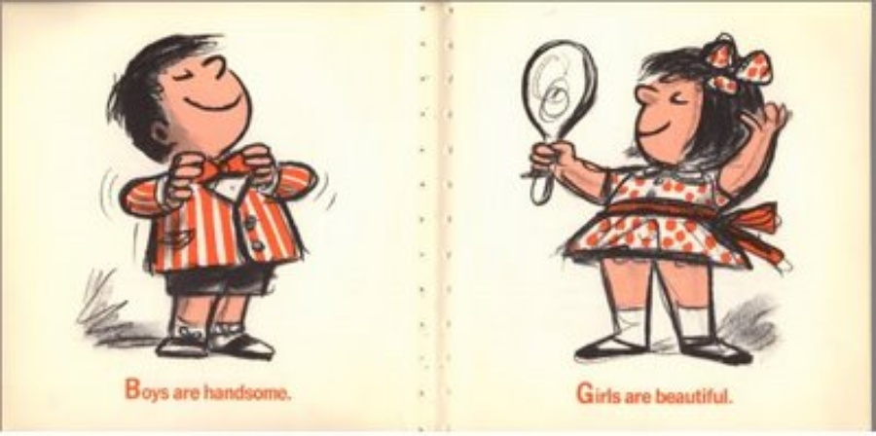
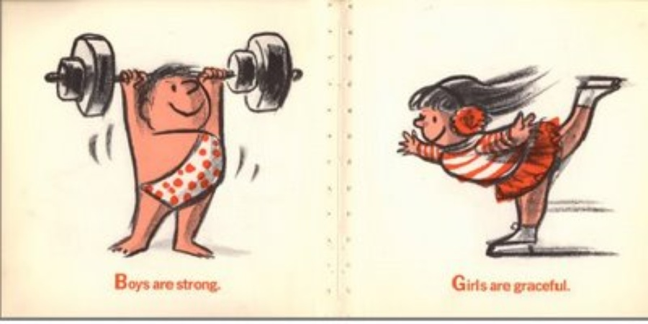
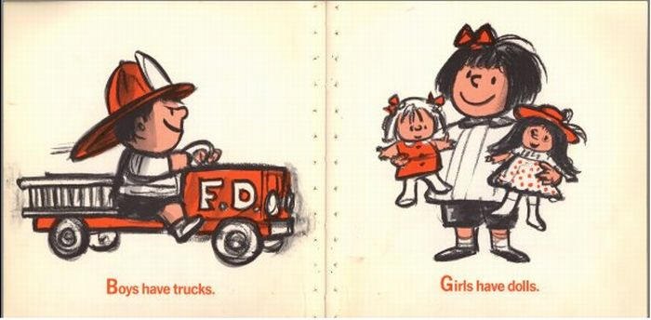

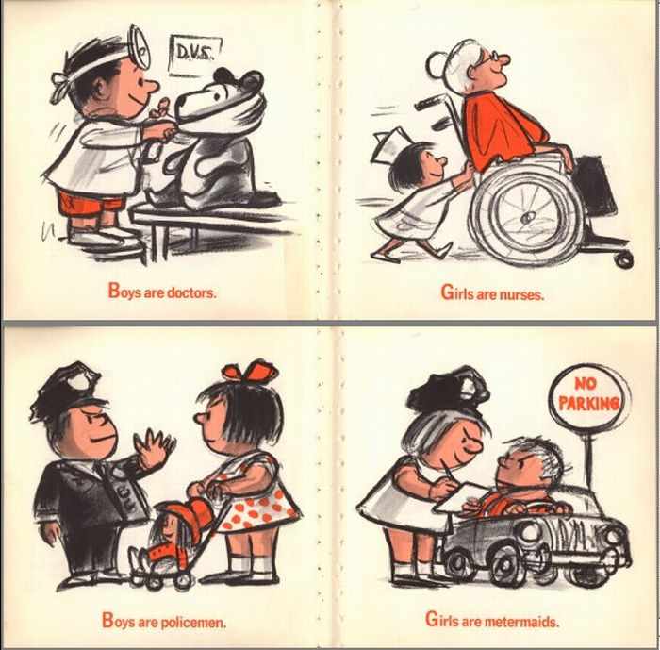

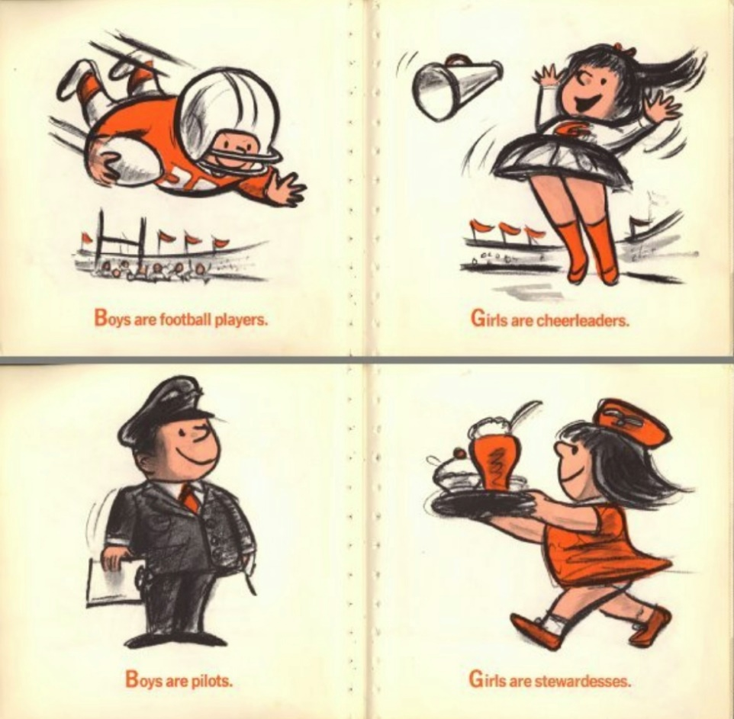
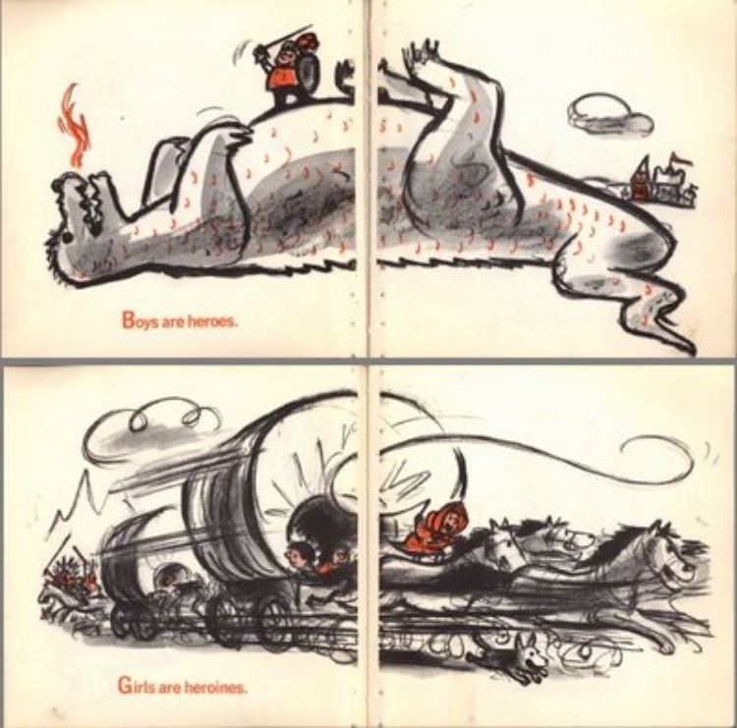
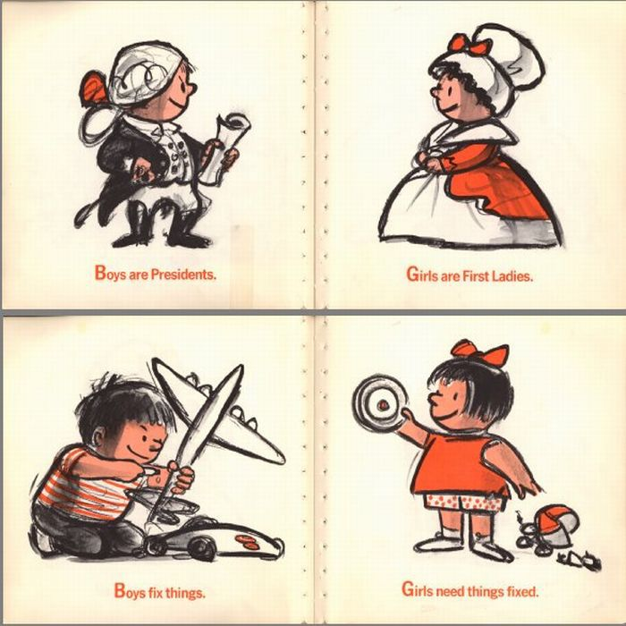
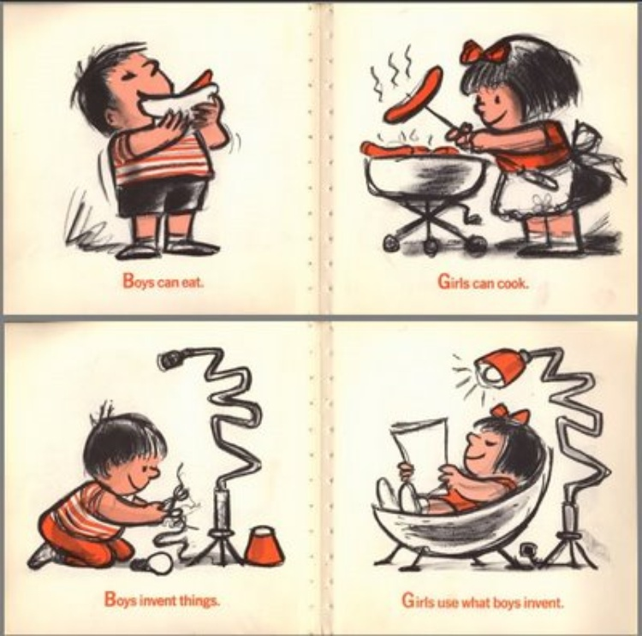

Fact or Bluff
Session 4: Activity 3  Fact or Bluff | Objective  - To distinguish facts from myths and misconceptions about puberty and human reproduction.
Time: 30 mins | Material required:  Printed statements (Tick for fact) & (cross for bluff)

Instructions:
- Explain the mechanics of the game. You will read aloud some statements about puberty and human reproduction. The participants will determine whether each statement is correct or incorrect. The participants will respond by saying “fact” and gesturing a big check for statements they deem correct or saying “bluff” and gesturing a big X for statements they deem incorrect. Each statement will be explained.
- Give some sample statements to familiarize the group with the mechanics of the game.
- Read aloud the following statements one by one:
- When a woman has her period, she is not allowed to run or exercise. (BLUFF)
- The male genitalia, commonly referred to as the penis, has bones, which is why it enlarges. (BLUFF)
- It is not advisable to take a bath when one has their period. (BLUFF)
- It is normal to experience wet dreams. (FACT)
- There are approximately 20 million sperm cells in a teaspoon of semen. (FACT)
- You cannot get pregnant on your first-time having sex. (BLUFF)
- Jumping or bouncing after having sex will prevent pregnancy. (BLUFF)
- Period blood is dirty blood from the body. (BLUFF)
*Facilitator can add more statements if required
4. Provide an explanation to clarify each statement.

FACT OR BLUFF EXPLANATION
- Statement a: During her period, a female can do anything she normally does. Exercise can even help reduce cramps and improve her mood.
- Statement b: Even though we sometimes call an erect penis a “boner”, the penis has no bone in it. A rush of blood into the penis causes an erection.
- Statement c: Teens need to shower even more as a result of puberty, especially during their period. They need to pay extra attention to their bathing routine during their period, for their comfort and also as part of their hygiene routine.
- Statement d: This is completely natural—nocturnal emissions or “wet dreams”. This often happens when people have dreams with sexual themes.
- Statement e: Sperm count varies from about 20 million to 100 million sperm cells per ejaculation. Healthy males produce 1.5ml to 5ml of semen each time they ejaculate. It takes only one sperm to fertilize an egg.
- Statement f: A female may get pregnant any time she has sex without reliable birth control. Sperm survive up to five days inside the female body and ovulation can happen even during a menstrual period. Without protection, there is a chance for the sperm and egg to get together. A sexually active heterosexual couple who does not want to get pregnant should always use reliable birth control.
- Statement g: Male and female reproductive organs function to get semen in and keep it there. Physical activity will not get semen out and thus cannot prevent pregnancy.
- Statement h: Menstrual blood is a natural bodily fluid that primarily consists of blood, uterine tissue, and other fluids. Menstruation is a normal and healthy part of the menstrual cycle in women.

FACILITATOR’S INFORMATION: If time permits these myths can also be included and addressed-
- Myth: Girls start puberty earlier than boys.
  - Fact: The onset of puberty can vary widely among individuals, and there is no strict rule that girls always start puberty earlier than boys. Timing can be influenced by genetic, environmental, and nutritional factors.
- Myth: Masturbation is harmful or causes health problems.
  - Fact: Masturbation is a normal and healthy part of sexual development. It does not cause physical harm, and there is no evidence that it leads to health problems. It's a private and personal choice for individuals.
- Myth: Acne is solely caused by poor hygiene.
  - Fact: While good hygiene practices are essential, acne during puberty is mainly caused by hormonal changes. Genetics, diet, and other factors can also play a role. Maintaining proper skincare can help manage acne but does not guarantee its prevention.
- Myth: Menstrual cycles should always be regular from the beginning.
  - Fact: It's common for menstrual cycles to be irregular during the first few years after menstruation starts. Irregular cycles are normal during puberty, and they often regulate over time.
- Myth: Breast size determines fertility or maturity.
  - Fact: Breast size is not an indicator of fertility or maturity. Breasts come in various shapes and sizes, and the development of breasts during puberty is influenced by genetics, hormones, and individual factors.
- Myth: Having a growth spurt means a person has finished puberty.
  - Fact: While a growth spurt is a significant aspect of puberty, it doesn't necessarily mean that puberty is complete. Puberty involves various physical and hormonal changes that continue for several years.
- Ask the group what feelings/insights do they have about the game. Have them share other myths and misconceptions they know of, that are related to puberty and human reproduction. Discuss these beliefs and perceptions with the group. Provide explanations, if needed.
- Tell them that these myths and misconceptions create confusion, embarrassment and/or fear among young people. Explain that puberty (the time of sexual maturation) can be a very confusing time. Young people experience a lot of physical and emotional changes. They need to be armed with the correct information so they can better manage themselves. Young people spend a lot of time wondering if they are “normal” or comparing themselves with their friends. They need a lot of reassurance as they head into this stage of human development. Even if kids are embarrassed to ask about it, parents/guardians need to guide them on what to expect during puberty and adolescence.
- Emphasize that when parents/guardians are open to children’s questions about their bodies, sexuality and human reproduction, they encourage the continued conversations and openness with their children. By welcoming questions about their children’s changing bodies and sexual issues; and not treating them as dirty or embarrassing subjects, parents/guardians teach their kids the value of respect, self-acceptance, and understanding. Children are more likely to come to their parents/guardians for information and guidance.
- Educators will be the main implementors of this education. They will be trained to have confidence, commitment, and resources to be able to teach more complex issues, on sexuality and sexual and reproductive health. This will provide students with life skills and positive behaviours that would prevent issues such as early pregnancies, school-related Gender-Based Violence, bullying, and the spread of STI/HIV infections
- Explain that there should be a discussion on puberty and human reproduction at home and also at school. This education will provide opportunities for students to acquire comprehensive, accurate, evidence-informed, and age-appropriate information on sexuality.

Good News Bad News
Session 4: Activity 4  Good News Bad News | Objective  - To classify news headlines in positive or negative news.
Time: 20 mins | Material required: None

Instructions:
- Ask the group to classify the following tabloid newspaper headlines into Good News or Bad News.
- Ask them to answer using hand gestures: thumbs up for Good News; thumbs down for Bad News.
HEADLINES
- Differently abled Student, bullied inside the classroom in an inclusive setup!
- Nude photos, spread by ex-boyfriend on social media!
- Gay person, raped in a Mall!
- Sex in exchange for a high grade, exposed!
- Parents auctioned their child on the internet!
- Young woman, assaulted by drinking companions.
- Date rape drugs, widespread!
- Minor, smuggled by a syndicate at the pier, rescued.
- Wife, slapped by husband for refusing intimacy.
- Transgender woman prohibited from using the women's restroom.
- Legal Victories: Landmark Judgments Upholding Rights of Persons with Disabilities.

- Ask the group about their feelings/insights during the game. Have them share similar stories/incidents/experiences.
- Introduce the concept of Gender-Based Violence (GBV) to the group. Explain the following:
- GBV is violence directed against a person because of their gender. Both women and men experience this, but the majority of victims are women and girls.
- GBV and violence against women (VAW) are often used interchangeably, as it has been widely acknowledged that most GBV is inflicted on women and girls by men.
- Violence against women and girls is one of the most prevalent human rights violations in the world. An estimated 1 in 3 women will experience physical or sexual abuse in her lifetime. GBV undermines the health, dignity, security, and autonomy of its victims, yet it continues to occur because we are “told” to be silent (culture of silence). Many forms of VAW are rooted in power inequalities between men and women.
- Ask the participants if they know of any types of gender-based violence or if they have ever witnessed it or heard of someone experiencing it? Facilitator to make a note of their answers. After that, explain the types of GBV:
  - Overt physical abuse (includes battering, sexual assault, at home or in the workplace)
  - Psychological abuse (includes deprivation of liberty, forced marriage, sexual harassment, at home or in the workplace)
  - Deprivation of resources needed for physical and psychological well-being (including health care, nutrition, education, and means of livelihood)
  - Treatment of women as commodities (includes trafficking in women and girls for sexual exploitation)
- Analysis of the impact of GBV is expanding — from considering the immediate effects on the women/children to examining the effects on the larger community, family, and society. GBV is not just a “women’s issue” but an issue that concerns all of us.

Consent is like Drinking Tea
Session 4: Activity 5  Consent is like Drinking Tea | Objective  - To identify the elements of sexual consent.
Time: 40 mins | Material required:  Consent pictures to understand and flip charts

Instructions:
- Ask participants what they understand by following concepts —sexual abuse, sexual assault, and intimate partner violence. Write their responses on flip charts.
- Tell them that these are human rights violations that need to be stopped. Part of putting an end to Gender Based Violence is for young people should be educated about personal boundaries, privacy, and sexual consent.
- Explain the meaning of sexual consent through picture storytelling or can be done through a PPT. Refer to Drinking tea is like consent. Given below
- Ask for reactions, insights or reflections about sexual consent.
- Explain the different elements of sexual consent:
  - Answer must be “Yes”.
  - Some people cannot consent.
  - Prior involvement does not count.
  - You must know if you have consent.
- Emphasize that sexual activity without consent is rape or sexual assault.
- Summarize the session by recalling the important messages about GBV from previous sessions.

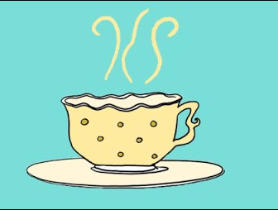 | sexual consent is similar to preparing a cup of tea.
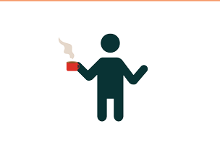 | You ask your partner!  Come, let's have Tea. Would you like some?"
 | When asked, the person replied  Response 1: "I want to! Alright, let's have Tea. Thank you."  This indicates an affirmative response, expressing a clear desire and acceptance of the invitation.
 | 'When asked, come on, let's have Tea?'  Response 2: Then the person answered, 'Hmm... I'm not sure...'.  In this case, the person is uncertain or hesitant about accepting the invitation. The response suggests doubt or indecision
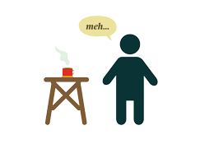 | You can choose to prepare tea for the person or not. Just be prepared because the person might not drink the tea you prepared."
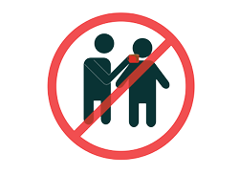 | Important to remember: Don't force the person to drink Tea. Just because you prepared the Tea, does not mean you can insist them to drink it.
 | And if the person says, "Oh, No Thank you." Don't prepare Tea for them. Just refrain from making and don't force them to have Tea.
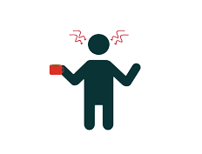 | Don't get angry or upset if the person doesn't want Tea and refuses to have it.
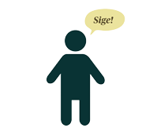 | Another possibility-  You went through the trouble to make tea but when the tea arrives, the person changes his/her mind.
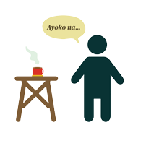 | Person says- “I'm sorry, I don't want Tea anymore.”  Of course, it can be frustrating because you went through the trouble of preparing it, but the person has no obligation to drink it.  Earlier, the person wanted tea, but now doesn't.
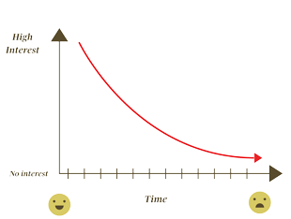 | Some people really change their minds. While you were busy preparing Tea, they changed their mind.  But It's okay if someone changes their mind. Don't insist on making them drink the Tea you've prepared."
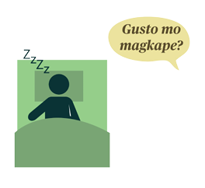 | "And if the guest is unaware, don't prepare Tea for them. A person who is unaware/unconscious cannot have Tea. Because they won't be able to answer the question, 'Do you want Tea?' Since they have no awareness."
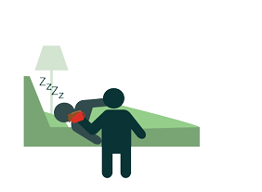 | If we offered a person to have Tea, they started drinking it, then fell asleep before finishing it, don't force them to drink the tea."
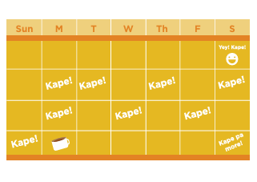 | If someone told you last Saturday that they wanted to have Tea. This doesn't mean they want you to make Tea for them all the time.
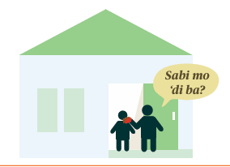 | This also doesn't mean going to their house unannounced, making Tea, forcing them to drink it, and saying, "You said last Saturday you wanted Tea, right?"
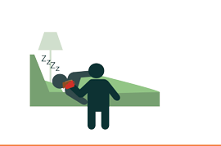 | Or, if they wake up and you insist on making them drink the tea, saying, "Don't you want tea from last night?"
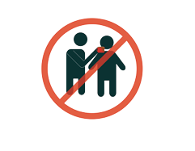 | If we understand that we shouldn't force people who don't want to drink tea to do so, and we understand when people can't have tea; we should also understand that the same applies when it comes to sexual relations or sex.
 | Making Tea or engaging in sex, "consent" is always important.
 | Remember: Consent or Agreement is always necessary.  And we must embed this in children.

  - Recall the meaning of consent (giving permission to someone for something; saying yes is consent) and situations where consent is needed.
  - Facilitator to share below pointers with participants that will help them in educating children.
      - Emphasize that a child gets to decide what to do with their body. No one else is entitled to decide what to do with their body except the child.
      - Children should always safeguard themselves and know the healthy boundaries for touch and personal space.
      - If someone breaks this boundary, children should talk to an adult they trust.
  - Enumerate ways for children to protect their bodies and set personal boundaries:
      - Say “no”! Tell the person that you don’t like it and you don’t want to be touched.
      - Get away fast! Run away from the person whose touch you don’t like. Never stay alone with that person ever again.
      - Call for help. You can scream.
      - Believe in yourself. You did nothing wrong.
      - Tell someone you trust what happened. If someone touches you in the wrong way, tell someone you trust what has happened. Don’t let threats scare you into running away or keeping quiet. When a person touches you and asks you to keep it a secret between the two of you. Ask yourself, “Does the secret bother me?”
      - Don’t keep secrets that make you feel uncomfortable. Go to a person you trust — parent, family, teacher, or doctor. If the person you go to doesn’t believe you, go to someone else you trust until someone believes you and helps you.
      - Stay away from the person who is touching you in the wrong way or making you feel uncomfortable. Don’t stay alone with a person who touches you in a way that makes you uncomfortable or makes you feel unsafe.

Gap Analysis
Session 4: Activity 6  Gap Analysis | Objective  - To surface prior knowledge, views, perspectives and questions about adolescence and sexuality.
Time: 40 mins | Material required: flip charts and markers/PPT

Instructions:
- Divide the participants in 3-4 groups. Ask the participants to discuss and complete the
sentences below and they have to write each answer as a group on flipcharts and present it
to the larger group.
  - What I know about adolescence…
  - What I don’t know about adolescence…
  - What I want to know about adolescence…
  - What were the questions I had about sexuality when I was a teen...
- Group similar answers.
- Summarize the answers of the participants. Discuss/clarify answers
FOR DETAILS- Adolescent health and development (who.int)
- Ask participants to individually fill the below worksheets-my shocking first signs of
entering adolescence.
- Ask if they felt helpless then? If yes, they need to see the importance of RSH
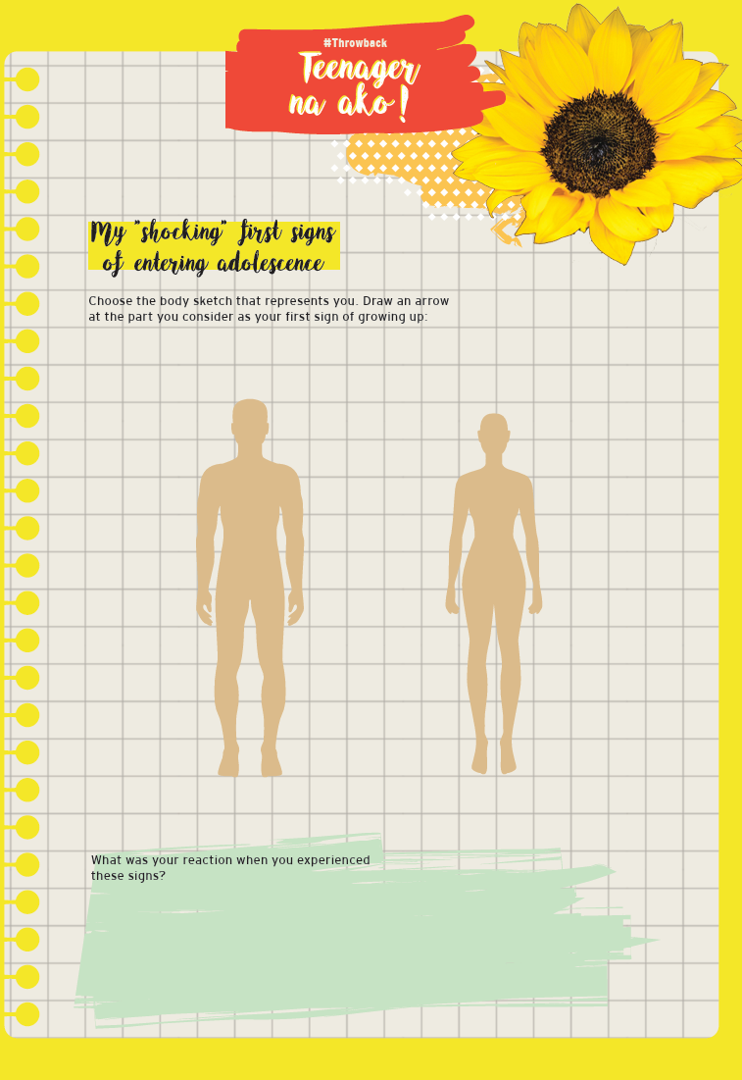

Action Planning
Session 4: Activity 7  Action Planning | Objective  - To brainstorm activities, techniques that can serve as motivation/stimulus for RSH discussion by educators & parents in their class and with their children or community at large.
Time: 30 mins | Material required: flip charts and markers/PPT

Instructions:
- Divide participants in group and ask them to brainstorm on how they can apply their learning with their children or other parents and educators on RSH.
- Ask the participants to share their ideas/activities/recommendations/suggestions.
- Share some possible activities that can serve as a stimulus to jumpstart their classroom discussion.
- creating awareness posters, designing informative brochures, or participating in role-playing scenarios.
- Ask participants to list advice for different issues related to adolescence.
- Facilitator to Pose a question: Where do children/young adults get information if they have concerns about their bodies, romance and relationships?
- Participants may mention the following: parents, teachers, friends, media, etc. Focus on their best friends. Tell them that young people turn to their best friends for opinions, information and support systems.
- Studies suggest that adolescents cope with stress better when they are around peers rather than adults.
- But we want to equip young people with accurate and age-appropriate information so they can be reliable support systems for their friends. Although we encourage young people to consult with parents, teachers and health professionals, we also recognize the important role of their friends in their lives.
- Ask the participants to pretend to be the best friends of their children. Tell them that their “best friends” are experiencing problems with their bodies, romance, and teenage pregnancy. They need to help them by giving some advice.
- Call some volunteers to highlight questions and the best response/advice to them.
Summarize: we have to become that best friend for our children to address their needs and queries.

CLOSING SESSION: FACILITATOR
In a comprehensive sexual health education program, three components—knowledge, skills, and attitudes—are interconnected and essential for promoting overall well-being and responsible behaviour. The goal is to empower individuals to make informed decisions, communicate effectively, and cultivate healthy attitudes toward their own and others' sexual health.
- Knowledge: Knowledge is what you know or understand about a particular subject or topic. It includes the facts, information, and awareness you have acquired through learning and experience. For example, knowing that the Earth revolves around the sun is a piece of knowledge.
- Attitude: Attitude refers to your feelings, opinions, or reactions toward something or someone. It reflects your mindset or approach. For instance, having a positive attitude means having a favourable outlook.
- Skill: Skill involves the ability to perform a task effectively. It's the practical application of knowledge and the capability to do something well through practice and experience. Driving a car, playing a musical instrument, or using a computer are examples of skills.
Let’s understand this from Sexual Health Education
Knowledge:
- Knowledge in sexual health education involves understanding factual information about human anatomy, reproductive systems, sexually transmitted infections (STIs), contraception methods, relationships, consent, and other relevant topics.
- Knowing the different types of contraceptives available, understanding how STIs are transmitted, and being aware of the stages of human sexual development are examples of sexual health knowledge.
Skills:
- Skills in sexual health education refer to the ability to apply knowledge effectively in various situations. This includes communication skills, decision-making skills, and the ability to negotiate and establish healthy relationships.
- Communication skills to discuss boundaries and consent with a partner, decision-making skills when choosing contraception methods, and negotiation skills to ensure both partners are comfortable and safe in a sexual relationship.
Attitude:
- Attitude in sexual health education encompasses one's beliefs, values, and emotional disposition toward sexuality, relationships, and personal responsibility. It involves fostering a positive and respectful attitude towards oneself and others.
- Having a non-judgmental attitude towards diverse sexual orientations, respecting individual choices about when to engage in sexual activity, and understanding the importance of open communication in relationships are examples of positive attitudes in sexual health.

LET’S APPLY THE IMPORTANCE OF Knowledge, Skills and Attitude (KSA) TO PARENTS & EDUCATORS
Knowledge:
  - Parents & educators need accurate and up-to-date knowledge about human anatomy, reproductive health, contraception, sexually transmitted infections (STIs), and relationships. This knowledge provides a foundation for addressing children's questions and concerns.
  - Understanding effective communication strategies enables parents & educators to convey information in an age-appropriate and sensitive manner. Knowledge about the developmental stages of children helps tailor discussions to their level of understanding.
Skills:
  - Parents & educators with good communication skills can create an open and non-judgmental environment for discussing sexual health topics. This involves active listening, responding empathetically, and encouraging questions.
  - Building a strong and trusting relationship with their children/students is a crucial skill for parents & educators. This relationship forms the basis for open communication and allows children to feel comfortable discussing sensitive topics.
Attitudes:
  - A positive and non-judgmental attitude is essential for creating an environment where children feel safe discussing their concerns and questions without fear of condemnation. Parents & educators with an open-minded approach are more likely to foster trust.
  - Parents & educators with a respectful attitude toward their children's autonomy and decision-making help create a supportive atmosphere. This encourages children to make responsible choices about their sexual health.
Implementation: How can you do it
- Age-Appropriate Education: Applying knowledge of child development, parents & educators can tailor discussions to their children's age and maturity level. This ensures that the information provided is both accurate and comprehensible.
- Promoting Healthy Relationships: Parents can impart skills related to building healthy relationships, emphasizing the importance of communication, consent, and mutual respect.
- Addressing Values: Attitudes play a key role in conveying values related to sexual health. Parents & educators can model positive attitudes and values, such as empathy, respect for diversity, and the importance of responsible decision-making.
In summary, a holistic approach that combines accurate knowledge, effective communication skills, and positive attitudes is essential for parents & educators when training their children on sexual education. By developing these KSAs, parents & educators can create an open and supportive environment that empowers their children to make informed and responsible choices regarding their sexual health.
In Participants’ handout proposed content, knowledge, attitudes and skills for children have been shared parents and educators can use them for reference.

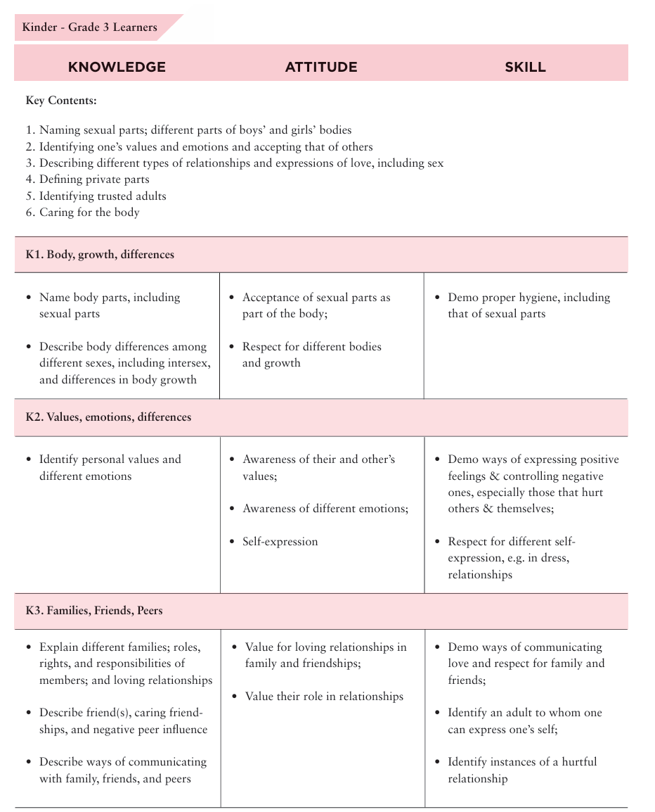
PARTICIPANTS’ HANDOUT

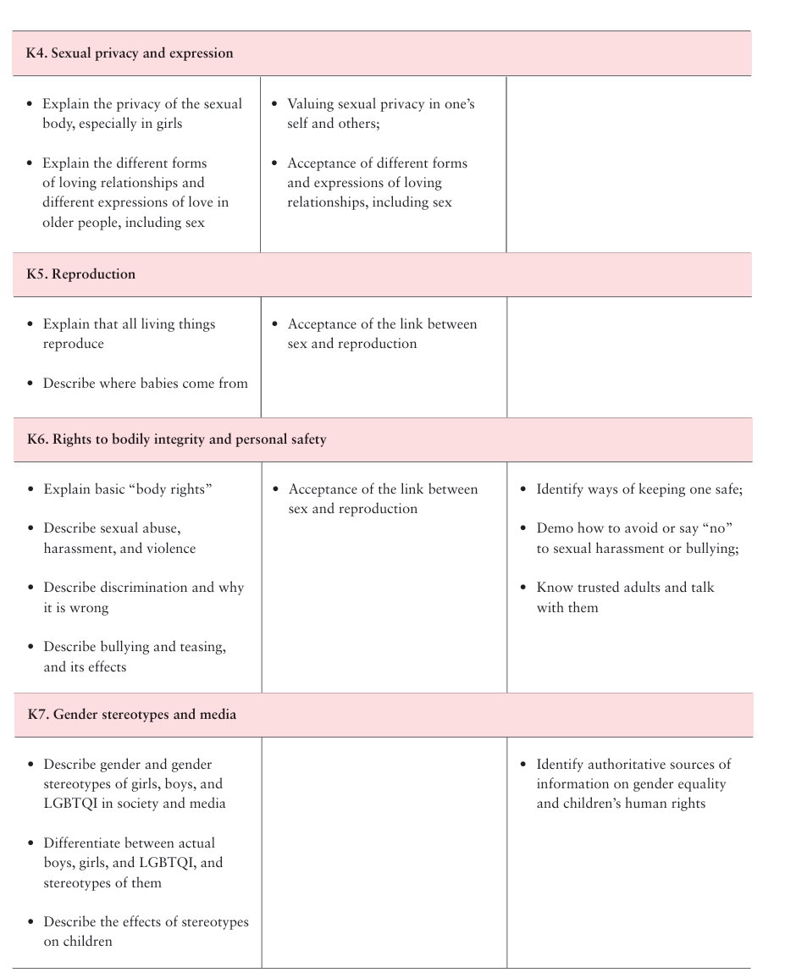

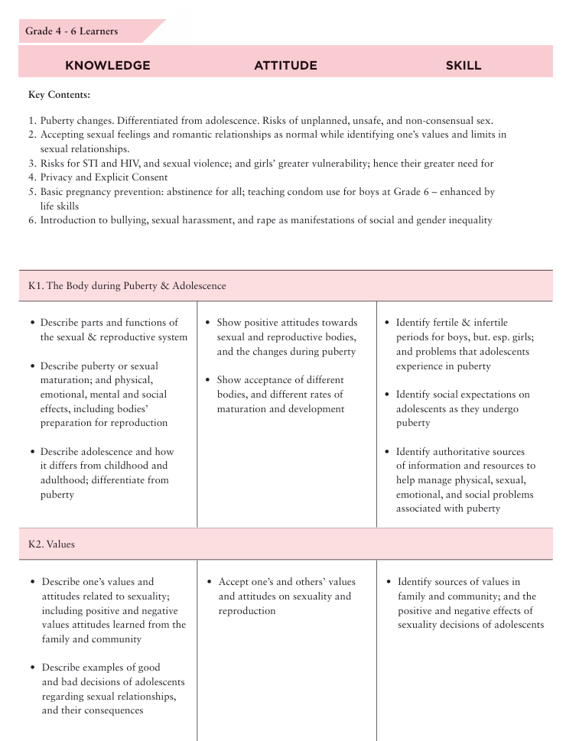
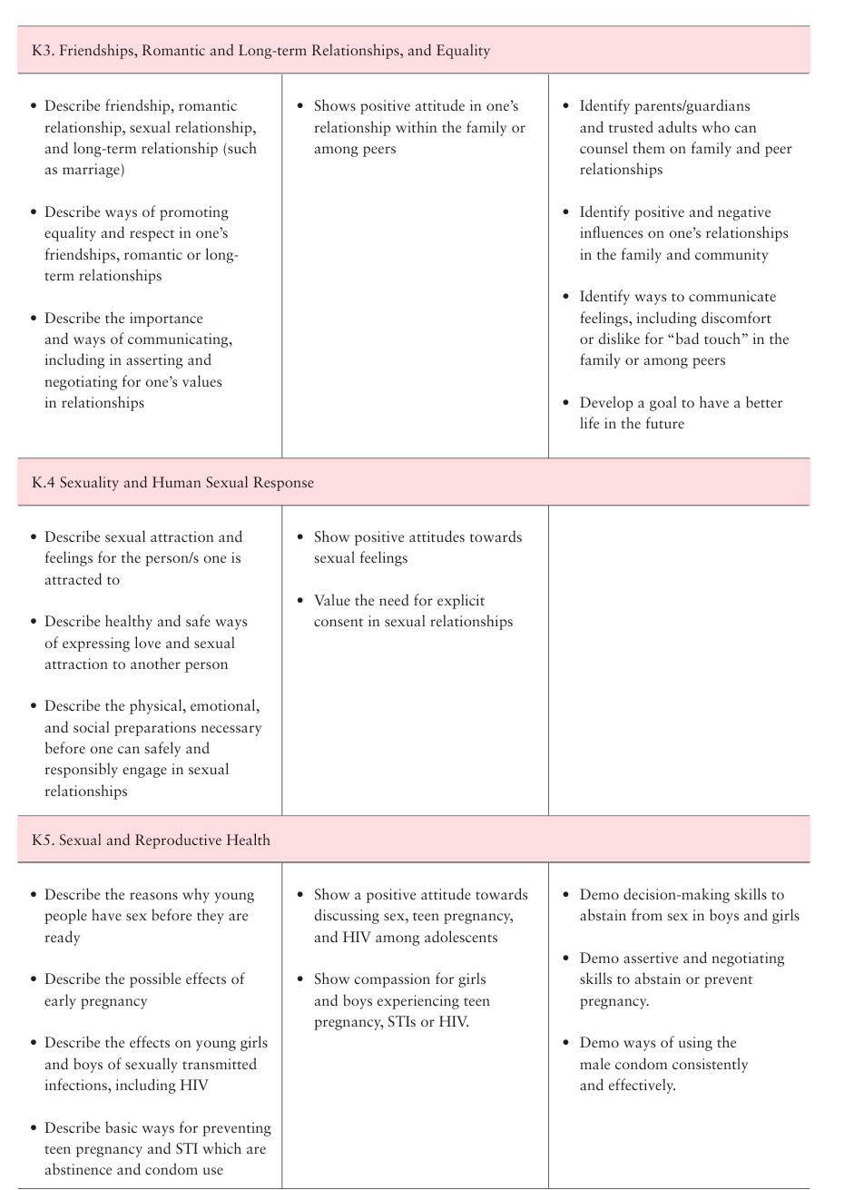
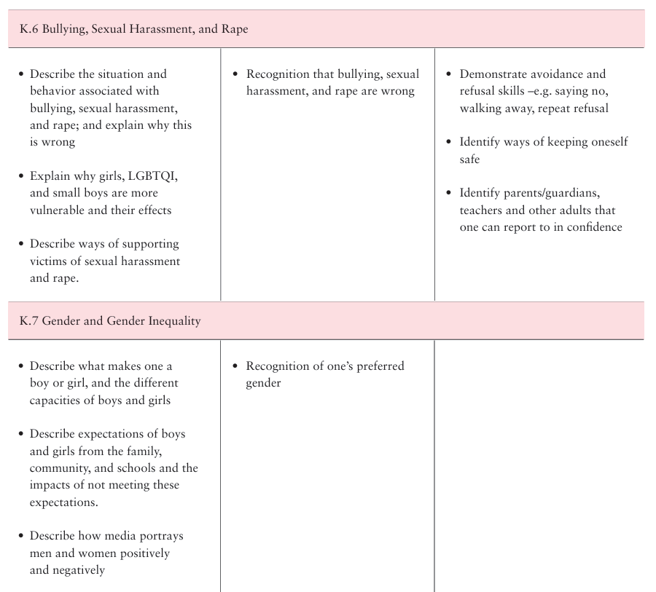

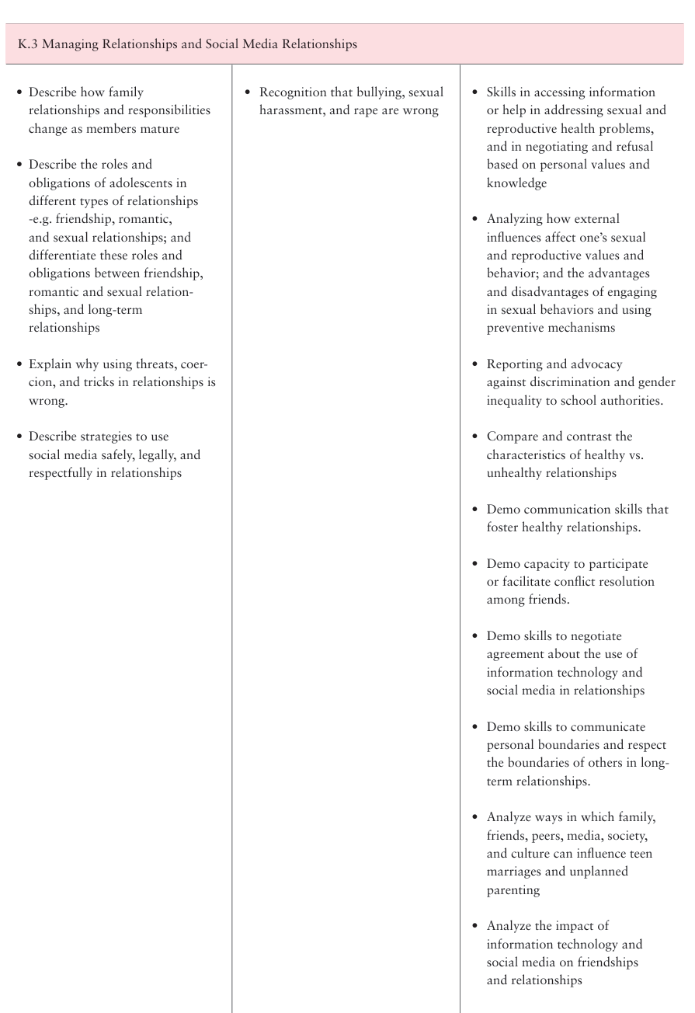
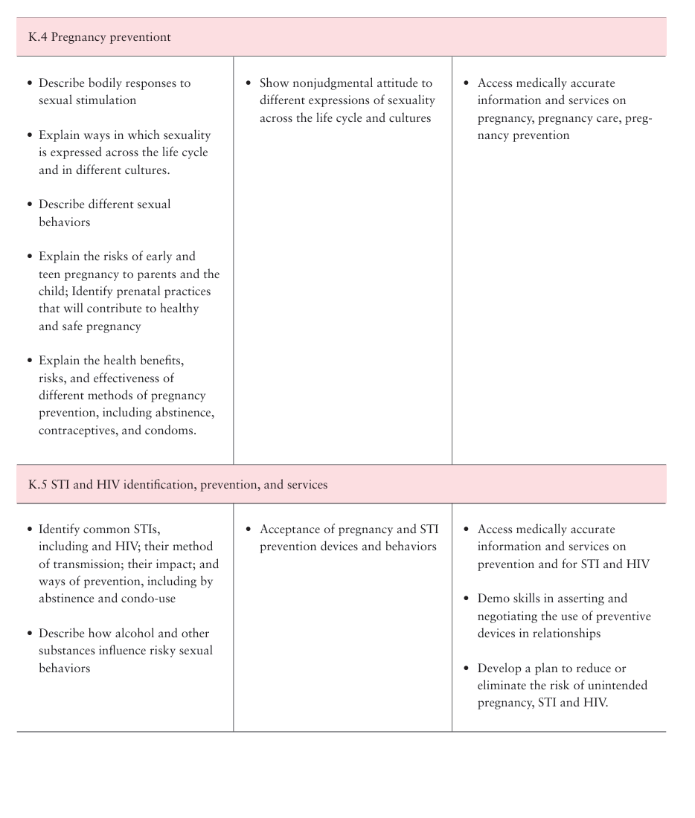

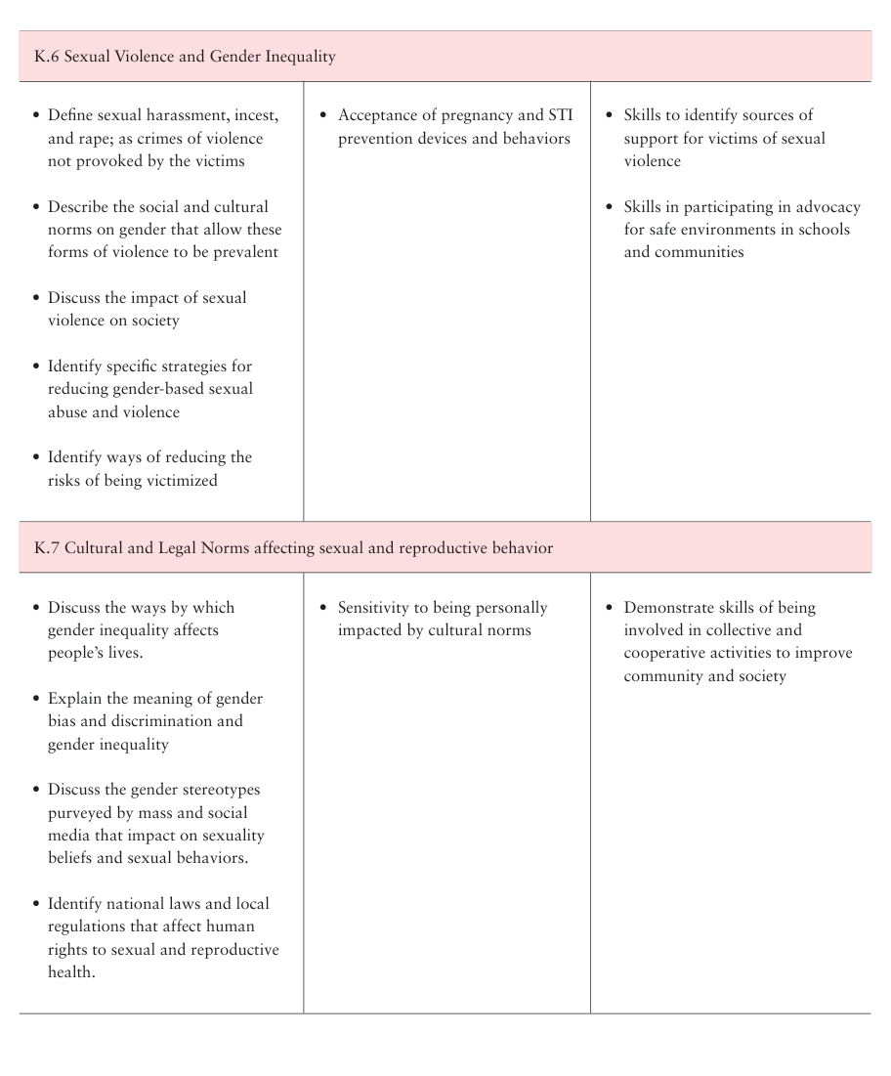

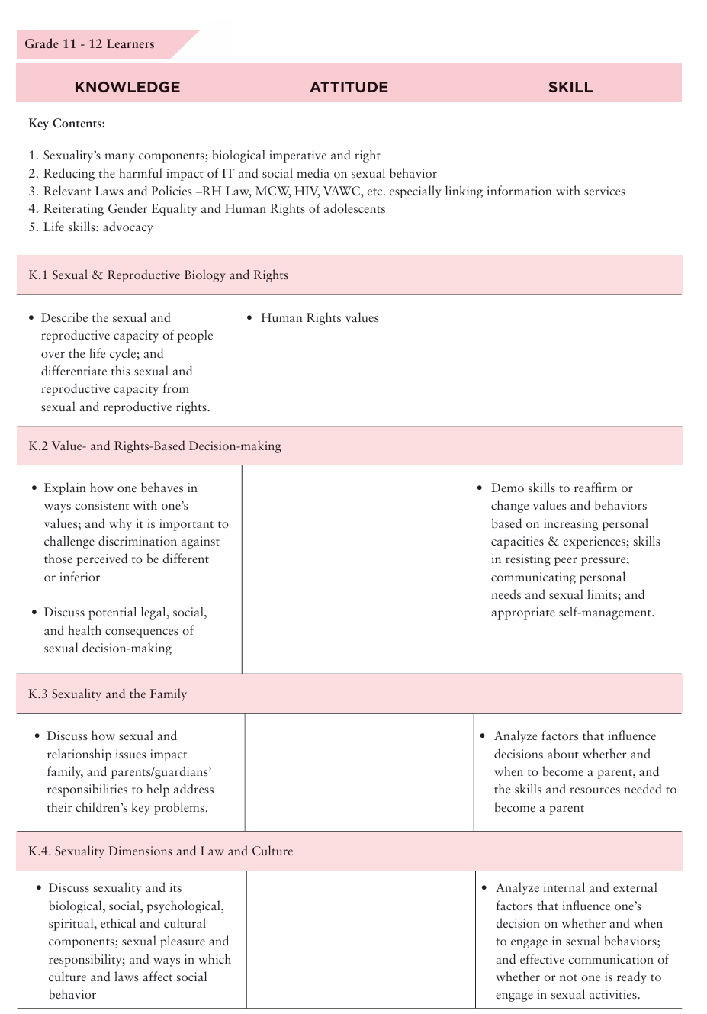
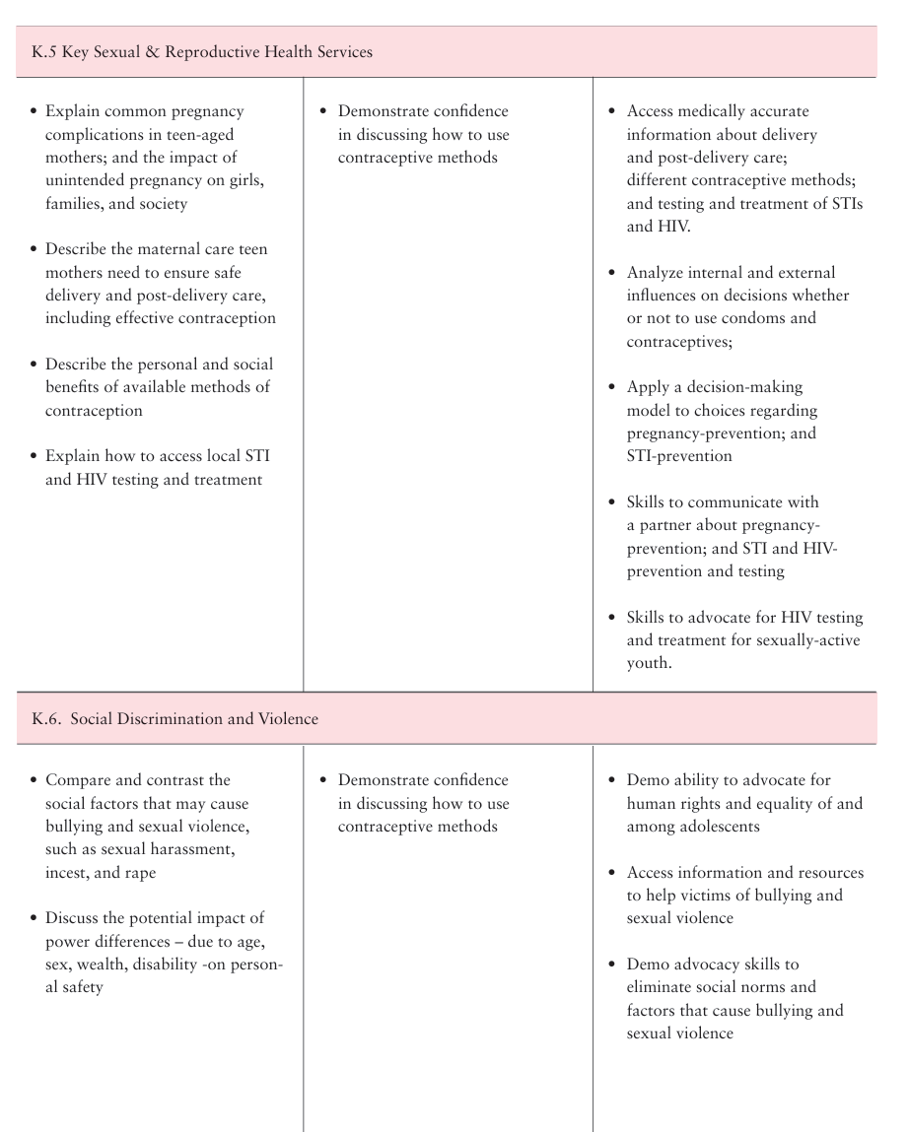

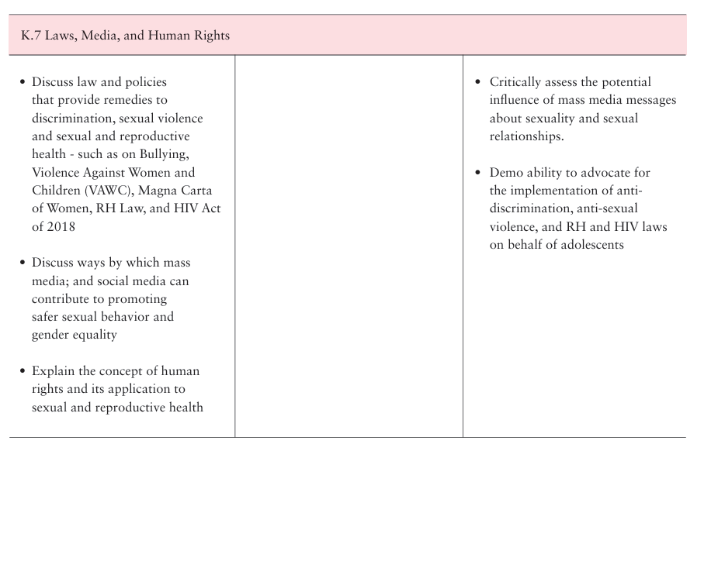

References/work-cited/ Bibliography:
WEBSITES
- Advocates for Youth | www.advocatesforyouth.org
  - The Parents’ Sex Ed Center provides information and resources on the role of parents as sex educators.
- KidsHealth | www.kidshealth.org
  - KidsHealth is a comprehensive health website for parents, kids and teens on health and development.
- Planned Parenthood | www.plannedparenthood.org
  - Planned Parenthood’s Tools for Parents provides resources and information for talking with children and teens about sex, sexuality and relationships.
Citations
- It’s That Easy! Collaborative. (2010). It’s That Easy! A Guide to Raising Sexually Healthy Children
- Ferguson, Gloria. (2010). Health Start/West Side Community Health Services, Saint Paul, MN
- Adapted from: Critical Multicultural Pavilion – Awareness Activities, Guide for Setting Ground Rules. Retrieved 2/8/16 from http://www.edchange.org/ multicultural/activities/groundrules.html
- Scribner-O’Pray, Emily. (2010). Teen Age Medical Service, Children’s Hospital and Clinics of Minnesota, Minneapolis, MN and Snuggerud, Molly (2010). West Suburban Teen Clinic, Excelsior, MN
- UNFPA. (2020) Awareness and Attitudes of Teachers and Parents to Comprehensive Sexuality Education. Conducted by Cedos Think Tank and Info Sapiens Research Agency, with the support of the Ministry of Education and Science of Ukraine.https://ukraine.unfpa.org/sites/default/files/pub-pdf/sexual_education_engl.pdf
- WHO Regional Office for Europe and BZgA. (2017) Training Matters: A Framework for Core Competencies of Sexuality Educators
https://www.bzga-whocc.de/fileadmin/user_upload/BZgA_TrainingMattersFramework_EN.pdf
- The Know Your Body Know Your Rights CSE curriculum/ The YP Foundation/ 2022
- https://3rs.org/wp-content/uploads/2018/10/its-that-easy-parent-workshop-manual-2016.pdf
- https://teachingsexualhealth.ca/app/uploads/sites/4/2023-FALL-Webinar-Series_What-is-CSHE.pdf
- I 'm Glad I'm a Boy! I'm Glad I'm a Girl! Book by Whitney Darrow Jr.
https://www.goodreads.com/en/book/show/2882044
- UNESCO Health and Education Resource Centre. (2007). Our Future: Sexuality and Life Skills Education for Young People. International HIV/AIDS Alliance. https://healtheducationresources.unesco.org/library/documents/our-future-sexuality-and-life-skills-education-young-people-grades-6-7
- UNFPA. (2003). Adolescent Reproductive Health Training Manual. Copyright Secretariat of the Pacific Community.
- UNICEF. (2017). Adolescent Girls Toolkit 2017 https://www.unicef.org/media/73606/file/Adolescent-Girls-Toolkit-2017.pdf.pdf
- HSE Sexual Health and Crisis Pregnancy Programme. (2020). Busy Bodies-A booklet about puberty and adolescence for you and your parents (additional edits 2023).https://www.sexualwellbeing.ie/for-parents/busy-bodies-english-language.pdf
- Center for Health Solutions and Innovations Philippines- Comprehensive sexuality education: primer for parents and guardians (a teaching resource for school-based orientation session on CSE) https://tciurbanhealth.org/courses/philippines-toolkit-community-support/lessons/comprehensive-sexuality-education-2/topic/cse-primer-for-parents-and-guardians-manual-powerpoiints-and-printables/
- Centre for Development and Population Activities. (2000). GENDER, REPRODUCTIVE HEALTH, AND ADVOCACY: A Trainer’s Manual.
- Norwegian Church Aid. (2022). Comprehensive Sexuality Education (CSE) Toolkit. Awiti, P., & Jura, C. (2022). Title of the Report. Edify Learning Forum Africa (ELFA) for Norwegian Church Aid. Retrieved from https://www.kirkensnodhjelp.no/globalassets/cse/comprehensive-sexuality-education-toolkit-trainers-manual.pdf
- https://www.unfpa.org/resources/adolescent-sexual-and-reproductive-health
- Y-PEER. (2020). SRHR Training Manual for Deaf and Hard of Hearing Young People- https://ypeerap.org/wp-content/uploads/2021/09/SRHR2021.pdf
- International Planned Parenthood Federation. (2017). Training Manual for Sensitizing Intermediaries on Sexual Rights of Young People with Learning Disabilities. https://europe.ippf.org/sites/europe/files/2017-12/KMS%20training%20manual%20for%20intermediaries.pdf
- Planet Puberty is a digital resource suite by Family Planning NSW that aims to provide parents and carers of children with intellectual disability and/or autism spectrum disorder with the latest information, strategies and resources for supporting their child through puberty.
Planet Puberty website and this is Funded by the Australian Government Department of Social Services. https://www.planetpuberty.org.au

